Savage Supers
Published Date : February 11, 2019
Author : mrnaterpg
Categories : Recommendations
With the recently released Savage Worlds Adventure Edition hitting virtual shelves, I was inspired to dig out my copy of Savage Worlds Deluxe Explorer Edition. In particular, I dug out all of the stuff I had accumulated while playing a super hero game with my daughter.
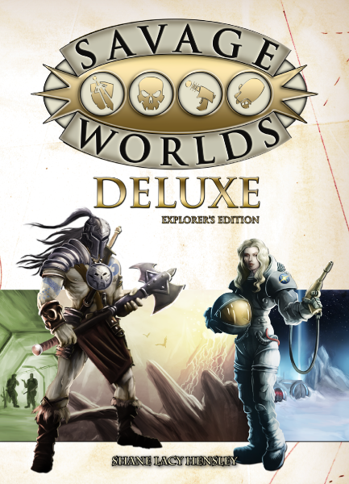
I had the pleasure of being introduced to Savage Worlds by our very own Caleb Chess, who is a huge proponent of the system. After he ran a game for us, I was convinced that Savage Worlds was not only a fantastic system for any seasoned roleplayer, but would work very nicely for kids as well. Up until this point I had already introduced my daughter to Hero Kids, First Fable, and My Little Pony Tails of Equestria. It should suffice to say she’s no stranger to tabletop RPGs.
When considering what style of game to play, I checked out all of the companion books that Savage Worlds has available. See, the core book has the core system along with a wealth of examples in how particular things can be used. So in the weapons section, you’ll see entries for swords, guns, and laser guns; it covers it all.
The companion series of books covers many different genres that you may want to play. Among these was the Supers Companion, and when I showed that one to my daughter, her eyes lit right up.
- 
The Fantasy companion provides everything you'd need for an epic fantasy campaign.

At the time she had been watching PJ Masks, so the idea of playing a super hero was very exciting for her. So, I ordered the Supers Companion and when it arrived we got straight to creating her character. And so…Unicorn Girl was born.
The system itself is simple enough for a kid to understand, but fun enough that running it with her was a lot of fun for me too. She recently stopped a girl at school from revealing her true identity and as it turns out, this girl wasn’t a real student at the school. She was an agent of the Dark Unicorn, Unicorn Girl’s arch nemesis. (She really likes unicorns).
An excellent supers game in it’s own right!
All told, we’ve had a blast with this fantastic companion book. The core Savage Worlds book plus this Super Powers Companion gives even the most fleshed out super hero rpgs a run for their money. It’s great for experienced players and novices new to the hobby, and I highly recommend it if you have a child that is even remotely interested in super heroes!

