# Using Linux for production

Published Date : February 3, 2019  
Author : mrnaterpg  
Categories : [Tech and Production](http://blog.unnamedproductioncompany.com/category/techandproduction/)

Many people think that using Linux for anything other than programming is an exercise in futility. However that couldn’t be further from the truth. There are so many great applications that can be used on GNU/Linux for both audio and video production.

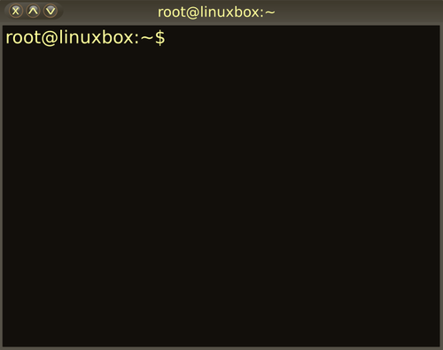

I ran a campaign for almost two years, using Linux for video and audio capture, video and audio editing, and general tasks such as creating maps and modifying public domain artwork. All of the programs required to do these things were 100% free and open source.

The reason I choose Linux for my day to day work is because of how well and stable it runs.  I don’t need to have some antivirus program running in the background, I can cleanly and easily control my system processes, and the programs I use are rock solid stable.

The only time I run in to trouble is when someone else wants to use a Windows only program for something.  I usually have to convince them to use something else, or dust off my Windows hard drive and let the thing update for 3 days before I can actually use it.

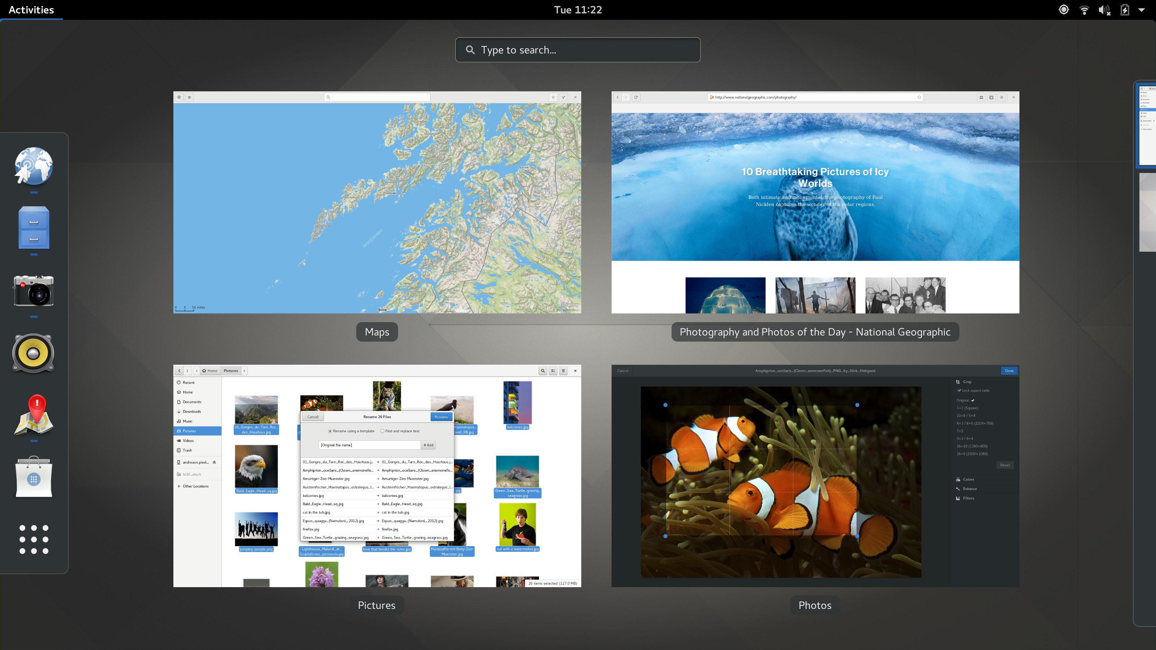

There are many great looking desktop environments for Linux.

If you are interested in trying Linux out, there are tons of great tutorials on how to try it without ever touching your hard drive and risking your data.  There is a great [PC World article](https://www.pcworld.com/article/205640/4_ways_to_give_linux_a_test_drive.html) that details 4 options to try out Linux. Of course you can always get at me at unnamedproductioncompany@gmail.com for questions!