[So I helped my daughter create a Monarchies of Mau character yesterday.  It is a great game where players play as anthropomorphic cats (awesome right?) who are rediscovering the world the Old Ones left behind.](http://blog.unnamedproductioncompany.com/category/recommended/)

The Old Ones are us, of course. For whatever reason, man is no longer present on Earth.  All that is left behind are the trinkets and technology left by the ancient humans.  No one knows, or ever will know, what has happened to them.

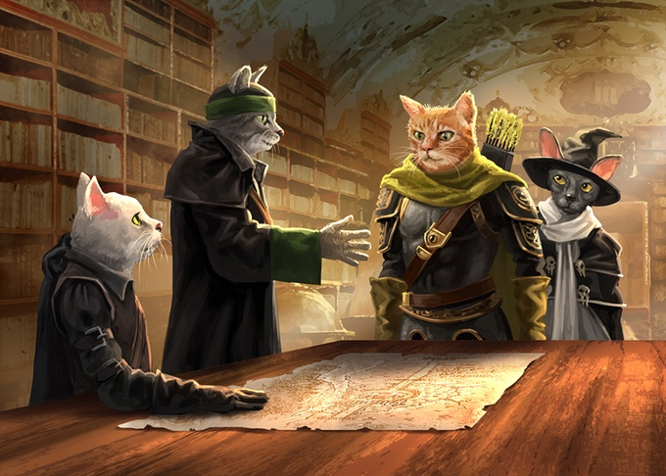

Kitty diplomats. Yup.

Monarchies of Mau is the other side of Pugmire, an RPG where players play (you guessed it) anthropomorphic dog people. There is a fun interplay between the Monarchies and the dogs of Pugmire, and there are a lot of opportunities for the cats and dogs to interact and roleplay.

Character creation is pretty simple, as the system itself is 5th Edition at its core.  It maxes out at level 10, but they managed to crunch a lot of good spells and content into those 10 levels.  My daughter and I have played it before, and she loves it.  She’s 8 and loves to roleplay her kitty character.

You can find this awesome game here:

<https://www.drivethrurpg.com/product/243273/Monarchies-of-Mau-Core-Rulebook?affiliate_id=718149>