### *Open Source and Cross Platform*

I love open source software. It serves so many uses and empowers so many people who couldn’t ordinarily buy into an expensive software ecosystem. My main focus in my professional life is usually audio software, as I’m a recording engineer by trade. I also use Linux, which means the vast majority of the software I run is going to be free and open source, just the way I like it. Thankfully, Linux has a robust audio community developing awesome open source projects and plugins, enabling me to accomplish things that would otherwise have been impossible without a huge amount of money spent on proprietary software.

However, when it comes to video editing (something I’m usually loathe to do) I normally just grab whatever video editor looks the easiest to use and go from there. I didn’t really care if it was open source, because the whole video thing isn’t really my wheel house; just give me something that works! And sadly, the state of affairs for Linux users who want a professional video editing experience has been somewhat lacking. Oh, there are definitely solutions, but many of them are prohibitively expensive or simply not that well ported to the Linux platform. I don’t need all that!

Enter Olive.

A lot of what you’ll read about video editors for Linux is about great projects like OpenShot, KDEnlive, and Shotcut. They are all excellent editors, but not what I’m discussing today.

I just finished using Olive to edit the first half of our Storm King’s Thunder session 1, and I have to say, it was awesome! Big **Disclaimer!** Olive is still in ALPHA. That’s right, not beta, alpha. I expected terrible functionality and a user experience that just wasn’t worth the time. However, what I found was an excellent and FAST editor that, for the most part, kept up with my demands.

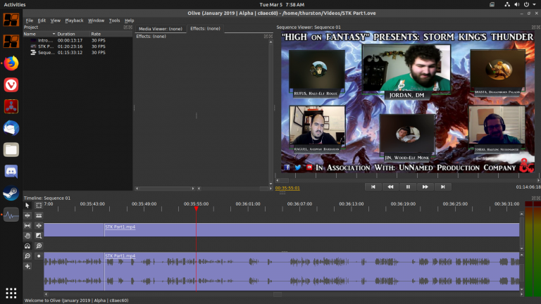

Editing session 1 with Olive Video Editor

Almost every video editor I’ve ever used has a problem keeping up with these large, long format videos. Often times I will be simply waiting for my transport bar to catch up with where I just told it to go. Not the case in Olive. It was SNAPPY. I had absolutely no problem navigating through this hour and a half long video, and making cuts where needed.

#### Effects

So, in the effects department, Olive has a TON of them built in. However, it was accessing them that I found kind of odd. When you select a clip, you’re presented with some options that looks like this: 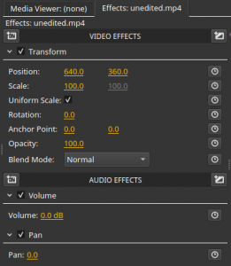

At first glance, it doesn’t look like anything I’ve ever dealt with before. But, when you look closer, you can see that this is where you will access effects and transitions. The video and audio effects are accessed on the left hand side icon, and there are a bunch!

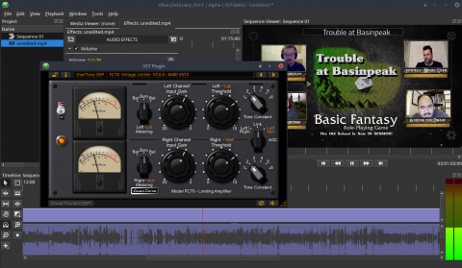

Fairchild FC70 Vintage Limiter

Of particularly awesome note, Olive can load VST2 audio plugins! Here I am using one of my favorite Compressors.

### Final Thoughts

All told, I’m very impressed with Olive. I have two major complaints. The first of which being that Olive has crashed on me a bit. This is of course expected; it’s an Alpha. My other complaint is that you can only add effects on a per-clip basis. This means that if I’ve already gone through the trouble of cutting up my video/audio in to clips and I want to apply an effect to ALL audio or ALL video, I have to go through and add that effect to each clip. This could be easily solved by placing the clips inside a virtual “track”, much the same way most other editors handle clips.

You can find Olive video editor here: [Olive Video Editor.](https://www.olivevideoeditor.org/)

While you’re here, check out some of the other content on the blog! Thanks for stopping by!