***A Basic Fantasy Adventure***

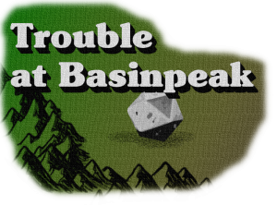

I ran a game for the UnNamed crew called Trouble at Basinpeak. It was originally meant to be a 1 shot adventure…and at first it totally was. We played the first session and by the end of it, everything was pretty much wrapped up in a little bow. I *did* leave a little cliffhanger at the end…but we’ll get there in a moment.

The premise behind this adventure is that our heroes begin in or just outside of a troubled town called Basinpeak. There isn’t anything too spectacular about Basinpeak, other than it has been on the up and up for a few years now. Business was good, life was good. Good.

The town is located in a cozy mountain range and situated next to some beautiful bodies of water. The denizens subsist mainly on the fish they gather from the nearby streams and lake. Every year the lake and streams have provided, and are one of the biggest contributing factors to the town’s success. You’re waiting for a BUUUUTTT… and here it is.

BUT, the town has seen a sudden downturn of luck. The lake and streams that always provide have not been providing. People have begun to get seriously worried, and some have even moved out and away. ….Reports have it that the fishermen have not been returning and some have even been found dead…ripped apart by some beast. Savage. Our heroes have arrived in the middle of this crisis.

What the players decided to do from here was entirely up to them, and this is what I absolutely love about tabletop roleplaying games: CHOICE. There is no pre-programmed set of responses to a pre-programmed set of allowable choices. The players act, and I as the GM, react. That said, there is of course a deeper plot that acts as a frame of reference for my reactions.

## What’s *ACTUALLY* happening.

Basinpeak has a visitor. Unbeknownst to the population of this little town, a hill giant named Zorvik has recently moved in to a neighboring forest.

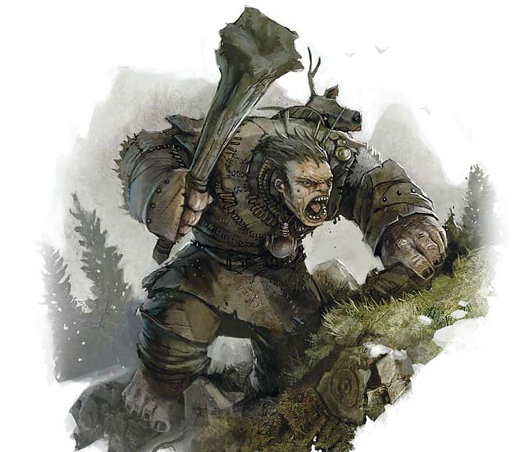  
Figure 1: An excellent piece of art from over at the [Forgotten Realms fandom Wiki](https://forgottenrealms.fandom.com/wiki/Hill_giant?file=Digest_0604_2_Hill_Giant.jpg)

Zorvik fancies himself a pet owner. In fact, he has been travelling far and wide in an attempt to find the biggest, baddest beasts to tame. His reason for doing so doesn’t go too far beyond ‘I like aminal, aminals fun!’. However, the beasts he’s been gathering are fearsome in their own right.

One such beast is his pet Owlbear. This Owlbear is currently kept in a cave, and watched over by the local Bugbears. When Zorvik captured the Owlbear, it was too savage to be tamed. So he’s doing what any great animal trainer would do: crate train! There is only one problem….Owlbears eat…A LOT. And they have a particular proclivity towards fish.

The Bugbears have been serving Zorvik out of fear. They aren’t really that attached to the giant, but they don’t dare oppose him. The Bugbears are the ones killing the fishermen and taking the town’s fish. It is their responsibility to care for the Owlbear.

## The stage is set!

The players were never actually aware that there might be a giant in the mix. For them, all they knew about was this fish crisis, and fishermen being killed. I could have left out the whole giant aspect altogether, and the game would have been exactly the same; but I couldn’t do that. The realist in me has to know that there is a reason for this random Owlbear to be parked in a cave.

In fact, I never intended for the players to actually meet the giant. The entire one shot adventure was meant to be played in one session, and end with the fish crisis being solved. At the end, I showed the players that this Owlbear they just felled may actually be a pet, and then let the credits roll. I thought, ‘Hah! Now they will never know Basinpeak’s true fate!’

However, after that first session, the players wanted to continue and see what happened next. I took that as a sign of a successful one shot adventure! If you want to see how that first session went, watch it here, or check it out over at our [Youtube channel!](https://www.youtube.com/channel/UCPyFZIIFXEdqqyD-Z5t3jhQ)

Keep your eyes peeled for session 2, where the players confront Zorvik!