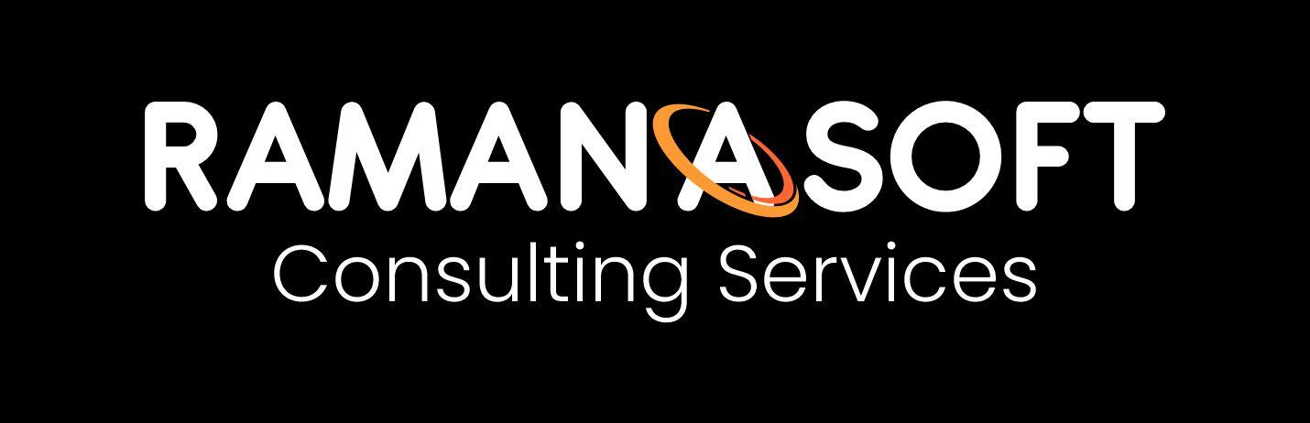

ERP Domain Knowledge Pack
For Gen AI Testers · Multi-Agent ERP Program · RamanaSoft
OFFICIAL NOTE — This document is issued by RamanaSoft Consulting Services (https://ramanasoft.com) as part of the ERP Multi-Agent + MCP Testing Program.

1. ERP Modules in Scope
Master Data (items, vendors, customers), Inventory & Warehouse, Procurement (P2P), Sales (O2C), Finance (open AR/AP read-only).

2. Critical Business Rules

Procurement
- Only DRAFT POs via agent; human release required.
- Auto-draft when stock < reorder AND preferred vendor AND total ≤ $50,000 AND no price spike >20%.
- Never invent vendors, prices, or stock.

Sales
- Draft SO only after ATP and credit checks.
- Credit: open AR + order value must not exceed credit limit.

Finance
- Read open invoices only. No payment posting or document reversal.

3. Multi-Agent Mapping
Inventory Agent → stock truth. Procurement Agent → draft PO chain. Sales Agent → draft SO. Finance Agent → invoice lists. Orchestrator routes; Guardrail blocks injection and autonomy violations.

4. Official Note
Prepared by RamanaSoft Consulting Services (ramanasoft.com) for internal and client enablement of Gen AI agent testing on ERP workloads.

