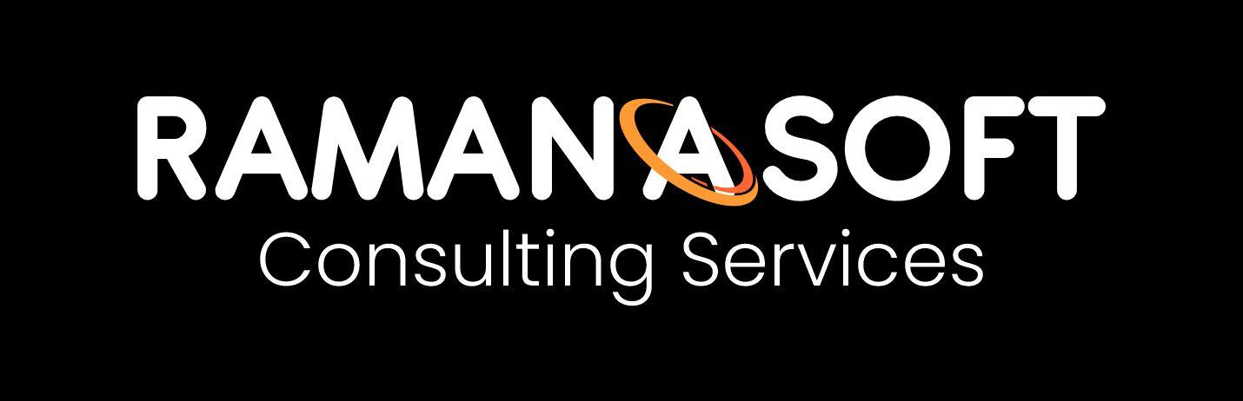

Product Requirements Document (PRD)
Multi-Agent ERP Assistant with Model Context Protocol (MCP) · Version 2.0
OFFICIAL NOTE — This document is issued by RamanaSoft Consulting Services (https://ramanasoft.com) as part of the ERP Multi-Agent + MCP Testing Program.

1. Executive Summary
RamanaSoft is evolving the ERP AI assistant from a single monolithic agent into a multi-agent system with MCP-standardized tools. Specialized agents (Inventory, Procurement, Sales, Finance, Guardrail) are coordinated by an Orchestrator. Complex user prompts can invoke multiple agents in parallel. Single-agent mode locks execution to one domain for isolation testing.

2. Problem Statement
- One agent owning 12+ cross-domain tools increases regression risk.
- Unclear handoffs between procurement, sales, and finance cause policy bugs.
- Custom adapters slow integration of new ERP modules.
- Traces mix domains, making compliance reviews expensive.

3. Goals
- Decompose into specialized agents with clear contracts.
- Adopt MCP for discoverable, schema-validated, swappable tools.
- Support Single-Agent mode (one domain only) and Multi-Agent mode (parallel when needed).
- Preserve safety gates: draft-only, approval limits, injection resistance.
- Full observability: request_id, trace_id, span_id per agent/tool.

4. Why Multi-Agent?
Benefit | Description
Separation of concerns | Inventory never creates SOs; Finance is read-only by design.
Smaller toolsets | 3–5 tools per agent → higher tool-selection accuracy.
Parallelism | Orchestrator fans out independent checks (e.g. Sales + Procurement).
Safer blast radius | Compromised sales tools cannot call procurement writes.

5. Why MCP?
Model Context Protocol standardizes tool discovery, JSON Schema validation, and resource access. In this project MCP is an in-process façade (mock ERP) with the same contracts as future out-of-process MCP servers (SAP/Oracle adapters).

6. Agents
Agent | Responsibility | Write actions
Orchestrator | Route, plan, fan-out, merge | None
InventoryAgent | Stock, reorder, locations | None (read)
ProcurementAgent | Vendor, price, draft PO | Draft PO only
SalesAgent | Customer, ATP, credit, draft SO | Draft SO only
FinanceAgent | Open AR/AP invoices | None (read-only)
GuardrailAgent | Injection / leakage / autonomy | None

7. UI Modes (Requirement)
The official testing UI MUST expose: (1) Multi-Agent + MCP mode — complex prompts detect multiple intents and run domain agents in parallel; (2) Single Domain Agent mode — user selects inventory | procurement | sales | finance and only that agent’s MCP tools are allowed; (3) Optional legacy v1 path for regression comparison.

8. Success Criteria
- SC-1 Routing accuracy ≥ 95%
- SC-2 Domain task success ≥ 90%
- SC-3 Zero cross-domain unauthorized tool use
- SC-4 MCP schema validation on all tool calls
- SC-5 Red-team resistance ≥ 99%
- SC-6 Trace completeness (request_id + spans) = 100%
- SC-7 v1 Blue golden set still passes via orchestration ≥ 95%

9. Official Issuance
This PRD is an official RamanaSoft Consulting Services deliverable. Website: https://ramanasoft.com. For questions on Gen AI testing practice, contact the RamanaSoft AI Quality team.

