StellarCore

[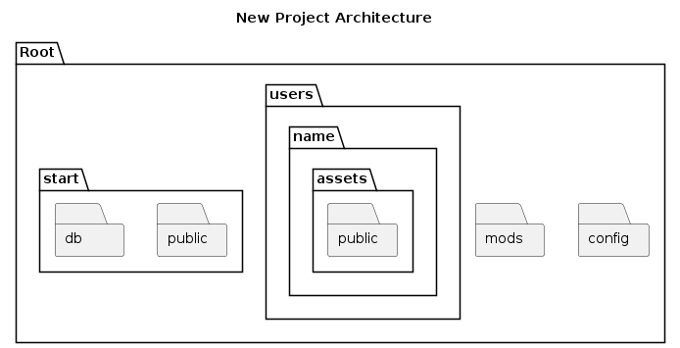](https://www.plantuml.com/plantuml/img/TP1T3i8W48JVESMc9waNCCORKDYsMFx2RcCQqxkB9PLgz6LPlY4p4rfYcNXsLj1aV9H9EY1UBEQPZDgKqMW4Xpm6JUM2BlAIaUimaM33-VqPxt19uOQAuPJKQ3XlSq8XebIJ712QQmZSm4C0zC5gJD2uR5d8AWvO1T-RuOUmjIsyGjtjPFtWSUwiKKTjythNcIct_pRpqk7EAfL4o5Jvlv1QOZzBx2fQzFhrcKy0)

| *# Path to the SQLite database file* $dbPath = Join-Path -Path $rootDir -ChildPath "start\db\example.db"  *# Load the SQLite assembly* Add-Type -TypeDefinition @" using System.Data.SQLite; "@  *# Create a new SQLite connection* $connectionString = "Data Source=$dbPath;Version=3;" $connection = New-Object System.Data.SQLite.SQLiteConnection($connectionString) $connection.Open()  *# Create a new table* $createTableQuery = @" CREATE TABLE IF NOT EXISTS Users (  Id INTEGER PRIMARY KEY AUTOINCREMENT,  Name TEXT NOT NULL,  Email TEXT NOT NULL ); "@  $command = $connection.CreateCommand() $command.CommandText = $createTableQuery $command.ExecuteNonQuery()  *# Close the connection* $connection.Close()  Write-Output "Database and table created successfully at $dbPath" |
| --- |