**作業三**

**R26094022 統計所 李權恩**

**Abstract**

In this project, we use three meta-heuristic algorithms: Cuckoo Search Optimization (CSO), Flower Pollination Algorithm (FPA), and Bat algorithm (BA) to find the global optimum of two familiar functions (briefly introduced in the first section). In the numerical experiment, the CSO and FPA can converge to the global minimum but BA can’t.

1. **Problem Statement**

In our implement, our goal is to find the minimization of the following two objective functions：(1) Ackley’s function($F_{1}$)；(2) Shifted and Rotated Weierstrass function($F_{2}$). For these two functions, we consider the search space have two condition： ${\left[-20,20\right]}^{10}$ and ${\left[-20,20\right]}^{20}$.Each methods with two different search space will be repeat 20 times and independently regenerate the 50 initial points.

**1.1 Ackley’s function**

$$F_{1}\left(x\right)=-20\exp\left(-0.2\sqrt{\frac{1}{D}\sum_{i=1}^{D}{x_{i}^{2}}}\right)-\exp\left(\frac{1}{D}\sum_{i=1}^{D}{\cos\left(2πx_{i}\right)}\right)+20+e$$

**1.2 Shifted and Rotated Weierstrass function**

$$F_{2}\left(x\right)=f\left(M\frac{0.5\left(x-o\right)}{100}\right)+600$$

where

$$f\left(x\right)=\sum_{i=1}^{D}{(\sum_{k=0}^{kmax}{[a^{k}cos⁡(2πb^{k}(x_{i}+0.5))]})}-D\sum_{k=0}^{kmax}{[a^{k}cos⁡(2πb^{k}∙0.5)]}$$

$$a=0.5,b=3,kmax=20$$

In addition, we set $o$ is zero vector and $M$ is identity matrix.

1. **Methodology**

According to our purpose, we use three different meta-heuristic algorithms: Cuckoo Search Optimization (CSO), Flower Pollination Algorithm (FPA), and Bat algorithm (BA). These three algorithms are derivatives-free method. We will give a simple introduction to the algorithm in this section.

* 1. **Cuckoo Search Optimization (CSO)**

In operations research, cuckoo search is an optimization algorithm developed by Xin-she Yang and Suash Deb in 2009. It was inspired by the obligate brood parasitism of some cuckoo species by laying their eggs in the nests of other host birds (of other species). Some host birds can engage direct conflict with the intruding cuckoos. For example, if a host bird discovers the eggs are not their own, it will either throw these alien eggs away or simply abandon its nest and build a new nest elsewhere. Cuckoo search idealized such breeding behavior, and thus can be applied for various optimization problems.

Algorithm：

1. Randomly generate $N$ initial host nests (or says population). $x_{i}^{0}={\left(x_{i1}^{0},x_{i2}^{0},…,x_{id}^{0}\right)}^{T},i=1,…,N$, $d$ is the dimention. Set the fraction $p_{a}$.
2. For each iteration：
3. Get a cuckoo randomly (say, $i$) and evaluate its solution by performing Lévy flights.

$$x_{i}^{t+1}=x_{i}^{t}+αL\left(s,λ\right)$$

Where

$$L\left(v,β\right)=\frac{u}{{\left|v\right|}^{\frac{1}{λ}}}$$

$$U\sim Normal\left(0, σ_{u}^{2}\right), V\sim Normal\left(0,1\right)$$

$$σ_{u}={\left(\frac{Γ\left(1+λ\right)\sin\left(\frac{πλ}{2}\right)}{Γ\left(0.5\left(1+λ\right)\right)∙λ∙2^{\left(0.5\left(λ-1\right)\right)}}\right)}^{1/λ}$$

1. Choose a nest among n (say, $j$) randomly. If the $i_{th}$ cuckoo(after performing Lévy flights) have better solution then replace $j_{th}$ nest by the new solution form $i_{th}$ cuckoo.
2. A fraction ($p_{a}$) of the worse nests are abandoned and new ones are built.
   1. **Flower Pollination Algorithm (FPA)**

FPA was developed by Xin-She Yang in 2012, inspired by the flow pollination process of flowering plants. For simplicity, the following four rules are used :

1. Biotic and cross-pollination can be considered processes of global pollination, and pollen-carrying pollinators move in a way that obeys Lévy flights (Rule 1).
2. For local pollination, abiotic pollination and self-pollination are used (Rule 2).
3. Pollinators such as insects can develop flower constancy, which is equivalent to a reproduction probability that is proportional to the similarity of two flowers involved (Rule 3).
4. The interaction or switching of local pollination and global pollination can be controlled by a switch probability, slightly biased toward local pollination (Rule 4).

Algorithm：

1. Randomly generate $N$ initial population(or flowers/pollen gametes). $x_{i}^{0}={\left(x_{i1}^{0},x_{i2}^{0},…,x_{id}^{0}\right)}^{T},i=1,…,N$, $d$ is dimension. Find $g^{*}$ from $min⁡\{f\left(x_{1}^{0}\right),f\left(x_{2}^{0}\right),…,f\left(x_{N}^{0}\right)\}$ (at $t=0$) and set a switch probability $p∈[0,1]$.
2. With each iteration and for each flowers in the population：

Generate a random number to decide execute global pollination or local pollination. The algorithm run the global pollination if the random number is less than the switch probability which we define above.

1. Global pollination：

$$x_{i}^{t+1}=x_{i}^{t}+γL(s,λ)(g^{*}-x_{i}^{t})$$

Where $L(s,λ)$ is random vector generate from Lévy distribution, $g^{*}$ represent current global best.

1. Local pollination：

$$x_{i}^{t+1}=x_{i}^{t}+ϵ(x_{j}^{t}-x_{k}^{t})$$

Where $ϵ$ is random vector from uniform distribution.

1. Update current global best after the pollination for each flowers in population.
   1. **Bat algorithm (BA)**

The idealization of the echolocation of microbats can be summarized as follows: Each virtual bat flies randomly with a velocity $v_{i}$ at position (solution) $x_{i}$ with a varying frequency or wavelength and loudness $A_{i}$. As it searches and finds its prey, it changes frequency, loudness and pulse emission rate $r$. Search is intensified by a local random walk. Selection of the best continues until certain stop criteria are met. This essentially uses a frequency-tuning technique to control the dynamic behavior of a swarm of bats, and the balance between exploration and exploitation can be controlled by tuning algorithm-dependent parameters in bat algorithm.

Algorithm：

1. Randomly generate $N$ initial population. $x_{i}^{0}={\left(x_{i1}^{0},x_{i2}^{0},…,x_{id}^{0}\right)}^{T},i=1,…,N$, set initial velocity $v_{i}^{0}=0$ and initialize maximum and minimum frequency $f_{min}, f_{max}$, pulse rates $r_{i}$ and the loudness $A_{i}$.
2. With each iteration:

For each bat $i$：

1. Randomly generate frequency.

$$f_{i}=f_{min}+\left(f_{max}-f_{min}\right)ϵ$$

Where $ϵ$ is random vector from uniform distribution.

1. Update velocities and locations.

$$v_{i}^{t+1}=v_{i}^{t}+\left(x_{i}^{t}-x_{*}\right)f_{i}$$

$$x_{i}^{t+1}=x_{i}^{t}+v_{i}^{t}$$

Where $x_{*}$ is current best location.

1. Some bats move with the following local search when the random number which is generated is over than $r_{i}$.

$$x_{i}^{t+1}=x_{*}+ϵ\overline{A}$$

where $ϵ$ is random number uniformly generated from interval [−1, 1], and $\overline{A}$ is averaged loudness of all bats.

1. Update the solution if random number is less than $A_{i}$ and $f\left(x_{i}\right)<f(x_{*})$.
2. Increase $r_{i}$ and reduce $A_{i}$.

$$A_{i}^{t+1}=αA_{i}^{t}$$

$$r_{i}^{t+1}=r_{i}^{0}(1-exp⁡(-γt))$$

Where $0<α<1$ and $γ>0$

1. Rank the bat and find the current best $x_{*}$.
2. **Numerical result**

We implement each algorithm for each objective functions with different dimension. In addition, we have repeated the experiment 20 times to take the best value in each experiment. In this section we will show (1) Calculate the mean and standard deviation of those best values; (2) Plot the max/mean/min curve of 20 times experiments.

We do not show the BA’s result since

* 1. **Ackley’s function**

1. CSO

|  |  |  |  |  |  |  |
| --- | --- | --- | --- | --- | --- | --- |
| Dimension | Parameters | | | Global minimum | Repeat 20 times best value | |
| Iteration |  | $$p_{a}$$ | Mean | Standard deviation |
| 10 | 350 | 0 | 0.25 | 0 | 0.2282 | 0.0425 |
| 20 | 500 | 0 | 0.25 | 0 | 0.6673 | 0.0651 |

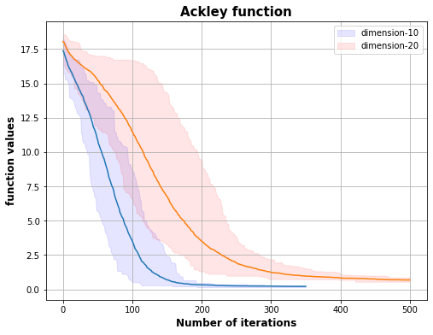

1. FPA

|  |  |  |  |  |  |  |
| --- | --- | --- | --- | --- | --- | --- |
| Dimension | Parameters | | | Global minimum | Repeat 20 times final best value | |
| Iteration |  | $$p$$ | Mean | Standard deviation |
| 10 | 300 | 600 | 0.8 | 0 | 0.0528 | 0.0362 |
| 20 | 1300 | 600 | 0.8 | 0 | 0.1143 | 0.0567 |

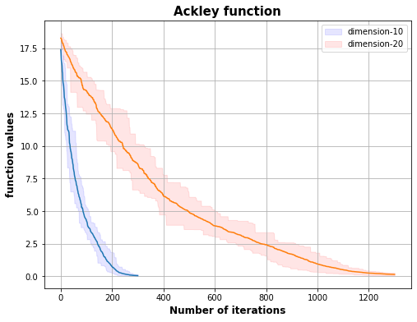

1. BA (Since BA can't get good results, so we do not show the table and print the plot.)
   1. **Shifted and Rotated Weierstrass function**
2. CSO

|  |  |  |  |  |  |  |
| --- | --- | --- | --- | --- | --- | --- |
| Dimension | Parameters | | | Global minimum | Repeat 20 times final best value | |
| Iteration | $$α$$ | $$p_{a}$$ | Mean | Standard deviation |
| 10 | 150 | 0.1 | 0.25 | 600 | 601.9222 | 0.4934 |
| 20 | 1000 | 0.1 | 0.25 | 600 | 600.8185 | 0.0633 |

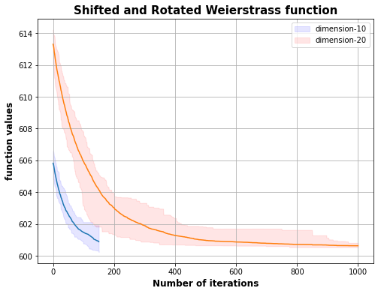

1. FPA

|  |  |  |  |  |  |  |
| --- | --- | --- | --- | --- | --- | --- |
| Dimension | Parameters | | | Global minimum | Repeat 20 times final best value | |
| Iteration | $$α$$ | $$p$$ | Mean | Standard deviation |
| 10 | 150 | 0.9 | 0.8 | 600 | 602.0657 | 0.3730 |
| 20 | 600 | 0.6 | 0.5 | 600 | 605.9876 | 1.6006 |

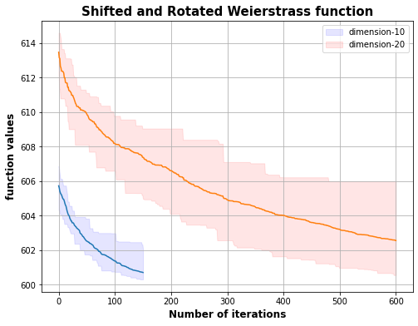

1. BA (Since BA can't get good results, so we do not show the table and print the plot.)