kiểm tra chính xác vị trí file streaming jar
sudo find / -name "hadoop-streaming*.jar" 2>/dev/null
- /home/hadooptrinh/hadoop/share/hadoop/tools/lib/hadoop-streaming-3.3.4.jar
thêm vào ~/.bashrc
export STREAM_JAR=/home/hadooptrinh/hadoop/share/hadoop/tools/lib/hadoop-streaming-3.3.4.jar
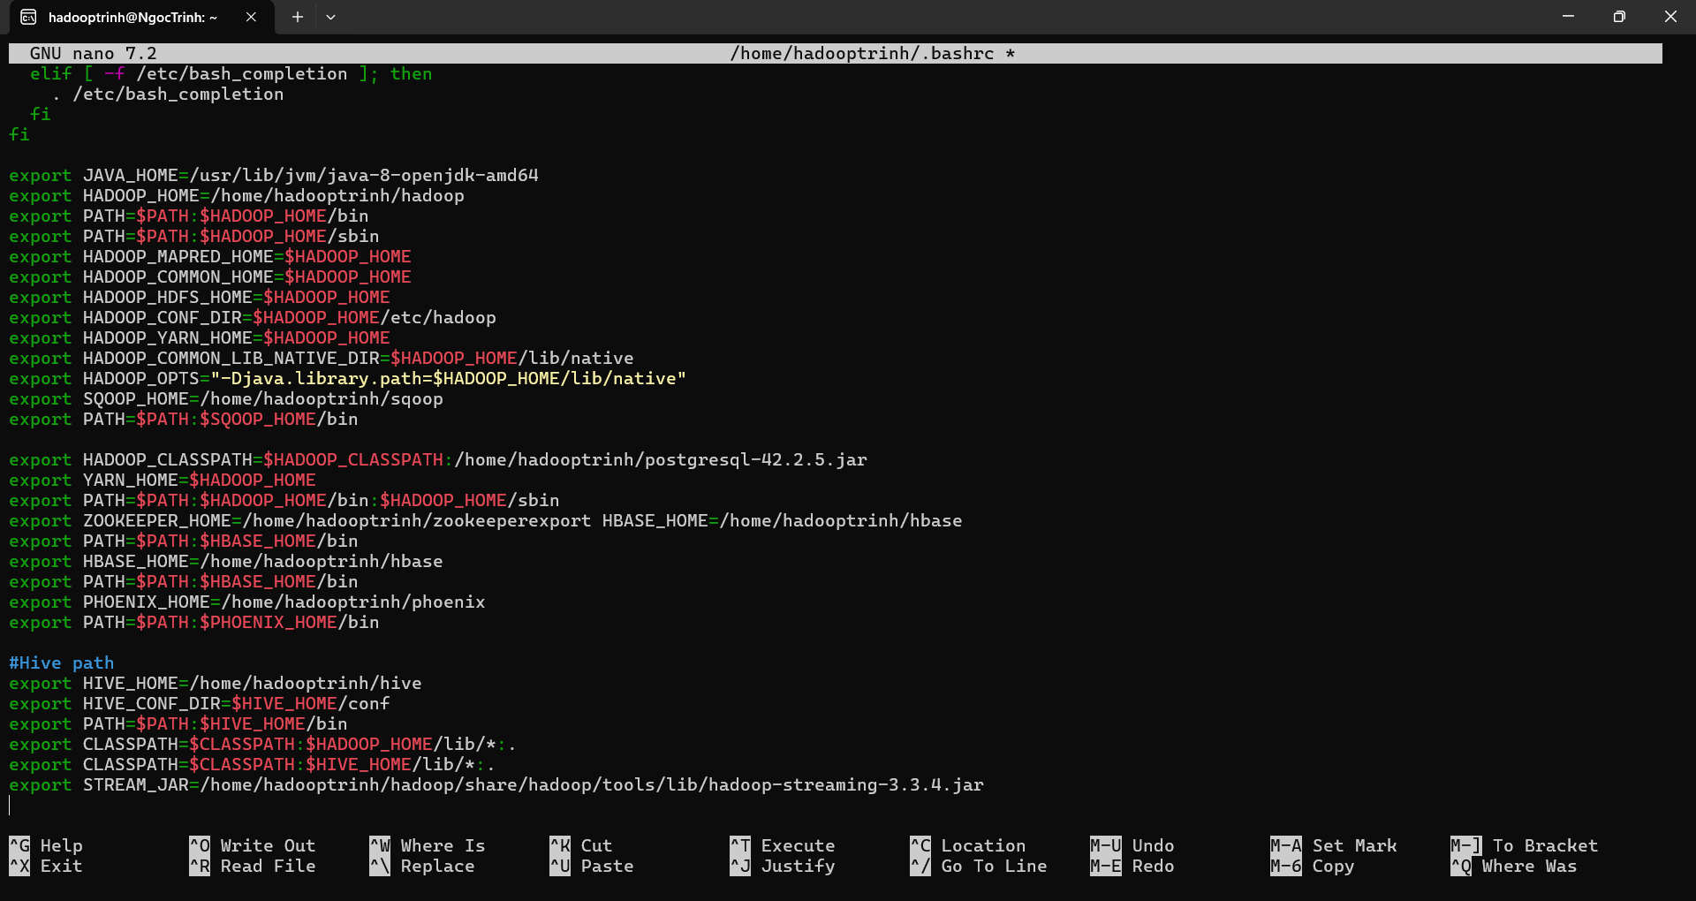
echo $STREAM_JAR
# Tạo thư mục trên HDFS
hdfs dfs -mkdir -p /user/hadooptrinh/tiki_input
C:\BDE_Office\Project\tiki_clean.csv (trên Windows)
đường dẫn trong WSL là:
/mnt/c/BDE_Office/Project/tiki_clean.csv
ls -lh /mnt/c/BDE_Office/Project/tiki_clean.csv
Để Hadoop dễ truy cập, copy file này vào thư mục home của bạn:
cp /mnt/c/BDE_Office/Project/tiki_clean.csv ~/tiki_clean.csv

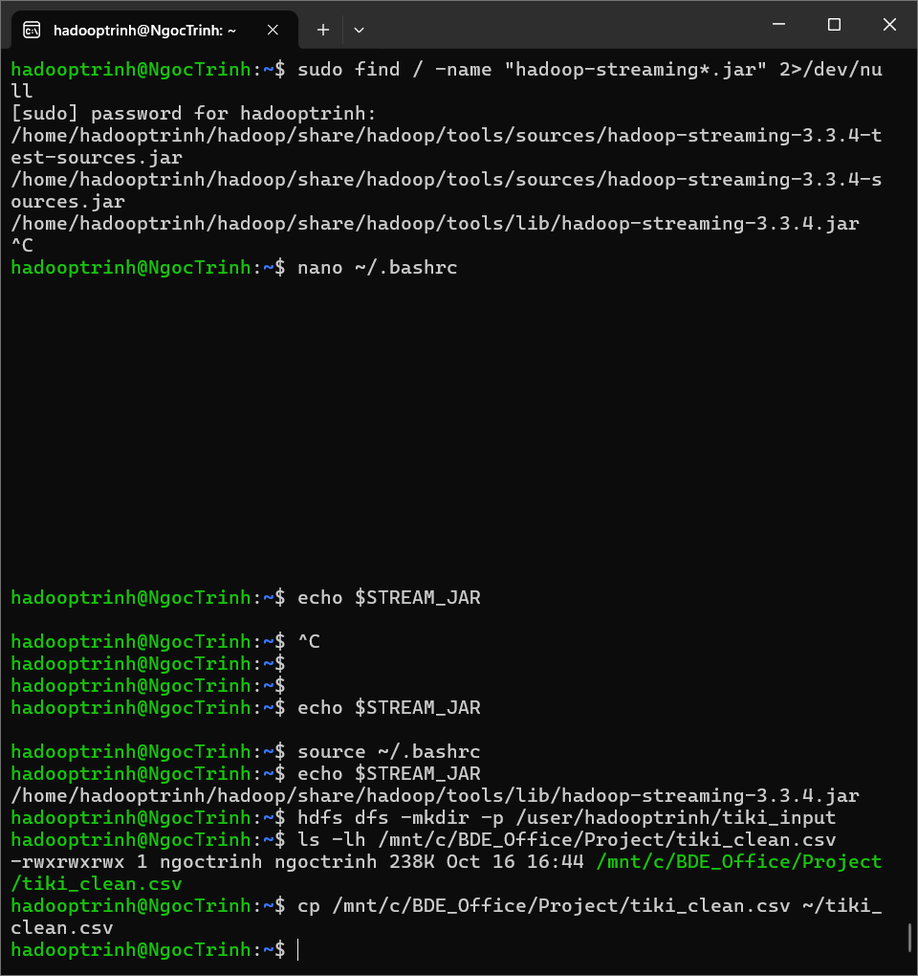
Kiểm tra lại:
ls -lh ~/tiki_clean.csv
Upload file lên HDFS
Chạy lệnh sau (theo user bạn là hadooptrinh):
hdfs dfs -mkdir -p /user/hadooptrinh/tiki_input
hdfs dfs -put ~/tiki_clean.csv /user/hadooptrinh/tiki_input/
Kiểm tra kết quả:
hdfs dfs -ls /user/hadooptrinh/tiki_input/

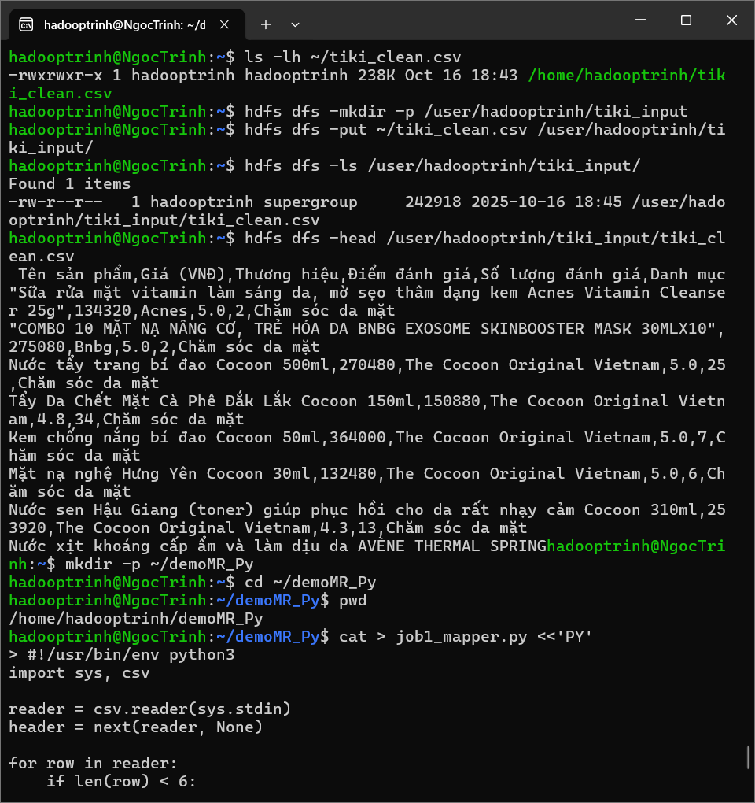
Xem vài dòng đầu để chắc chắn file đúng:
hdfs dfs -head /user/hadooptrinh/tiki_input/tiki_clean.csv
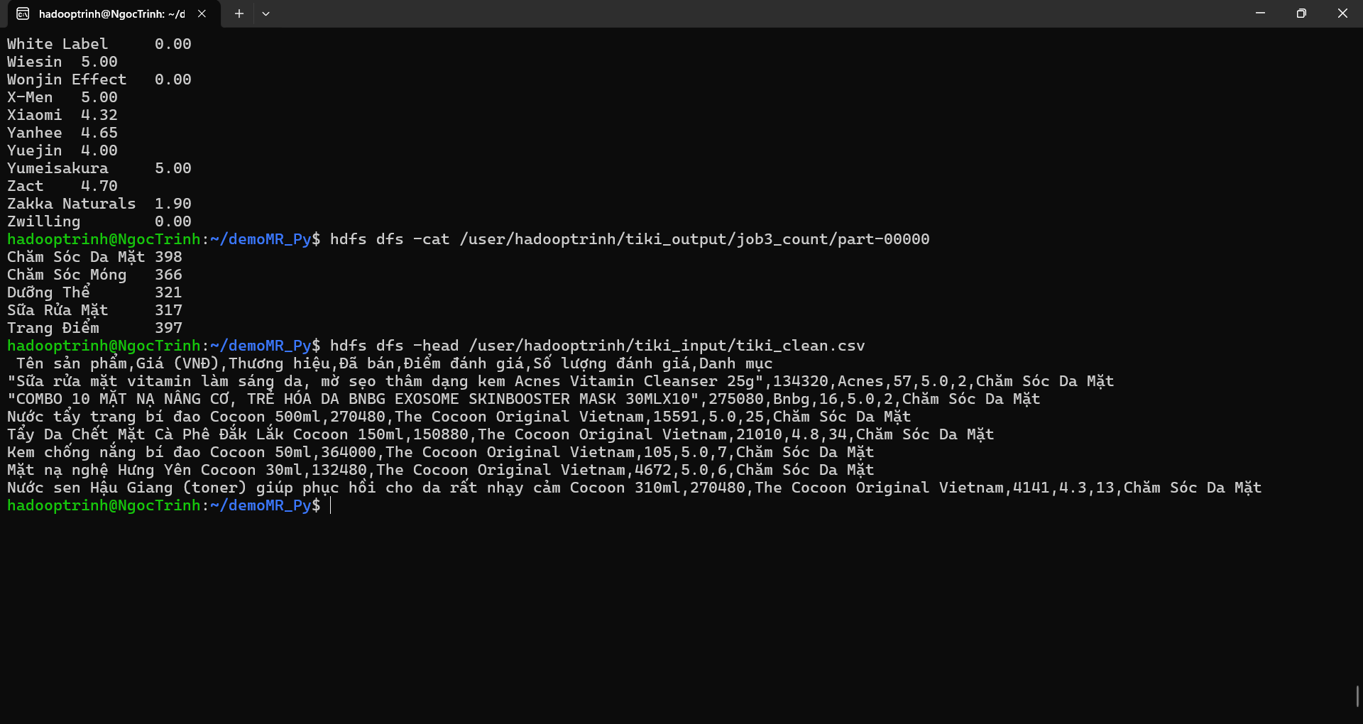
Job 1 — Tìm giá cao nhất theo danh mục
job1_mapper.py
cat > job1_mapper.py <<'PY'
#!/usr/bin/env python3
import sys, csv

reader = csv.reader(sys.stdin)
header = next(reader, None)
if header and header[0].startswith('\ufeff'):
header[0] = header[0][1:]

for row in reader:
if len(row) < 7:
continue
try:
category = row[6].strip().strip('"') or "UNKNOWN"
price = float(row[1].replace(',', '').strip())
except:
continue
print(f"{category}\t{price}")
PY

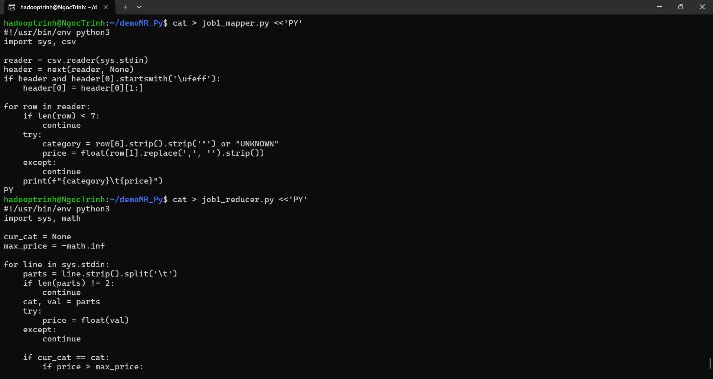
job1_reducer.py
cat > job1_reducer.py <<'PY'
#!/usr/bin/env python3
import sys, math

cur_cat = None
max_price = -math.inf

for line in sys.stdin:
parts = line.strip().split('\t')
if len(parts) != 2:
continue
cat, val = parts
try:
price = float(val)
except:
continue

if cur_cat == cat:
if price > max_price:
max_price = price
else:
if cur_cat is not None:
print(f"{cur_cat}\t{int(max_price)}")
cur_cat, max_price = cat, price

if cur_cat is not None:
print(f"{cur_cat}\t{int(max_price)}")
PY
chmod +x job*_mapper.py job*_reducer.py
Xem kết quả sau khi chạy
# Job 1
hdfs dfs -cat /user/hadooptrinh/tiki_output/job1_max_price/part-00000 | head
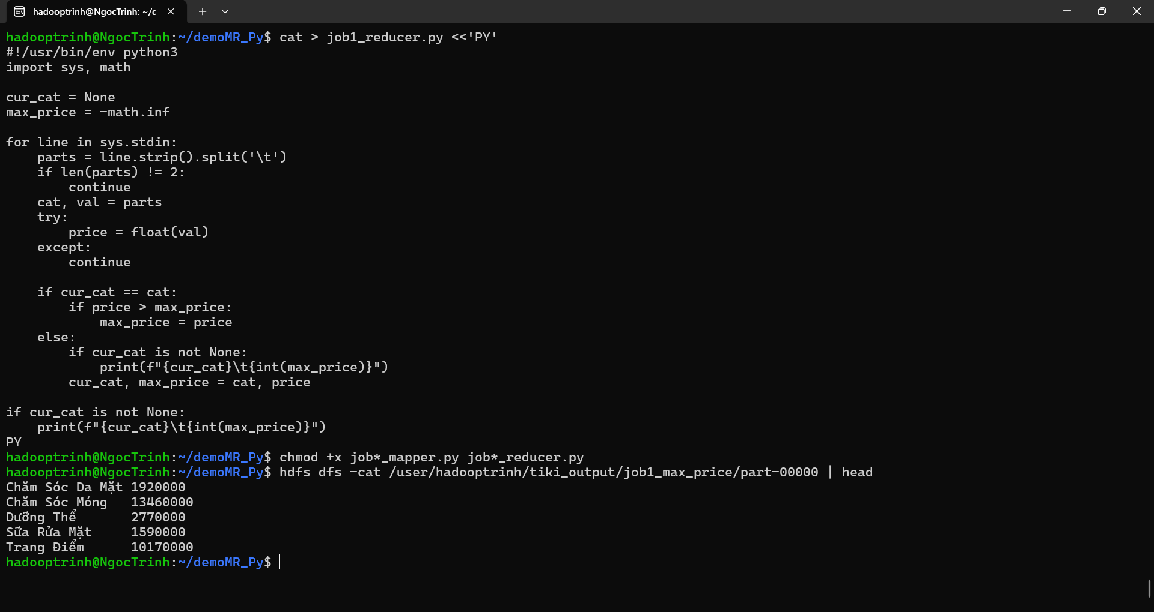
Job 2 — Tính điểm trung bình theo thương hiệu
job2_mapper.py
cat > job2_mapper.py <<'PY'
#!/usr/bin/env python3
import sys, csv

reader = csv.reader(sys.stdin)
header = next(reader, None)
if header and header[0].startswith('\ufeff'):
header[0] = header[0][1:]

for row in reader:
if len(row) < 7:
continue
try:
brand = row[2].strip().strip('"') or "UNKNOWN"
rating = float(row[4])
except:
continue
print(f"{brand}\t{rating}")
PY

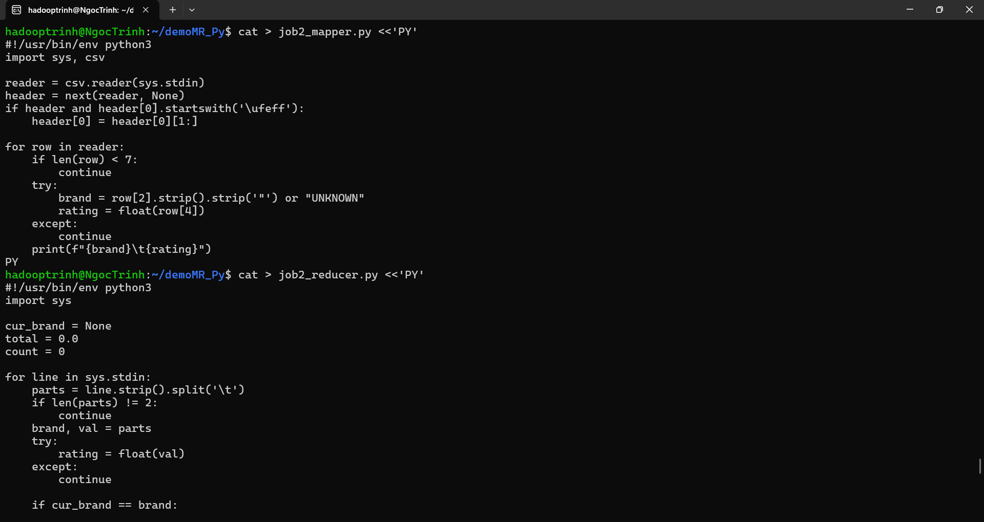
job2_reducer.py
cat > job2_reducer.py <<'PY'
#!/usr/bin/env python3
import sys

cur_brand = None
total = 0.0
count = 0

for line in sys.stdin:
parts = line.strip().split('\t')
if len(parts) != 2:
continue
brand, val = parts
try:
rating = float(val)
except:
continue

if cur_brand == brand:
total += rating
count += 1
else:
if cur_brand is not None and count > 0:
avg = total / count
print(f"{cur_brand}\t{avg:.2f}")
cur_brand, total, count = brand, rating, 1

if cur_brand is not None and count > 0:
avg = total / count
print(f"{cur_brand}\t{avg:.2f}")
PY

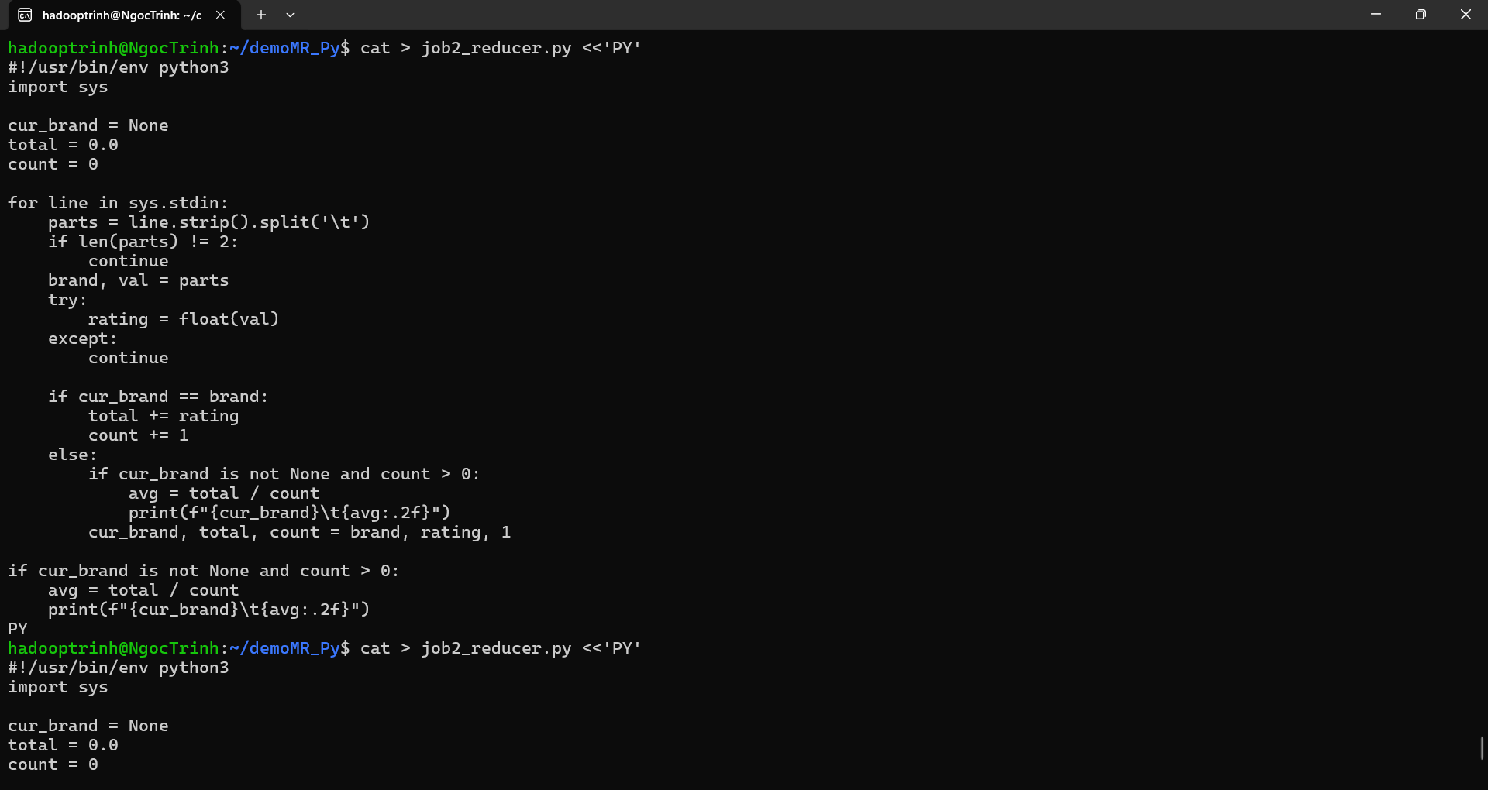
OUT=/user/hadooptrinh/tiki_output/job2_avg_rating

hdfs dfs -rm -r -f "$OUT"

hadoop jar /home/hadooptrinh/hadoop/share/hadoop/tools/lib/hadoop-streaming-3.3.4.jar \
-files job2_mapper.py,job2_reducer.py \
-mapper "python3 job2_mapper.py" \
-reducer "python3 job2_reducer.py" \
-input "$IN" \
-output "$OUT"
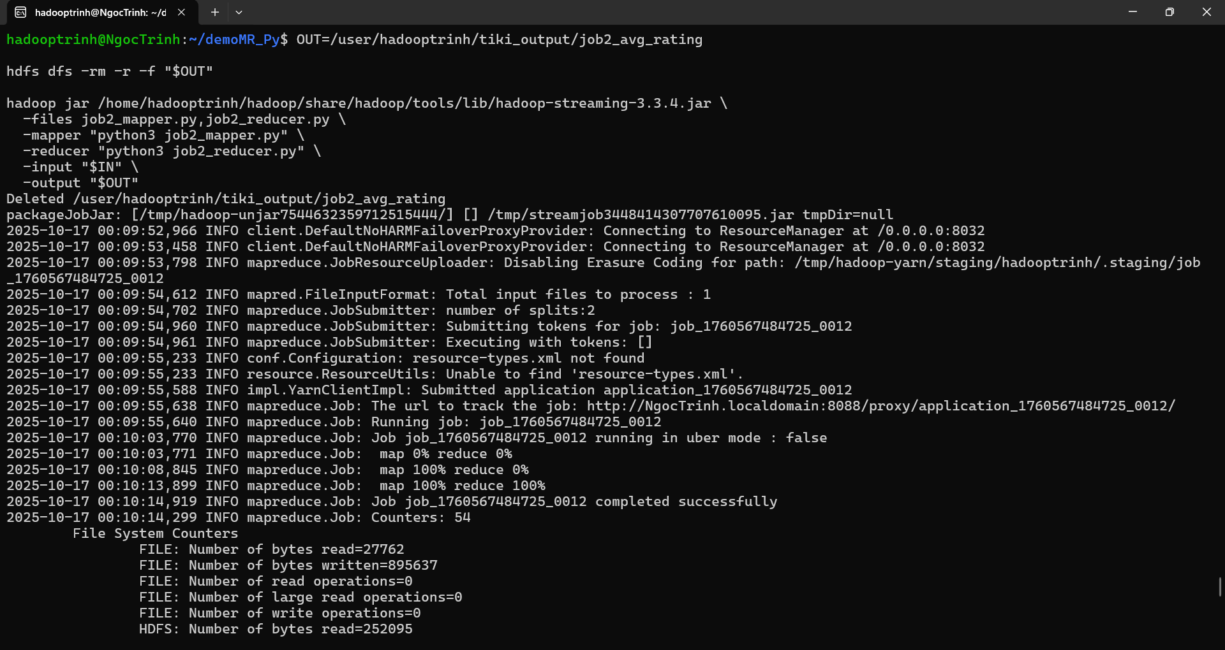
hdfs dfs -cat /user/hadooptrinh/tiki_output/job2_avg_rating/part-00000
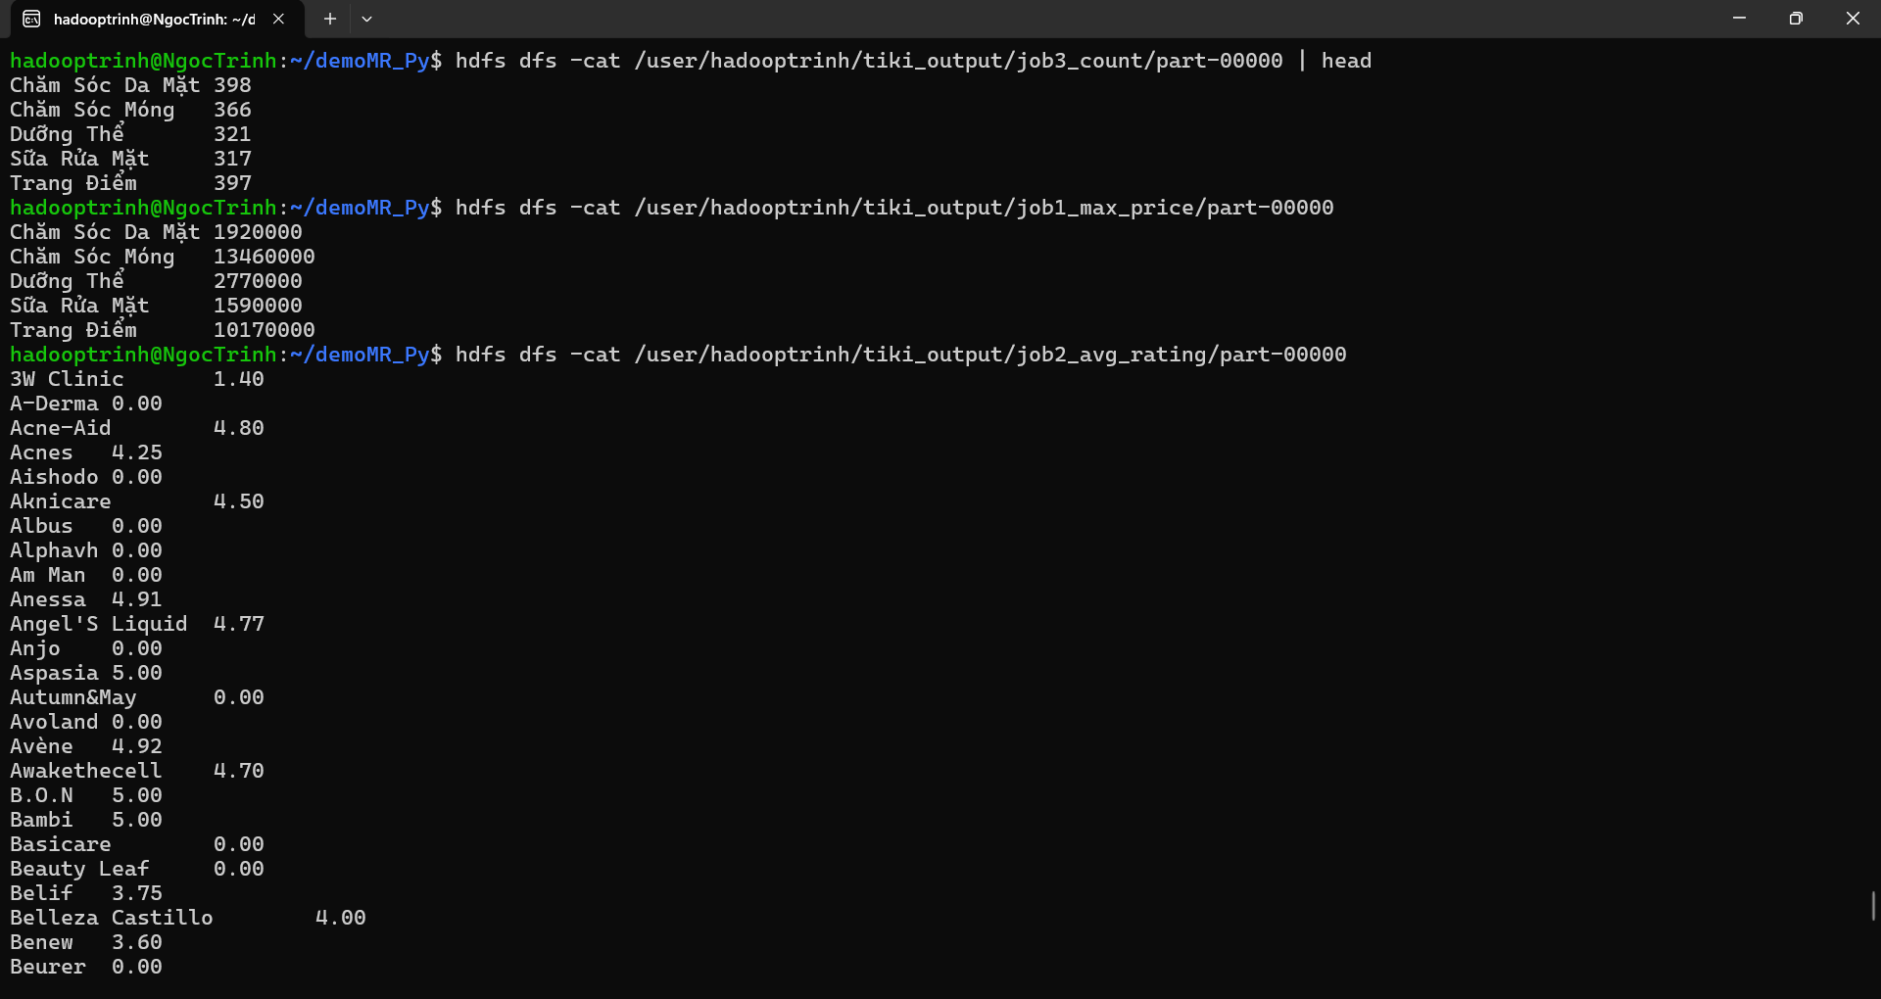
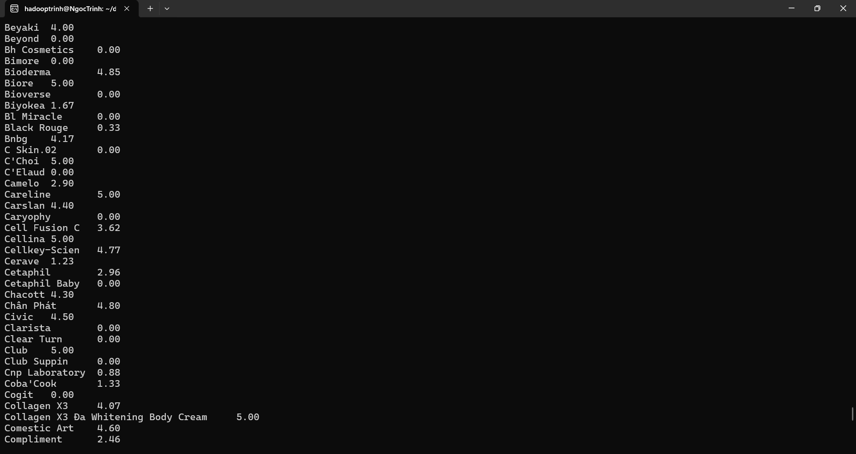
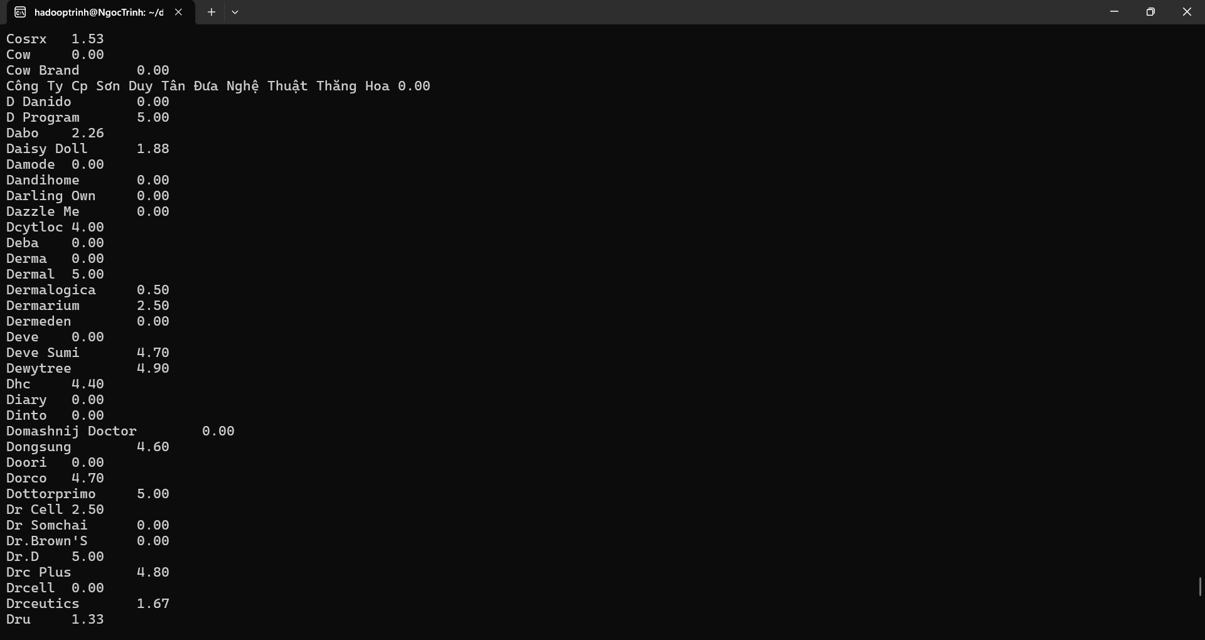
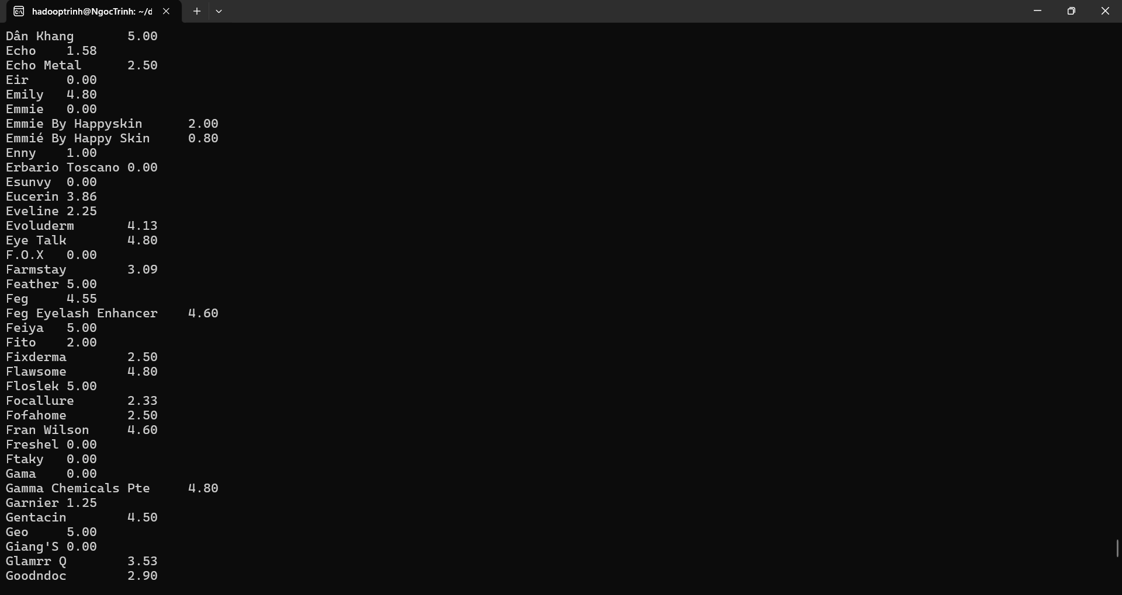
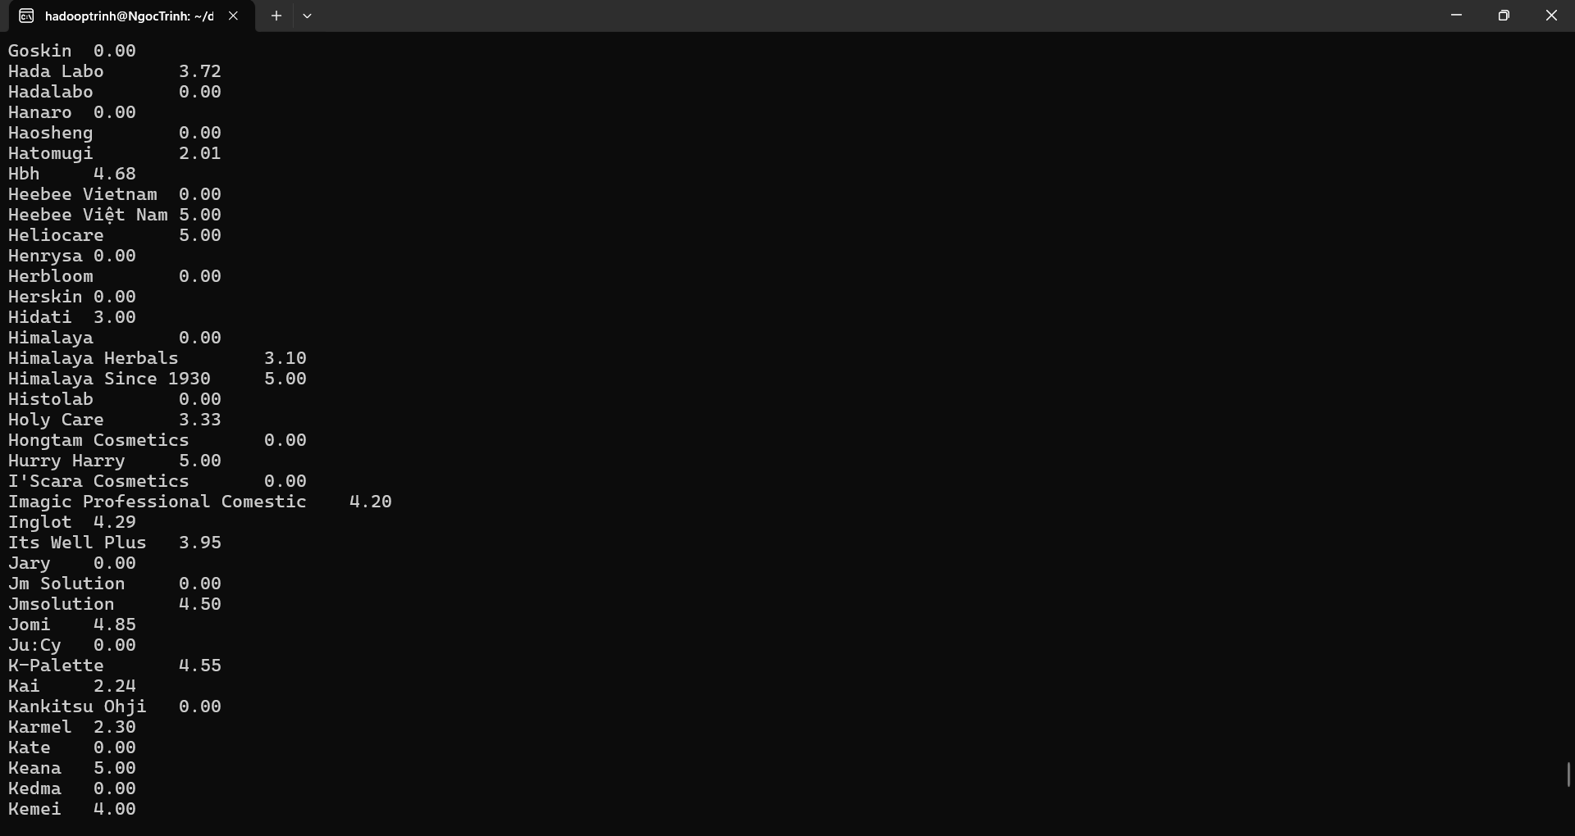
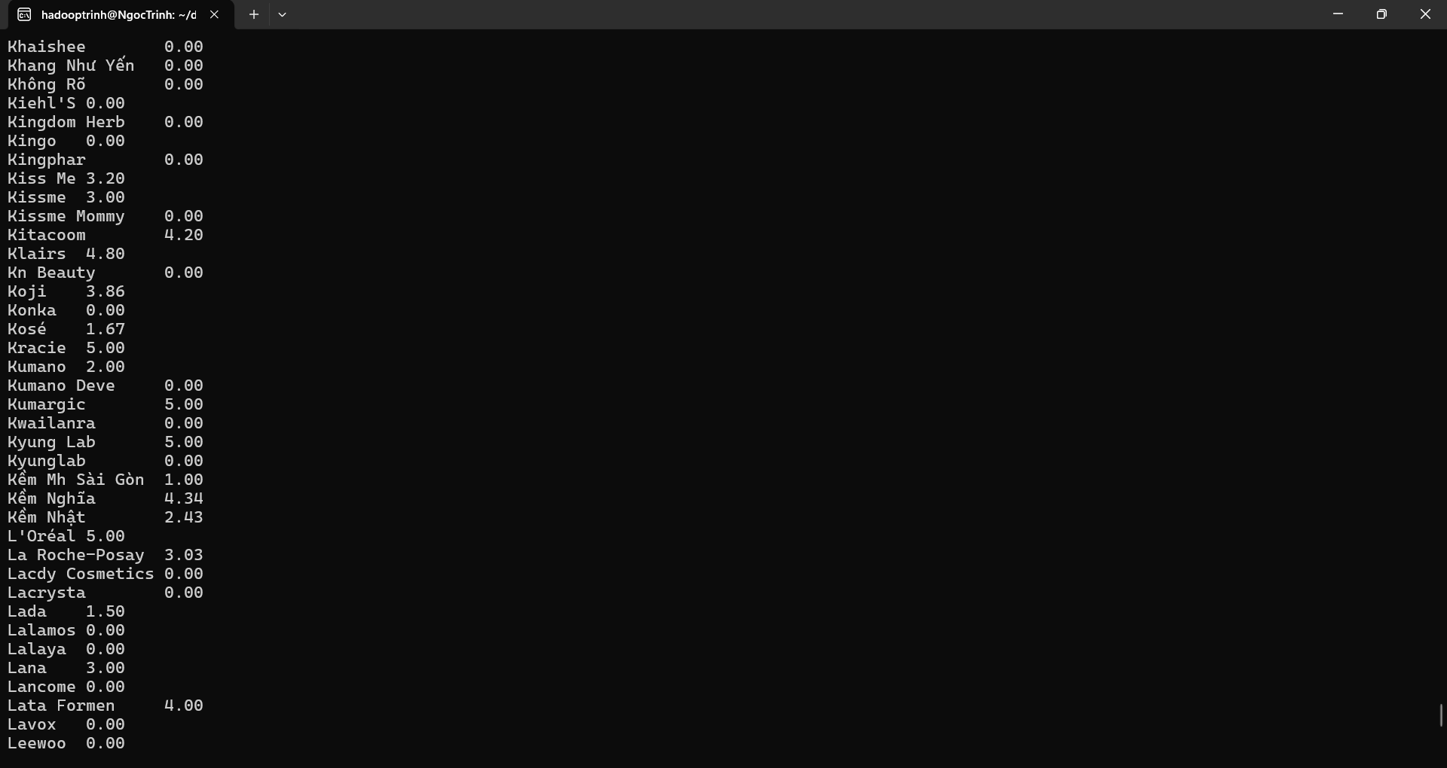
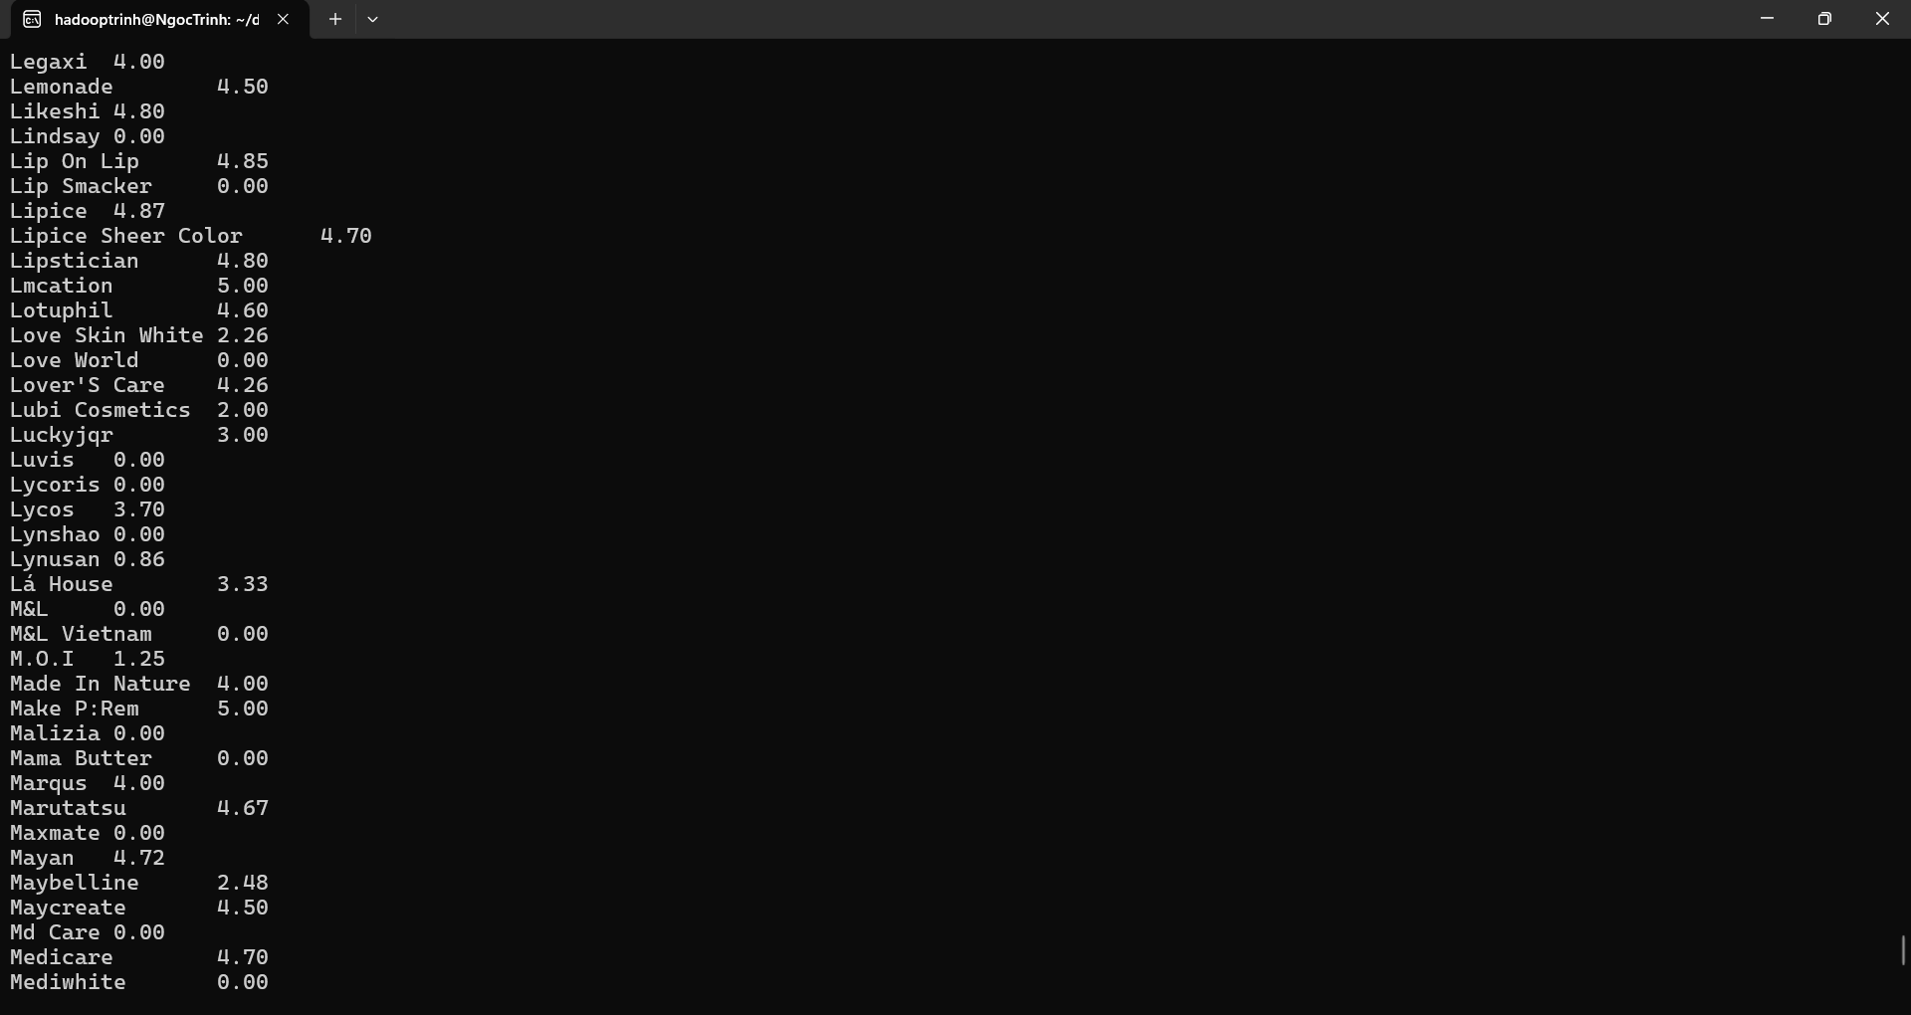
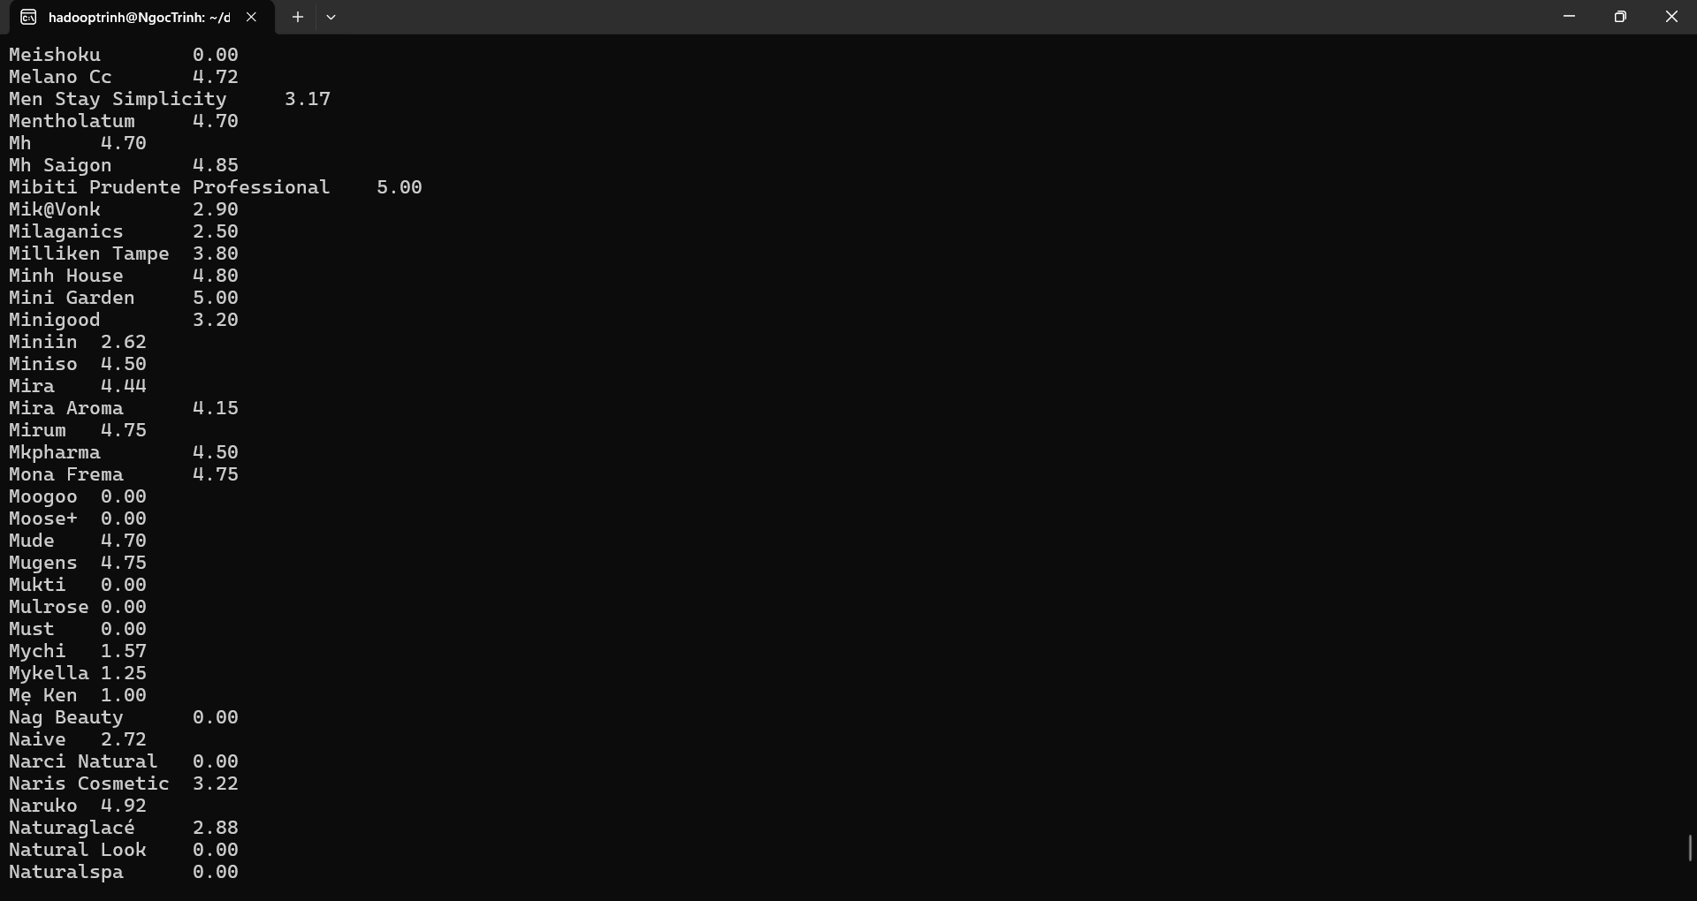
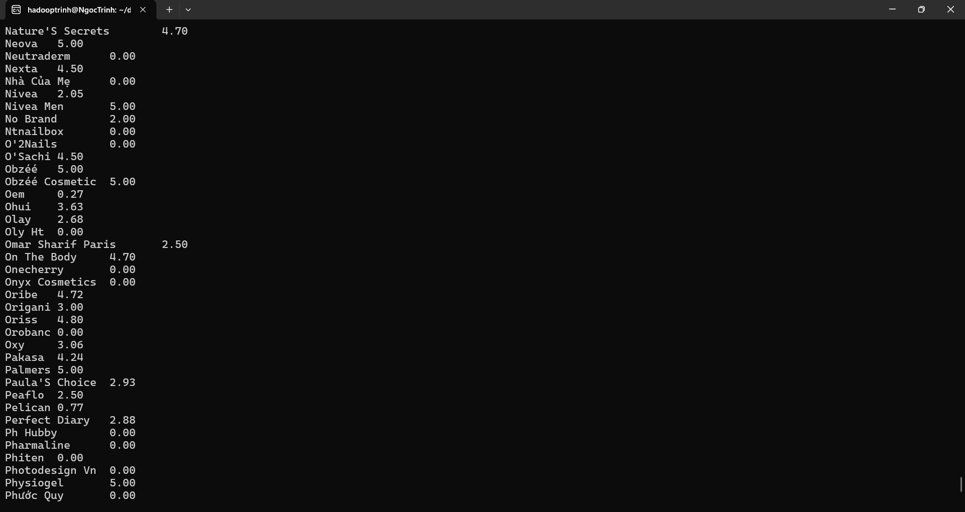
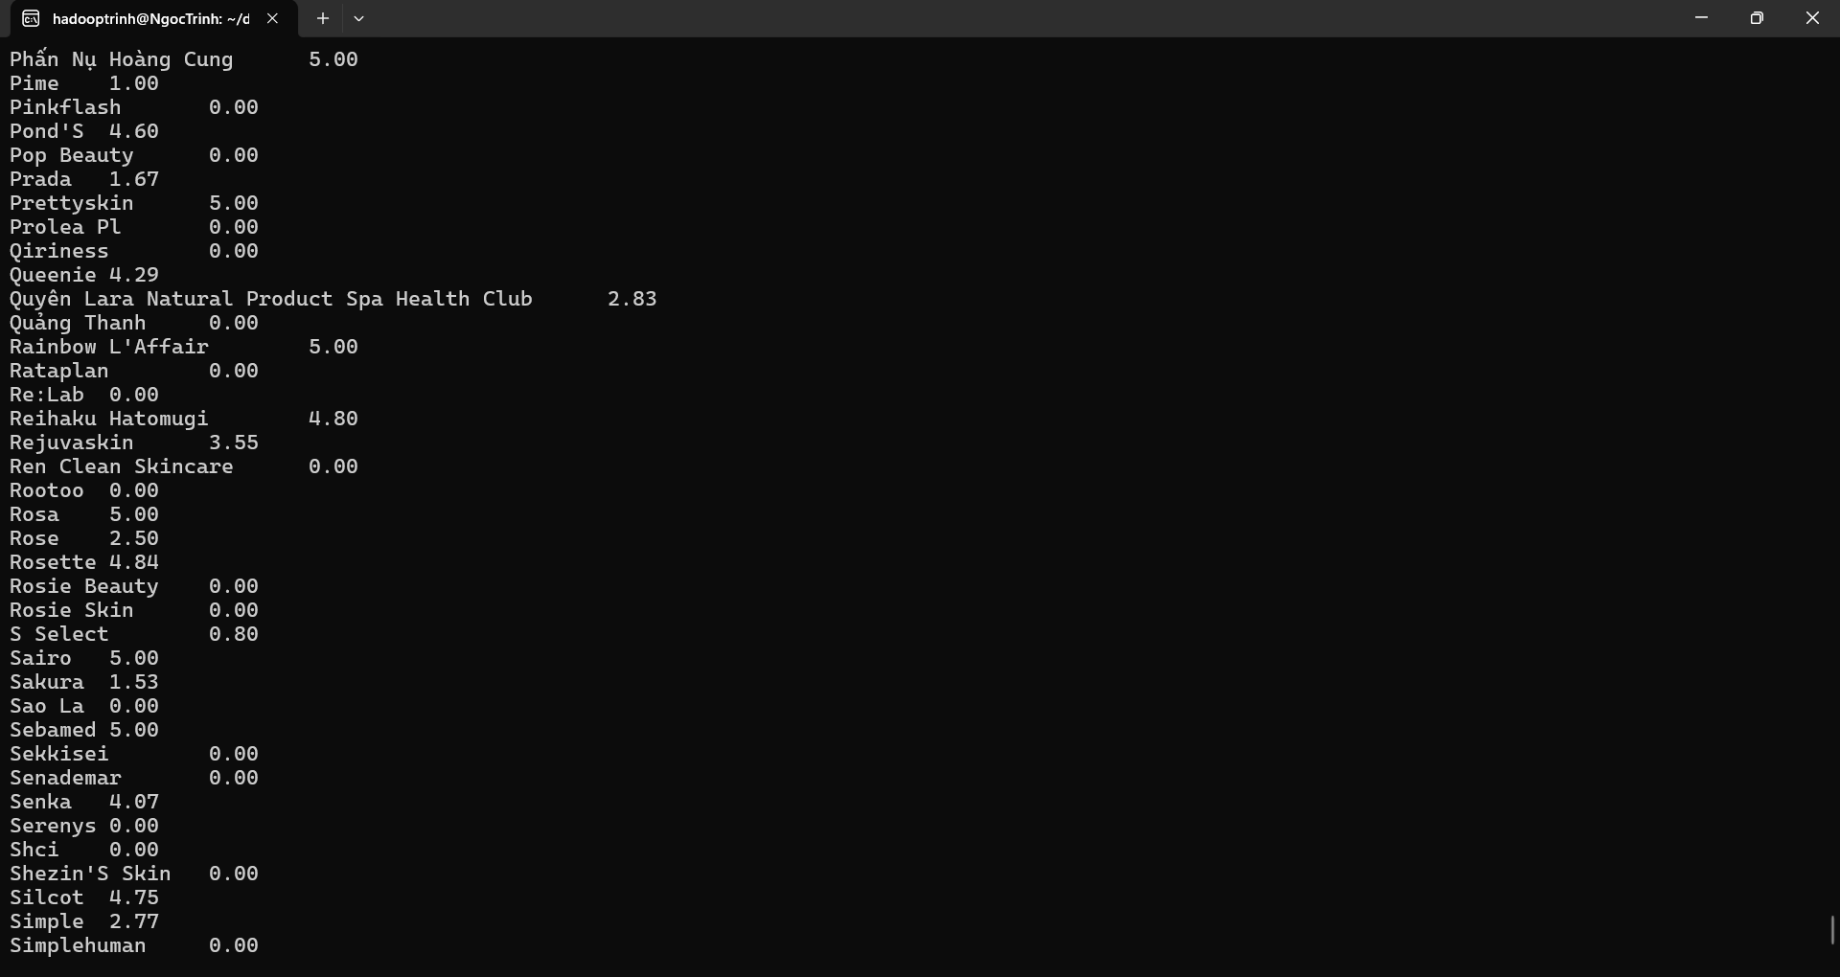
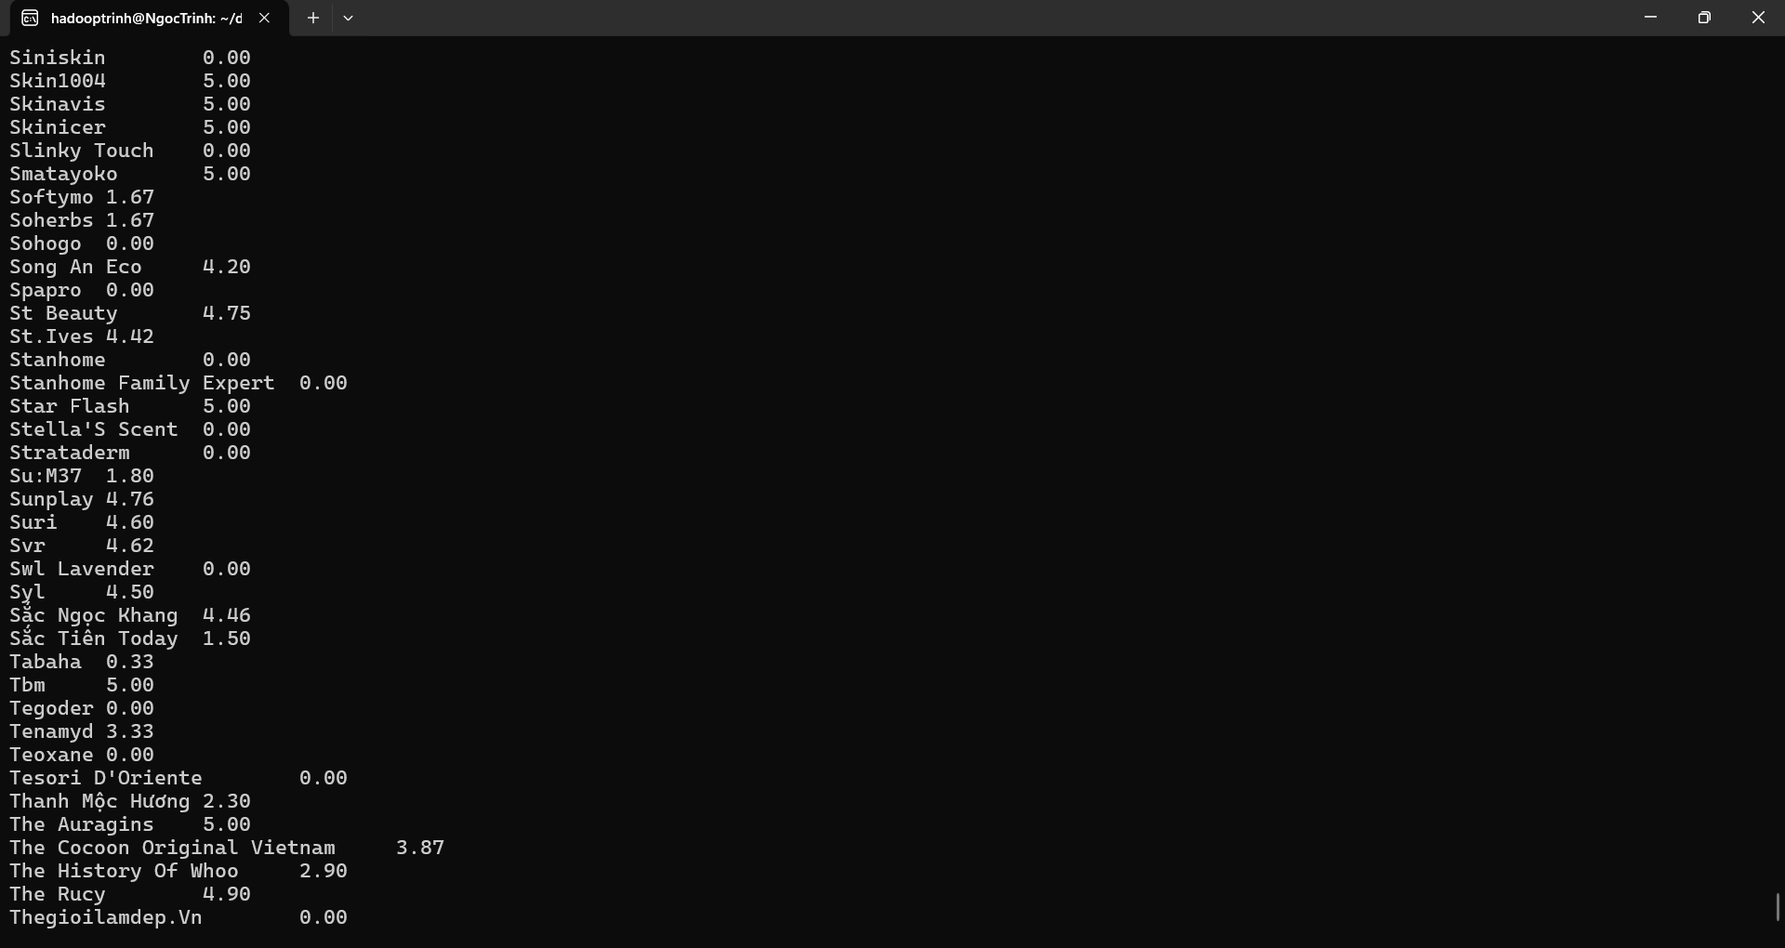
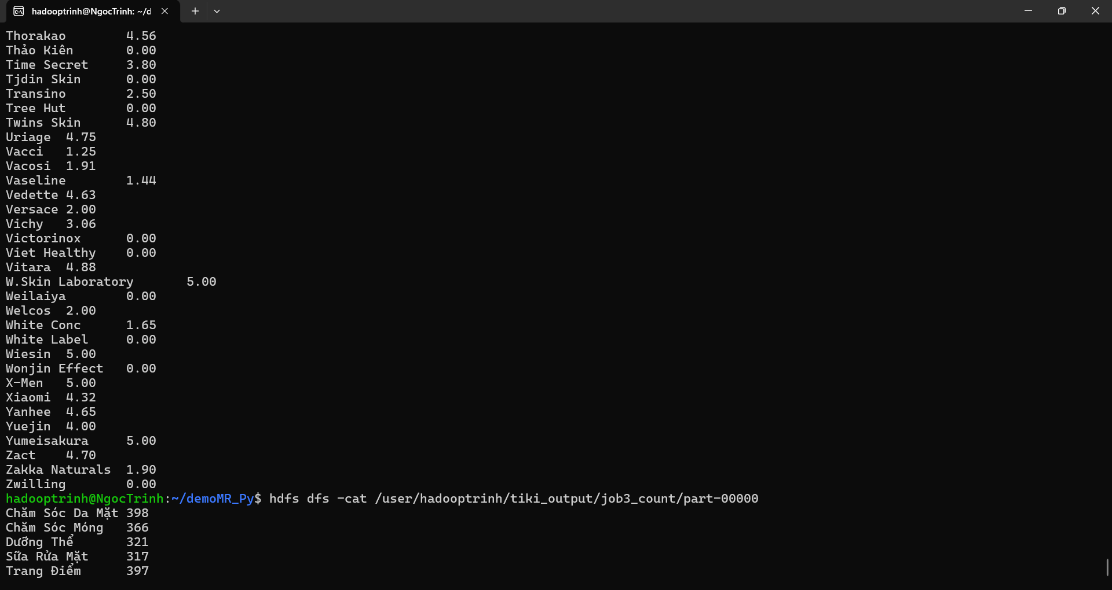
Job 3 — Đếm số lượng sản phẩm theo danh mục
job3_mapper.py
cat > job3_mapper.py <<'PY'
#!/usr/bin/env python3
import sys, csv

reader = csv.reader(sys.stdin)
header = next(reader, None)
if header and header[0].startswith('\ufeff'):
header[0] = header[0][1:]

for row in reader:
if len(row) < 7:
continue
category = row[6].strip().strip('"') or "UNKNOWN"
print(f"{category}\t1")
PY

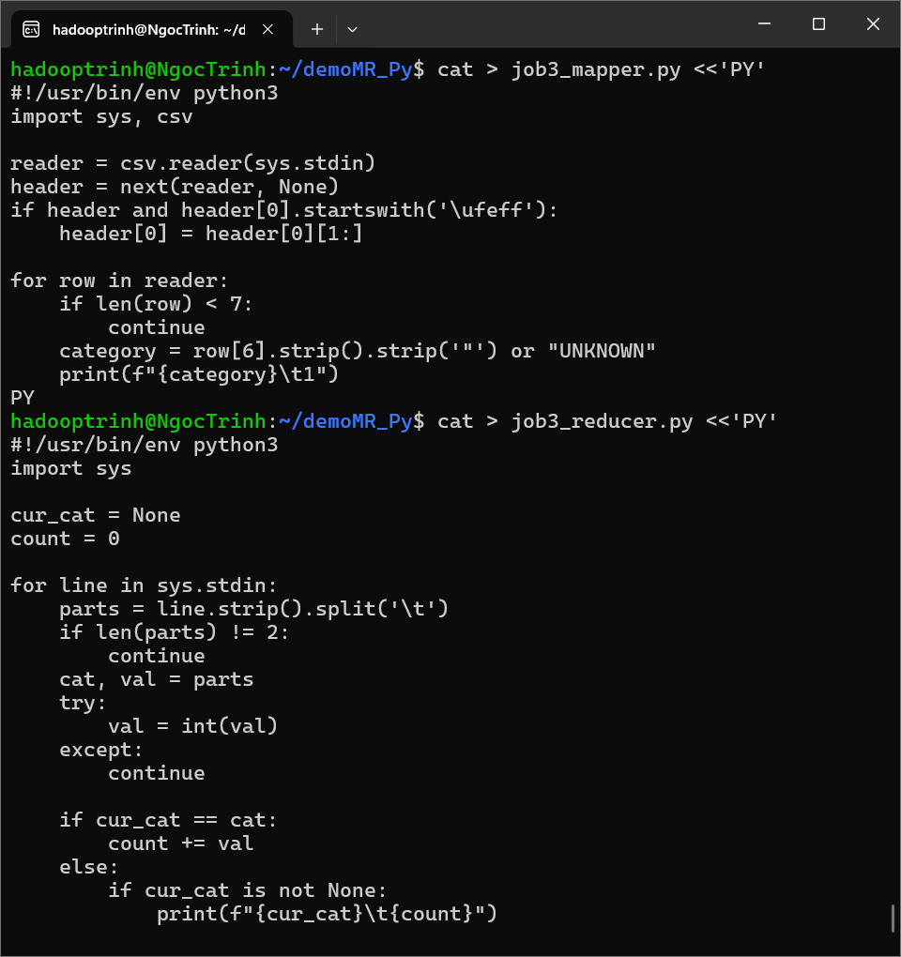
job3_reducer.py
cat > job3_reducer.py <<'PY'
#!/usr/bin/env python3
import sys

cur_cat = None
count = 0

for line in sys.stdin:
parts = line.strip().split('\t')
if len(parts) != 2:
continue
cat, val = parts
try:
val = int(val)
except:
continue

if cur_cat == cat:
count += val
else:
if cur_cat is not None:
print(f"{cur_cat}\t{count}")
cur_cat, count = cat, val

if cur_cat is not None:
print(f"{cur_cat}\t{count}")
PY
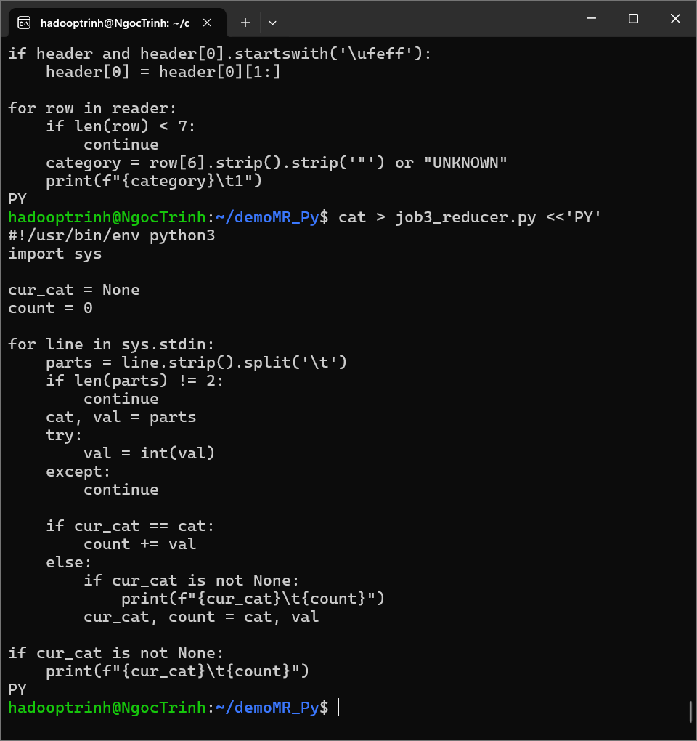
chmod +x job*_mapper.py job*_reducer.py
hdfs dfs -cat /user/hadooptrinh/tiki_output/job3_count/part-00000
