**Homework 3**

**Name**: Quan Yuan **UNI**: qy2205

**2.2**

No, we cannot make that conclusion. Since when $β_{1}<0$, there exists a negative correlation between X and Y.

**2.23**

(a) ANOVA Table

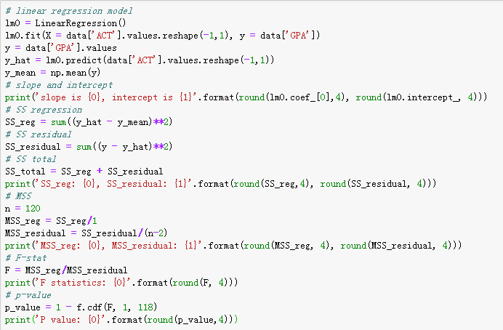

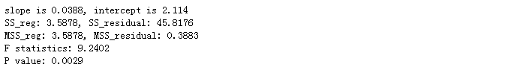

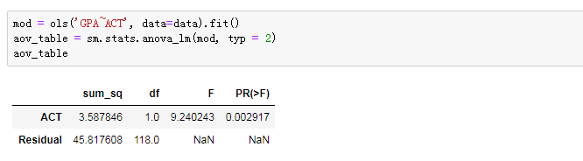

**Table 1: ANOVA Table**

|  |  |  |  |  |  |
| --- | --- | --- | --- | --- | --- |
|  | **df** | **SS** | **MSS** | **F-stat** | **p-value** |
| **Regression** | 1 | 3.5878 | 3.5878 | 9.2402 | 0.0029 |
| **Residual** | 118 | 45.8176 | 0.3883 |  |  |
| **Total** | 119 | 49.4055 |  |  |  |

(b)

$$SSR=\sum{{(\hat{Y_{i}}-\overline{Y})}^{2}}$$

$$SSE=\sum{{(\hat{Y_{i}}-Y_{i})}^{2}}$$

MSR in ANOVA Table is 3.5878, MSE is 0.3883.

$$E\left(MSR\right)=E\left(\sum_{i=1}^{n}{{\left(\hat{Y_{i}}-\overline{Y}\right)}^{2}}\right)=σ^{2}+{β_{1}}^{2}\sum_{i=1}^{n}{{(x_{i}-\overline{x})}^{2}}$$

$$E(MSE)=σ^{2}$$

So, when $β_{1}=0$, $MSR=MSE$

(c)

Alternatives: $H_{0}: β_{1}=0, H_{1}: β_{1}≠0$

F-test: $F-statistics:F=\frac{MSR}{MSE}=9.2402$

Decision rule: $F-statistics>F\left(0.99;1, 118\right)=6.8546, reject H_{0}$

So $β_{1}≠0$

(d)

The absolute magnitude of the reduction is $SS_regression=3.5878$

The relative reduction is

$$R^{2}=\frac{SS_regression}{SS_total}=\frac{3.5878}{49.4054}=0.0726$$

The name of latter is called coefficient of determination.

(e)

Since slope is 0.0388, r should be positive

$$r = \sqrt{R^{2}}=0.2694$$

(f)

$R^{2}$ has more clear-cut operational interpretation. It shows the proportionate reduction of total variation associated with the use of predictor variable X.

**2.26**

(a) ANOVA table

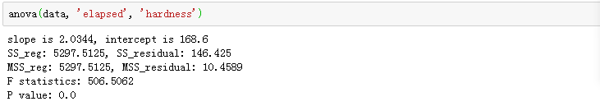

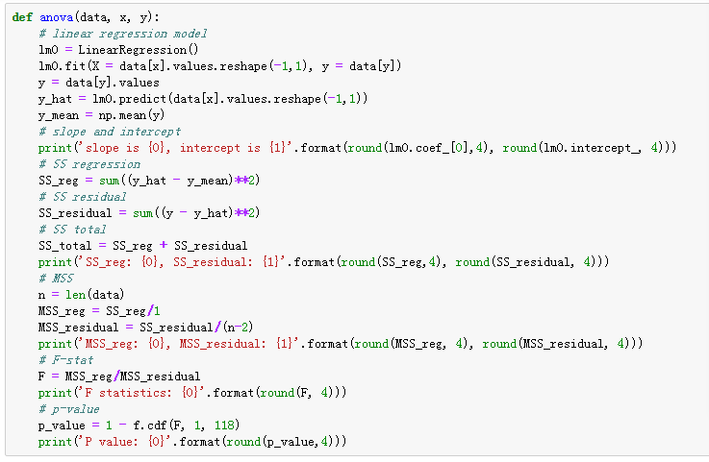

**Table 2: ANOVA Table**

|  |  |  |  |  |  |
| --- | --- | --- | --- | --- | --- |
|  | **df** | **SS** | **MSS** | **F-stat** | **p-value** |
| **Regression** | 1 | 5297.513 | 5297.513 | 506.506 | 0.0 |
| **Residual** | 14 | 146.425 | 10.459 |  |  |
| **Total** | 15 | 5443.938 |  |  |  |

(b)

Alternatives: $H_{0}: β_{1}=0, H_{1}: β_{1}≠0$

F-test: $F-statistics:F=\frac{MSR}{MSE}=9.2402$

Decision rule: $F-statistics>F\left(0.99;1, 118\right)=6.8546, reject H_{0}$

So $β_{1}≠0$

(c)

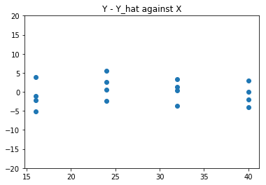

**Figure 1: Y – Y_hat against X**

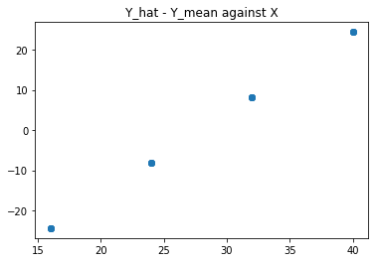

**Figure 2: Y_hat – Y_mean against X**

From the plot, we can see that SSR appear to be the larger proportion of SSTO, it implies that $R^{2}$ is close to 1 than to 0.

(d)

$$R^{2}=\frac{{SS}_{Regression}}{{SS}_{Total}}=\frac{5297.512}{5443.938}=0.9731$$

*Since $β_{1}=2.034>0$, $r$* should be positive*.*

$$r=\sqrt{R^{2}}=\sqrt{0.9731}=0.9865$$

**2.56**

(a)

$$E\left(MSR\right)=E\left(\sum_{i=1}^{n}{{\left(\hat{Y_{i}}-\overline{Y}\right)}^{2}}\right)=σ^{2}+{β_{1}}^{2}\sum_{i=1}^{n}{{(x_{i}-\overline{x})}^{2}}=1026.36$$

$$E\left(MSE\right)=σ^{2}=0.36$$

(b)

It would be worse since the distance between $x_{i}$ are small, which makes MSR small and F-statistics equal to 1.

No. Since the confidence interval is

$$Y±qMSE\sqrt{\frac{1}{n}+\frac{{(x-\overline{x})}^{2}}{\sum{{(x_{i}-\overline{x})}^{2}}}}$$

Since the mean of X = 6, 7, 8, 9, 10 and the mean of X = 1, 4, 10, 11, 14 are the same. So the confidence intervals for two observations are of the same.

**2.61**

According to 1.10 (a)

$$b_{1}=\frac{\sum{\left(X_{i}-\overline{X}\right)(Y_{i}-\overline{Y})}}{\sum{{\left(X_{i}-\overline{X}\right)}^{2}}}$$

According to 2.51

$$SSR={b_{1}}^{2}\sum{{\left(X_{i}-\overline{X}\right)}^{2}}$$

$$SSTO=\sum{{\left(Y_{i}-\overline{Y}\right)}^{2}}$$

$$\frac{SSR}{SSTO}=\frac{{b_{1}}^{2}\sum{{\left(X_{i}-\overline{X}\right)}^{2}}}{\sum{{\left(Y_{i}-\overline{Y}\right)}^{2}}}=\frac{{(\sum{\left(X_{i}-\overline{X}\right)\left(Y_{i}-\overline{Y}\right)})}^{2}}{\sum{{\left(Y_{i}-\overline{Y}\right)}^{2}}\sum{{\left(X_{i}-\overline{X}\right)}^{2}}}$$

So based on the formula above, we could see whether $Y_{1}$ is regressed on $Y_{2}$ or $Y_{2}$ is regressed on $Y_{1}$, the results are the same.

**2.66**

(a)

Confidence interval for $E(Y_{h})$, $1-α$ confidence limits are:

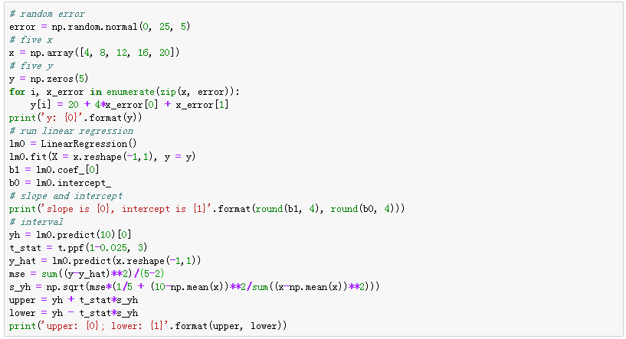

C:\Users\ADMINI~1\AppData\Local\Temp\WeChat Files\13c4868ca1202a07f5a361cde531f10.png

(b) & (c)

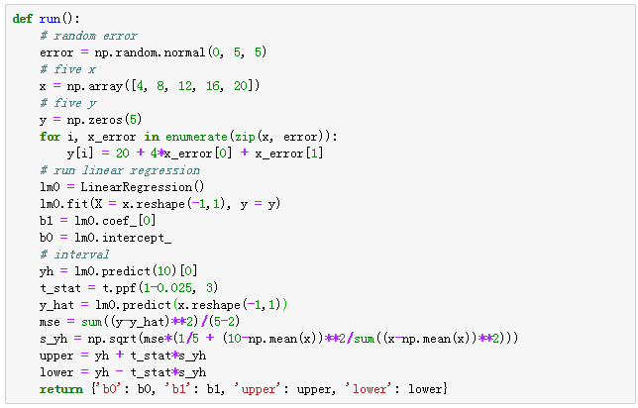

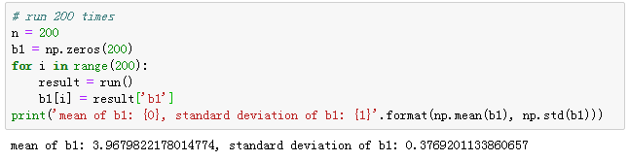

Based on the program output, the results consistent with theoretical expectations.

(d)

The proportion is 96% and the result consistent with theoretical expectations.

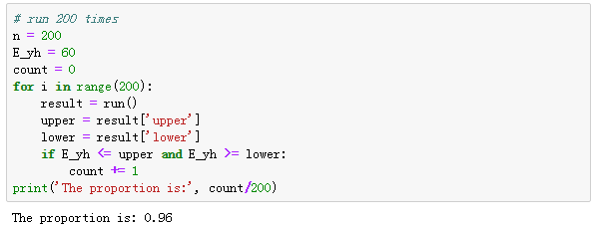

**2.68**

(a)

With the class we developed in homework 1, the result is showing below.

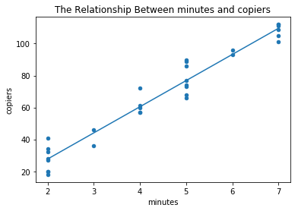

(b)

The confidence band for regression line is

$$\hat{Y_{h}}±w∙s\{\hat{Y_{h}}\}$$

Where:

$$w^{2}=2F\left(1-α;2,n-2\right)$$

$$\hat{Y_{h}}=b_{0}+b_{1}X_{h}$$

$$s^{2}\left\{\hat{Y_{h}}\right\}=MSE\left[\frac{1}{n}+\frac{{(x_{h}-\overline{x})}^{2}}{\sum{{(x_{i}-\overline{x})}^{2}}}\right]$$

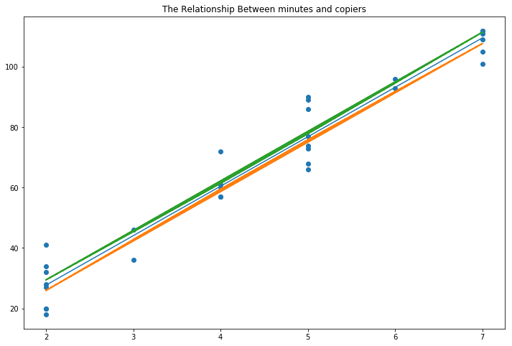

Yes, the confidence band suggest that the true regression relation has been precisely estimated since all three lines are close to each other.

