**Homework 6**

UNI: qy2205 Eric Yuan

**3.14**

**(a)**

$$H_{0}: Y_{ij}=β_{0}+β_{1}X_{j}+ϵ_{ij}, reduced model$$

$$H_{0}: Y_{ij}=μ_{ij}+ϵ_{ij}, full model$$

$$SSR(R)=\sum_{j=1}^{4}{\sum_{i}{{(β_{0}+β_{1}X_{j}-Y_{ij})}^{2}}}$$

$$SSR(F)=\sum_{j=1}^{4}{\sum_{i}{{(Y_{ij}-\overline{Y_{j}})}^{2}}}$$

$$F^{*}=\frac{SSE\left(R\right)-SSE(F)}{df_{r}-df_{F}}÷\frac{SSE(F)}{df_{F}}$$

$$=\frac{SSE-SSPE}{c-2}÷\frac{SSPE}{n-c}$$

$$=\frac{146.425-128.75}{4-2}÷\frac{128.75}{16-4}$$

$$=0.8237$$

Since $F^{*}≤F\left(0.99, 3,11\right)=6.9266$, so the conclusion is .

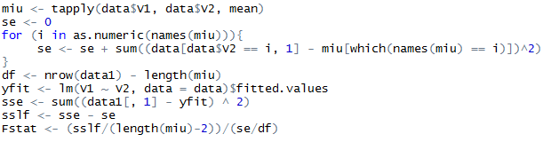

C:\Users\ADMINI~1\AppData\Local\Temp\WeChat Files\9a1c220fda4ae4dcf00729358e05276.png

C:\Users\ADMINI~1\AppData\Local\Temp\WeChat Files\aa0edd310ca7d94116263ffaf609252.png

**(b)**

There is no substantial advantage or disadvantage.

**(c)**

The test indicate that the linear regression line is invalid and transformation to data may generate better results.

**7.7**

**(a)**

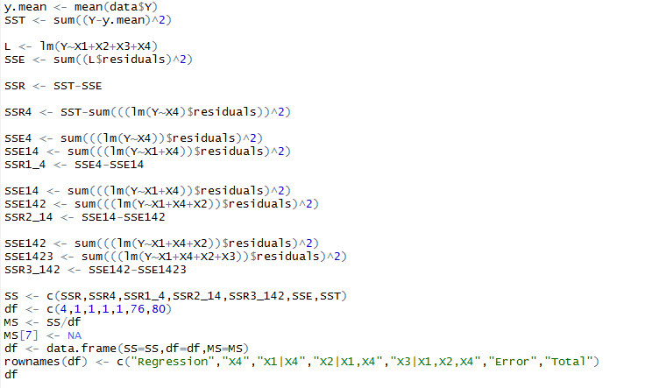

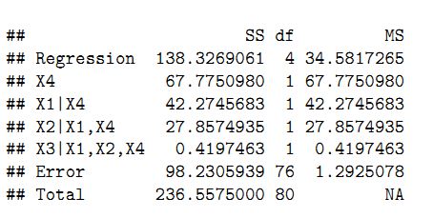

**(b)**

$$H_{0}: β_{3}=0$$

$$H_{A}: β_{3}≠0$$

$$F^{*}=\frac{SSE\left(R\right)-SSE(F)}{df_{r}-df_{F}}÷\frac{SSE(F)}{df_{F}}$$

$$=\frac{SSR\left(X_{3} | X_{1}, X_{2}, X_{4}\right)}{\left(n-4\right)-\left(n-5\right)}÷\frac{SSE\left(X_{1}, X_{2}, X_{3}, X_{4}\right)}{n-5}$$

$$=\frac{0.4197}{1}÷\frac{98.2306}{76}$$

$$=0.3247$$

Since $F^{*}≤F\left(0.99, 1,76\right)=6.9806$, so the conclusion is .

C:\Users\ADMINI~1\AppData\Local\Temp\WeChat Files\55abd9dae3357f4daad88845d80838d.png

**7.10**

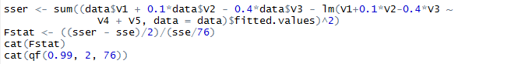

Based on the calculation result, we can conclude $H_{0}$

**7.16**

**(a)**

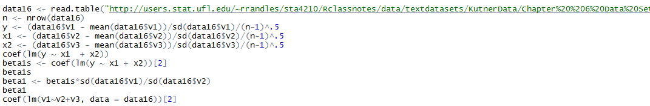

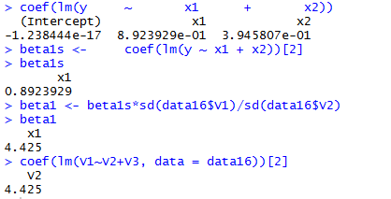

$$Y^{*}=-1.238×{10}^{-17}+0.892X_{1}^{*}+0.395X_{2}^{*}$$

**(b)**

When $X_{1}^{*}$ increase 1-unit, $Y^{*}$ will increase 0.892 if $X_{2}^{*}$ is constant.

**(c)**

Yes, they are the same.

**7.24**

C:\Users\ADMINI~1\AppData\Local\Temp\WeChat Files\17bf60e19ebff3497d2fe9e938cb1da.png



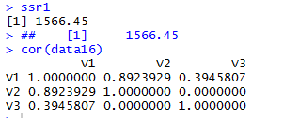

The fitted line is:

$$Y=50.775+4.425X_{1}$$

The coefficient of first order regression function with Y is the same as the coefficient obtained before. So, they are the same.

Yes, $SSR\left(X_{1}\right)=SSR(X_{1}|X_{2})$

It shows that $X_{1} and X_{2}$ are independent.

**7.37**

**(a)**

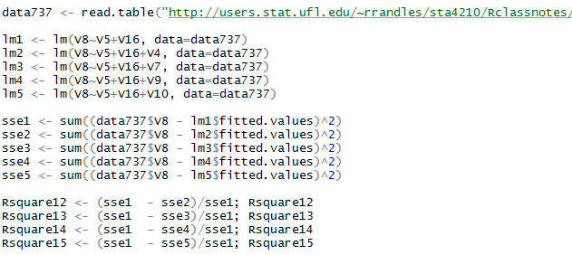

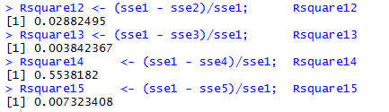

**(b)**

Number of hospital beds is the best one, It has the largest coeﬃcients of partial determination.

**(c)**

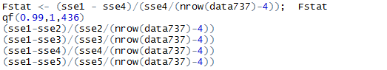

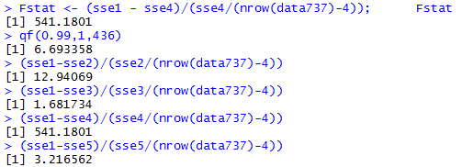

$$F^{*}=541.1801≤F\left(0.99;1,437\right)=6.693358$$

So, we conclude $H_{A}$, $X_{5}$ is helpful to the model.

No, F-statistics for other three variables are not as large as it for number of hospita beds since their coeﬃcients of partial determination are smaller.