**Linear Regression Homework 7**

Name: Eric Yuan

UNI: qy2205

**1. Chapter 8 problem 6**

**(a)**

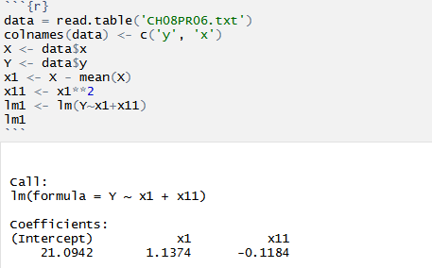

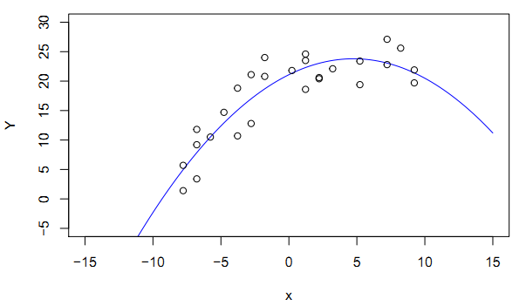

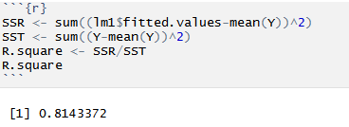

Based on the result, we could see quadratic function seems a good fit.

**(b)**

$$Y=β_{0}+β_{1}x_{1}+β_{11}x_{1}^{2}$$

$$H_{0}: β_{1}=β_{11}=0$$

$$H_{1}:either of β_{1}, β_{11}≠0$$

$$F^{*}=\frac{SSR\left(x_{1}, {x_{1}}^{2}\right)}{p}÷\frac{SSE\left(x_{1}, {x_{1}}^{2}\right)}{n-p-1}$$

$$=\frac{1046.266}{2}÷\frac{238.5408}{24}$$

$$=52.63$$

Since $F^{*}=52.633>F\left(0.99;2, 24\right)=5.614$

So we reject $H_{0}$ which means there is a regression relation

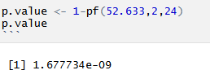

**(c)**

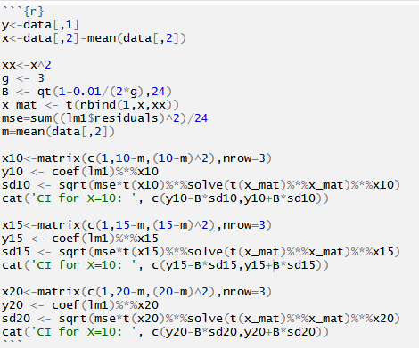

99% confidence interval for x=10: [7.559977,13.580437]

99% confidence interval for x=15: [17.22897,23.04688]

99% confidence interval for x=20: [20.99140,26.57975]

**(d)**

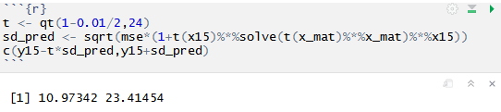

99% prediction interval for x=15 is [10.97342,23.41454]

**(e)**

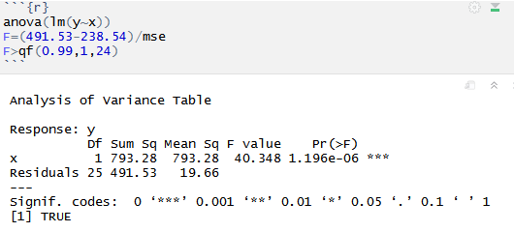

$$Y=β_{0}+β_{1}x_{1}+β_{11}x_{1}^{2}$$

$$H_{0}: β_{11}=0$$

$$H_{1}: β_{11}≠0$$

$$F^{*}=\frac{SSR\left({x_{1}}^{2}|x_{1}\right)}{1}÷\frac{SSE\left(x_{1}, {x_{1}}^{2}\right)}{n-p-1}$$

$$=\frac{252.9853}{1}÷\frac{238.5408}{24}$$

$$=25.45329$$

Since $F^{*}=25.45>F\left(0.99;1, 24\right)=7.82$

So we reject $H_{0}$

**(f)**

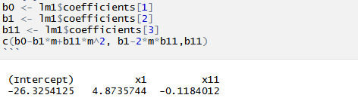

**2. Chapter 8 problem 42**

**(a)**

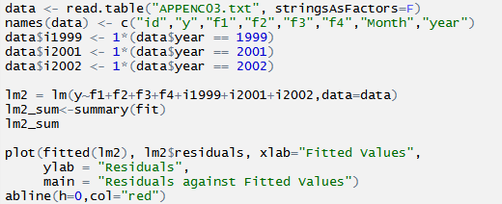

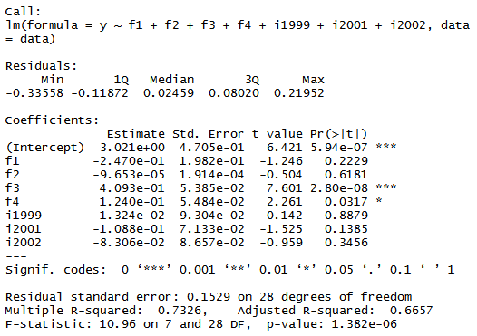

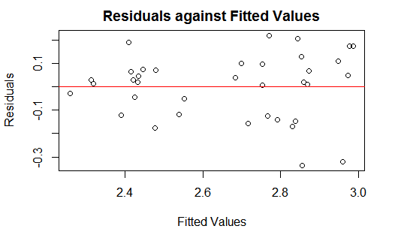

The first-order model is good since the residual seems follow the normal distribution.

**(b)**

C:\Users\ADMINI~1\AppData\Local\Temp\WeChat Files\09b0c19950d2460949ac80d080738f0.png

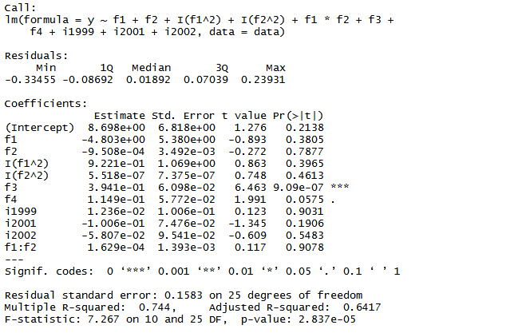

Since

So we reject $H_{0}$ and conclude $H_{1}$

**(c)**

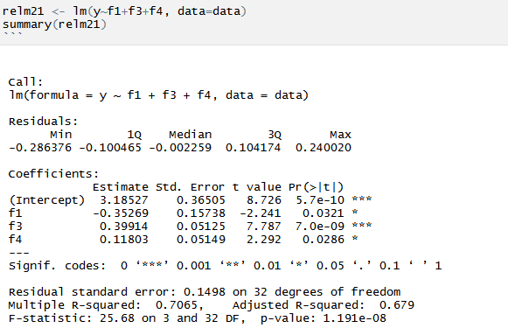

$$H_{0}: β_{2}=β_{5, 99}=β_{5, 01}=β_{5, 02}=0$$

$$H_{1}: at least one of them not equal to 0$$

$$F^{*}=\frac{SSR\left(x_{2},X_{5,99},X_{5,01},X_{5, 02}|X_{1},X_{3},X_{4}\right)}{4}÷\frac{SSE}{n-p-1}$$

$$=\frac{0.0637}{4}÷\frac{0.6542}{28}$$

$$=0.6817$$

Since $F^{*}=0.6817<F\left(0.95;4, 28\right)=2.7141$

So we conclude $H_{0}$

**3. Chapter 8 problem 43**

Fit the first order regression model first.

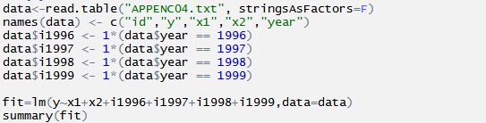

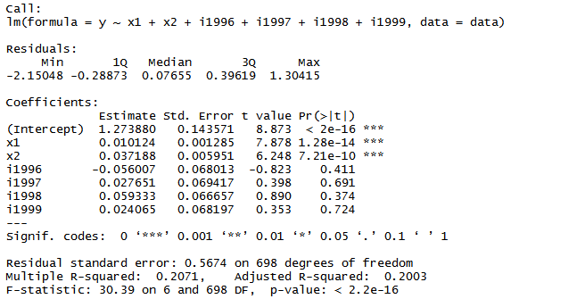

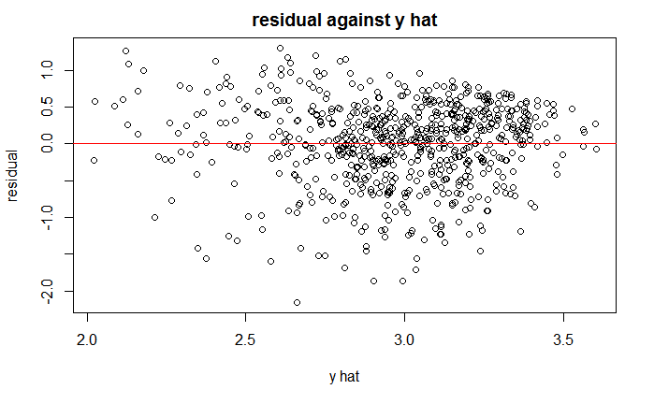

It seems the first order model is not good. Let’s try second order model.

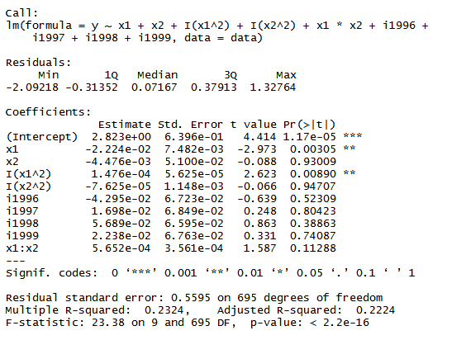

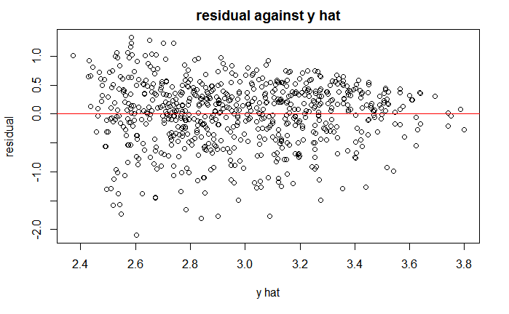

Based on the summary result, we can see that $X_{2}^{2},X_{1}X_{2} and X_{3}$ could be dropped from the model.

$$H_{0}: β_{22}=β_{12}=β_{3, 97}=β_{3, 98}=β_{3, 99}=β_{3, 00}=0$$

$$H_{1}: at least one of them not equal to 0$$

$$F^{*}=\frac{1.719789}{6}÷\frac{217.5797}{704-10}$$

$$=0.91425$$

Since $F^{*}=0.91425<F\left(0.99;6, 694\right)=2.828$

So we conclude $H_{0}$

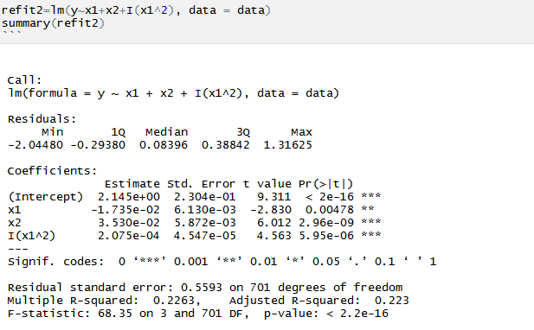

So the final model will be:

$$Y=2.15-0.0173X_{1}+0.0353X_{2}+0.0002X_{1}^{2}$$

**4. Chapter 10, problem 9 abcdg**

**(a)**

$$t_{i}=\frac{d_{i}}{s\{d_{i}\}}=\frac{e_{i}}{\sqrt{{MSE}_{\left(i\right)}(1-h_{ii})}}$$

$$t_{i}=e_{i}{\left[\frac{n-p-1}{SSE\left(1-h_{ii}\right)-{e_{i}}^{2}}\right]}^{1/2}$$

Decision rule:

If $\left|t_{i}\right|>t^{*}\left(0.9969;12\right)=3.307783$, the $i^{th}$ data is an outlier

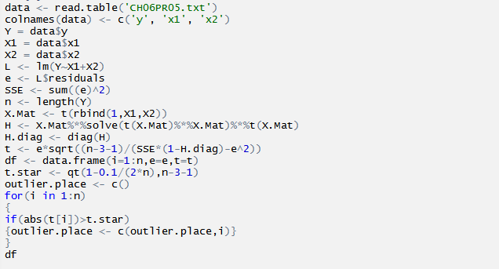

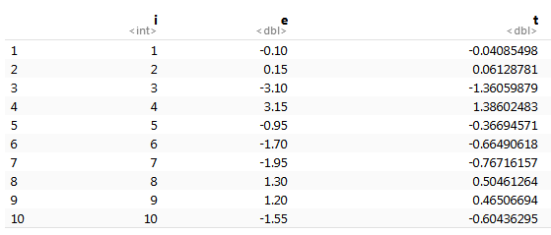

No outlying y observations.

**(b)**

$$H=X{(X^{T}X)}^{-1}X^{T}$$

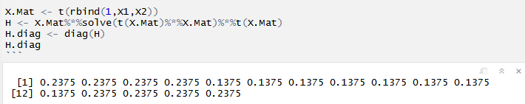

**(c)**

If $H_{ii}>\frac{2p}{n}=0.375$ which means ith data is an outlier. Write R code to test that.

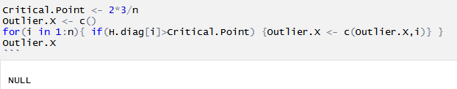

No outliers

**(d)**

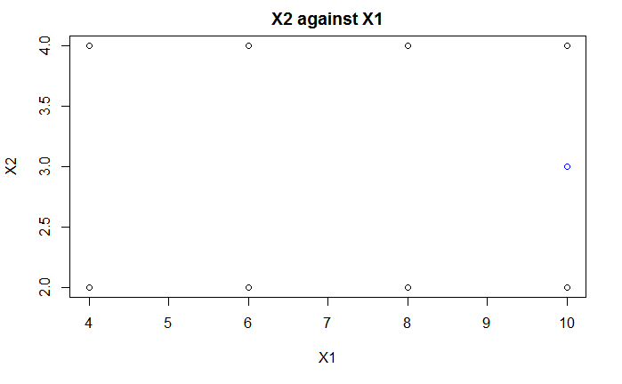

$H_{ii}=0.175<\frac{2p}{n}=0.375, \left(X_{1}, X_{2}\right)=\left(10, 3\right)$ is not an outlier

**(g)**

$$D_{i}=\frac{e_{i}^{2}}{pMSE}\frac{h_{ii}}{{(1-h_{ii})}^{2}}$$

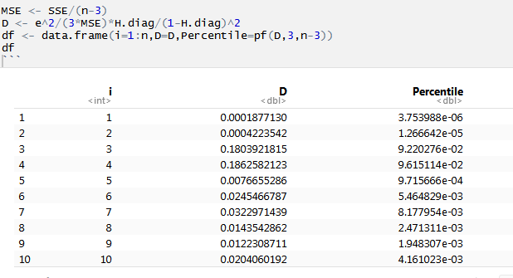

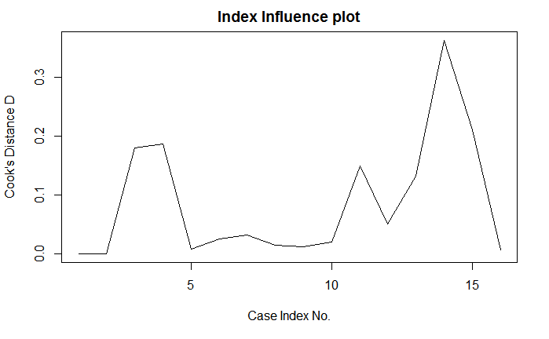

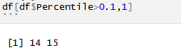

Case 14 and 15 is inﬂuential.

**5.**

$$\hat{β}=\hat{β_{(i)}}$$

$$D_{i}=\frac{{\left(\hat{β}-\hat{β_{\left(i\right)}}\right)}^{T}X^{T}X(\hat{β}-\hat{β_{\left(i\right)}})}{pMSE}=0$$

$$D_{i}=\frac{e_{i}^{2}}{pMSE}\frac{h_{ii}}{{(1-h_{ii})}^{2}}=0$$

$$e_{i}=0$$

This is because $h_{ii}≥\frac{1}{n}>0$

$$Y_{i}={\hat{Y}}_{i}$$