Document 2f9cc8801ed5
Document ID: 2f9cc8801ed5
Created at: 2025-12-17T15:19:46
Type: Normal

Image 1: Screenshot_380_.png
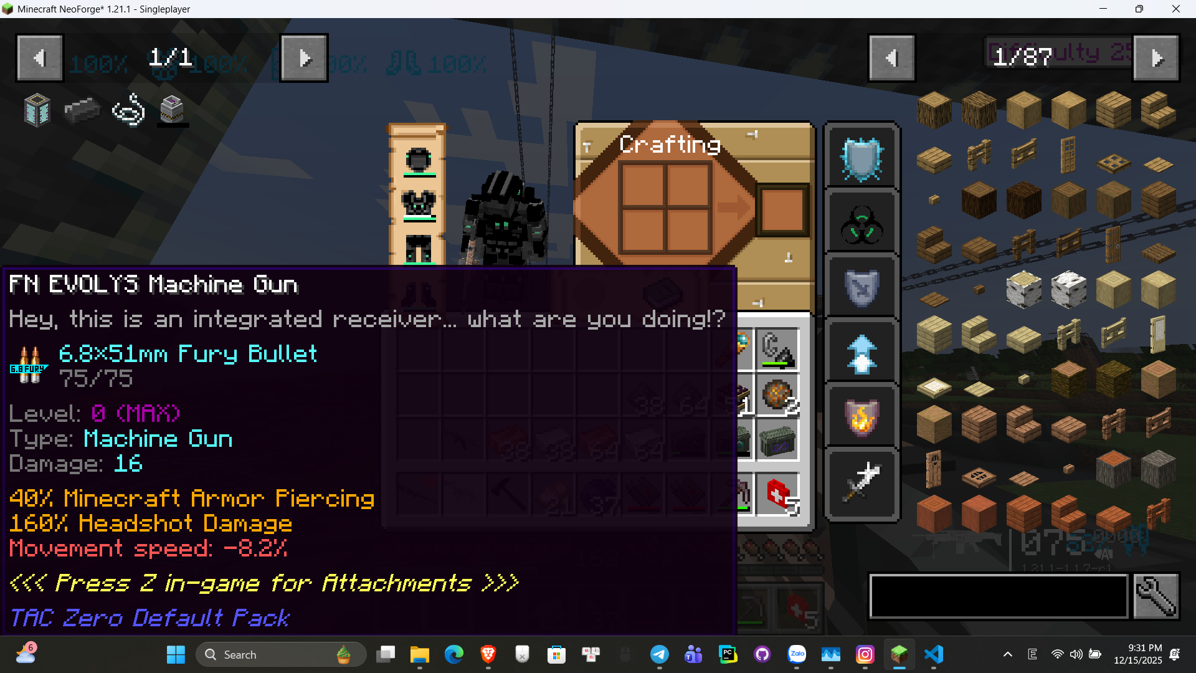
OCR Text:
Minecraft NeoForge*
21, ~
Singleplayer
[1x8z(ty
6Nevoyis(achinex@ui
0e4 (i9@@ditegratececeivens@hat @regoudoin91
68,51nrGur98uilet
85375
Level
((1
tspsgachina@d
0a6ag316
40}
Minecraftarnor
Ciercing
1e@xheadshotdanage
tovement6peed=82
(6es9Qu JENBfor@ttachnert9
@AcZer?@efalGack
9.31 PM
Search
E
12/15/2025

