Document 5abd88cf3d15
Document ID: 5abd88cf3d15
Created at: 2025-12-17T15:24:10
Type: Normal

Image 1: Screenshot_2025-12-17_152217.png
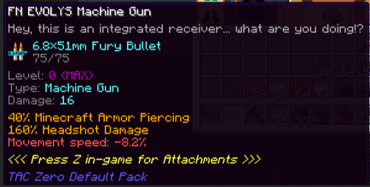
OCR Text:
FN EVoLYS Machine Gun
Hey, this is an integrated receiver
What are You doingi?
68x51nn Fury Bullet
75/75
Level
(MAa>
Type; Machine Gun
Danage: 16
40" Minecraft Arnor Piercing
160" Headshot Danage
Movenent speed: -82/
{<< Fress Z in-gane for Attachments
2>
Tac Zero Defaulf Pack

