Document d6f8e1df43c7
Document ID: d6f8e1df43c7
Created at: 2025-12-17T15:22:35
Type: Normal

Image 1: Screenshot_2025-12-17_152217.png
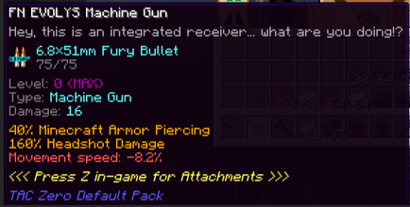
OCR Text:
TN EVQLY? Nachne Qun
Hey. this is an integrated reoeiver
are You doingi?
4 {9*71nm Furw Bullet
75/75 _
Q49
Typo
Machine Gun,
Danage: 16
40Y; Ninacraft Arnor Fiercing
160Y Headshot Danage
rpood .824
{<< Fress Z in-gane for Aftachpents >}~
Ti
Daleuti
uhat
noven

