

Requirement & Design Specification
Global Access Management System (GAMS)
Version: 1.0

– Hanoi, August 2022 –

Record of Changes
Version | Date | A*  M, D | In charge | Change Description
V1.0 | 15/2 | A | KienNTHE11
*A - Added M - Modified D - Deleted

Contents
Record of Changes 2
I. Overview 4
1. User Requirements 4
1.1 Actors 4
1.2 Use Cases 4
2. Overall Functionalities 5
2.1 Screens Flow 5
2.2 Screen Descriptions 5
2.3 Screen Authorization 5
2.4 Non-UI Functions 6
3. System High Level Design 6
3.1 Database Design 6
3.2 Code Packages 7
II. Requirement Specifications 8
1. <<Feature Name>> 8
1.1 <<UseCaseCode_UC Name>> 8
2. Common Functions 11
2.1 UC-2_Login System 11
3. Patron Feature 12
3.1 UC-5_Order a Meal 12
3.2 UC-6_Register for Payroll Deduction 13
III. Design Specifications 14
1. <<Feature Name>> 14
1.1 <<SubFeature Name>> 14
1.2 System Access 15
IV. Appendix 19
1. Assumptions & Dependencies 19
2. Limitations & Exclusions 19
3. Business Rules 19
4. .. 19

I. Overview

1. User Requirements

1.1 Actors

 | Actor | Description
1 | Guest | A user who has not registered or logged in. Can view public projects, register an account, log in, change language, and reset password.
2 | User | A user who has successfully logged in. Can manage personal profile, create projects, join projects, comment, chat, and view notifications.
3 | Member | A user who has joined a specific project. Can view and work on tasks, upload or delete files, commit, create pull requests, and view change history.
4 | Project Manager | A user who manages a project. Can invite members, assign roles, assign tasks, send reminders, search, view dashboard, manage and delete tasks/projects, and monitor progress.
5 | Admin | System administrator. Can create, manage, and deactivate users, monitor projects, view system logs, issue violation warnings, and stop invalid projects.

1.2 Use Cases

a. Diagram(s)

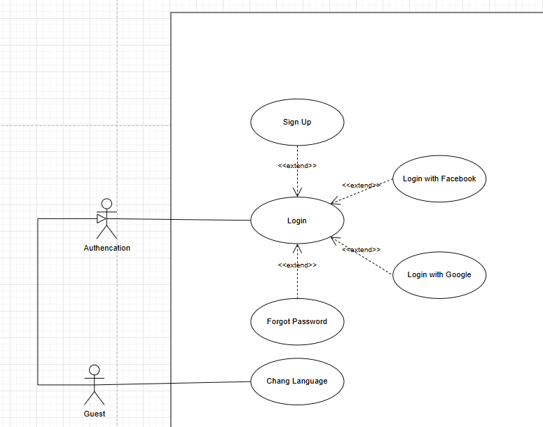
- Diagram(s) Guest
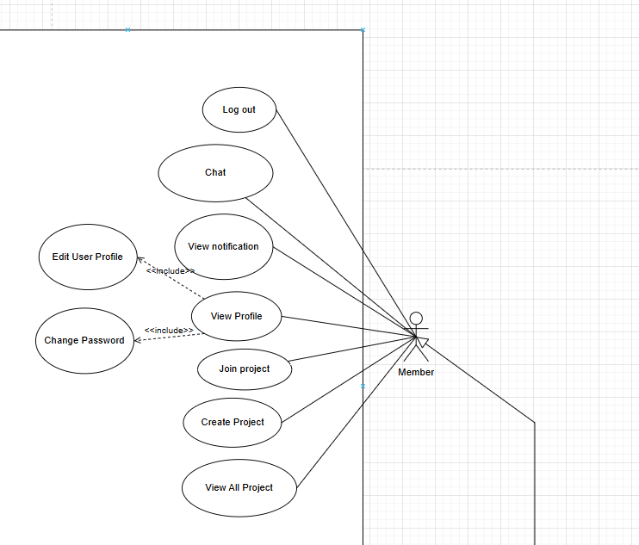
- Diagram(s) Member
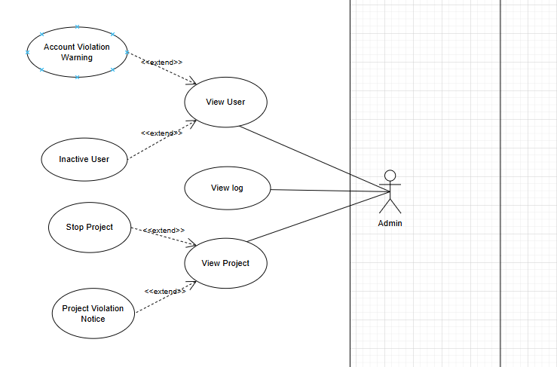
- Diagram(s) Admin

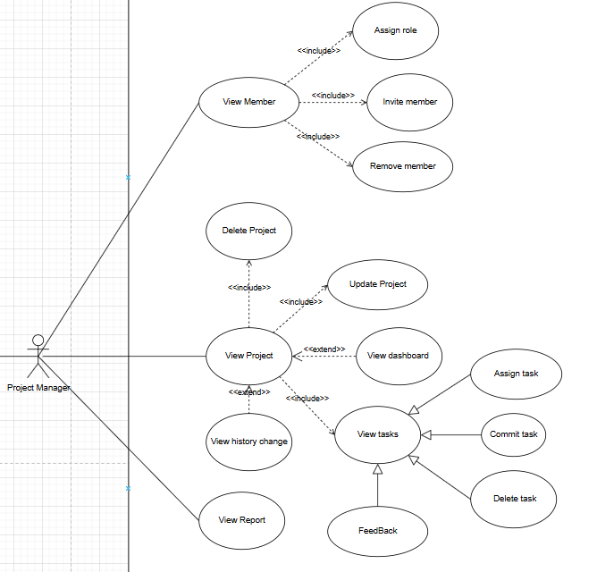
- Diagram(s) Project Manager
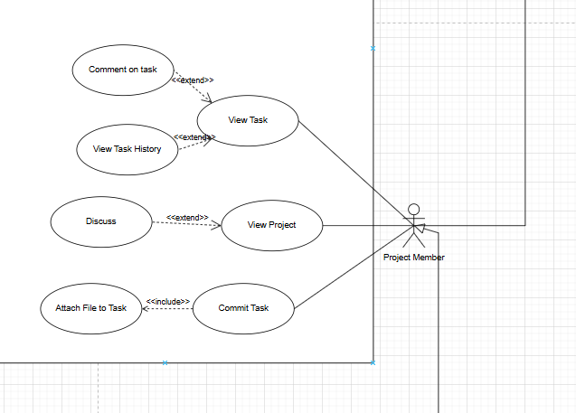

- Diagram(s) Project Member

b. Descriptions

ID | Feature | Use Case | Use Case Description
UC01 | Guest Management | Change Language | Guest changes the display language of the system
UC02 | Guest Management | Register | Guest registers an account to become a User
UC03 | Guest Management | Login | Guest enters account information to log in to the system
UC04 | Guest Management | Reset Password | Guest recovers password when forgotten
UC05 | Guest Management | View Project | Guest can view the list of public projects
UC06 | User Management | View Notification | User views the list of notifications
UC07 | User Management | Log Out | User logs out of the system
UC08 | User Management | Chat | User chats directly with other members
UC09 | User Management | View Profile | User views personal profile information
UC10 | User Management | Edit User Profile | User edits personal profile information
UC11 | User Management | Change Password | User changes password
UC12 | User Management | Create Project | User creates a new project
UC13 | User Management | Join Project | User joins an existing project
UC14 | User Management | Comment | User comments in a project or task
UC15 | User Management | View Project | User views list and details of projects
UC16 | Member Management | View Task | Member views task details in a project
UC17 | Member Management | View History Change | Member views history of changes in a project or task
UC18 | Member Management | Upload File | Member uploads files to the system
UC19 | Member Management | Delete File | Member deletes a file in the project
UC20 | Member Management | Commit to Task | Member commits code or content related to a task
UC21 | Member Management | Pull Request | Member creates a pull request to request a code merge
UC22 | Project Manager Management | Invite Member | Project Manager invites members to join the project
UC23 | Project Manager Management | Assign Role | Project Manager assigns roles to members
UC24 | Project Manager Management | Assign Task | Project Manager assigns tasks to members
UC25 | Project Manager Management | Delete Task | Project Manager deletes a task
UC26 | Project Manager Management | Remind Member | Project Manager sends reminders to members
UC27 | Project Manager Management | Commit Task | Project Manager commits content related to a task
UC28 | Project Manager Management | Search Task | Project Manager searches for tasks in the project
UC29 | Project Manager Management | View Dashboard | Project Manager views project overview dashboard
UC30 | Project Manager Management | Delete Project | Project Manager deletes a project
UC31 | Project Manager Management | View Project | Project Manager views list and details of projects
UC32 | Project Manager Management | View Task | Project Manager views task details
UC33 | Project Manager Management | View Notification | Project Manager views notifications
UC34 | Admin Management | Manage User | Admin manages the user list
UC35 | Admin Management | Create User | Admin creates a new user account
UC36 | Admin Management | Inactivate User | Admin locks or deactivates a user
UC37 | Admin Management | View Project | Admin views the project list
UC38 | Admin Management | View Log | Admin views the system activity logs
UC39 | Admin Management | Warning Violation | Admin issues warnings for user or project violations
UC40 | Admin Management | Stop Project | Admin stops a violating or invalid project

2. Overall Functionalities

2.1 Screens Flow
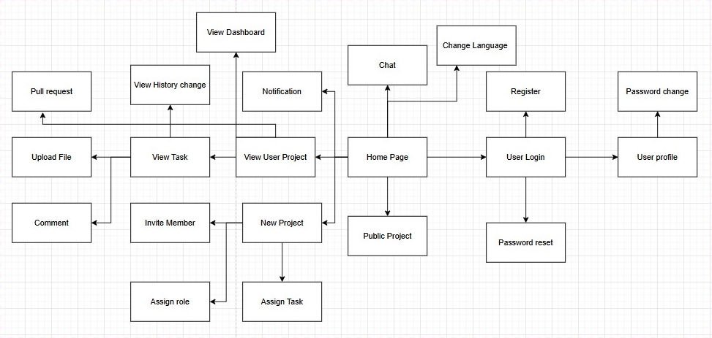

2.2 Screen Descriptions
# | Feature | Screen | Description
1 | Authentication | User Login | Screen where users enter username and password to access the system.
2 | Authentication | Register | Screen for new users to create an account by filling in personal details.
3 | Authentication | Password reset | Screen for recovering account when users forget their password.
4 | Authentication | Password change | Screen where logged-in users can update their password.
5 | User Profile | User profile | Screen that displays and allows editing of user’s personal information.
6 | Project Management | New Project | Screen to create a new project with required details.
7 | Project Management | View User Project | Screen where users can view their projects and project details.
8 | Project Management | Public Project | Screen showing public projects accessible to guests.
9 | Task Management | View Task | Screen listing all tasks in a project with their status.
10 | Task Management | Assign Task | Screen for project managers to assign tasks to members.
11 | Task Management | Assign Role | Screen for project managers to assign roles to project members.
12 | Task Management | Invite Member | Screen for project managers to invite new members to join a project.
13 | Task Management | View History change | Screen showing task or project modification history.
14 | Task Management | Comment | Screen where members can comment on tasks or project activities.
15 | Task Management | Upload File | Screen for uploading files related to tasks or projects.
16 | Task Management | Pull Request | Screen for creating pull requests to merge code or project updates.
17 | Communication | Chat | Screen for real-time messaging between project members.
18 | Notification | Notification | Screen displaying system or project notifications for users.
19 | Dashboard | View Dashboard | Screen providing an overview of project progress and key metrics.
20 | General | Home Page | The main landing page after login, containing shortcuts to main features.
21 | General | Change Language | Screen/option allowing users to switch system language.

2.3 Screen Authorization
Screen | Guest | User | Member | Project Manager | Admin
Home Page | x | x | x | x | x
Change Language | x | x | x | x | x
Register | x
User Login | x
Password reset | x
Password change |  | x | x | x | x
User profile |  | x | x | x | x
Public Project | x | x | x | x | x
New Project |  | x |  | x | x
View User Project |  | x | x | x | x
View Task |  |  | x | x | x
Assign Task |  |  |  | x | x
Assign Role |  |  |  | x | x
Invite Member |  |  |  | x | x
View History change |  |  | x | x | x
Comment |  | x | x | x | x
Upload File |  |  | x | x | x
Pull Request |  |  | x | x | x
Chat |  | x | x | x | x
Notification |  | x | x | x | x
View Dashboard |  |  |  | x | x

2.4 Non-UI Functions
# | Feature | System Function | Description
1 | Authentication | Password Encryption | The system encrypts user passwords before storing them in the database.
2 | Authentication | Session Management | The system creates, maintains, and terminates user sessions after login.
 | Authentication | Access Control | The system verifies user roles to ensure only authorized users can access certain screens.
 | User Profile | Data Validation | The system validates input fields (e.g., email format, phone number) before saving user information.
 | User Profile | Audit Logging | The system logs profile updates for traceability.
 | Project Management | Project ID Generation | The system automatically generates a unique identifier for each project.
 | Project Management | Project Backup | The system periodically saves project data to prevent loss.
 | Task Management | Task ID Generation | The system automatically assigns a unique ID to each task created.
 | Task Management | Status Tracking | The system updates task status (e.g., To Do, In Progress, Done) automatically.
 | Task Management | Version Control | The system keeps track of file versions when users upload or commit files.
 | Notification | Event Triggering | The system generates notifications automatically when an event occurs (e.g., new task assigned).
 | Notification | Delivery Scheduling | The system sends notifications immediately or queues them for later delivery.
 | Communication (Chat) | Message Storage | The system stores chat history securely for later retrieval.
 | Communication (Chat) | Real-time Sync | The system synchronizes chat messages in real time across all devices.
 | Admin Management | User Monitoring | The system tracks user activities and logs violations.
 | Admin Management | Project Suspension | The system automatically disables projects flagged as violating policies.
 | System Maintenance | Data Backup & Restore | The system allows scheduled backups and restore functionality.
 | System Maintenance | Performance Monitoring | The system monitors performance metrics like CPU, memory, and response times.

3. System High Level Design

3.1 Database Design

a. Database Schema
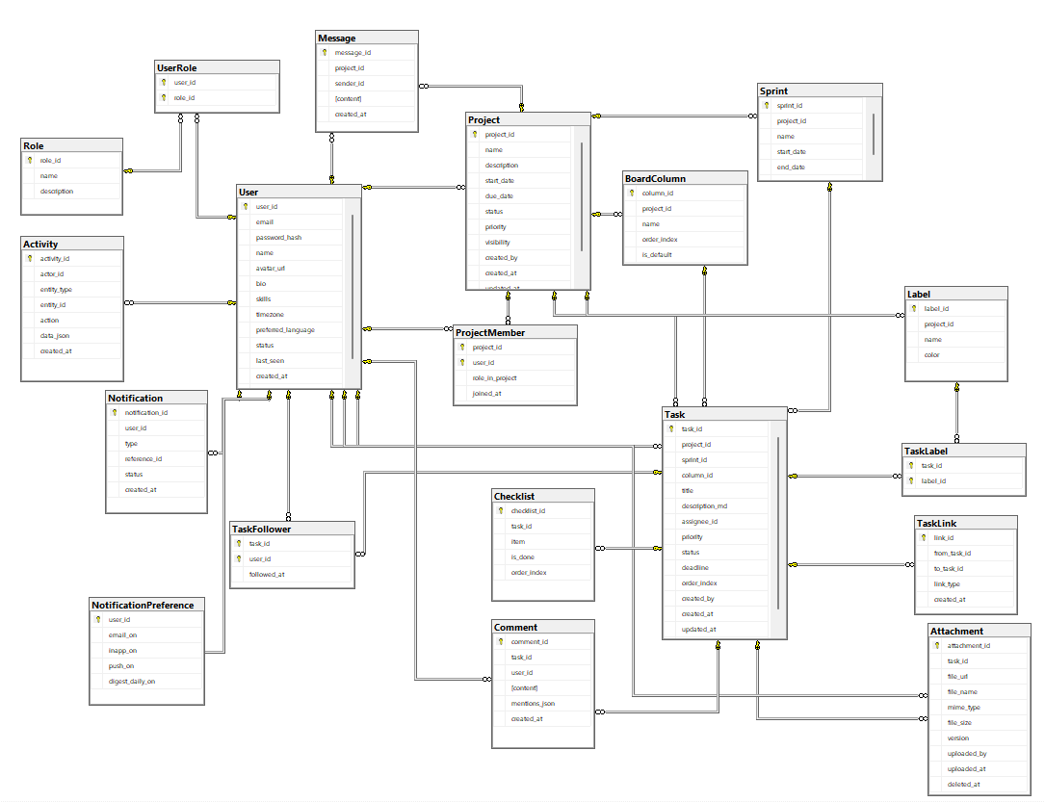

b. Table Descriptions
No | Table | Description
01 | User | Stores system users’ information.  - Primary keys: user_id  - Foreign keys: (none)
02 | Role | Stores all system roles.  - Primary keys: role_id  - Foreign keys: (none)
03 | UserRole
  N-N relationship between User and Role.
  - Primary keys: (user_id, role_id)
  - Foreign keys: user_id → User, role_id → Role
04 | Project
  Stores project information.
  - Primary keys: project_id
  - Foreign keys: created_by → User
05 |  | Stores members participating in projects.  - Primary keys: (project_id, user_id)  - Foreign keys: project_id → Project, user_id → User
  ProjectMember
06 | Sprint | Represents iterations in projects.  - Primary keys: sprint_id  - Foreign keys: project_id → Project
07 | BoardColumn | Defines Kanban columns for projects.  - Primary keys: column_id  - Foreign keys: project_id → Project
08 | Task | Stores tasks within a project.  - Primary keys: task_id  - Foreign keys: project_id → Project, sprint_id → Sprint, column_id → BoardColumn, assignee_id → User, created_by → User
09 |  | List of users following tasks.  - Primary keys: (task_id, user_id)  - Foreign keys: task_id → Task, user_id → User
  TaskFollower
10
  Checklist
  Stores subtasks for tasks.
  - Primary keys: checklist_id
  - Foreign keys: task_id → Task
11 |  | Stores comments on tasks.  - Primary keys: comment_id  - Foreign keys: task_id → Task, user_id → User
  Comment
12 |  | Stores task attachments (supports versioning).  - Primary keys: attachment_id  - Foreign keys: task_id → Task, uploaded_by → User
  Attachment
13 | Label | Stores task labels within a project.  - Primary keys: label_id  - Foreign keys: project_id → Project
14 | TaskLabel | N-N relationship between Task and Label.  - Primary keys: (task_id, label_id)  - Foreign keys: task_id → Task, label_id → Label
15 | TaskLink | Stores task dependencies and relationships.  - Primary keys: link_id  - Foreign keys: from_task_id → Task, to_task_id → Task
16 |  | Stores chat messages in projects.  - Primary keys: message_id  - Foreign keys: project_id → Project, sender_id → User
  Message
17 | Notification | Stores notifications sent to users.  - Primary keys: notification_id  - Foreign keys: user_id → User
18 | NotificationPreference | Stores notification settings per user.  - Primary keys: user_id  - Foreign keys: user_id → User
19 | Activity | Stores activity logs (audit trail).  - Primary keys: activity_id  - Foreign keys: actor_id → User

Column Details

User Table
Column | Description | Datatype | Notes
user_id | Unique user ID | INT (IDENTITY) | Auto-increment
email | Login email | VARCHAR(255) | Required, unique
password_hash | Hashed password | VARBINARY(256) | Required
name | Full name | NVARCHAR(120) | Required
avatar_url | Profile picture URL | NVARCHAR(512) | Cloud URL
bio | Short biography | NVARCHAR(1000) | Optional
skills | List of skills | NVARCHAR(500) | Optional
timezone | User’s time zone | NVARCHAR(64) | Example: Asia/Ho_Chi_Minh
preferred_language | Preferred language | NVARCHAR(16) | 'vi' or 'en'
status | Account status | NVARCHAR(16) | active / suspended / deleted
last_seen | Last activity timestamp | DATETIME2
created_at | Creation timestamp | DATETIME2 | Auto-filled
updated_at | Last update timestamp | DATETIME2 | Auto-updated

Role Table
Column | Description | Datatype | Notes
role_id | Role ID | INT (IDENTITY) | Auto-increment
name | Role name | NVARCHAR(50) | Admin, PM, Member, Guest
description | Role description | NVARCHAR(255) | Optional

UserRole Table
Column | Description | Datatype | Notes
user_id | User ID | INT | FK → User
role_id | Role ID | INT | FK → Role

Project Table
Column | Description | Datatype | Notes
project_id | Project ID | INT (IDENTITY)
name | Project name | NVARCHAR(200) | Required
description | Project description | NVARCHAR(MAX)
start_date | Start date | DATE
due_date | Due date | DATE
status | Project status | NVARCHAR(16) | Active / Archived
priority | Priority level | NVARCHAR(16) | High / Normal / Low
visibility | Project visibility | NVARCHAR(16) | private / public
created_by | Creator user ID | INT | FK → User
created_at | Created at | DATETIME2
updated_at | Updated at | DATETIME2
archived_at | Archived at | DATETIME2

ProjectMember Table
Column | Description | Datatype | Notes
project_id | Project ID | INT | FK
user_id | User ID | INT | FK
role_in_project | Role in project | NVARCHAR(32) | PM / Member
joined_at | Join date | DATETIME2

Sprint Table
Column | Description | Datatype | Notes
sprint_id | Sprint ID | INT (IDENTITY)
project_id | Parent project | INT | FK
name | Sprint name | NVARCHAR(100)
start_date | Start date | DATE
end_date | End date | DATE
goal | Sprint goal | NVARCHAR(255)

BoardColumn Table
Column | Description | Datatype | Notes
column_id | Kanban column ID | INT (IDENTITY) | Auto-increment
project_id | Parent project | INT | FK
name | Column name | NVARCHAR(100) | To-do, In Progress, Review, Done
order_index | Display order | INT | Default 0
is_default | Default column flag | BIT | 0 = No, 1 = Yes

Task Table
Column | Description | Datatype | Notes
task_id | Task ID | INT (IDENTITY)
project_id | Parent project | INT | FK
sprint_id | Sprint this task belongs to | INT | FK
column_id | Kanban column | INT | FK
title | Task title | NVARCHAR(300)
description_md | Task description | NVARCHAR(MAX)
assignee_id | Assigned user | INT | FK
priority | Task priority | NVARCHAR(16) | CRITICAL / HIGH / MEDIUM / LOW
status | Task status | NVARCHAR(16) | OPEN / IN_PROGRESS / REVIEW / DONE
deadline | Due date | DATETIME2
order_index | Order in column | INT
created_by | Creator user ID | INT | FK
created_at | Created at | DATETIME2
updated_at | Last update | DATETIME2
closed_at | Closed at | DATETIME2

TaskFollower Table
Column | Description | Datatype | Notes
task_id | Task ID | INT | FK
user_id | User ID | INT | FK
followed_at | Followed at | DATETIME2 | Auto-filled

Checklist Table
Column | Description | Datatype | Notes
checklist_id | Checklist ID | INT (IDENTITY)
task_id | Parent task | INT | FK
item | Checklist item | NVARCHAR(500)
is_done | Completion status | BIT | 0/1
order_index | Display order | INT

Comment Table
Column | Description | Datatype | Notes
comment_id | Comment ID | INT (IDENTITY)
task_id | Task | INT | FK
user_id | User | INT | FK
content | Comment text | NVARCHAR(MAX)
mentions_json | Mentioned users | NVARCHAR(MAX) | JSON
created_at | Created at | DATETIME2

Attachment Table
Column | Description | Datatype | Notes
attachment_id | Attachment ID | INT (IDENTITY)
task_id | Related task | INT | FK
file_url | File URL | NVARCHAR(700)
file_name | File name | NVARCHAR(300)
mime_type | File type | NVARCHAR(100)
file_size | File size | INT | bytes
version | File version | INT | Default 1
uploaded_by | Uploaded by | INT | FK
uploaded_at | Uploaded at | DATETIME2
deleted_at | Deleted at | DATETIME2

Label Table
Column | Description | Datatype | Notes
label_id | Label ID | INT (IDENTITY)
project_id | Parent project | INT | FK
name | Label name | NVARCHAR(60)
color | Display color | NVARCHAR(24) | HEX or color name

TaskLabel Table
Column | Description | Datatype | Notes
task_id | Task ID | INT | FK
label_id | Label ID | INT | FK

TaskLink Table
Column | Description | Datatype | Notes
link_id | Link ID | INT (IDENTITY)
from_task_id | Source task | INT | FK
to_task_id | Target task | INT | FK
link_type | Link type | NVARCHAR(20) | BLOCKS / RELATES / DUPLICATES
created_at | Created at | DATETIME2

Message Table
Column | Description | Datatype | Notes
message_id | Message ID | INT (IDENTITY)
project_id | Project | INT | FK
sender_id | Sender user ID | INT | FK
content | Message content | NVARCHAR(MAX)
created_at | Sent at | DATETIME2

Notification Table
Column | Description | Datatype | Notes
notification_id | Notification ID | INT (IDENTITY)
user_id | Recipient user ID | INT | FK
type | Notification type | NVARCHAR(40) | task_assign / mention / deadline_reminder
reference_id | Related entity ID | INT
status | Status | NVARCHAR(16) | unread / read
created_at | Created at | DATETIME2

NotificationPreference Table
Column | Description | Datatype | Notes
user_id | User ID | INT | PK + FK
email_on | Email notifications | BIT
inapp_on | In-app notifications | BIT
push_on | Push notifications | BIT
digest_daily_on | Daily digest | BIT

Activity Table
Column | Description | Datatype | Notes
activity_id | Activity log ID | INT (IDENTITY)
actor_id | User performing action | INT | FK
entity_type | Entity type | NVARCHAR(40) | PROJECT / TASK / COMMENT
entity_id | Entity ID | INT
action | Action | NVARCHAR(40) | CREATE / UPDATE / DELETE / ASSIGN
data_json | Change data | NVARCHAR(MAX) | JSON
created_at | Logged at | DATETIME2

3.2 Code Packages
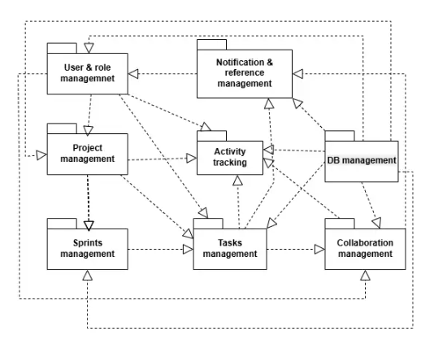
Package descriptions
No | Package | Desciption
01 | User & Role Management | Manages user accounts, personal information, and system roles (Admin, PM, Member, Guest)
02 | Project Management | Handles project information, project members, access rights, and Kanban board configuration
03 | Sprint Management | Manages development iterations (sprints), including start/end dates and sprint goals
04 | Task Management | Manages tasks, their status, priority, assignees, checklists, labels, and task dependencies
05 | Collaboration | Provides collaboration features such as comments, file attachments, and project chat messages
06 | Notification | Manages system notifications: task assignment, deadline reminders, mentions in comments, and user notification settings
07 | Activity Tracking | Records user activity logs: create, update, delete actions on projects, tasks, and comments for auditing and history tracking
08 | Database (Persistence Layer) | Stores all system data, including users, projects, sprints, tasks, comments, notifications, and logs

II. Requirement Specifications

1. Guest Features

1.1 UC-01_Change Language

a. Functional Description
Functional Description Template
UC ID and Name: | UC-01_Change Language
Created By: | Hung | Date Created: | 25/09/2025
Primary Actor: | Guest | Secondary Actors: | None
Trigger: | Guest clicks on the "Change Language" option on the Home Page.
Description: | As a Guest, I want to change the display language of the system so that I can view all menus, forms, and instructions in my preferred language.
Preconditions: | PRE-1: Guest has accessed the Home Page.
Postconditions: | POST-1: System updates the UI language setting for the current session.v  POST-2: All screens reload and display in the selected language.
Normal Flow: | - Guest accesses the Home Page.  - Guest clicks the “Change Language” button.  - System displays a list of available languages.  - Guest selects a preferred language.  - System reloads the page with updated language.
Alternative Flows: | 1.1 Guest cancels the action → system keeps the current language setting.
Exceptions: | 1.0.E1: Selected language file is missing → System shows error and keeps default language.
Priority: | Must Have
Frequency of Use: | Often, depending on Guest preference.
Business Rules: | FR1
Other Information: | None
Assumptions: | Supported language files exist in the system.

b. Business Rules
ID | Business Rule | Business Rule Description
FR1 | Language Availability | System must only display languages that have full translation files.

1.2 UC-02_Register

a. Functional Description
Functional Description Template
UC ID and Name: | UC-02_Register
Created By: | Hung | Date Created: | 25/09/2025
Primary Actor: | Guest | Secondary Actors: | None
Trigger: | Guest clicks “Register” button on Login Page.
Description: | As a Guest, I want to register an account so that I can become a User and access system features.
Preconditions: | PRE-1: Guest is not logged in.  PRE-2: Guest provides a valid email and password.
Postconditions: | POST-1: New User account is created in the database.  POST-2: Confirmation email is sent to the Guest.
Normal Flow: | - Guest clicks “Register” from Login Page.  - System shows registration form.  - Guest fills in required information (username, email, password).  - System validates inputs (see 2.0.E1).  - System saves new account into database.  - System sends confirmation email to Guest.  - Guest becomes a registered User.
Alternative Flows: | 2.1 Guest registers via Google account → System redirects to Google, verifies, and returns to step 5.  2.2 Guest registers via Facebook account → System redirects to Facebook, verifies, and returns to step 5.
Exceptions: | 2.0.E1: Email already exists → System shows error and asks Guest to use another email.  2.0.E2: Password is too weak → System prompts Guest to enter a stronger password.
Priority: | Must Have
Frequency of Use: | New users occasionally.
Business Rules: | FR2, FR3
Other Information: | None
Assumptions: | Mail server is working properly to send confirmation.

b. Business Rules
ID | Business Rule | Business Rule Description
FR2 | Unique Email | Each account must have a unique email address.
FR3 | Password Complexity | Password must be at least 8 characters, with 1 uppercase, 1 lowercase, and 1 number.

1.3 UC-03_Login

a. Functional Description
Functional Description Template
UC ID and Name: | UC-03 Login
Created By: | Hung | Date Created: | 25/09/2025
Primary Actor: | Guest | Secondary Actors: | None
Trigger: | Guest clicks the “Login” button on the system’s header.
Description: | As a Guest, I want to log into the system so that I can access personalized features and manage my projects.
Preconditions: | PRE-1: Guest has a registered account.  PRE-2: Guest enters correct login details.
Postconditions: | POST-1: Guest becomes an authenticated User.  POST-2: System logs the successful login into the Activity Log.
Normal Flow: | - Guest clicks “Login” button.  - System displays login form.  - Guest enters email and password.  - Guest clicks “Login”.  - System validates login details (see 3.0.E1).  - System grants access and redirects User to Home Page.
Alternative Flows: | 3.1 Guest logs in using Google account → System redirects to Google, verifies, and returns to step 6.  3.2 Guest logs in using Facebook account → System redirects to Facebook, verifies, and returns to step 6.
Exceptions: | 3.0.E1: Incorrect login details → System shows error message.  3.0.E2: Account not verified → System asks Guest to verify email.  3.0.E3: Account locked → System notifies Guest and blocks login attempt.
Priority: | Must Have
Frequency of Use: | Daily
Business Rules: | FR4, FR5, FR6
Other Information: | Session timeout is set to 30 minutes of inactivity.
Assumptions: | Authentication server is available.

b. Business Rules
ID | Business Rule | Business Rule Description
FR4 | Password Encoding | Passwords must be stored using one-way hashing algorithm.
FR5 | Login Attempts Limit | After 5 failed login attempts, account is locked for 30 minutes.
FR6 | Multi-login Control | A user can log in from multiple devices, but system must track all sessions for security.

1.4 UC-04_Reset Password

a. Functional Description
Functional Description Template
UC ID and Name: | UC-04_Reset Password
Created By: | Hung | Date Created: | 25/09/2025
Primary Actor: | Guest | Secondary Actors: | Email Service
Trigger: | Guest clicks “Forgot Password?” link on Login Page.
Description: | As a Guest, I want to reset my password when I forget it so that I can log back into the system.
Preconditions: | PRE-1: Guest must have a registered account.  PRE-2: Guest provides a valid email.
Postconditions: | POST-1: System sends a password reset link to Guest’s email.  POST-2: Guest creates a new password and gains access again.
Normal Flow: | - Guest clicks “Forgot Password?”.  - System displays “Reset Password” screen.  - Guest enters registered email.  - System validates email (see 4.0.E1).  - System sends reset link to email.  - Guest clicks reset link in email.  - System displays “New Password” screen.  - Guest enters new password.  - System updates password and confirms reset.
Alternative Flows: | 4.1 Guest cancels password reset → System returns to Login Page.
Exceptions: | 4.0.E1: Email not found → System shows error message.  4.0.E2: Reset link expired → System shows error, Guest must request again.
Priority: | Must Have
Frequency of Use: | Occasionally, only when password is forgotten.
Business Rules: | FR7, FR8
Other Information: | Reset link expires after 24 hours.
Assumptions: | Guest has access to registered email.

b. Business Rules
ID | Business Rule | Business Rule Description
FR7 | Password Reset Expiry | Reset password link is valid for 24 hours only.
FR8 | Password Validation | New password must comply with system’s password complexity rules (see FR3).

1.5 UC-05_Guest View Project

a. Functional Description
Functional Description Template
UC ID and Name: | UC-05_Guest View Project
Created By: | Hung | Date Created: | 25/09/2025
Primary Actor: | Guest | Secondary Actors: | None
Trigger: | Guest selects “View Projects” from the main menu.
Description: | As a Guest, I want to view the list of public projects so that I can understand what kinds of projects exist before deciding to register..
Preconditions: | PRE-1: Guest has access to the system’s homepage.  PRE-2: System has at least one public project available.
Postconditions: | POST-1: System displays a list of public projects with basic details (title, short description, project manager).  POST-2: Guest remains in “read-only” mode and cannot interact further with project details.
Normal Flow: | - Guest clicks “View Projects”.  - System retrieves a list of projects marked as public.  - System displays the list including project title, short description, and manager’s name.  - Guest browses the list.
Alternative Flows: | 5.1 No public projects available → System shows message “No public projects available”.
Exceptions: | 5.0.E1: Database error while fetching projects → System shows error “Unable to load projects, please try again later”.
Priority: | Must Have
Frequency of Use: | Frequently, especially for new visitors.
Business Rules: | FR9, FR10
Other Information: | Guest cannot join or interact with a project without registering.
Assumptions: | Public projects are pre-defined by Project Managers or Admins.

b. Business Rules
ID | Business Rule | Business Rule Description
FR9 | Public Projects Visibility | Only projects marked as “Public” are visible to Guests.
FR10 | Read-Only Access | Guests can only view basic project information, without interacting or joining.

2. User Feature

2.1 UC-06_User View Notification

a. Functional Description
UC ID and Name: | UC-06_User View Notification
Created By: | Hung | Date Created: | 25/Sep/2025
Primary Actor: | User | Secondary Actors: | Notification Service
Trigger: | User selects the “Notifications” option from the navigation menu.
Description: | As a User, I want to view a list of my notifications so that I can stay updated on project activities, invitations, or messages.
Preconditions: | PRE-1: User must be logged into the system.  PRE-2: There are notifications generated by the system related to the User.
Postconditions: | POST-1: Notifications are displayed in chronological order.  POST-2: User is aware of pending actions or updates.
Normal Flow | - User clicks on “Notifications”.  - System retrieves all notifications linked to the User account.  - System displays a list of notifications with timestamp, type, and content summary.  - User views notification details.
Alternative Flows: | 6.1 No notifications available → System shows message “No new notifications”.
Exceptions: | 6.0.E1: Notification service not responding → System shows error message “Unable to load notifications, please try again later”.
Priority: | Must Have
Frequency of Use: | Frequently, especially when participating in multiple projects.
Business Rules: | FR11, FR12
Other Information: | Notifications can include project invitations, task updates, comments, or reminders.
Assumptions: | Notification Service is active and properly integrated with system events.

b. Business Rules
ID | Business Rule | Business Rule Description
FR11 | Notification Relevance | Only notifications directly related to the User are displayed.
FR12 | Chronological Ordering | - Notifications must be shown with the most recent first.

2.2 UC-07_User Log out

a. Functional Description
UC ID and Name: | UC-07_User Log out
Created By: | Hung | Date Created: | 25/Sep/2025
Primary Actor: | User | Secondary Actors: | None
Trigger: | User clicks “Log out” from the navigation menu.
Description: | As a User, I want to log out so that I can end my session and secure my account.
Preconditions: | PRE-1: User must be logged into the system.
Postconditions: | POST-1: User session is terminated.  POST-2: User is redirected to the Login page.
Normal Flow | - User clicks “Log out”.  - System clears User session and authentication tokens.  - System redirects to the Login page.
Alternative Flows: | 7.1 User closes the browser → Session automatically ends after timeout.
Exceptions: | 7.0.E1: System error during logout → System displays “Logout failed, please try again”.
Priority: | Must Have
Frequency of Use: | Very frequent (every login session).
Business Rules: | FR13
Other Information: | Session data must be securely cleared.
Assumptions: | System has session timeout mechanism enabled.

b. Business Rules
ID | Business Rule | Business Rule Description
FR13 | Session Termination | System must invalidate all active

2.3 UC-08_User Chat

a. Functional Description
UC ID and Name: | UC-08_User Chat
Created By: | Hung | Date Created: | 25/Sep/2025
Primary Actor: | User | Secondary Actors: | Messaging Service
Trigger: | User selects “Chat” and starts a new conversation.
Description: | As a User, I want to chat with other members so that I can communicate directly about projects or tasks.
Preconditions: | PRE-1: User must be logged in.  PRE-2: Target member must exist in the system.
Postconditions: | POST-1: Chat messages are delivered and stored in the system.  POST-2: Conversation history is updated in real time.
Normal Flow | - User opens “Chat” feature.  - System displays contact list or ongoing conversations.  - User selects a member and types a message.  - System sends message via Messaging Service.  - Recipient sees message in real time.
Alternative Flows: | 8.1 User sends attachments (file, image) → System uploads and sends as part of chat.
Exceptions: | 8.0.E1: Network error → System retries sending message.  8.0.E2: Recipient not online → System marks message as “unread”.
Priority: | Should Have
Frequency of Use: | Frequent, depending on collaboration level.
Business Rules: | FR14, FR15
Other Information: | Messages must be encrypted.
Assumptions: | Messaging Service is always available.

b. Business Rules
ID | Business Rule | Business Rule Description
FR14 | Message Persistence | All messages must be stored in the database for retrieval.
FR15 | Real-time Delivery | Messages must be delivered in real time using WebSocket or equivalent.

2.4 UC-09_User View Profile

a. Functional Description
UC ID and Name: | UC-09_User View Profile
Created By: | Hung | Date Created: | 25/Sep/2025
Primary Actor: | User | Secondary Actors: | None
Trigger: | User selects “Profile” from the menu.
Description: | As a User, I want to view my profile so that I can check my personal information.
Preconditions: | PRE-1: User must be logged into the system.
Postconditions: | POST-1: User profile information is displayed.
Normal Flow | - User clicks on “Profile”.  - System retrieves User’s profile data.  - System displays profile including name, email, role, and other details.
Alternative Flows: | 9.1 Profile data partially missing → System displays available data with placeholders.
Exceptions: | 9.0.E1: Database connection error → System shows error message.
Priority: | Must Have
Frequency of Use: | Occasionally
Business Rules: | FR16
Other Information: | Sensitive data (password) must not be shown.
Assumptions: | User has valid stored profile data.

b. Business Rules
ID | Business Rule | Business Rule Description
FR16 | Data Privacy | Sensitive fields such as password must not be displayed.

2.5 UC-10_User Edit Profile

a. Functional Description
UC ID and Name: | UC-10_User Edit Profile
Created By: | Hung | Date Created: | 25/Sep/2025
Primary Actor: | User | Secondary Actors: | None
Trigger: | User selects “Edit Profile”.
Description: | As a User, I want to edit my profile so that I can update my personal information.
Preconditions: | PRE-1: User must be logged into the system.
Postconditions: | POST-1: Updated profile is saved in the system.
Normal Flow | - User clicks “Edit Profile”.  - System displays editable form with current details.  - User updates information and submits.  - System validates input.  - System updates profile in database.
Alternative Flows: | 10.1 User cancels → System discards changes.
Exceptions: | 10.0.E1: Invalid input → System displays error message.  10.0.E2: Database error → System fails to update, shows message.
Priority: | Must Have
Frequency of Use: | Occasionally
Business Rules: | FR17
Other Information: | Email changes may require re-verification.
Assumptions: | User provides valid inputs.

b. Business Rules
ID | Business Rule | Business Rule Description
FR17 | Input Validation | User profile fields must meet format rules (email, phone, etc.).

2.6 UC-11_User Change Password

a. Functional Description
UC ID and Name: | UC-11_User Change Password
Created By: | Hung | Date Created: | 25/Sep/2025
Primary Actor: | User | Secondary Actors: | None
Trigger: | User selects “Change Password”.
Description: | As a User, I want to change my password so that I can secure my account.
Preconditions: | PRE-1: User must be logged in.  PRE-2: User knows current password.
Postconditions: | POST-1: Password is updated in the system.  POST-2: User must use new password for next login.
Normal Flow | - User selects “Change Password”.  - System displays change password form.  - User enters current password and new password.  - System validates current password.  - System validates new password (see 11.0.E1).  - System updates password in database.
Alternative Flows: | 11.1 User cancels → System discards request.
Exceptions: | 11.0.E1: New password invalid → System shows error message.  11.0.E2: Current password incorrect → System denies update.
Priority: | Must Have
Frequency of Use: | Occasionally
Business Rules: | FR18, FR19
Other Information: | Strong password policy enforced.
Assumptions: | User provides valid credentials.

b. Business Rules
ID | Business Rule | Business Rule Description
FR18 | Password Validation | New password must meet system complexity rules.
FR19 | Password Confirmation | User must re-enter new password for confirmation.

2.7 UC-12_User Create Project

a. Functional Description
UC ID and Name: | UC-12_User Create Project
Created By: | Hung | Date Created: | 25/Sep/2025
Primary Actor: | User | Secondary Actors: | None
Trigger: | User clicks “Create Project”.
Description: | As a User, I want to create a new project so that I can start organizing tasks and members.
Preconditions: | PRE-1: User must be logged into the system.
Postconditions: | POST-1: A new project entry is saved in the system.
Normal Flow | 1.User clicks “Create Project”.  2. System displays project creation form.  3. User enters project details and submits.  4. System validates input.  5. System creates project record and assigns ownership.  6. System displays project dashboard.
Alternative Flows: | 12.1 User cancels → System discards request.
Exceptions: | 12.0.E1: Missing/invalid input → System shows error.  12.0.E2: Database error → System cannot save project.
Priority: | Must Have
Frequency of Use: | Occasionally
Business Rules: | FR20
Other Information: | Project names must be unique.
Assumptions: | User provides valid project data.

b. Business Rules
ID | Business Rule | Business Rule Description
FR20 | Project Name Uniqueness | Project names must be unique in the system.

2.8 UC-13_User Join Project

a. Functional Description
UC ID and Name: | UC-13_User Join Project
Created By: | Hung | Date Created: | 25/Sep/2025
Primary Actor: | User | Secondary Actors: | None
Trigger: | User clicks “Join Project” button on a public project.
Description: | As a User, I want to join an existing project so that I can collaborate with its members.
Preconditions: | PRE-1: User must be logged into the system.  PRE-2: Project must allow new members.
Postconditions: | POST-1: User is added to project members.  POST-2: User can now access project tasks and communication.
Normal Flow | - User clicks “Join Project”.  - System checks eligibility.  - System adds User to project members.  - System notifies Project Manager of new member.
Alternative Flows: | 13.1 User requests to join private project → Project Manager must approve.
Exceptions: | 13.0.E1: Project is full → System denies request.  13.0.E2: Project closed → System denies request.
Priority: | Must Have
Frequency of Use: | Occasionally
Business Rules: | FR21, FR22
Other Information: | Access rights depend on assigned role.
Assumptions: | Project is active and open to new members.

b. Business Rules
ID | Business Rule | Business Rule Description
FR21 | Membership Approval | Private projects require manager
FR22 | Member Capacity Limit | Projects have a maximum number of members allowed.

2.9 UC-14_User Comment

a. Functional Description
UC ID and Name: | UC-14_User Comment
Created By: | Hung | Date Created: | 25/Sep/2025
Primary Actor: | User | Secondary Actors: | None
Trigger: | User writes and submits a comment in a project or task.
Description: | As a User, I want to comment in projects or tasks so that I can share feedback or information.
Preconditions: | PRE-1: User must be logged into the system.  PRE-2: User must be a member of the project.
Postconditions: | POST-1: Comment is stored and visible to other members.
Normal Flow | - User types comment in project/task thread.  - System validates comment text.  - System saves comment to database.  - System displays comment in thread.
Alternative Flows: | 14.1 User edits or deletes their comment later.
Exceptions: | 14.0.E1: Invalid/malicious input → System blocks comment.
Priority: | Should Have
Frequency of Use: | Frequent
Business Rules: | FR23
Other Information: | Comments may support rich text/attachments.
Assumptions: | Database supports threaded discussions.

b. Business Rules
ID | Business Rule | Business Rule Description
FR23 | Content Moderation | Comments must be sanitized to prevent malicious code injection.

2.10 UC-15_User View Project

a. Functional Description
UC ID and Name: | UC-15_User View Project
Created By: | Hung | Date Created: | 25/Sep/2025
Primary Actor: | User | Secondary Actors: | None
Trigger: | User selects “Projects” from the menu.
Description: | As a User, I want to view the list and details of projects so that I can track my work.
Preconditions: | PRE-1: User must be logged into the system.
Postconditions: | POST-1: User sees list of projects they belong to.  POST-2: User can select a project to see details.
Normal Flow | - User clicks on “Projects”.  - System retrieves list of User’s projects.  - System displays projects with summary info (name, status, owner).  - User clicks project to see details.
Alternative Flows: | 15.1 No projects found → System shows “No projects available”.
Exceptions: | 15.0.E1: Database not responding → System shows error message.
Priority: | Must Have
Frequency of Use: | Frequent
Business Rules: | FR24
Other Information: | Project details include tasks, members, and timeline.
Assumptions: | User has at least one project.

b. Business Rules
ID | Business Rule | Business Rule Description
FR24 | Project Visibility | User can only view projects they are a member of.

3. Member Feature

3.1 UC-16_View Task

a. Functional Description
ID and Name: | UC-16_View Task
Created By: | Hung | Date Created: | 25/Sep/2025
Primary Actor: | Member | Secondary Actors: | None
Description: | As a Member, I want to view task details so that I can understand my assigned work and requirements.
Trigger: | Member selects a task from the list.
Preconditions: | PRE-1: Member must log in to the system.  PRE-2: Task exists in the project that Member participates in.
Postconditions: | POST-1: The system displays full information of the task.
Normal Flow: | - Member selects a task from the list.  - The system displays task details (title, description, assignee, deadline, status, attachments if any).
Alternative Flows: | - Task does not exist → System reports error.
Exceptions: | 16.0.E1: System connection error → No data displayed.
Priority: | Must Have
Frequency of Use: | Frequently
Business Rules: | FR25
Other Information: | Task may include attached files.
Assumptions: | Member has permission to view tasks in the project.

b. Business Rules
ID | Business Rule | Business Rule Description
FR25 | Task Visibility | Member can only view tasks within their project.

3.2 UC-17_Member View History Change

a. Functional Description
ID and Name: | UC-17_Member View History Change
Created By: | Hung | Date Created: | 25/Sep/2025
Primary Actor: | Member | Secondary Actors: | None
Description: | As a Member, I want to view the history of project or task changes so that I can track updates.
Trigger: | Member selects “View history change” from menu.
Preconditions: | PRE-1: Member must be logged into the system.  PRE-2: Changes must have been recorded in the system.
Postconditions: | POST-1: System displays history logs (who, what, when).
Normal Flow: | - Member selects “View history change”.  - System retrieves logs of changes.  - System displays the history list.
Alternative Flows: | 17.1 No history available → System shows “No changes recorded”.
Exceptions: | 17.0.E1: Data retrieval error → System shows error message.
Priority: | Should Have
Frequency of Use: | Frequently
Business Rules: | FR26
Other Information: | History includes timestamp and user info.  Assumptions: System maintains a change log.
Assumptions: | System maintains a change log.

b. Business Rules
ID | Business Rule | Business Rule Description
FR26 | Change Tracking | System must record all changes with timestamp and user ID.

3.3 UC-18_Member Upload File

a. Functional Description
ID and Name: | UC-18_Member Upload File
Created By: | Hung | Date Created: | 25/Sep/2025
Primary Actor: | Member | Secondary Actors: | File Storage Service
Description: | As a Member, I want to upload files so that my team can access and share project resources.
Trigger: | Member clicks “Upload file”.
Preconditions: | PRE-1: Member must be logged into the system.  PRE-2: Target project or task exists.
Postconditions: | POST-1: File is uploaded and saved in the system.  POST-2: File appears in the project’s file list.
Normal Flow: | 1. Member clicks “Upload file”.  2. System displays file selection dialog.  3. Member selects file.  4. System validates file size and type.  5. System uploads and stores the file.  6. System confirms upload success.
Alternative Flows: | 18.1 File too large → System rejects upload and shows error.  18.2 Invalid file format → System shows error message.
Exceptions: | 18.0.E1: File storage error → Upload fails.
Priority: | Must Have
Frequency of Use: | Frequently
Business Rules: | FR27, FR28
Other Information: | File metadata (uploader, timestamp) is recorded.
Assumptions: | Member has permission to upload to the project.

b. Business Rules
ID | Business Rule | Business Rule Description
FR27 | File Size Limit | Maximum file size is 50 MB.
FR28 | File Format Restriction | Only pdf, docx, xlsx, jpg, png, and

3.4 UC-19_Member Delete File

a. Functional Description
ID and Name: | UC-19_Member Delete File
Created By: | Hung | Date Created: | 25/Sep/2025
Primary Actor: | Member | Secondary Actors: | File Storage Service
Description: | As a Member, I want to delete outdated or incorrect files so that the project stays organized.
Trigger: | Member selects a file and clicks “Delete”.
Preconditions: | PRE-1: Member must be logged into the system.  PRE-2: File must exist in the project.
Postconditions: | POST-1: File is removed from the system.
Normal Flow: | - Member selects file.  - Member clicks “Delete”.  - System shows confirmation dialog.  - Member confirms deletion.  - System deletes file and updates file list.
Alternative Flows: | 19.1 Member cancels action → System does not delete file.
Exceptions: | 19.0.E1: File storage error → File remains in system.
Priority: | Should Have
Frequency of Use: | Frequently
Business Rules: | FR29
Other Information: | Deleted files cannot be recovered by Members.  Assumptions: Member has permission to delete file.
Assumptions: | Member has permission to delete file.

b. Business Rules
ID | Business Rule | Business Rule Description
FR29 | File Delete Permission | Only file owner or Project Manager

3.5 UC-20_Member Commit to Task

a. Functional Description
ID and Name: | UC-20_Member Commit to Task
Created By: | Hung | Date Created: | 25/Sep/2025
Primary Actor: | Member | Secondary Actors: | Version Control System
Description: | As a Member, I want to commit code or content so that my contributions are tracked and linked to a task.
Trigger: | Member selects “Commit” on a task.
Preconditions: | PRE-1: Member must be logged into the system.  PRE-2: Task must exist and be active.
Postconditions: | POST-1: Commit is recorded in version control.  POST-2: Task shows latest commit reference.
Normal Flow: | - Member opens task.  - Member clicks “Commit”.  - Member enters commit message.  - System saves commit in version control.  - System confirms commit success.
Alternative Flows: | 20.1 No commit message → System requests a message.ge.
Exceptions: | 20.0.E1: Version control connection error → Commit fails.
Priority: | Must Have
Frequency of Use: | Frequently
Business Rules: | FR30, FR31
Other Information: | Commits are traceable to specific tasks.
Assumptions: | Member has commit rights in the repository.

b. Business Rules
ID | Business Rule | Business Rule Description
FR30 | Commit Message Required | Each commit must include a message describing changes.
FR31 | Task Commit Linkage | Commits must be linked to a specific task ID.

3.6 UC-21_Member Pull Request

a. Functional Description
ID and Name: | UC-21_Member Pull Request
Created By: | Hung | Date Created: | 25/Sep/2025
Primary Actor: | Member | Secondary Actors: | Version Control System
Description: | As a Member, I want to create a pull request so that my code can be reviewed and merged into the main branch.
Trigger: | Member clicks “Create Pull Request”.
Preconditions: | PRE-1: Member must be logged into the system.  PRE-2: Commit must exist in a branch.
Postconditions: | POST-1: Pull request is created and stored in system.  POST-2: Pull request is visible to Project Manager for review.
Normal Flow: | - Member clicks “Create Pull Request”.  - Member selects source branch and target branch.  - Member enters title and description.  - System validates request.  - System creates pull request and notifies Project Manager.
Alternative Flows: | 21.1 Member cancels action → System does not create pull request.
Exceptions: | 21.0.E1: Source branch not found → System shows error.  21.0.E2: Version control connection fails → System shows error.
Priority: | Must Have
Frequency of Use: | Frequently
Business Rules: | FR32, FR33
Other Information: | Pull request includes commit list and file changes.
Assumptions: | Member has write access to the repository.

b. Business Rules
ID | Business Rule | Business Rule Description
FR32 | PR Review Required | All pull requests must be reviewed before merge.
FR33 | PR Target Restriction | Pull requests can only target branches defined by Project Manager.

4. Member Feature

4.1 UC-22_Project Manager Invite Member

a. Functional Description
ID and Name: | UC-22_Project Manager Invite Member
Created By: | Hung | Date Created: | 25/Sep/2025
Primary Actor: | Project Manager | Secondary Actors: | Email Service
Description: | As a Project Manager, I want to invite new members so that they can join and collaborate in the project.
Trigger: | Project Manager selects “Invite Member”.
Preconditions: | PRE-1: Project Manager must be logged into the system.  PRE-2: Project must exist.
Postconditions: | POST-1: Invitation is sent to the invited user.  POST-2: Invited user can accept and join the project.
Normal Flow: | - Project Manager clicks “Invite Member”.  - System displays invitation form.  - Project Manager enters email or username.  - System validates input.  - System sends invitation.  - Invited user receives notification or email.
Alternative Flows: | 22.1 Invalid email → System shows error.
Exceptions: | 22.0.E1: Email service unavailable → Invitation fails.
Priority: | Must Have
Frequency of Use: | Occasional
Business Rules: | FR34
Other Information: | Invitations expire after 7 days.
Assumptions: | Invited person has a valid account.

b. Business Rules
ID | Business Rule | Business Rule Description
FR34 | Invitation Expiry | Invitation is valid for 7 days only.

4.2 UC-23_Project Manager Assign Role

a. Functional Description
ID and Name: | UC-23_Project Manager Assign Role
Created By: | Hung | Date Created: | 25/Sep/2025
Primary Actor: | Project Manager | Secondary Actors: | None
Description: | As a Project Manager, I want to assign roles to members so that permissions are properly managed.
Trigger: | Project Manager selects “Assign Role”.
Preconditions: | PRE-1: Project Manager must be logged in.  PRE-2: Member must exist in the project.
Postconditions: | POST-1: Member’s role is updated in the project.
Normal Flow: | - Project Manager selects “Assign Role”.  - System shows list of members.  - Project Manager chooses a member and selects role.  - System updates member’s role.  - System confirms success.
Alternative Flows: | 23.1 Invalid role selected → System shows error.
Exceptions: | 23.0.E1: Database update fails → Role not assigned.
Priority: | Must Have
Frequency of Use: | Occasional
Business Rules: | FR35
Other Information: | Roles determine project permissions.
Assumptions: | Role hierarchy is predefined.

b. Business Rules
ID | Business Rule | Business Rule Description
FR35 | Role Hierarchy | System supports roles: Viewer, Member, Manager.

4.3 UC-24_Project Manager Assign Task

a. Functional Description
ID and Name: | UC-24_Project Manager Assign Task
Created By: | Hung | Date Created: | 25/Sep/2025
Primary Actor: | Project Manager | Secondary Actors: | None
Description: | As a Project Manager, I want to assign tasks to members so that project work is distributed effectively.
Trigger: | Project Manager selects “Assign Task”.
Preconditions: | PRE-1: Project Manager must be logged in.  PRE-2: Project must have members.
Postconditions: | POST-1: Task is assigned to the selected member.
Normal Flow: | - Project Manager selects “Assign Task”.  - System shows task list.  - Project Manager selects task and member.  - System updates task assignment.  - System confirms assignment.
Alternative Flows: | 24.1 Task already assigned → System shows warning.
Exceptions: | 24.0.E1: Database update error → Task not assigned.
Priority: | Must Have
Frequency of Use: | Frequent
Business Rules: | FR36
Other Information: | Multiple members may be assigned.  Assumptions: Task exists in project.
Assumptions: | Task exists in project.

b. Business Rules
ID | Business Rule | Business Rule Description
FR36 | Assignment Rule | Each task must be assigned to at least one member.

4.4 UC-25_Project Manager Delete Task

a. Functional Description
ID and Name: | UC-25_Project Manager Delete Task
Created By: | Hung | Date Created: | 25/Sep/2025
Primary Actor: | Project Manager | Secondary Actors: | None
Description: | As a Project Manager, I want to delete unnecessary tasks so that the project stays clean and organized.
Trigger: | Project Manager selects a task and clicks “Delete”.
Preconditions: | PRE-1: Project Manager must be logged in.  PRE-2: Task must exist.
Postconditions: | POST-1: Task is removed from the project.
Normal Flow: | - Project Manager selects task.  - Project Manager clicks “Delete”.  - System shows confirmation dialog.  - Project Manager confirms deletion.  - System deletes task and updates list.
Alternative Flows: | 25.1 Project Manager cancels action → Task remains.
Exceptions: | 25.0.E1: Database error → Task not deleted.
Priority: | Should Have
Frequency of Use: | Occasional
Business Rules: | FR37
Other Information: | Deleted tasks cannot be recovered.
Assumptions: | Task deletion does not break project flow.

b. Business Rules
ID | Business Rule | Business Rule Description
FR37 | Task Delete Authority | Only Project Manager can delete tasks.

4.5 UC-26_Project Manager Remind Member

a. Functional Description
ID and Name: | UC-26_Project Manager Remind Member
Created By: | Hung | Date Created: | 25/Sep/2025
Primary Actor: | Project Manager | Secondary Actors: | Notification Service
Description: | As a Project Manager, I want to send reminders to members so that they complete tasks on time.
Trigger: | Project Manager selects “Send Reminder” for a member.
Preconditions: | PRE-1: Project Manager must be logged in.  PRE-2: Member must be assigned at least one active task.
Postconditions: | POST-1: Reminder notification is sent to the member.
Normal Flow: | - Project Manager navigates to Task or Member list.  - Project Manager selects a member and clicks “Send Reminder”.  - System sends reminder notification to the member.  - System confirms reminder was sent.
Alternative Flows: | 26.1 No active tasks for member → System prevents sending reminder.
Exceptions: | 26.0.E1: Notification service unavailable → System shows error message.
Priority: | Must Have
Frequency of Use: | Occasional
Business Rules: | FR38
Other Information: | Reminder includes task deadlines.
Assumptions: | Member has access to system notifications or email.

b. Business Rules
ID | Business Rule | Business Rule Description
FR38 | Reminder Validity | Reminders can only be sent for ongoing

4.6 UC-27_Project Manager Commit Task

a. Functional Description
ID and Name: | UC-27_Project Manager Commit Task
Created By: | Hung | Date Created: | 25/Sep/2025
Primary Actor: | Project Manager | Secondary Actors: | Repository Service
Description: | As a Project Manager, I want to commit task content to repository so that project progress is updated.
Trigger: | Project Manager selects “Commit Task”.
Preconditions: | PRE-1: Project Manager must be logged in.
Postconditions: | POST-1: Task is committed and saved in repository.
Normal Flow: | - Project Manager selects a task.  - Project Manager clicks “Commit”.  - System validates changes.  - System saves commit to repository.  - System confirms commit success.
Alternative Flows: | 27.1 Project Manager cancels action → System prevents commiting task
Exceptions: | 27.0.E1: Repository unavailable → System shows error.
Priority: | Must Have
Frequency of Use: | Frequent
Business Rules: | FR39
Other Information: | Commit message is required.
Assumptions: | The Project Manager has the necessary access rights to commit tasks.

b. Business Rules
ID | Business Rule | Business Rule Description
FR39 | Commit Message | Every commit must include a meaningful message.

4.7 UC-28_Project Manager Search Task

a. Functional Description
ID and Name: | UC-28_Project Manager Search Task
Created By: | Hung | Date Created: | 25/Sep/2025
Primary Actor: | Project Manager | Secondary Actors: | None
Description: | As a Project Manager, I want to search tasks by name, assignee, or status so that I can quickly find relevant tasks.
Trigger: | Project Manager enters keyword in “Search Task” bar.
Preconditions: | PRE-1: Project Manager must be logged in.
Postconditions: | POST-1: Search results are displayed.
Normal Flow: | - Project Manager opens “Tasks”.  - Project Manager enters search keyword.  - System filters tasks.  - System displays matching results.
Alternative Flows: | 28.1 No matches found → System shows “No tasks found”.
Exceptions: | 28.0.E1: Database error → System shows error.
Priority: | Must Have
Frequency of Use: | Frequent
Business Rules: | FR40
Other Information: | Search supports multiple criteria.
Assumptions: | Tasks are indexed for fast searching.

b. Business Rules
ID | Business Rule | Business Rule Description
FR40 | Search Criteria | Search supports task name, assignee, status, and deadline.

4.8 UC-29_Project Manager View Dashboard

a. Functional Description
ID and Name: | UC-29_Project Manager View Dashboard
Created By: | Hung | Date Created: | 25/Sep/2025
Primary Actor: | Project Manager | Secondary Actors: | None
Description: | As a Project Manager, I want to view the dashboard so that I can monitor project status.
Trigger: | Project Manager selects “Dashboard”.
Preconditions: | PRE-1: Project Manager must be logged in.
Postconditions: | POST-1: Dashboard data is displayed.
Normal Flow: | - Project Manager clicks “Dashboard”.  - System retrieves project data.  - System displays charts, metrics, and summaries.
Alternative Flows: | 29.1 Dashboard empty → System shows “No active data available”.
Exceptions: | 29.0.E1: Data source unavailable → System shows error.
Priority: | Must Have
Frequency of Use: | Frequent
Business Rules: | FR41
Other Information: | Dashboard shows progress, overdue tasks, and resource allocation.
Assumptions: | Project data is updated in real time.

b. Business Rules
ID | Business Rule | Business Rule Description
FR41 | Dashboard Data | Dashboard must include project progress, open tasks, and deadlines.

4.9 UC-30_Project Manager Delete Project

a. Functional Description
ID and Name: | UC-30_Project Manager Delete Project
Created By: | Hung | Date Created: | 25/Sep/2025
Primary Actor: | Project Manager | Secondary Actors: | None
Description: | As a Project Manager, I want to delete a project so that irrelevant or finished projects are removed.
Trigger: | Project Manager selects “Delete Project”.
Preconditions: | PRE-1: Project Manager must be logged in.  PRE-2: Project Manager must be the project owner.
Postconditions: | POST-1: Project removed from system.
Normal Flow: | - Project Manager selects a project.  - Project Manager clicks “Delete”.  - System asks for confirmation.  - Project Manager confirms deletion.  - System removes project.
Alternative Flows: | 30.1 Project deletion canceled → System returns to project list.
Exceptions: | 30.0.E1: Project has active tasks → System prevents deletion.
Priority: | Must Have
Frequency of Use: | Occasional
Business Rules: | FR42
Other Information: | Deleted projects are archived before permanent removal.
Assumptions: | No critical dependencies remain.

b. Business Rules
ID | Business Rule | Business Rule Description
FR42 | Project Deletion Restriction | Project with active tasks cannot be deleted.

4.10 UC-31 View Project

a. Functional Description
ID and Name: | UC-31 View Project
Created By: | Hung | Date Created: | 25/Sep/2025
Primary Actor: | Project Manager | Secondary Actors: | None
Description: | As a Project Manager, I want to view the list and details of projects so that I can manage them.
Trigger: | Project Manager selects “Projects”.
Preconditions: | PRE-1: Project Manager logged in.
Postconditions: | POST-1: List of projects displayed. POST-2: Details view available.
Normal Flow: | - Project Manager clicks “Projects”.  - System retrieves list of projects.  - System displays summary info (name, status, owner).  - Project Manager selects a project.  - System shows project details.
Alternative Flows: | 31.1 No projects available → System shows “No projects found”.
Exceptions: | 31.0.E1: Database unavailable → System shows error.
Priority: | Must Have
Frequency of Use: | Frequent
Business Rules: | FR43
Other Information: | Project details include tasks, members, and timeline.
Assumptions: | At least one project exists.

b. Business Rules
ID | Business Rule | Business Rule Description
FR43 | Project Access | Project Manager can view only projects they manage.

4.11 UC-32_Project Manager View Task

a. Functional Description
ID and Name: | UC-32_Project Manager View Task
Created By: | Hung | Date Created: | 25/Sep/2025
Primary Actor: | Project Manager | Secondary Actors: | None
Description: | As a Project Manager, I want to view task details so that I can track progress.
Trigger: | Project Manager selects a task.
Preconditions: | PRE-1: Project Manager logged in.
Postconditions: | POST-1: Task details displayed.
Normal Flow: | - Project Manager opens task list.  - Project Manager selects a task.  - System retrieves task details.  - System displays task name, assignee, deadline, and status.
Alternative Flows: | 32.1 Task completed → System shows completed status but details still viewable.
Exceptions: | 32.0.E1: Task not found → System shows error.
Priority: | Must Have
Frequency of Use: | Frequent
Business Rules: | FR44
Other Information: | Task history can also be displayed.
Assumptions: | Tasks belong to projects managed by Project Manager.

b. Business Rules
ID | Business Rule | Business Rule Description
FR44 | Task Access | Project Manager can only view tasks within their projects.

4.12 UC-33_Project Manager View Notification

a. Functional Description
ID and Name: | UC-33_Project Manager View Notification
Created By: | Hung | Date Created: | 25/Sep/2025
Primary Actor: | Project Manager | Secondary Actors: | Notification Service
Description: | As a Project Manager, I want to view notifications so that I am aware of important updates.
Trigger: | Project Manager selects a task and clicks “Delete”.
Preconditions: | PRE-1: Project Manager logged in.
Postconditions: | POST-1: Notifications displayed.
Normal Flow: | - Project Manager clicks “Notifications”.  - System retrieves recent notifications.  - System displays notification list with timestamp.
Alternative Flows: | 33.1 No notifications → System shows “No new notifications”.
Exceptions: | 33.0.E1: Notification service unavailable → System shows error.
Priority: | Must Have
Frequency of Use: | Frequent
Business Rules: | FR45
Other Information: | Notifications may include reminders, task updates, or system alerts.
Assumptions: | Notifications are stored in the system for a limited time.

b. Business Rules
ID | Business Rule | Business Rule Description
FR45 | Notification Retention | Notifications are stored and viewable for 30 days.

5. Adminr Feature

5.1 UC-34_Admin Manage User

a. Functional Description
ID and Name: | UC-34_Admin Manage User
Created By: | Hung | Date Created: | 25/Sep/2025
Primary Actor: | Admin | Secondary Actors: | None
Description: | Admin manages the user list to ensure the system operates stably.
Trigger: | Admin selects “Manage User” from the menu.
Preconditions: | PRE-1: Admin has logged into the system.
Postconditions: | POST-1: The user list is displayed.  POST-2: Admin can edit or delete user information.
Normal Flow: | - Admin selects “Manage User”.  - The system displays the user list.  - Admin selects a user to view or edit.
Alternative Flows: | 34.1 No user in the list → Display “No users available”.
Exceptions: | 34.0.E1: Database not responding → Display error message.
Priority: | Must Have
Frequency of Use: | Frequent
Business Rules: | FR46
Other Information: | Allows searching and filtering users by status.
Assumptions: | Admin has the highest authority over user data.

b. Business Rules
ID | Business Rule | Business Rule Description
FR46 | User Management Control | User Management Control Admin has full authority to edit/delete users.

5.2 UC-35_Admin Create User

a. Functional Description
ID and Name: | UC-35_Admin Create User
Created By: | Hung | Date Created: | 25/Sep/2025
Primary Actor: | Admin | Secondary Actors: | None
Description: | Admin creates a new user account to add personnel to the system.
Trigger: | Admin selects “Create User”.
Preconditions: | PRE-1: Admin is logged in.
Postconditions: | POST-1: New user is successfully created and saved to the database.
Normal Flow: | - Admin selects “Create User”.  - The system displays the user creation form.  - Admin enters the necessary information (username, email, role, …).  - Admin confirms saving.  - The system saves and displays a successful message.
Alternative Flows: | 35.1 User already exists → Displays the message “User already exists”.
Exceptions: | 35.0.E1: DB connection error → Displays an error message.
Priority: | Must Have
Frequency of Use: | Occasional
Business Rules: | FR47
Other Information: | User is created by default in Active status.
Assumptions: | Admin enters valid information.

b. Business Rules
ID | Business Rule | Business Rule Description
FR47 | User Creation Rules | Admin must enter sufficient valid information to create a user.

5.3 UC-36_Admin Inactive User

a. Functional Description
ID and Name: | UC-36_Admin Inactive User
Created By: | Hung | Date Created: | 25/Sep/2025
Primary Actor: | Admin | Secondary Actors: | None
Description: | Admin locks or disables the user to limit system access.
Trigger: | Admin selects the “Inactive User” function.
Preconditions: | PRE-1: User exists in the system.
Postconditions: | POST-1: Disabled user cannot log in.
Normal Flow: | - Admin selects the user to be disabled.  - The system displays user details.  - Admin selects “Inactive”.  - The system updates the status and notifies success.
Alternative Flows: | 36.1 User is inactive → Display message “User already inactive”.
Exceptions: | 36.0.E1: DB update error → Display error message.
Priority: | Must Have
Frequency of Use: | Occasional
Business Rules: | FR48
Other Information: | Admin can restore user if needed.
Assumptions: | Admin has valid permissions.

b. Business Rules
ID | Business Rule | Business Rule Description
FR48 | Inactivation Control | Admin has the right to disable or reactivate user.

5.4 UC-37_Admin View Project

a. Functional Description
ID and Name: | UC-37_Admin View Project
Created By: | Hung | Date Created: | 25/Sep/2025
Primary Actor: | Admin | Secondary Actors: | None
Description: | Admin can view the list of projects in the system.
Trigger: | Admin selects “View Project”.
Preconditions: | PRE-1: Admin is logged in.
Postconditions: | POST-1: The list of projects is displayed.
Normal Flow: | - Admin selects “View Project”.  - The system gets the list of projects from the DB.  - The system displays the list with name, status, manager.
Alternative Flows: | 37.1 No projects → Display “No projects available”.
Exceptions: | 37.0.E1: Database does not respond → Display error message.
Priority: | Should Have
Frequency of Use: | Occasional
Business Rules: | FR49
Other Information: | Admin only has the right to view, not intervene in details.
Assumptions: | There is at least 1 project in the system.

b. Business Rules
ID | Business Rule | Business Rule Description
FR49 | Project Visibility | Admin only has the right to view project overview information.

5.5 UC-38_Admin View Log

a. Functional Description
ID and Name: | UC-38_Admin View Log
Created By: | Hung | Date Created: | 25/Sep/2025
Primary Actor: | Admin | Secondary Actors: | None
Description: | Admin views the activity log to track events in the system.
Trigger: | Admin selects “View Log”.
Preconditions: | PRE-1: Admin is logged in.
Postconditions: | POST-1: The system displays the activity log by time.
Normal Flow: | - Admin selects “View Log”.  - The system retrieves log data from the DB.  - The system displays the log by time (date, user, action).
Alternative Flows: | 38.1 No log → Display “No logs available”.
Exceptions: | 38.0.E1: Database not responding → Display error message.
Priority: | Must Have
Frequency of Use: | Frequent
Business Rules: | FR50
Other Information: | Logs are stored for at least 6 months.
Assumptions: | The system records logs correctly.

b. Business Rules
ID | Business Rule | Business Rule Description
FR50 | Log Retention | Logs must be stored for at least 6 months.edit/delete users.

5.6 UC-39_Admin Warning Violation

a. Functional Description
ID and Name: | UC-39_Admin Warning Violation
Created By: | Hung | Date Created: | 25/Sep/2025
Primary Actor: | Admin | Secondary Actors: | None
Description: | Admin warns of user or project violations to ensure compliance.
Trigger: | Admin selects “Warning Violation”.
Preconditions: | PRE-1: Violation detected.
Postconditions: | POST-1: Warning sent to related user/project.
Normal Flow: | - Admin selects the user or project that violated.  - Admin enters the warning content.  - System saves the warning and sends notification.
Alternative Flows: | 39.1 User/project has received a previous warning → System notifies “Already warned”.
Exceptions: | 39.0.E1: DB connection error → Displays error message.
Priority: | Must Have
Frequency of Use: | Occasional
Business Rules: | FR51
Other Information: | Warning is recorded in the log.
Assumptions: | Admin verifies the correct violation.

b. Business Rules
ID | Business Rule | Business Rule Description
FR51 | Warning Regulation | Each warning must be saved and notified to the relevant object.

5.7 UC-40_Admin Stop Project

a. Functional Description
ID and Name: | UC-40_Admin Stop Project
Created By: | Hung | Date Created: | 25/Sep/2025
Primary Actor: | Admin | Secondary Actors: | None
Description: | Admin stops the project that violates or is invalid.
Trigger: | Admin selects “Stop Project”.
Preconditions: | PRE-1: The project exists in the system.
Postconditions: | POST-1: The project is suspended, no longer active.
Normal Flow: | - Admin selects the project to stop.  - The system displays project information.  - Admin confirms “Stop Project”.  - The system updates the status and notifies members.
Alternative Flows: | 40.1 Previously stopped project → Display “Project already stopped”.
Exceptions: | 40.0.E1: DB update error → Display error message.
Priority: | Must Have
Frequency of Use: | Rare
Business Rules: | FR52
Other Information: | The project is stopped but still retains data for audit.
Assumptions: | Admin has the highest authority to stop the project.

b. Business Rules
ID | Business Rule | Business Rule Description
FR52 | Project Termination | When stopped, the project is locked and read-only, cannot be edited.

IV. Appendix

1. Assumptions & Dependencies
ID | Type | Description
AS-01 | Assumption | Users have a stable internet connection and a modern browser (Chrome, Edge, Firefox) to access the system. → Otherwise, they will not be able to access the web application.
AS-02 | Assumption | Users possess basic technical knowledge (e.g., logging in, creating tasks) → This helps reduce training costs.
AS-03 | Assumption | Servers and databases have sufficient resources to handle the expected number of users and tasks → Otherwise, data entry and system performance may be delayed.
DE-01 | Dependency | The system depends on authentication services (JWT + Refresh Token) to ensure security → If this service is unavailable, users cannot log in.
DE-02 | Dependency | Depends on file storage services (Cloudinary/Google Drive) for avatar uploads and file attachments → If these services fail, file upload/download will be interrupted.
DE-03 | Dependency | Depends on SMTP or Email APIs (Gmail API, SendGrid) for sending notifications and password reset emails → If email cannot be sent, users cannot receive reset links or deadline reminders.

2. Limitations & Exclusionss

ID | Type | Description
LE-01 | Limitation | The first release (MVP) supports only web browsers (responsive design) and does not provide a native mobile app.
LE-02 | Limitation | Supports only bilingual interface (English / Vietnamese) and does not include additional languages (Japanese, Korean, Chinese).
LE-03 | Limitation | Does not provide advanced charts (Gantt Chart, Workload View, Burndown Chart) in Phase 1.
LE-04 | Limitation | The system does not yet have integrated CI/CD for automated deployment (manual or semi-automated deployment process is required).
EX-01 | Exclusion | No integration with external tools (Jira, Asana, Slack, GitHub/GitLab) in the initial phase.
EX-02 | Exclusion | No project cost management, budgeting, or detailed time tracking (ERP features).
EX-03 | Exclusion | No data import from Excel files or other project management systems in the MVP phase.

3. Business Rules

ID | Category | Rule Definition
BR-01 | Constraints | Each task must belong to at least one project (project_id) and can only be created by a user with the role Project Manager or Admin.
BR-02 | Constraints | Users can edit or delete only the tasks they created or are assigned to, unless they have Admin/PM privileges (then they can manage all tasks in the project).
BR-03 | Facts | Valid task statuses: OPEN, IN_PROGRESS, REVIEW, DONE. (PMs may define custom statuses in Phase 2).
BR-04 | Facts | Each project must have at least one Project Manager to approve critical changes (e.g., adding members, changing deadlines).
BR-05 | Constraints | Task deadline (deadline) cannot be earlier than its creation date (created_at).
BR-06 | Constraints | File attachments must be ≤ 25MB and in valid formats (PDF, DOCX, XLSX, PNG, JPG). File deletion uses soft delete (mark deleted_at instead of removing physically).
BR-07 | Constraints | Each notification is sent only once to each recipient to prevent spam.
BR-08 | Constraints | Task Dependency: If Task A “BLOCKS” Task B, Task B can only be moved to the next status when Task A is completed.
BR-09 | Computations | Project progress = (Number of tasks with status DONE / Total number of tasks) × 100%.
BR-10 | Computations | If a task is overdue (deadline < today & status ≠ DONE), the system marks it as “Overdue” and sends up to 3 reminder notifications.
BR-11 | Computations | All actions (CREATE/UPDATE/DELETE/ASSIGN) are logged in the Activity table for reporting and auditing purposes.
BR-12 | Preferences | Users can customize their notification channels (Email, In-App, Push, Daily Digest).

