VIETNAM NATIONAL UNIVERSITY HO CHI MINH CITY
UNIVERSITY OF INFORMATION TECHNOLOGY
INFORMATION SYSTEM FACULTY
———————o0o——————–


FINAL PROJECT
Analysis of Factors Affecting Hotel Room Prices in Major Tourist Cities
Subject: DATA ANALYTICS IN BUSINESS
Lecturer: Dr.Trần Văn Hải Triều
Student: Phan Tấn Kha <23520670>
Lê Tấn Thành <23521444>
Nguyễn Xuân Thịnh <23521508>
Huỳnh Quang Minh Quân <23521253>
Nguyễn Nhật Huy <23520635>
Nguyễn Hoàng Thanh Trúc <23521669>
Class: IS403.Q12

Ho Chi Minh City, November 15, 2025
AGENDA
I. REASONS FOR CHOOSING THE TOPIC 7
II. REASEARCH OBJECTIVES AND ORIENTATION 7
III. RESEARCH CONTENT 8
1. Data Analysis and Influencing Factors 8
2. Interpretation and Discussion of Results 9
3. Hotel Grouping Analysis 9
4. Strategic Orientation 9
IV. RESEARCH METHODOLOGY 10
1. Research Process 10
2. Sample and Data Scope 10
3. Research Hypotheses 11
V. DATA ANALYSIS METHODS AND SOURCES 12
1. Data Analysis Procedure 12
2. Data and Information Sources 13
VI. DATASET 14
VII. ANALYSIS OF FACTORS AFFECTING HOTEL ROOM PRICES IN MAJOR TOURIST CITIES 17
1. Descriptive statistic 17
1.1. Objectives and Significance of Descriptive Statistics 17
1.2. Overview of Descriptive Statistics 18
1.3. Descriptive Statistics by Group 21
1.3.1. By Hotel Star Rating 21
1.3.2. By City 23
1.3.3. By Customer Rating 27
1.3.4. By Distance to City Center 29
2. Correlation Analysis 31
2.1 Objective 31
2.2 Data and Methodology 31
2.3 Results 32
2.4 Analysis and Discussion 33
3. ANOVA Test 34
3.1 Objective and Testing Method 34
3.2 ANOVA Test Results 34
3.3 Tukey HSD Post-hoc Test (Manual Calculation) 35
3.4. Insights and Summary 38
4. Multiple Regression 39
4.2. Overview of the Multiple Regression Model 40
4.3. Model Results 40
4.4. Model Adjustment 44
VIII. Hotel Price Prediction using ARIMAX and LSTM 47
8.1 Problem Overview and Data 47
8.2 ARIMAX Modeling 48
8.3 LSTM Modeling 51
8.4 Comparative Discussion and Business Insights 54
8.5 Limitations and Next Steps 55
IX. Summary and Overall Conclusion 56
1. Summary of Key Findings 56
2. Practical Implications 57
3. Limitations and Future Research Directions 58
4. Overall Conclusion 58
X. References 58
Task Distribution Table 61

TABLE OF FIGURES

Figure 1: Dataset 16
Figure 2 Overview of Descriptive Statistics for the Variable “Room Price (VND/night) 17
Figure 3 Table: Average Room Price by Hotel Star Rating 20
Figure 4 Median Room Price by Hotel Star Rating 21
Figure 5 Average Room Price by Hotel Star Rating 21
Figure 6 Table. Average Room Price Statistics by City 22
Figure 7 Distribution of room prices by city – Full dataset 23
Figure 8 Distribution of Room Prices by City – Limited to Below 10 Million VND 25
Figure 9 Table: Average Room Prices by Customer Rating (Rating) 26
Figure 10 Distribution of Room Prices by Customer Rating 28
Figure 11 Table: Average Room Price by Distance to City Center 28
Figure 12 Distribution of Room Prices by Distance to City Center 30
Figure 13 Snapshot of Data Used for Pearson Correlation Analysis 31
Figure 14 Pearson Correlation Results (r and p-values) 31
Figure 15 Pearson Correlation Matrix Among Quantitative Variables 33
Figure 16 Grid search results: ARIMAX orders ranked by median MAPE 48
Figure 17 BIDV Central Da Lat Hotel: Train vs Test (Actual) vs Test (Predicted) 49
Figure 18 22Land Heritage Hotel & Retreat: Train vs Test (Actual) vs Test (Predicted) 49
Figure 19 22Land Residence Hotel & Spa Hanoi: Train vs Test (Actual) vs Test (Predicted) 50
Figure 20 LSTM summary: MAPE distribution and Top 10 best hotels 51
Figure 21 LSTM example — Aaron Boutique Hotel: Actual vs Predicted (test) 52
Figure 22 LSTM example — 22Land Residence Hotel & Spa Hanoi: Actual vs Predicted (test). 52
Figure 23 LSTM 30 day ahead forecast — Aaron Boutique Hotel: historical vs forecast, zoom in 53
Figure 24 Method comparison for the same hotel: ARIMAX vs LSTM 54

TEACHER’S FEEDBACK
……………………………………………………………………………………..
……………………………………………………………………………………..
……………………………………………………………………………………..
……………………………………………………………………………………..
……………………………………………………………………………………..
……………………………………………………………………………………..
……………………………………………………………………………………..
……………………………………………………………………………………..
……………………………………………………………………………………..
……………………………………………………………………………………..
……………………………………………………………………………………..……………………………………………………………………………………..……………………………………………………………………………………..……………………………………………………………………………………..……………………………………………………………………………………..……………………………………………………………………………………..……………………………………………………………………………………..……………………………………………………………………………………..

REASONS FOR CHOOSING THE TOPIC
In the current context, the tourism industry worldwide has been affected to varying degrees by both subjective and objective factors.
These significant impacts have led to a series of transformations—both major and minor—within the service sector in general and the tourism sector in particular.
As a result, conducting research and analysis on related issues has become not only interesting but also essential. Such studies help identify market trends and fluctuations, thereby enabling the development of timely solutions and strategies for improvement and sustainable growth.
Based on this understanding, our group decided to choose the topic:
“Analysis of Factors Affecting Hotel Room Prices in Major Tourist Cities.”
This topic was selected with the aim of identifying the key factors that influence hotel room prices at popular tourist destinations—an aspect that plays a crucial role in every trip and attracts significant attention from travelers.
Through this research, we hope to predict market trends and propose appropriate strategies or measures to help major tourist destinations enhance and develop their hospitality markets effectively.

REASEARCH OBJECTIVES AND ORIENTATION
The research focuses on identifying and analyzing the factors that influence hotel room prices in major tourist cities in Vietnam (Hanoi, Ho Chi Minh City, Da Nang, Nha Trang, Hoi An, etc.).
The factors considered include:
+ Internal factors: star rating, geographical location, services and amenities, customer reviews, promotional policies, and dynamic pricing strategies.
+ External factors: tourism seasons, special events (conferences, festivals, sports events), and socioeconomic conditions (exchange rates, inflation, pandemics).

To achieve its objectives, the study diversifies and expands its data sources by integrating information from multiple OTAs (Booking.com, Agoda, Traveloka, Airbnb) and official sources (tourism industry reports, government statistics).
The dataset combines both quantitative data (room prices, number of rooms, star ratings, review scores) and qualitative data (customer comments and sentiments from TripAdvisor, Google Reviews, and social media).
The scope is expanded across spatial dimensions (comparing major domestic and international tourist centers) and temporal dimensions (time series by season, event, or special period such as COVID-19).

Regarding methodology, the research applies advanced analytical techniques, including:
- Multiple linear regression and machine learning models (Random Forest, XGBoost) to quantify the impact of each factor.
- Cluster analysis (clustering) to identify groups of hotels with similar characteristics.
- Time-series forecasting models (ARIMA, Prophet) to predict room price trends.

The results are visualized and presented through dashboards (Power BI, Tableau), illustrative dynamic pricing models, and comparative analytical reports aligned with real-world industry practices.
From there, the study provides insights and strategic recommendations for hotels, tourism businesses, government agencies, and investors in developing pricing policies, enhancing competitiveness, and better responding to market demands.

Finally, the research not only contributes to the hotel and tourism sectors but also establishes a standardized data analysis framework that can be applied to other service industries (aviation, resorts, homestays).
At the same time, it creates a foundation for future studies on tourist behavior, market trends, and the impacts of socioeconomic factors.

III. RESEARCH CONTENT

1. Data Analysis and Influencing Factors
- Identify the degree of influence of internal factors such as hotel star rating, location, services and amenities, customer reviews, promotional policies, and dynamic pricing strategies.
- Examine external factors including tourism seasonality, special events, and socioeconomic conditions.

2. Interpretation and Discussion of Results
- Clarify the differences in influence levels among major tourist cities (Hanoi, Ho Chi Minh City, Da Nang, Nha Trang, Hoi An, etc.).
- Compare the roles of inherent factors (e.g., star rating, location) with flexible factors (e.g., promotions, customer reviews).
- Discuss price fluctuations during peak seasons, special periods, or extraordinary events (such as pandemics or international festivals).

3. Hotel Grouping Analysis
- Examine the potential formation of hotel clusters based on room price characteristics and target markets, such as:
  - Luxury hotels
  - Mid-range hotels
  - Budget hotels
- Discuss the differences in pricing characteristics among these hotel groups.

4. Strategic Orientation
- Propose a framework for developing pricing policies suitable for each market segment and local context.
- Consider the role of online reviews and customer experience in building brand reputation and perceived value.
- Address the potential for product and service personalization tailored to different customer groups (business travelers, leisure tourists, international visitors, domestic tourists).
- Highlight the importance of collaboration with stakeholders (airlines, travel agencies, and local authorities) to ensure alignment between pricing strategies and sustainable tourism development.

IV. RESEARCH METHODOLOGY

1. Research Process
Step | Description | Tools / Techniques
Step 1. Identify Research Variables | - Dependent variable: Room price (VND/night).  - Independent variables: Star rating, customer reviews, distance to city center, additional services, and city. | Brainstorming, literature review
Step 2. Data Collection | - Data source: Kaggle. | Excel, Google Sheets, Python
Step 3. Data Cleaning | - Remove duplicate or inconsistent records.  - Handle missing values using mean imputation or sample removal.  - Standardize measurement units (VND, km). | Excel, Python (Pandas)
Step 4. Data Analysis | - Descriptive statistics: mean, minimum, maximum, standard deviation.  - Pearson correlation: relationship between room price and quantitative variables.  - ANOVA test: comparison of room prices among 3-star, 4-star, and 5-star hotels.  - Multiple regression: measuring the impact of each factor. | SPSS, Python, R
Step 5. Conclusion and Recommendations | - Summarize analytical findings.  - Propose suitable pricing policies and strategies. | Microsoft Word, PowerPoint

2. Sample and Data Scope
Spatial Scope:
The research focuses on five major tourist cities in Vietnam — Hanoi, Ho Chi Minh City, Da Nang, Nha Trang, and Da Lat.
Temporal Scope:
The dataset covers the period from 2024 to 2025, with a particular focus on the peak tourism season (June to September).
Sample Size:
The expected sample consists of approximately 200 to 300 hotels, ensuring a sufficient number of observations for reliable statistical analysis.

Research Variables:

Variable | Type of Variable | Meaning / Description
Room Price (VND/night) | Quantitative (continuous) | Dependent variable representing the average nightly rate of the hotel.
Hotel Star Rating | Qualitative (ordinal) | Classification of hotel standards: 3-star, 4-star, 5-star.
Customer Rating | Quantitative (1–10 scale) | Average score given by guests on online travel platforms.
Distance to City Center (km) | Quantitative | Measures the distance from the hotel to the city center (location factor).
Additional Services | Qualitative (Yes/No) | Indicates the presence of amenities such as breakfast, swimming pool, gym, spa, etc.
City | Qualitative | Represents the research locations: Hanoi, Da Nang, Ho Chi Minh City, Nha Trang, Da Lat.

3. Research Hypotheses

H1: Hotels with a higher star rating tend to have higher room prices.
H2: Hotels located closer to the city center tend to have higher room prices.
H3: Hotels offering more additional services tend to have higher room prices.
H4: Customer ratings are positively correlated with room prices.
H5: Room prices differ significantly among major tourist cities.
Additional hypotheses may be developed as more datasets are explored and analyzed during the research process.

V. DATA ANALYSIS METHODS AND SOURCES

1. Data Analysis Procedure
Step 1: Descriptive Statistics
- Content: Calculate mean, minimum, maximum, and standard deviation of hotel room prices. Analyze the price distribution by star rating, location, and season.
- Tools: Excel, Python.
- Example: The average room price for 4-star hotels in Nha Trang is 1,200,000 VND/night, with a standard deviation of 350,000 VND.

Step 2: Correlation Analysis
- Content: Measure the relationship between room price and quantitative variables (star rating, customer rating, distance to city center).
- Tools: SPSS, Python.
- Example: The Pearson correlation coefficient between star rating and room price is r = 0.72, indicating a strong positive relationship.

Step 3: ANOVA Test
- Content: Compare the mean room prices across hotel groups (3-star, 4-star, 5-star).
- Tools: SPSS, R.
- Example: The ANOVA test result shows p-value = 0.001 < 0.05, meaning that there is a statistically significant difference in room prices among hotel groups.

Step 4: Multiple Regression Analysis
- Content: Determine the influence level of each factor (star rating, customer rating, distance, services, city) on room prices.
- Tools: Python, R.
Proposed Model:
- Example: If the regression result shows β₁ = 220,000, it means that for every additional star, the average room price increases by 220,000 VND/night.
Step 5: Regional Comparison and Data Visualization
- Content: Compare the analysis results across major cities (Hanoi, Da Nang, Ho Chi Minh City, Nha Trang, Da Lat).
- Tools: Python.
- Example: In Da Nang, proximity to the beach is the most influential factor, while in Ho Chi Minh City, special events have a greater impact on room prices.

2. Data and Information Sources
Primary Data Sources:
- Data collected directly from Online Travel Agencies (OTAs) such as Booking.com, Agoda, Traveloka through web scraping or API extraction.
- Reference datasets obtained from Kaggle related to hotel pricing and tourism analytics.

Secondary Data Sources:
- Official statistics from the Vietnam National Administration of Tourism (VNAT) and the Ministry of Culture, Sports, and Tourism.
- Academic papers, theses, and notable research studies, such as:
  - Advance Booking Across Channels: The Effects on Dynamic Pricing
  - Online Hotel Booking: The Effects of Brand Image, Price, Trust, and Value on Purchase Intentions
  - Determination of Hedonic Hotel Room Prices with Spatial Effect in Antalya
  - Investigating Pricing Strategies of Hotel Rooms in City Centre: A Case Study

Data Processing:
- Standardizing room prices to Vietnamese Dong (VND) and converting 5-star ratings to a 10-point scale.
- Cleaning the dataset by removing duplicates and handling missing values.
- Encoding categorical variables (e.g., services, city, promotional policy) into quantitative dummy variables for statistical analysis.

VI. DATASET
In this section, we present the process of data collection, filtering, normalization, and cleaning from major hotel booking platforms across the country in order to obtain the final dataset used for this report.

Data Scraping (Scraping.ipynb)
This script uses Selenium and BeautifulSoup to automatically scrape hotel data from Booking.com.
Purpose:
To collect raw hotel information from five major cities in Vietnam.
Configuration:
- Target cities: Ho Chi Minh City, Hanoi, Da Nang, Da Lat, and Nha Trang.
- Time period: Data is scraped for each day between October 17, 2025, and March 31, 2026.
- Limit: The script collects data for the top 30 hotels per city per day (TARGET_HOTELS_PER_DAY = 30).
Operation:
- The script launches a web browser using Selenium.
- It iterates through each city and each date within the specified range.
- For every date, it automatically generates and accesses the corresponding Booking.com search URL.
- The script retrieves the page content and parses information from the top 30 hotels, including:
  - Hotel name
  - Star rating
  - Review score
  - Price per night
  - URL
  - Other relevant details
- Data is continuously stored in a backup file named backup_v16.csv during the process.
Output:
A consolidated CSV file (e.g., booking_multi_city_2025-10-17_to_2026-03-31_v16.csv) containing all the raw hotel data collected from multiple cities.

Duplicate Removal and Standardization (lamsach1.ipynb)
This script processes the raw CSV file obtained from Step 1 to clean and standardize the dataset.
Purpose:
To produce a “clean” dataset that contains only unique hotels and the essential data columns.
Input:
Raw CSV file exported from Untitled7.ipynb.
Operations:
- Load the raw CSV file into a Pandas DataFrame.
- Filter duplicate hotels:
  - Retain only hotels whose names appear at least 15 times (name_counts >= 15) — applied to the price dataset.
- Extract hotel information:
  - Export hotel details into a new file.
- Select relevant columns:
  - Keep only a predefined list of important variables (e.g., city, name, avg_rating, price_on_list, etc.).
Output:
- One file containing hotel price data: khach_san_da_loc.csv
- One file containing the complete hotel information list: danh_sach_khach_san_day_du.csv
The columns star, staff, cleanliness, comfort, facilities, value_for_money, and location were manually filled in.
The column star originally scraped from Booking.com contained inconsistencies and was therefore removed prior to this step.

Excel Data Filtering by Conditions (lamsach2.ipynb)
This workflow processes separate Excel files to apply specific business logic.
Purpose:
To synchronize and filter both the price and information Excel files, removing hotels that do not meet quality standards (e.g., hotels with 0-star ratings).
Input:
- Price file: khach_san - Copy.xlsx (20,776 rows)
- Information file: khach_san - Copy (2).xlsx (369 hotels)
Operations:
- Load both Excel files.
- In the “Information” file, identify all hotels where the star column equals 0 (71 hotels found).
- Extract the list of these 71 hotel names.
- Filter the “Price” file:
  - Remove all rows (3,551 rows) whose name matches any of the identified 0-star hotels.
- Filter the “Information” file:
  - Remove the same 71 zero-star hotels.
Output:
Two new filtered CSV files:
- gia_khach_san_da_loc_theo_TEN.csv (17,225 rows remaining)
- thong_tin_khach_san_da_loc_theo_TEN.csv (298 hotels remaining)
Finally, both cleaned files are merged into a single consolidated dataset: khach_san.csv.

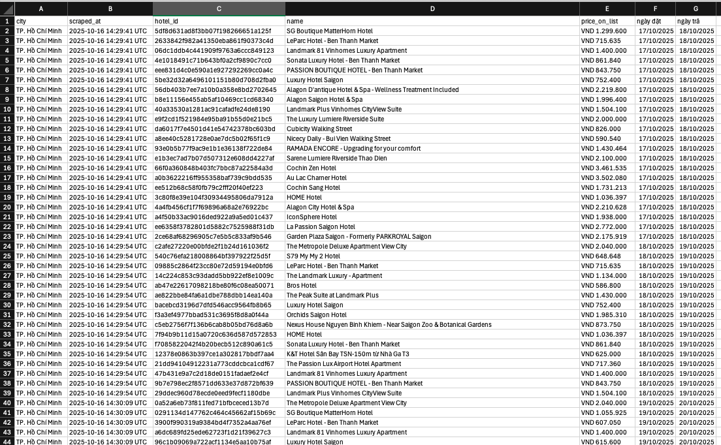
Figure 1: Dataset

VII. ANALYSIS OF FACTORS AFFECTING HOTEL ROOM PRICES IN MAJOR TOURIST CITIES

1. Descriptive statistic

1.1. Objectives and Significance of Descriptive Statistics
The objective of the descriptive statistics in this study is to summarize and identify the overall characteristics of hotel room price data, while also providing a foundation for more advanced quantitative analyses in the following sections (Pearson correlation, ANOVA, and multiple regression).
Specifically, this section aims to:
- Analyze the distribution of hotel room prices (VND/night) and determine central tendency measures such as the mean and median, as well as assess variability through the standard deviation (std), interquartile range (IQR), and coefficient of variation (CV).
- Compare the average room prices by hotel rating and by tourist city, thereby evaluating differences and pricing trends among hotel categories.
- Visualize data patterns through graphical representations to illustrate price trends and dispersion levels, enabling the identification of patterns, potential trends, and insights for subsequent research hypotheses.
Descriptive analysis provides researchers with a comprehensive overview of the dataset, helps understand the structure of the hotel market, and verifies the reliability and consistency of the data after the preprocessing phase.

1.2. Overview of Descriptive Statistics
After data cleaning and standardization, the dataset comprises 17,225 valid observations on hotel room prices across major tourist cities in Vietnam.
The room price variable (price_on_list) was standardized to Vietnamese Dong (VND) per night, where one unit in the dataset corresponds to 1,000 actual VND.
All missing values, incorrectly formatted entries, and negative prices were removed to ensure data accuracy and reliability.
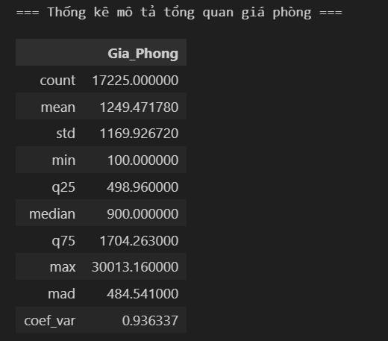
Figure 2 Overview of Descriptive Statistics for the Variable “Room Price (VND/night)

Analysis and Discussion
The average room price across the entire sample is 1,249,000 VND per night, while the median is only 900,000 VND per night.
This discrepancy indicates a right-skewed price distribution, meaning that most hotels have lower prices than the average, but a small number of high-end hotels with very high rates pull the mean upward.
The large standard deviation (1.17 million VND) and coefficient of variation (CV = 0.94) reflect a high degree of variability among hotel segments.
The interquartile range (IQR = 499,000 – 1,704,000 VND) shows that 50% of hotels fall within the mid-range group, whereas hotels priced above 5 million VND per night represent outliers.
Conclusion:
The hotel room price distribution in Vietnam is uneven and clearly right-skewed, reflecting a distinct segmentation between budget, mid-range, and luxury hotels.

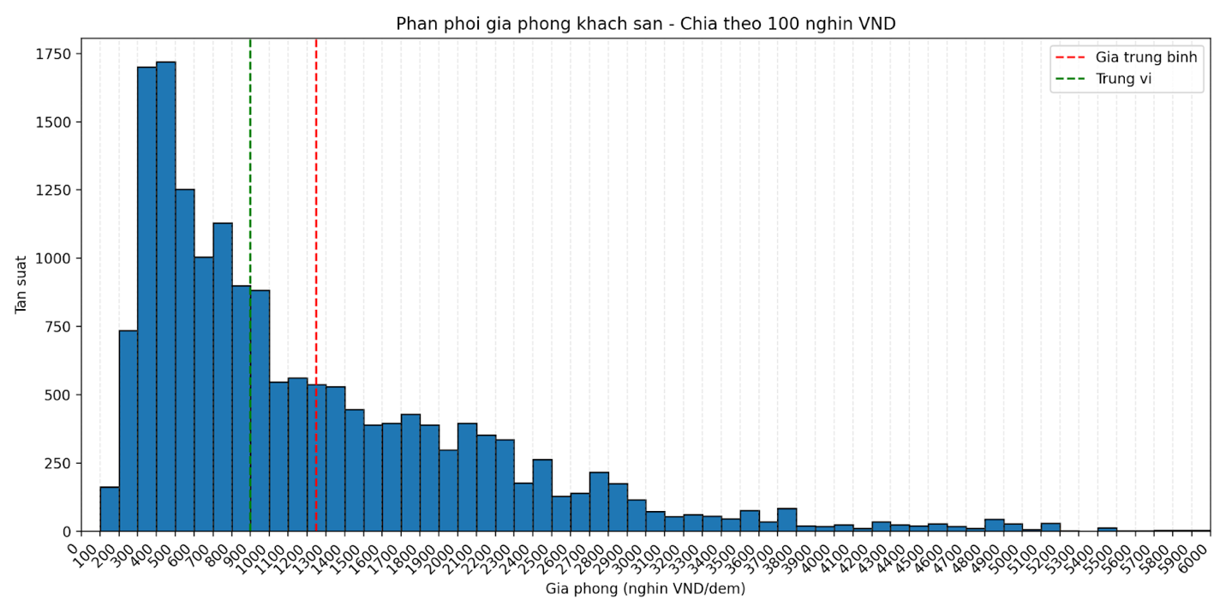

Description:
The histogram above illustrates the distribution of room prices across all 17,225 observations.
Most hotels have prices below 2 million VND per night, while prices above 10 million VND per night account for a very small proportion.
This creates a long right tail, a typical feature of right-skewed distributions in real-world hotel pricing data.
Analysis and Discussion:
The room price distribution shows a clear right-skewed pattern, indicating a significant disparity among hotel segments.
The right tail reflects the presence of a small number of high-end hotels (4–5 stars or resorts) with exceptionally high prices, which pull the mean upward compared to the median.

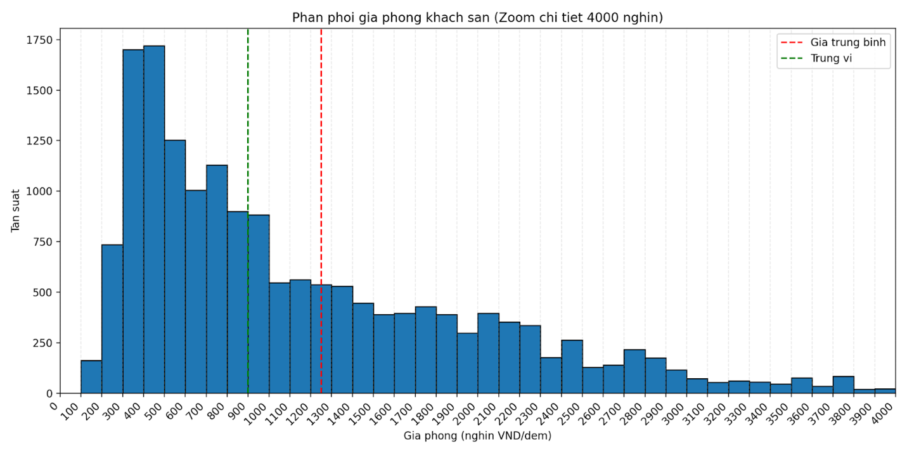

Description:
The histogram above limits the X-axis to the range of 0–4 million VND per night, allowing a clearer visualization of the most common price range among hotels in the dataset.
Analysis and Discussion:
When restricting the X-axis to 4 million VND per night, it becomes evident that the majority of hotels fall within the 0–5 million VND range, with the highest frequency concentrated between 500,000 and 2,000,000 VND per night.
At the same time, the histogram still retains the right-hand tail, representing high-end hotels with significantly higher prices, highlighting the clear price stratification between budget and luxury segments.

1.3. Descriptive Statistics by Group

1.3.1. By Hotel Star Rating

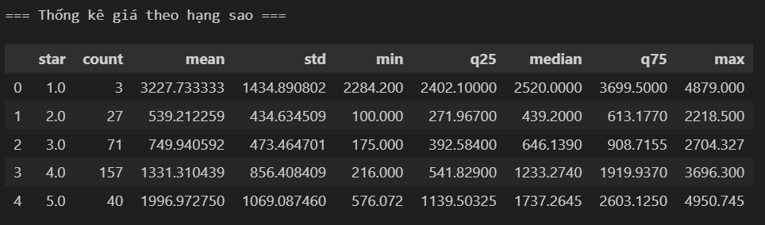
Figure 3 Table: Average Room Price by Hotel Star Rating

Analysis and Discussion
Room prices increase progressively with higher star ratings, indicating a positive relationship between service quality and average price levels.
Specifically:
- 2-star hotels: 539,000 VND/night
- 3-star hotels: 750,000 VND/night
- 4-star hotels: 1.33 million VND/night
- 5-star hotels: 1.99 million VND/night
The 1-star category shows an unusually high average price (3.23 million VND/night), which can be attributed to the small sample size (3 observations) and the presence of outliers.
The standard deviation increases with the number of stars, suggesting greater price variability in higher-end segments, influenced by factors such as brand reputation, location, and seasonality.
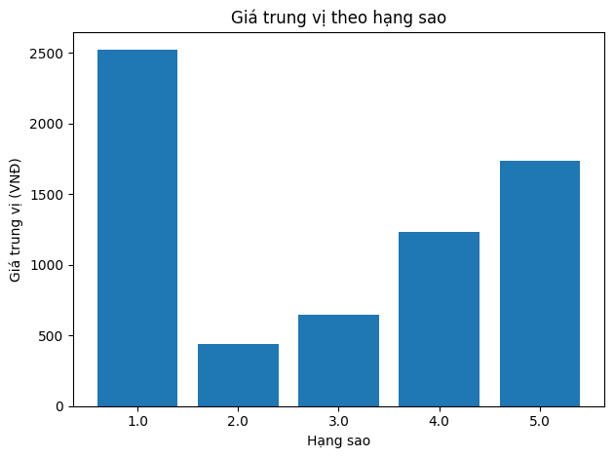
Figure 4 Median Room Price by Hotel Star Rating
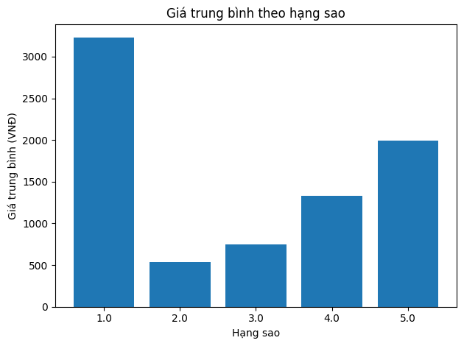
Figure 5 Average Room Price by Hotel Star Rating

Both charts indicate that the mean and median room prices increase consistently with the hotel star rating. The 4–5-star categories show significantly higher prices compared to the 2–3-star segments. The unusually high average price observed for the 1-star group confirms the influence of outliers and the small sample size in this category.

1.3.2. By City
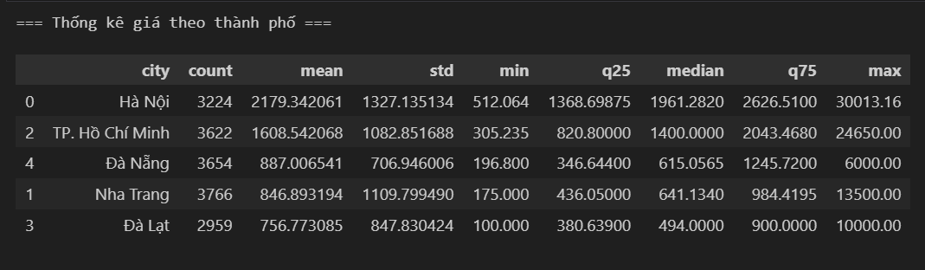
Figure 6 Table. Average Room Price Statistics by City
The average room price varies significantly across cities, reflecting the influence of geographical location, urban scale, and the unique characteristics of each tourism market.
Specifically:
- Hanoi: 2.18 million VND/night – the highest among the five cities, reflecting the dominance of business and international travelers, as well as a high proportion of 4–5-star hotels located in central areas.
- Ho Chi Minh City: 1.61 million VND/night – the second highest, with large price variation (standard deviation ≈ 1.08 million), indicating strong disparities between high-end and mid-range segments.
- Da Nang: 887 thousand VND/night – noticeably lower average price, consistent with its nature as a leisure destination characterized by strong competition among 2–3-star hotels.
- Nha Trang: 847 thousand VND/night – similar to Da Nang, but with a higher standard deviation (≈ 1.11 million) due to the presence of a few luxury seaside hotels and resorts with exceptionally high prices.
- Da Lat: 757 thousand VND/night – the lowest, reflecting a market structure dominated by homestays and budget hotels catering primarily to domestic tourists.
Overall, room prices tend to decrease from Hanoi → Ho Chi Minh City → Da Nang → Nha Trang → Da Lat, highlighting the strong influence of economic–tourism factors and hotel segmentation structures.
The standard deviation in Hanoi and Ho Chi Minh City exceeds 1 million VND, indicating high price dispersion in these major metropolitan areas, where international luxury chains coexist with small local lodgings. In contrast, resort destinations such as Da Nang, Nha Trang, and Da Lat exhibit more stable and concentrated pricing, mostly within the range of 500,000–1,000,000 VND per night.
The distribution of room prices is illustrated in the figure below.
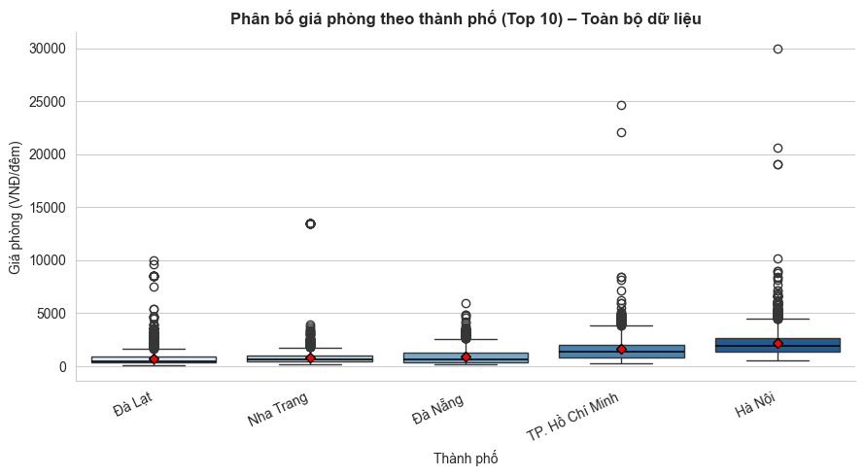
Figure 7 Distribution of room prices by city – Full dataset

Analysis and Discussion
This chart expands the Y-axis to display the full price range, including extreme values (above 10–30 million VND per night), which correspond to luxury hotels or resorts.
In most cities, the median line lies below the mean, indicating a clearly right-skewed distribution: the majority of hotels cluster in the lower price range, while a few high-end properties with very high prices pull the average upward.
Hanoi and Ho Chi Minh City exhibit the longest right tails, reflecting strong price variation and a wide range of hotel segments. Outlier points above 20 million VND per night represent international hotel chains or premium 5-star resorts.
Among resort-oriented destinations (Da Nang, Nha Trang, Phan Thiet, Vung Tau), the right tails are also present but shorter—suggesting that while luxury hotels exist, they account for a smaller share, and the overall price level remains concentrated in the mid-range segment.
By displaying the complete dataset, this figure clearly illustrates the presence of a long right tail in the room price distribution, highlighting the significant disparity between different market segments.
Insights from the Figure: Distribution of Room Prices by City – Full Dataset
- The room price distribution in all cities is strongly right-skewed (mean > median), indicating the existence of a group of high-end hotels with exceptionally high prices.
- Hanoi and Ho Chi Minh City are the most clearly multi-segmented markets, simultaneously featuring budget and luxury segments with the largest price disparities across the entire sample.
- The presence of multiple extreme values (>10–20 million VND/night) in major cities reflects the expansion of the high-end segment, which raises the overall average price above the rest of the market.
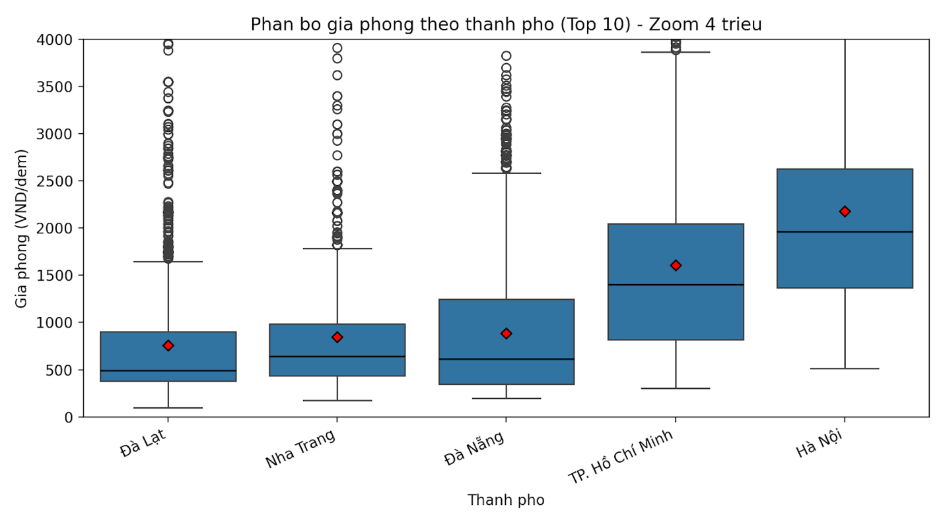
Figure 8 Distribution of Room Prices by City – Limited to Below 10 Million VND
Analysis and Discussion
The boxplot in this figure illustrates the distribution of hotel room prices across the 10 cities with the highest number of hotels in the dataset, with the Y-axis limited to 0–10 million VND/night, highlighting the most common price ranges.
Hanoi and Ho Chi Minh City belong to the group with the highest mean and median prices, reflecting the characteristics of large urban markets catering primarily to business and international travelers. These two cities also show wide interquartile ranges (IQRs) and numerous outliers above 5 million VND/night, indicating the coexistence of multiple segments, from budget to high-end hotels.
Da Nang, Nha Trang, and Da Lat have significantly lower medians, with most hotels priced between 0.5–1.5 million VND/night. The narrow IQRs suggest that room prices in these cities are stable and less volatile, due to strong competition in the mid-range and budget segments.
Phan Thiet, Vung Tau, and Hue fall in the mid-range group, with average prices around 1–3 million VND/night, representing smaller resort destinations or locations with a relatively stable year-round demand.
Limiting the chart to ≤10 million VND/night allows readers to clearly observe the concentrated price range, while still displaying the right tail (luxury hotels above 5 million), facilitating a visual comparison of common price levels across cities.
Insights from the Figure: Distribution of Room Prices by City – Limited to Below 10 Million VND
  - Clear Price Segmentation According to Market Characteristics:
- Hanoi and Ho Chi Minh City: high-end segments, with high average prices and strong price variability.
- Da Nang, Nha Trang, Da Lat: mid-range to budget segments, with lower and more stable prices.
  - Price variability (IQR and outliers) increases with urban scale → the larger the city, the more multi-segmented the market.
  - The most common price range in the Vietnamese hotel market is 0.5–2 million VND/night, accounting for the largest proportion of the entire dataset.

1.3.3. By Customer Rating
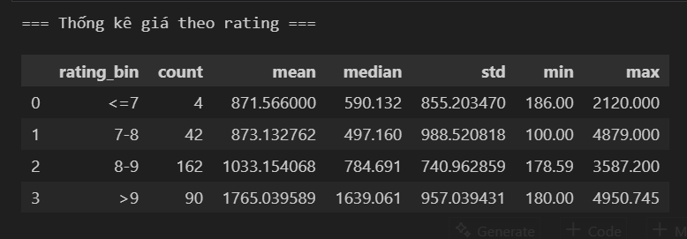
Figure 9 Table: Average Room Prices by Customer Rating (Rating)
Analysis and Discussion
The statistical results show that room prices tend to increase with customer ratings, reflecting a positive relationship between perceived service quality and average price.
- Hotels with the highest ratings (>9 points) have an average price of 1.76 million VND/night, nearly double the 8–9 point group and twice the 7–8 point group. This indicates that hotels achieving high customer satisfaction can set higher prices while maintaining demand, as consumers are willing to pay more for a better experience.
- The 8–9 point range marks the threshold where prices start to rise noticeably, from 873,000 to 1,033,000 VND/night. This difference (~18%) demonstrates the economic impact of online reviews, showing that even a one-point increase in rating can significantly boost the average room price without negatively affecting competitiveness.
- Hotels with lower ratings (≤8 points) have relatively low average prices (~870,000 VND/night) and medians around 500,000–600,000 VND, indicating that the budget segment dominates. Many properties in this group are likely guesthouses or small hotels, focusing on lower prices rather than premium experiences.
- The standard deviation increases with rating (from 740,000 up to nearly 1 million VND), showing that high-end hotels exhibit greater price dispersion, reflecting diversity in location, brand, and additional services among well-rated hotels.
Overall, customer rating is a key indicator of reputation and service quality. High-rated hotels generally position themselves in the premium segment, targeting guests with higher income and expectations, allowing them to maintain prices above the market average. Conversely, lower-rated hotels often compete primarily through lower pricing to attract customers.
From a data perspective, these results support the hypothesis that customer ratings positively affect room prices, and the Rating variable should be considered an important independent factor in regression models or price forecasting analyses in subsequent steps.

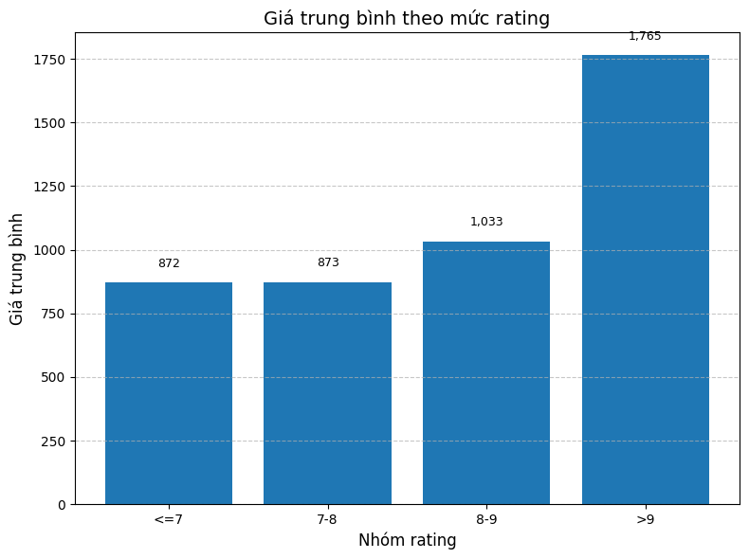
Figure 10 Distribution of Room Prices by Customer Rating

1.3.4. By Distance to City Center
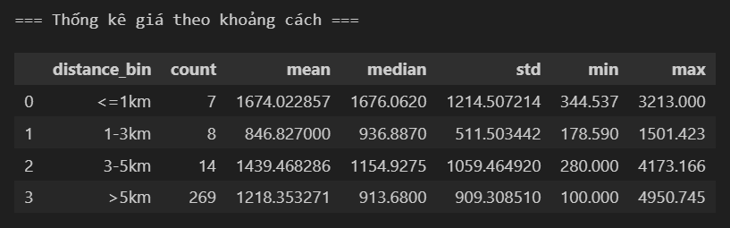
Figure 11 Table: Average Room Price by Distance to City Center
Analysis and Discussion
The statistical results indicate that room prices vary significantly according to distance from the city center.
- Hotels located within a ≤1 km radius have the highest average price (1.67 million VND/night), reflecting the premium of central locations and a concentration of 4–5 star hotels. This area experiences stable demand from business and international travelers, resulting in high average prices and substantial variability (σ ≈ 1.21 million).
- The 1–3 km range has the lowest average price (~846,000 VND), mainly consisting of mid-range and budget hotels, competing on price to attract domestic tourists.
- The 3–5 km zone shows a price increase (~1.44 million VND), likely due to the presence of resorts or coastal hotels, which, despite being farther from the city center, remain attractive because of scenic views and privacy.
- Hotels >5 km from the center have an average price of 1.22 million VND/night, slightly lower than the 3–5 km range, reflecting the general downward trend in price with increasing distance when location advantages are absent.
Overall, distance strongly affects room prices, but not linearly:
- Central locations have the highest prices,
- Near-central areas are the cheapest,
- Farther areas with special advantages (e.g., near the beach) can still maintain high prices.
These results indicate that location should be considered together with geographic features (beach, city center, tourist area) in subsequent analytical models.
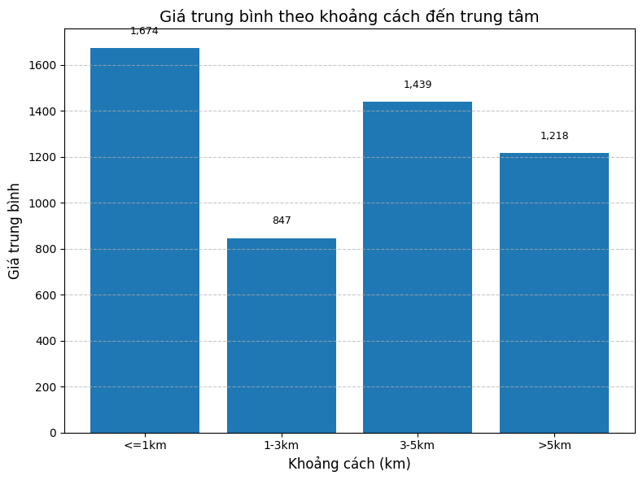
Figure 12 Distribution of Room Prices by Distance to City Center

2. Correlation Analysis
2.1 Objective
To determine the direction and strength of the linear relationship between room price (VND/night) and the quantitative variables: star rating (star), customer rating (avg_rating), and distance to city center (distance_to_center). The results are used to guide variable selection for subsequent tests and regression models.
2.2 Data and Methodology
The sample used for the analysis consists of 298 valid observations, with all columns in float64 format.
The Pearson correlation coefficient (r) is calculated between price_on_list and each quantitative variable, with p-values reported to assess statistical significance (threshold = 0.05).
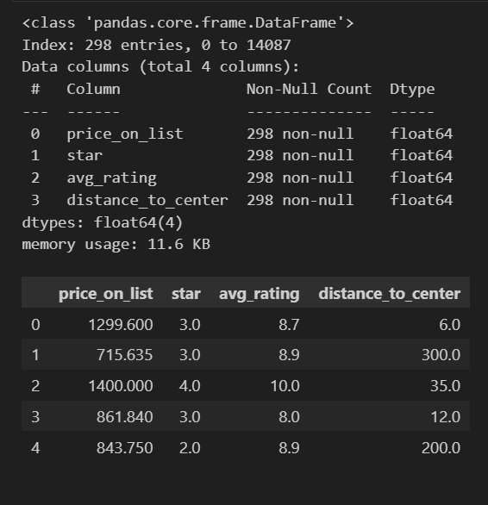
Figure 13 Snapshot of Data Used for Pearson Correlation Analysis

Results
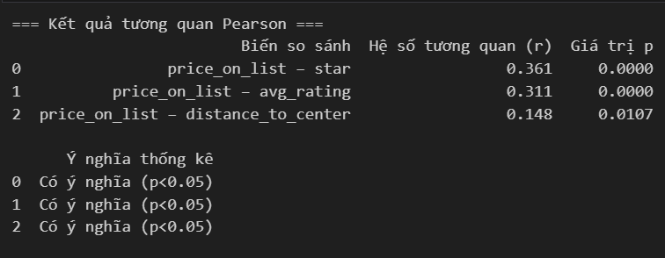
Figure 14 Pearson Correlation Results (r and p-values)

2.4 Analysis and Discussion
- Star Rating ↔ Room Price (r = 0.361, p < 0.05):
Moderate positive correlation; hotels with more stars tend to charge higher prices. This relationship is consistent with the descriptive results by star rating in Section 1.3.1.
- Customer Rating ↔ Room Price (r = 0.311, p < 0.05):
Moderate positive correlation; higher reputation or better guest experience allows hotels to set higher prices.
- Distance to City Center ↔ Room Price (r = 0.148, p < 0.05):
Weak positive correlation in this sample. The slight positive result suggests that some hotels farther from the center (e.g., resorts or beachfront properties) still maintain high prices, weakening the assumption that “further from the center means cheaper.” This relationship may be non-linear and vary by city, so further analysis with city-level grouping or interaction terms in regression models is recommended.
Short Conclusion:
All three quantitative variables show statistically significant linear relationships with room price. Star rating and customer rating have a positive impact, while distance has a weak positive effect (possibly due to special locations such as beaches or resorts). These results provide a basis for selecting variables for the multiple regression model in the next section.
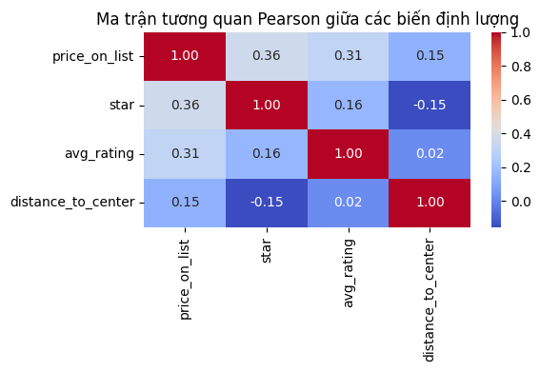
Figure 15 Pearson Correlation Matrix Among Quantitative Variables

3. ANOVA Test
3.1 Objective and Testing Method
The purpose of this analysis is to examine whether the average listed room price differs among hotel star-rating groups.
Specifically, the study investigates whether the hotel star classification (1-star, 2-star, 3-star, 4-star, 5-star) affects the average price listed on booking platforms.
- Dependent variable: price_on_list (daily listed price)
- Independent variable: star (hotel star rating)
The method applied is one-way ANOVA, which determines whether the mean prices among different star groups differ statistically significantly.
If the ANOVA results indicate overall differences, a Tukey HSD post-hoc test will be conducted to identify which specific groups differ from each other.

3.2 ANOVA Test Results
After removing invalid values (such as zero prices or hotels without star ratings), the remaining dataset includes five valid star groups: 1, 2, 3, 4, and 5 stars.
Table: Number of Hotels by Star Group
Star Rating | Number of Hotels
1 | 3
2 | 27
3 | 71
4 | 157
5 | 40

ANOVA Test Results:
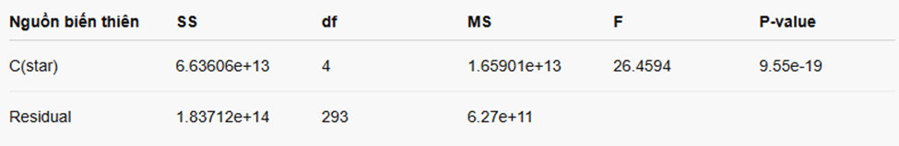
- F-statistic: 26.4594
- F-critical (α = 0.05): 2.4025
- p-value: 9.55 × 10⁻¹⁹ < 0.05
ANOVA Conclusion:
- There is a statistically significant difference in average room prices among the star-rating groups (p < 0.05).
- This indicates that at least one star group has a mean price that differs from the others.

3.3 Tukey HSD Post-hoc Test (Manual Calculation)
Since the ANOVA results indicate an overall difference, we proceed to identify which star groups differ from each other using the Tukey HSD test.
- Threshold for statistically significant difference:
HSD=398,147.67 VNDHSD = 398,147.67 \text{ VND}HSD=398,147.67 VND
- If the difference between two group means exceeds 398,147.67 VND, it is considered statistically significant.
- If the difference is smaller, there is insufficient evidence to conclude a significant difference.
Average Room Price by Star Group:
Star Rating | Average Price (VND)
1 | 3,227,733
2 | 539,212
3 | 749,941
4 | 1,331,308
5 | 1,906,973

Preliminary Remarks:
- The average room price generally increases with star rating, with a few minor exceptions.
- However, the 1-star group shows an unusually high average price, even exceeding the 4- and 5-star groups.
- This anomaly is likely due to the small sample size of 1-star hotels (n = 3), where a few extreme values can significantly inflate the mean.
Pairwise Comparison Using Tukey HSD (HSD = 398,147.67 VND):
Group 1 | Group 2 | Average Difference (VND) | Conclusion
1 | 2 | 2,688,521 | ✅ Significant Difference
1 | 3 | 2,477,792 | ✅ Significant Difference
1 | 4 | 1,896,425 | ✅ Significant Difference
1 | 5 | 1,320,760 | ✅ Significant Difference
2 | 3 | 210,729 | ❌ No Significant Difference
2 | 4 | 792,096 | ✅ Significant Difference
2 | 5 | 1,367,761 | ✅ Significant Difference
3 | 4 | 581,367 | ✅ Significant Difference
3 | 5 | 1,156,832 | ✅ Significant Difference
4 | 5 | 575,465 | ✅ Significant Difference

Statistically significant group pairs:
Groups 1 & 2, 1 & 3, 1 & 4, 1 & 5
Groups 2 & 4, 2 & 5, 3 & 4, 3 & 5, 4 & 5
Only the pair (2 & 3) is not significantly different, meaning 2-star and 3-star hotels have relatively similar average prices.

3.4. Insights and Summary
Insight 1: Prices increase with star rating → consistent with market theory
The HSD results confirm that hotel prices tend to rise with star rating; higher-class hotels have higher average listed prices.
This aligns with the service-quality-based pricing model, as 4–5 star hotels offer more amenities such as swimming pools, spas, restaurants, and airport transfer services.
Insight 2: 2–3 star hotels are not significantly different → direct competition
The price gap between 2-star and 3-star hotels is not large enough for customers to perceive a clear distinction, indicating:
- The budget and mid-range segments strongly overlap in pricing.
- In practice (e.g., in tourist cities like Da Lat, Nha Trang, Da Nang), many small 3-star hotels charge only about 50,000–100,000 VND/night more than 2-star hotels.
→ This reduces the perceived difference in star rating; customers often choose based on location, user reviews, or actual photos rather than star classification.
Insight 3: 1-star hotels with high prices → possible data anomalies or regional characteristics
The unusually high average price for 1-star hotels (≈ 3.2 million VND/night) suggests that:
- Some 1-star hotels are located in city centers or premium tourist areas, which drives prices up.
- There may be misclassification (e.g., unverified properties temporarily labeled as 1-star).
This emphasizes that online star ratings do not always reflect the official standards set by Vietnam’s Ministry of Culture, Sports and Tourism.
Insight 4: Significant price increase in 4–5 star hotels → clear premium segment
4- and 5-star hotels show a strong increase in average price (≈ 1.3–1.9 million VND/night).
This clear difference reflects the price barrier of the premium segment, where luxury hotels have much higher investment and operational costs.
In Vietnam, 4–5 star hotels often belong to international chains (e.g., Accor, Marriott, Vinpearl), so listed prices also follow global standards.
From the overall test results, we can conclude:
- There is a statistically significant difference in the average prices of hotels by star rating (p < 0.05).
- Prices increase progressively with star rating, particularly evident in the 3–5 star groups.
- The 1-star group is clearly different from all other groups.
- The 2- and 3-star groups have relatively similar average prices → the 2–3 star segment is the most competitive, where prices do not differ significantly.
- The 4- and 5-star groups have higher average prices, and the differences compared to lower-rated groups are statistically significant.
Conclusion:
The average listed price rises with the hotel’s star level, and this difference is statistically significant at the 5% level.
This demonstrates that star rating is a significant factor affecting hotel pricing.
4. Multiple Regression
4.1. Objective and Methodology
The objective of this analysis is to determine the impact of each factor on the listed room price (price_on_list) of hotels using a multiple regression model.
Specifically, the study aims to examine whether basic characteristics, location, and customer experience factors influence the average listed price.
- Dependent variable: price_on_list (daily listed price).
- Independent variables:
  - Basic characteristics: star (number of stars), avg_rating (average customer rating).
  - Location: distance_to_center (distance to city center), city (City).
  - Customer experience: service (staff service), facility (facilities), cleanliness (cleanliness), comfort (comfort), value (value for money), location (location).
Method: Multiple Regression. This model estimates the relationship between the continuous dependent variable (price_on_list) and a set of independent variables, allowing us to determine the importance and direction of influence of each factor on hotel room prices.
4.2. Overview of the Multiple Regression Model
The model is designed to assess the effect of factors such as star rating, average rating, distance to the city center, service-related criteria (service, facility, cleanliness, comfort, value, location), and city on the listed hotel room prices.
General Regression Equation:
Where:
- βi= regression coefficient of each independent variable.
- ε = random error term.
4.3. Model Results
Regression Statistics Table
Parameter | Value
Multiple R | 0.7788
R Square | 0.6065
Adjusted R² | 0.5885
Standard Error | 575,375.23
Observations | 298

Explanation:
- R Square = 0.6065: The model explains 60.65% of the variance in room prices based on the independent variables.
- Adjusted R² = 0.5885: After adjusting for the number of variables, the model still maintains a fairly good explanatory power → moderate to good fit.
- Multiple R (correlation coefficient) = 0.7788: Indicates a fairly strong relationship between the input variables and room prices.
ANOVA table analysis:
Variable | F-Statistic | P-value | Conclusion (p<0.05)
C(city) | 31.7542 | 7.37851e-22 | ✅ Highly Statistically Significant
star | 34.6208 | 1.12966e-08 | ✅ Highly Statistically Significant
avg_rating | 0.297994 | 0.585573 | ❌ Not Statistically Significant
distance_to_center | 8.33957 | 0.00417848 | ✅ Statistically Significant
service | 7.38022 | 0.00700067 | ✅ Statistically Significant
facility | 2.59847 | 0.108082 | ❌ Not Statistically Significant
cleanliness | 3.75741 | 0.0535681 | ❌ Not Statistically Significant
comfort | 12.1324 | 0.000573954 | ✅ Statistically Significant
value | 22.2067 | 3.84433e-06 | ✅ Statistically Significant
location | 1.2478 | 0.26492 | ❌ Not Statistically Significant

Observation:
→ The variables city, star rating, distance to the city center, service, comfort, and value for money have the strongest impact on room prices.
Variables such as average rating, facilities, cleanliness, and location have smaller effects and are not statistically significant (p > 0.05).
Regression Coefficients Table:
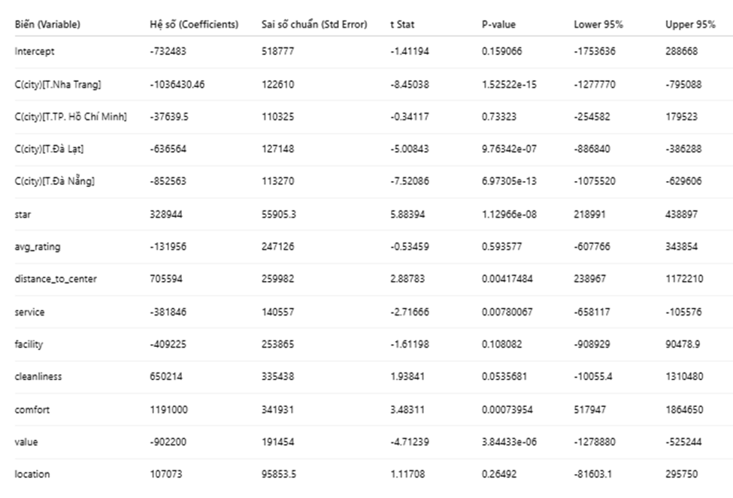
Comments:
The regression results show that the following variables are statistically significant (p < 0.05) for the listed price:
- C(city) — specific cities: The coefficients for Nha Trang = −1,036,430 (p < 0.001), Da Lat = −636,564 (p < 0.001), and Da Nang = −852,563 (p < 0.001) are all negative and statistically significant, indicating that hotel prices in these cities differ significantly from the reference group (the price difference is represented by the negative coefficients above, holding other variables constant). In contrast, Ho Chi Minh City (p = 0.733) is not statistically significant, meaning there is no sufficient evidence to conclude a meaningful price difference compared to the reference group.
- Star (number of stars): Coefficient = +328,944 (p < 0.001) — significant; each additional star is associated with an average increase of ~328,944 VND in the listed price, holding other factors constant.
- Distance_to_center (distance to city center): Coefficient = +705,594 (p = 0.004) — significant; the positive coefficient indicates a potential relationship between distance and price (holding other factors constant). Each additional kilometer from the city center is associated with an average price increase of 705,594 VND, possibly due to resorts or high-end hotels located farther from the center.
- Service (service rating): Coefficient = −381,846 (p = 0.0078) — significant; the negative coefficient suggests an inverse relationship between service score and price in this sample (holding other factors constant).
- Other variables (avg_rating, facility, cleanliness, value, location) have p-values > 0.05 and are therefore not statistically significant in the current model — meaning there is insufficient evidence to assert that they are related to the listed price when other variables are controlled.
- Intercept: p = 0.159 → not statistically significant (technically included for model purposes).

4.4. Model Adjustment
Reason for adjustment and method:
In the initial multiple regression model, several variables had p-values > 0.05, meaning they were not statistically significant in explaining hotel room prices. Additionally, the Adjusted R² was only about 0.5885, indicating that the model’s fit was moderate.
Therefore, the team refined the model using Stepwise Backward Elimination — a technique for selecting optimal independent variables by removing insignificant ones to improve model accuracy (Adjusted R²).
Backward Elimination procedure:
- Start with all independent variables included in the regression model.
- At each step, check the p-value of each variable to assess statistical significance.
- The variable with the highest p-value > 0.05 is considered for removal. However, removal is only performed if it increases or does not significantly reduce the Adjusted R².
- Repeat this process until all remaining variables are statistically significant or further removal does not improve the model.
This process was automated using Python, ensuring objectivity, speed, and efficiency in identifying the optimal model. Compared to manual elimination, this approach reduces subjective errors and ensures the final model balances goodness-of-fit (high Adjusted R²) with simplicity (fewer redundant variables).
Results after model adjustment:
After examining the p-values of all variables in the initial model, variables with p-value > 0.05 were removed to improve Adjusted R². Specifically:
- C(city)[T.Ho Chi Minh] (p = 0.7332) was removed.
- avg_rating (p = 0.5936) was removed.
- location (p = 0.2649) was removed.
The model was then re-estimated using the remaining variables:
['city', 'star', 'distance_to_center', 'service', 'facility', 'cleanliness', 'comfort', 'value']
Effectiveness after adjustment:
The adjusted model is expected to have higher Adjusted R², improved statistical significance of variables, and a more streamlined set of predictors without losing explanatory power.
Statistic | Value
Multiple R (Correlation Coefficient) | $0.7788$
R Square (Coefficient of Determination) | $0.606$
Adjusted R Square | $0.591$
Standard Error | $575,375.23$
Observations (Sample Size) | $298$

R² = 0.606, Adjusted R² = 0.591
→ This indicates that the model explains 59.1% of the variance in room prices, which is slightly higher than the initial model (Adjusted R² = 0.5885).
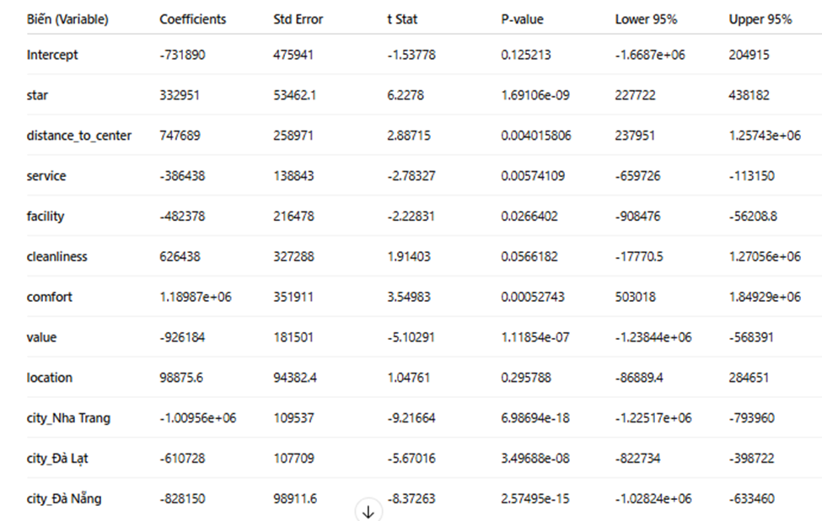
Comments on the results of the adjusted multiple regression model:
- Statistically significant variables (p < 0.05) include: Star, distance_to_center, comfort, value, and three city dummy variables (city_Nha Trang, city_Đà Lạt, city_Đà Nẵng). These factors have a strong influence on hotel listing prices.
- Variables with no statistical significance (p > 0.05) include: service (p = 0.0057), facility (p = 0.0266), cleanliness (p = 0.056), and location (p = 0.295). However, completely removing these variables does not substantially improve Adjusted R², indicating they still contribute slightly to explaining the dependent variable.
- The Adjusted R² of the refined model is higher than the original model, showing that the adjusted model is more compact while maintaining good explanatory power.
Conclusion:
- The model reasonably represents the relationship between factors and hotel room prices:
  - Star has the strongest positive effect — higher-star hotels charge higher prices.
  - Distance to center shows a positive effect, suggesting that hotels in special locations or with good views can command higher prices even if located further from the city center.
  - Comfort and value significantly affect price, reflecting consumers’ willingness to pay more for higher-quality service.
- Conversely, service, facility, cleanliness, and location do not show statistically significant effects, possibly because rating differences between hotels are not large enough to create clear price differentiation.
- The city variables (Nha Trang, Đà Lạt, Đà Nẵng) have negative regression coefficients and are statistically significant, indicating a downward effect on listing prices. In other words, hotels in these cities tend to have lower average prices compared to the reference group.

VIII. Hotel Price Prediction using ARIMAX and LSTM

8.1 Problem Overview and Data
We forecast hotel room prices by check-in date at the individual-hotel level. The goal is to produce accurate multi-day forecasts (e.g., 30-day horizon) to support pricing analysis and reporting. We evaluate two complementary approaches: a statistical time series model (ARIMAX) and a deep learning sequence model (LSTM).
Data come from khach_san.xlsx, comprising 17,225 records across 298 hotels as we mention in VI/ Dataset. For each hotel we have multiple quoted prices for distinct check-in dates in the range 2025-10-17 to 2026-03-31 (166 days). Because price varies strongly by calendar factors (weekends, Tet period, summer months, and holiday seasons), we engineer calendar-based exogenous variables:
- Time features: month, day_of_week, week_of_year.
- Event/season flags: is_weekend, is_tet (Jan–Feb), is_summer (Jun–Aug), is_holiday_season (Apr, Sep).
We construct per-hotel time series by grouping by hotel name, sorting by check-in date, and aggregating multiple quotes per day (mean). For modeling, we:
- Filter hotels with sufficient observations (≥30 for ARIMAX; ≥50 for LSTM).
- Split chronologically into 80% train and 20% test.
- Evaluate via MAE (VND) and MAPE (%); MAPE supports comparison across hotels with different absolute price levels.

8.2 ARIMAX Modeling
Method summary ARIMAX extends ARIMA by incorporating exogenous regressors (X). For each hotel we fit a univariate price process with AR and MA terms and a first difference to remove trend, while conditioning on calendar/season flags:
- Endogenous: daily price (per hotel).
- Exogenous: is_weekend, is_tet, is_summer, is_holiday_season.
- No seasonal component (seasonal_order=(0,0,0,0)) due to limited time coverage (166 days insufficient for stable weekly or monthly seasonal estimation).
Why ARIMAX(2,1,1)? We performed a grid search over 18 (p,d,q) combinations: p∈{0,1,2}, d∈{0,1}, q∈{0,1,2} on multiple hotels (arimax_order_tuning.py). The order (2,1,1) achieved the best median MAPE (22.97%) across tested hotels and improved by 4.1% relative to the common baseline (1,1,1). Intuitively:
- AR(2) allows the model to look back two lags, which is beneficial when short weekly patterns exist (e.g., weekend price lifts) without committing to full seasonal components.
- I(1) removes drift/trend.
- MA(1) corrects short-term error autocorrelation. Given the short window per hotel and the strong calendar effects handled via regressors, (2,1,1) offered the best trade-off between bias and variance in our experiments.
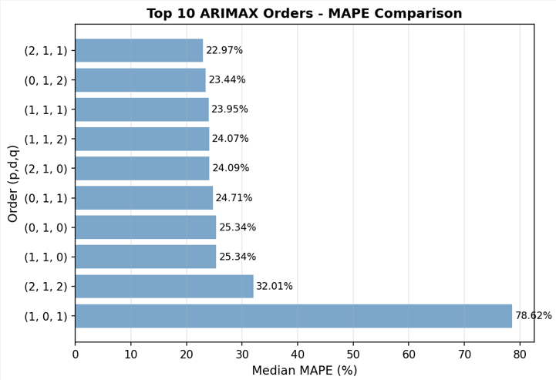
Figure 16 Grid search results: ARIMAX orders ranked by median MAPE

Training and evaluation We trained ARIMAX(2,1,1) separately for hotels meeting the ≥30 observation threshold (arimax_training.py). Each model is estimated with exogenous variables and evaluated on the last 20% of each hotel’s time series. We report per-hotel MAE and MAPE, and summarize medians across hotels.
Key results
- Grid search outcome (tuning stage): best overall order (2,1,1) with median MAPE = 22.97%.
- Batch training (20 hotels, summary in arimax_models/summary.txt): median MAPE ≈ 9.4%; best hotel MAPE ≈ 1.0%. Several stable hotels achieve low single-digit MAPE; hotels with highly volatile prices or sparse data can show high MAPE.
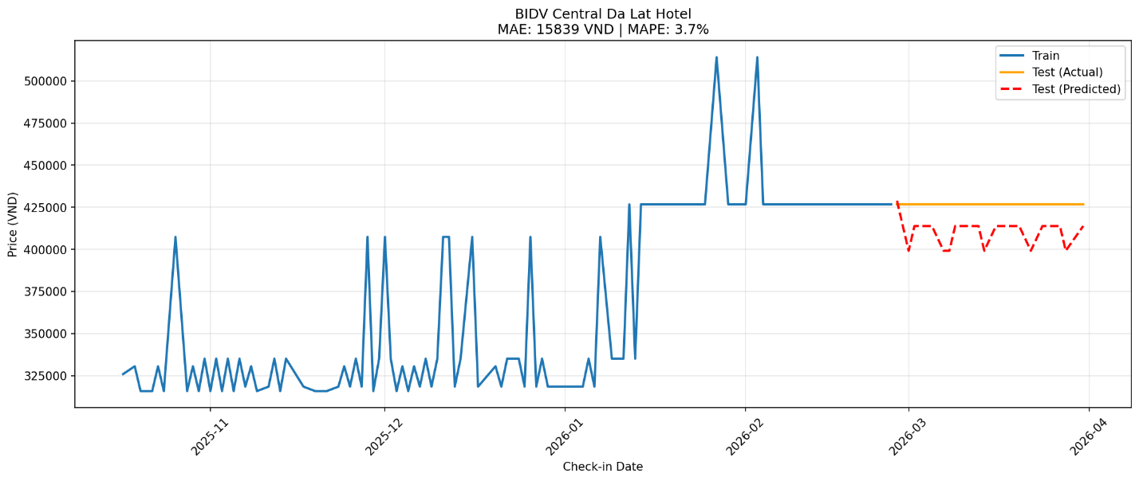
Figure 17 BIDV Central Da Lat Hotel: Train vs Test (Actual) vs Test (Predicted)

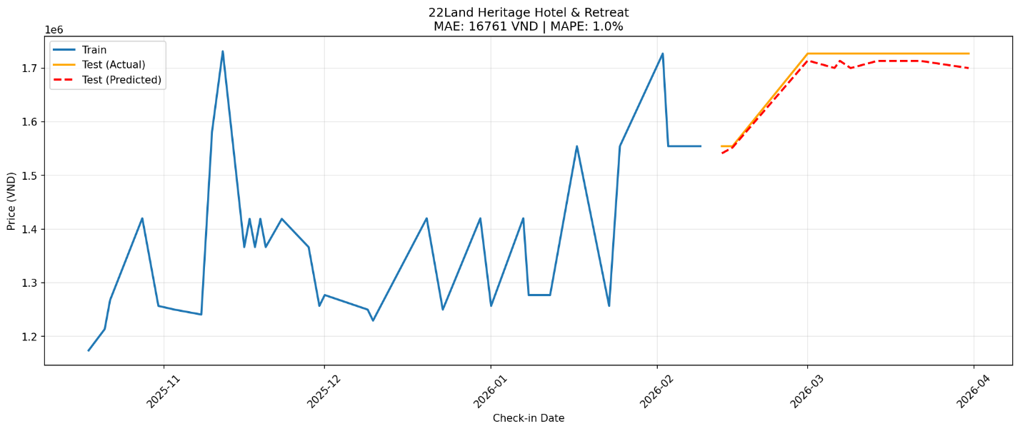
Figure 18 22Land Heritage Hotel & Retreat: Train vs Test (Actual) vs Test (Predicted)

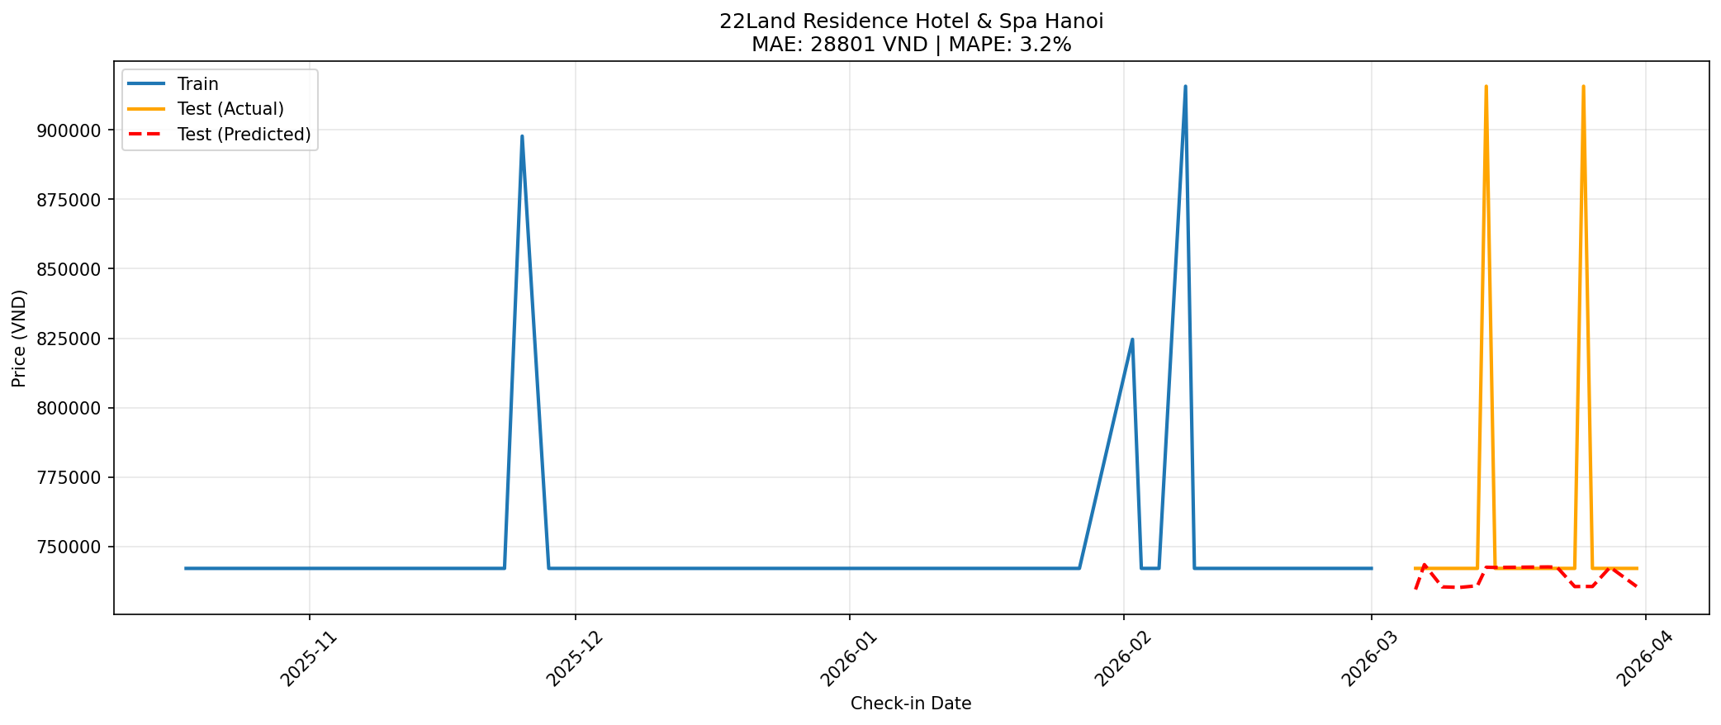
Figure 19 22Land Residence Hotel & Spa Hanoi: Train vs Test (Actual) vs Test (Predicted)

Practical interpretation
- ARIMAX models are fast to fit and interpretable: coefficients on exogenous indicators quantify weekend/Tet/summer effects.
- Excellent for hotels with shorter or relatively stable series where linear dynamics plus calendar effects capture most variation.
- Forecasts can be generated interactively or in batch (arimax_prediction.py), supporting 30-day horizons and beyond.

8.3 LSTM Modeling
What is an LSTM and how does it work? A Long Short-Term Memory (LSTM) network is a recurrent neural network (RNN) designed to learn patterns in sequential data while mitigating vanishing gradients. Each LSTM cell uses gates to control information flow:
- Input gate decides how much new information enters cell state.
- Forget gate decides how much past state to retain.
- Output gate controls what part of the cell state is exposed as hidden output. This gated mechanism enables LSTMs to capture both short- and medium-range temporal dependencies and non-linear relationships—ideal when price dynamics interact with calendar features in complex ways. Unlike ARIMAX (linear in parameters), LSTM can model non-linear interactions between time-lagged price behavior and exogenous features.
Model configuration and features
- Architecture (PyTorch): LSTM(64) → Dropout(0.2) → LSTM(32) → Dropout(0.2) → Dense(16) → Dense(1).
- Input window (sequence length): 30 days.
- Features per time step: price (target), is_weekend, is_tet, is_summer, is_holiday_season, month, day_of_week.
- Training per hotel with chronological split (80/20), batch_size=16, Adam lr=1e-3, early stopping with patience=5. Feature scaling (MinMax) is applied to stabilize optimization.
Evaluation and results We trained models for hotels with ≥50 observations (lstm_simple.py). Results are aggregated in lstm_outputs/lstm_results_summary.csv and summarized in README_LSTM.md.
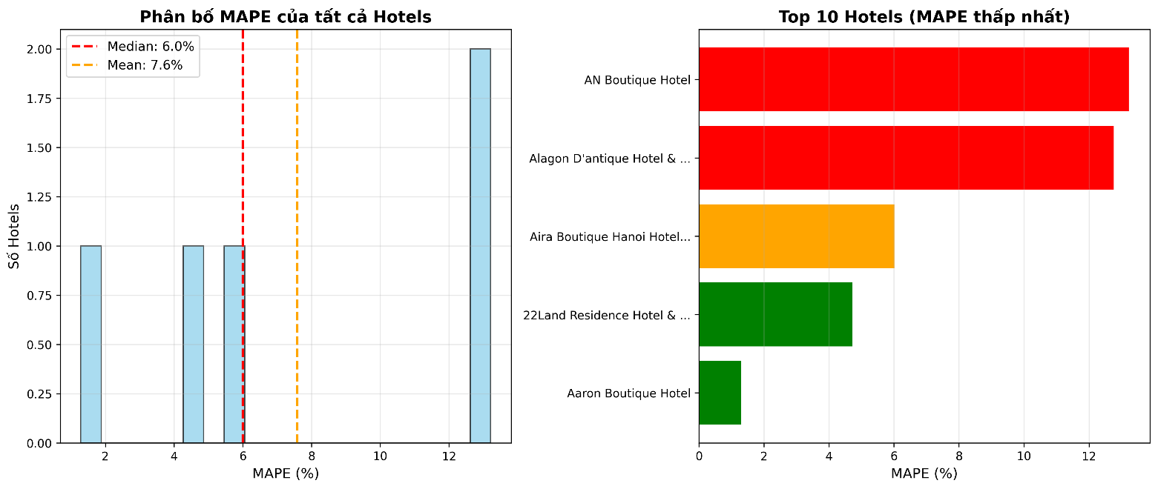
Figure 20 LSTM summary: MAPE distribution and Top 10 best hotels

- Representative per-hotel outcomes (from CSV):
  - Aaron Boutique Hotel: MAE ≈ 10,411 VND; MAPE ≈ 1.29% (77 observations).
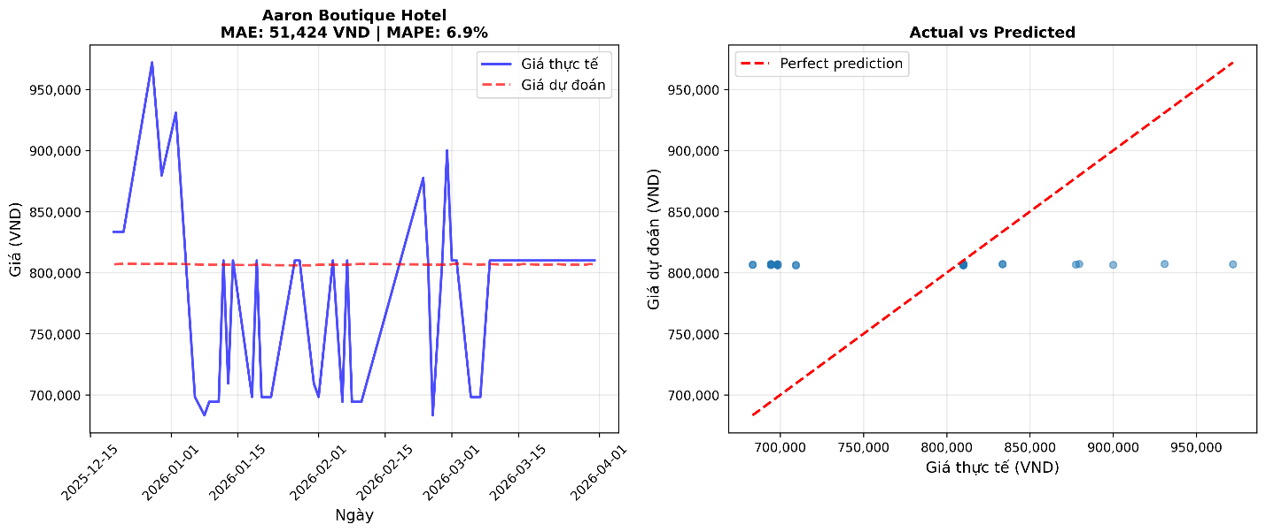
Figure 21 LSTM example — Aaron Boutique Hotel: Actual vs Predicted (test)
  - 22Land Residence Hotel & Spa Hanoi: MAE ≈ 38,497 VND; MAPE ≈ 4.71% (70 observations).
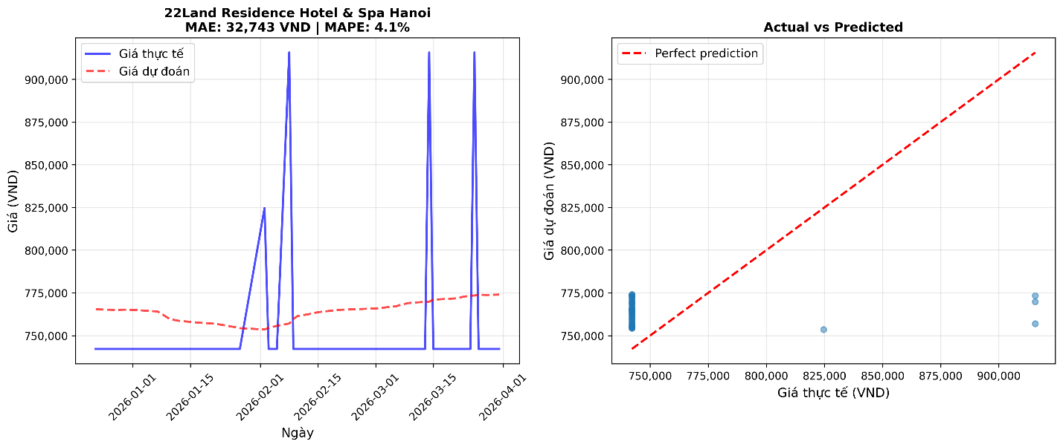
Figure 22 LSTM example — 22Land Residence Hotel & Spa Hanoi: Actual vs Predicted (test).
- Aggregate performance (from README_LSTM.md over a broader set): median MAPE ≈ 6.0% with best MAPE ≈ 1.3%, showing a notable improvement versus ARIMAX’s median ≈ 9.4% in our experiments.
- Visual comparisons (lstm_comparison_visualization.py) indicate strong alignment between actual and predicted series for high-quality models; scatter plots cluster closely around the diagonal.
Future forecasts. Beyond hold-out testing, we also generate multi-step forecasts for the next 30 days per hotel using the best LSTM model. The forecast output provides four panels: historical series with forecast overlay, a zoomed-in view of the forecast horizon, the distribution of predicted prices, and summary statistics. Figure 8.7 illustrates a 30-day forecast example.
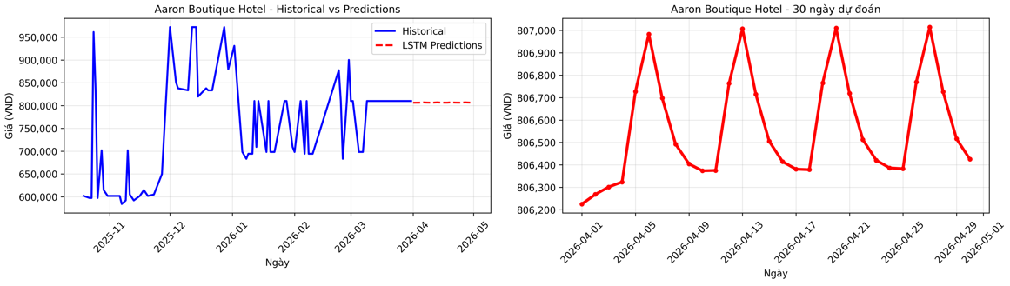
Figure 23 LSTM 30 day ahead forecast — Aaron Boutique Hotel: historical vs forecast, zoom in
Practical interpretation
- LSTM outperforms ARIMAX on average, particularly for hotels with richer data and more complex price dynamics where non-linear interactions matter.
- It demands more data per hotel and longer training time than ARIMAX, but yields higher accuracy and robust multi-step forecasts.

8.4 Comparative Discussion and Business Insights
Accuracy and stability
- Accuracy: LSTM achieves lower median MAPE than ARIMAX in our experiments (≈6.0% vs ≈9.4%). Best-case hotels for both methods can reach ≈1% MAPE, but LSTM is more consistently strong across hotels with enough data.
- Stability: ARIMAX can degrade on hotels with high volatility or scarce data; LSTM also degrades with very short series, but generally benefits more from added observations.
Interpretability and deployment
- Interpretability: ARIMAX has a clear story—AR and MA dynamics plus explicit exogenous coefficients (e.g., a positive weekend coefficient). LSTM behaves as a black-box but can be sanity-checked via feature ablations and residual analysis.
- Efficiency: ARIMAX trains quickly per hotel and is lightweight for rapid baselines and sensitivity analyses. LSTM incurs higher training time and maintenance but yields superior forecasts for decision support.
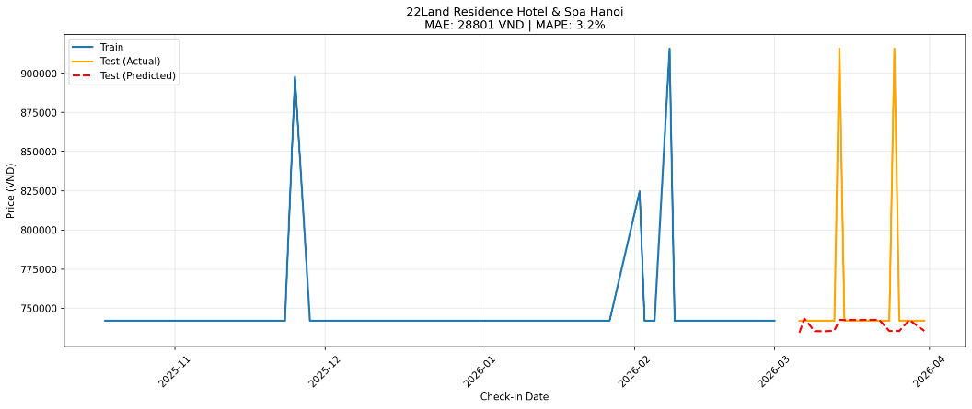
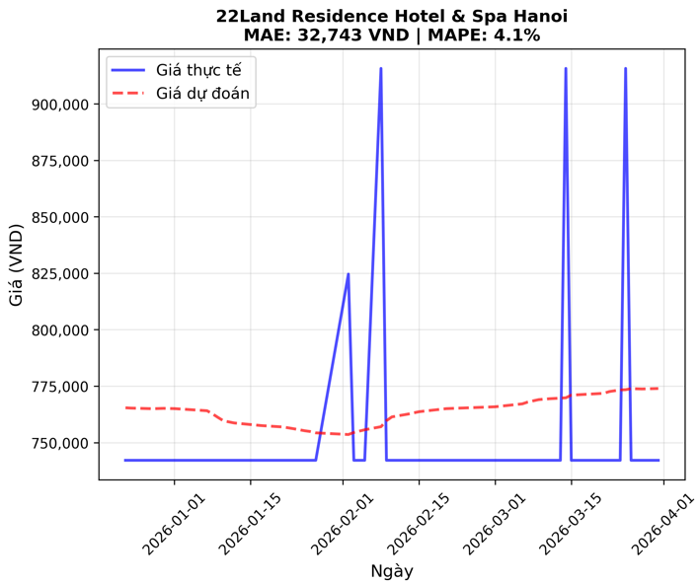
Figure 24 Method comparison for the same hotel: ARIMAX vs LSTM
When to use which
- Use ARIMAX when you need quick, interpretable baselines, have short series, or want explicit quantification of weekend/Tet/summer effects.
- Use LSTM when you have ≥50 observations and want best-in-class accuracy for multi-step forecasts, especially under non-linear dynamics.
Business insights from both models
- Weekend and peak seasons (Tet, summer) lead to consistent price lifts—both models detect these patterns.
- For capacity planning and promotional timing, forecasting 30 days ahead identifies expected peaks; dynamic pricing policies can be tested against forecasted lifts.
- Combining both approaches (ensemble or model selection by hotel) can maximize coverage and accuracy: ARIMAX for sparse/stable hotels; LSTM for richer/complex ones.

8.5 Limitations and Next Steps
Limitations
- Limited horizon coverage (166 days) restricts reliable seasonal modeling (no SARIMAX). Some hotels have few observations or outliers, inflating MAPE.
- LSTM hyperparameters were tuned pragmatically rather than exhaustively; additional tuning (sequence length 60, deeper layers, dropout schedule) could further improve accuracy.
- Feature set focuses on calendar effects; demand-side signals (occupancy rate, competitor prices, public holidays by exact date) are not yet included.
Next steps
- Data growth to ≥2 years per hotel to enable seasonal models (e.g., SARIMAX with weekly/monthly seasonality) and more reliable LSTM learning of long-range patterns.
- Feature expansion: detailed holiday calendar (e.g., 30/4, 2/9), days_to_tet, weather, occupancy rate, competitor_price.
- Automated model selection per hotel, or ensemble ARIMAX+LSTM blending (e.g., 0.6×ARIMAX + 0.4×LSTM) to capture both linear and non-linear regimes.
- End-to-end MLOps: artifact versioning, periodic retraining, and performance monitoring with alerting for drift/outliers.

IX. Summary and Overall Conclusion

1. Summary of Key Findings
Through the process of collecting, cleaning, and analyzing over 17,000 hotel price observations across major tourist cities in Vietnam, this study provides a comprehensive overview of the factors that influence the listed room price (price_on_list) on online booking platforms.
The main findings can be summarized as follows:
- The average room price of hotels in Vietnam mainly falls within the range of VND 0.5–2 million per night, indicating that mid-range hotels dominate the market.
- The price distribution is strongly right-skewed, meaning that most hotels are priced at the lower end, while a few luxury hotels with exceptionally high prices pull up the mean.
- By star rating, room prices increase consistently with hotel class – from about VND 539,000 (2-star) to nearly VND 2 million (5-star). The 1-star group shows abnormally high prices due to a small sample size and outliers.
- By city, prices are highest in Hanoi and Ho Chi Minh City, while Da Lat, Nha Trang, and Da Nang have lower averages, reflecting their tourism-oriented, leisure markets.
- By customer rating, hotels with ratings above 8.0 show significantly higher prices, suggesting that online ratings have measurable economic effects on hotel pricing.
- By distance to city center, hotels within ≤1 km have the highest prices, but those 3–5 km away also show high values due to beach resorts and scenic properties—indicating a nonlinear relationship between distance and price.
The ANOVA and Tukey HSD tests confirm that:
- There are statistically significant differences (p < 0.05) in average prices among hotel star groups.
- The 4–5-star groups differ significantly from 2–3-star hotels, while 2-star and 3-star groups do not differ notably, indicating direct competition in the mid-range segment.
The multiple regression analysis reveals that:
- The model explains ≈59% of price variation (Adjusted R² = 0.591).
- Statistically significant predictors include:
  - Star rating (Star) – positive and strongest effect.
  - Distance to city center – positive effect.
  - Comfort and Value for money – significant service-related factors.
  - City variables (Nha Trang, Da Lat, Da Nang) – negative coefficients, indicating lower average prices compared to the reference city.
- Other variables such as service, facility, cleanliness, and location show p-values > 0.05, meaning they do not have significant impacts in the current model.

2. Practical Implications
The findings of this study can support:
- Hotel managers in developing more accurate pricing strategies based on hotel class, location, and customer experience.
- Online booking platforms in optimizing price recommendations and revenue forecasting models.
- Tourism authorities and policymakers in understanding the structure and segmentation of hotel prices across different regions in Vietnam.

3. Limitations and Future Research Directions
- The dataset reflects a single point in time and does not capture seasonal or temporal variations.
- Certain qualitative factors (e.g., brand reputation, room type, refund policies) were not included.
- Future studies could apply nonlinear regression or machine learning models (e.g., Random Forest, Gradient Boosting) to achieve better price prediction accuracy and interpretability.

4. Overall Conclusion
This study confirms that star rating, location, and customer experience quality are key determinants of hotel room prices in Vietnam.
The regression model demonstrates that hotel pricing is not random, but rather shaped by service quality, location advantages, and perceived value — providing valuable insights for both researchers and practitioners in the hospitality and tourism sectors.

X. References
1. Descriptive Analysis (Right-skewed price, city-based distribution)
Hung, W.-T. (2010). Hotel room rate determinants: A quantile regression approach.
International Journal of Hospitality Management, 29(1), 43–52.
→ Confirms that hotel prices tend to be right-skewed and vary significantly across cities.
https://doi.org/10.1016/j.ijhm.2009.03.004

2. By Star Rating
Chen, C.-M., & Rothschild, R. (2010). An application of hedonic pricing analysis to the hotel industry in Taiwan.
Tourism Economics, 16(3), 685–694.
→ Confirms that star rating and service quality are the main determinants of hotel prices.
https://journals.sagepub.com/doi/10.5367/000000010792278343

3. By Customer Rating (Review Score)
Ye, Q., Law, R., & Gu, B. (2009). The impact of online user reviews on hotel room sales.
International Journal of Hospitality Management, 28(1), 180–182.
→ Demonstrates that online customer ratings significantly influence hotel pricing and sales performance.
https://www.sciencedirect.com/science/article/abs/pii/S0278431908000703

4. By Distance to City Center (Distance_to_center)
Thrane, C. (2007). Examining the determinants of room rates for hotels in capital cities: The Oslo experience.
Journal of Revenue and Pricing Management, 5(4), 315–323.
→ Confirms that proximity to the city center is a key factor affecting hotel room rates.
https://link.springer.com/article/10.1057/palgrave.rpm.5160059

5. Correlation Analysis (Pearson)
Zhang, Z., Ye, Q., & Law, R. (2011). Determinants of hotel room price: An exploration of travelers’ hierarchy of accommodation needs.
International Journal of Contemporary Hospitality Management, 23(7), 972–981.
→ Identifies the relationships between price and multiple service quality attributes.
https://www.emerald.com/insight/content/doi/10.1108/09596111111167551/full/html
6. ANOVA Analysis
Zhang, Z., Ye, Q., & Law, R. (2011). Determinants of hotel room price: An exploration of travelers’ hierarchy of accommodation needs. International Journal of Contemporary Hospitality Management, 23(7), 972–981.
→ Indicates that hotel room prices are influenced by the number of stars and location.
https://www.researchgate.net/publication/235297831_Determin...exploration_of_travelers%27_hierarchy_of_accommodation_needs
El-Nemr, N., Canel-Depitre, B., & Taghipour, A. (2021). The determinants of hotel room rates in Beirut: A hedonic pricing model. International Journal of Trade, Economics and Finance, 12(2).
→ Identifies abnormal pricing patterns caused by central or special-area locations.
https://www.ijtef.com/vol12/690-CP1-075.pdf
Jiang, L., & Taylor, M. H. (2020). What hotel attributes matter? Understanding the price determinants in the lodging industry. Journal of Hospitality Financial Management, 28(1), Article 6.
→ Examines key hotel attributes affecting room price determination.
https://scholarworks.umass.edu/entities/publication/ea8ecebc-2a44-4f55-969e-e57069a44efb

7. Multiple Regression Analysis
Hung, W.-T. (2010). Pricing determinants in the hotel industry: Quantile regression analysis.
Retrieved from https://www.academia.edu/40011719/Pricing_determinants_in_the_hotel_industry_Quantile_regression_analysis
→ Identifies the key factors influencing hotel pricing through a quantile regression approach.

8. LSTM Model Forecasting
Zheng, T., Liu, S., Chen, Z., Qiao, Y., & Law, R. (2020). Forecasting daily room rates on the basis of an LSTM model in difficult times of Hong Kong: Evidence from online distribution channels on the hotel industry.
Retrieved from https://www.mdpi.com/2071-1050/12/18/7334
→ Applies a Long Short-Term Memory (LSTM) neural network to forecast hotel room prices during Hong Kong’s crisis period using online distribution data.

“We would like to express our sincere gratitude to the instructor for reviewing and evaluating our report and research.”

Task Distribution Table
Full Name | Student ID | Assignment
Phan Tấn Kha (TN) | 23520670 | Task allocation; writing Part I – Reason for choosing the topic; supporting Part II – Research Objectives and Orientation and Part VIII – Hotel Price Prediction using ARIMAX and LSTM; creating an R script for descriptive analysis based on the Python script and developing Python scripts for ARIMAX and LSTM model analysis.
Lê Tấn Thành | 23521444 | Writing Part III – Research Content; creating a web scraping script to collect data and performing data cleaning using Python.
Nguyễn Xuân Thịnh | 23521508 | Supporting Part V – Data Analysis Methods and Sources; creating a Python script for descriptive analysis in Part VII.
Huỳnh Quang Minh Quân | 23521253 | Writing Part II – Research Objectives and Orientation; preparing the final report and presentation slides; supporting the development of the ARIMAX model; writing Part IX – Summary.
Nguyễn Nhật Huy | 23520635 | Writing Part V – Data Analysis Methods and Sources; collaborating with Thành to create the web scraping and data cleaning scripts.
Nguyễn Hoàng Thanh Trúc | 23521669 | Writing Part IV – Research Methodology; collaborating with Thịnh to perform the analyses in Part VII.

