Credit Scoring System timeline:
Day 1(8/6/2026):
I created new virtual environment on anaconda name “credit_scoring_system”, I have to re-install all of the basic libraries since I’ll be using a new environment just for this project. Required libraries are: pandas, numpy, matplotlib, scikit-learn, pytorch. In order to run a notebook file, I need to install ipykernel.
So the target for the next few days (or probably a whole week) is to clean and get the data ready for EDA.
I try to create some functions to load and validate data. I made a mistake by creating a test-code file in the src folder where the production-ready code is contained. That file should be put outside.
I learn a new function called bisec_left from the bisect package, that function would make an output as an index of the right-side threshold in an array of threshold bins.

Day 2(9/6/2026): I plot some feature’s distribution and notice that some distribution be looking really weird like this,
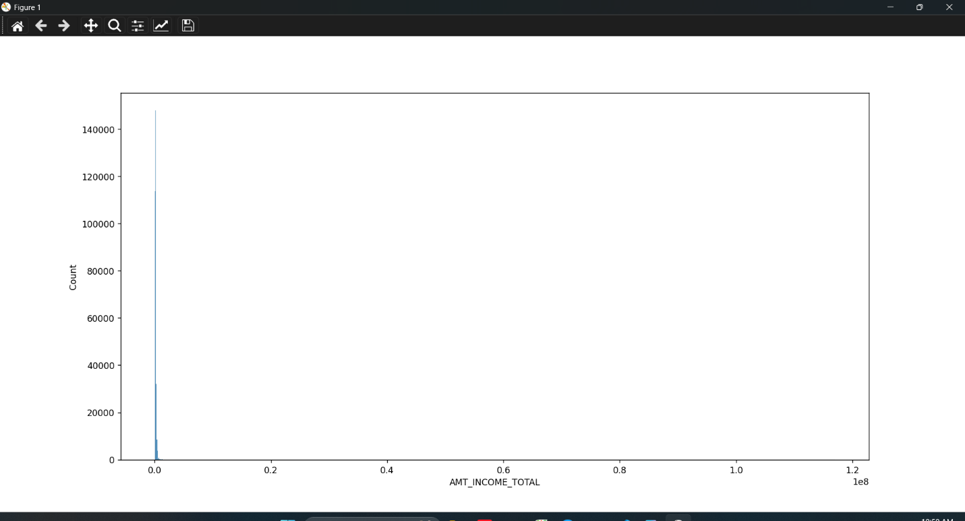
So I decided to use log transform
I need to create a pipline to automate the imputing process. I created 3 classes: DataLoader for loading data from files, MissingValueTracker for tracking columns that contain missing values and its missing ratio, AutomaticImputing for automatically imputing based on each column’s distribution
I learnt a new technique to classify which features need ordinal and which need onehot encoding, that is to write a data_schema file contains metadata. I created an automatically schmea-creating class to create a data_schema.json file.
I’m still creating a automatically encoding class based on the data_schema file.

