SURVEY REPORT REQUIREMENTS GATHERING

Contents

I. Survey header 1

1. Header info 1

2. Survey overall info 2

II. Survey detail info 2

1. Table Management 2

2. Table construction 2

a. Free text box 2

b. Upload picture (only 1) 2

3. Table Occupancy 3

a. Processes record 3

b. Free Text box to describe process 3

4. Table Protection 3

a. Free text box manual input 3

b. Protection info 3

c. Table Fire Pump 4

5. Natural hazard 4

a. Free text box 4

b. Upload picture (only 1) 4

6. Loss history 4

a. Free Text box 4

b. Detail extract from PA system 4

7. Upload picture 4

8. Temple report 4

III. Functions survey report 4

1. Report function 4

a. New survey report 4

b. Edit survey report 4

c. Final survey report 4

d. Approve survey report 4

2. Generate report 5

IV. Location management 5

V. Client 5

VI. Search function 5

VII. Statistic report 5

# Survey header

## Header info

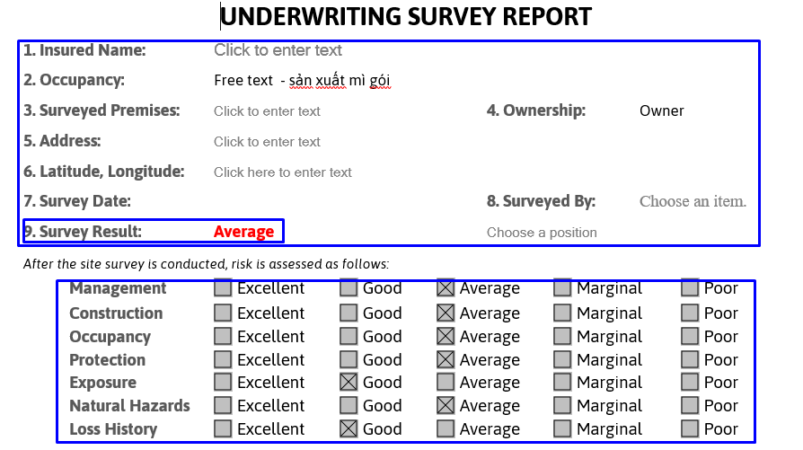

* LOB ( ENG , IAR )
* Create date / ID
* Final date
* User created
* User/date approve
* Branch
* J/ NJ
* Status ( Pending, Final , approve )
* TranNo ( số lần survey , new survey - DATE Survey )
* Prefix Survey Number + running number auto

## Survey overall info

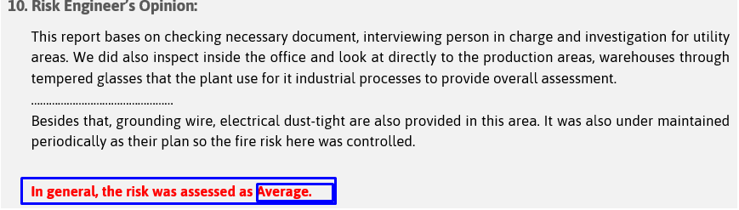

# Survey detail info

## Table Management

Free text box, manual input

## Table construction

General layout of the factory

### Free text box

Manual input to describe about manufacture / building

### Upload picture (only 1)

1. Describe manufacture / building by table

Column can be flexible

Row is fixed with the following:

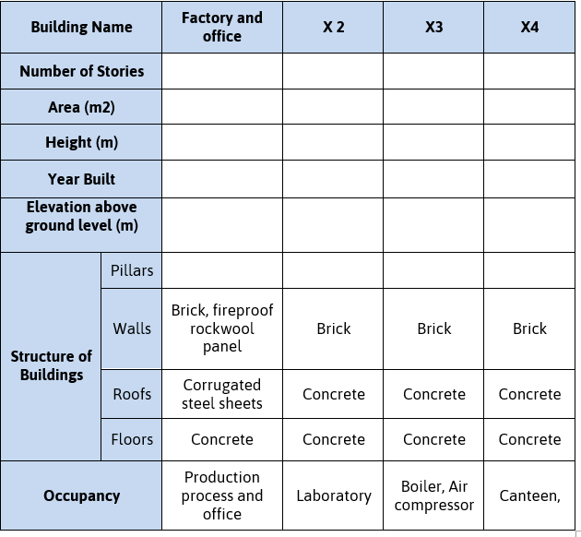

## Table Occupancy

### Processes record

There 2 option to describe processes:

* + Content of process of manufacturing / Bulidiing

Contents “Xxxxxxx” should be record in system

i.e

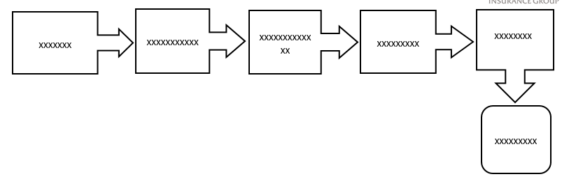

* + Upload picture of process

### Free Text box to describe process

## Table Protection

## Free text box manual input

### Protection info

Column can be fixed by UW

Line is flexible depend on RE

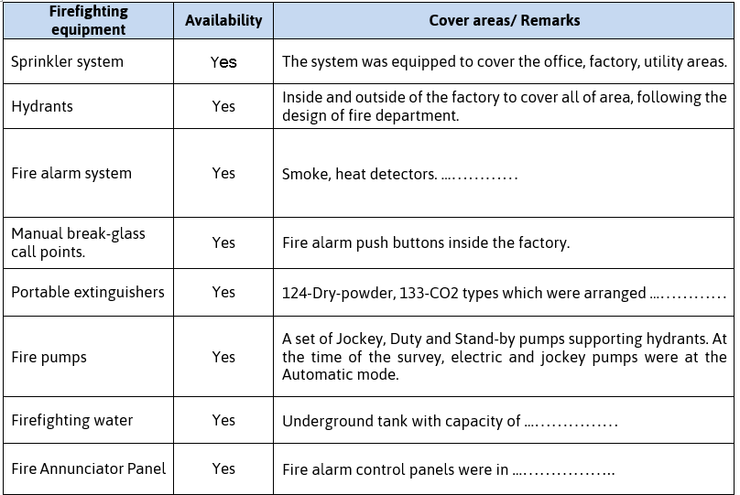

### Table Fire Pump

Column fixed, Line flexible,

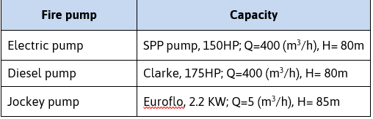

## Natural hazard

### Free text box

### Upload picture (only 1)

## Loss history

### Free Text box

### Detail extract from PA system

1. Phần này lấy từ PA system theo client & product

|  |  |  |  |  |
| --- | --- | --- | --- | --- |
| Name | DOL | Claim description | Products ( Fire / IAR, Eng ) | 5 năm gần nhất |
|  |  | Mô tả màn hình A ( 2 lines) |  |  |

## Upload picture

Flexible upload can be 3-20 pictures with describe for each one.

## Temple report



# Functions survey report

## Report function

### New survey report

### Edit survey report

### Final survey report

### Approve survey report

## Generate report

PDF & Word

Draft & final version

# Location management

Location should be pre- defined

1 client have many location,

1 survey event 🡨 🡪 1 location

# Client

New / existing client

Survey prospects (pre –sale)/ survey existing

# Search function

Client name

Survey number

Location (option)

# Statistic report

1. Dimension inquiry:

|  |  |  |  |  |  |  |
| --- | --- | --- | --- | --- | --- | --- |
| Management | Construction | Occupation | Protection | Exposure | Nature hazard | Loss history |

1. Value inquiry :

|  |  |  |  |  |
| --- | --- | --- | --- | --- |
| Excellent | Good | Average | Marginal | Poor |

1. Occupation by “Key word”
2. Survey result ( overall )

## 