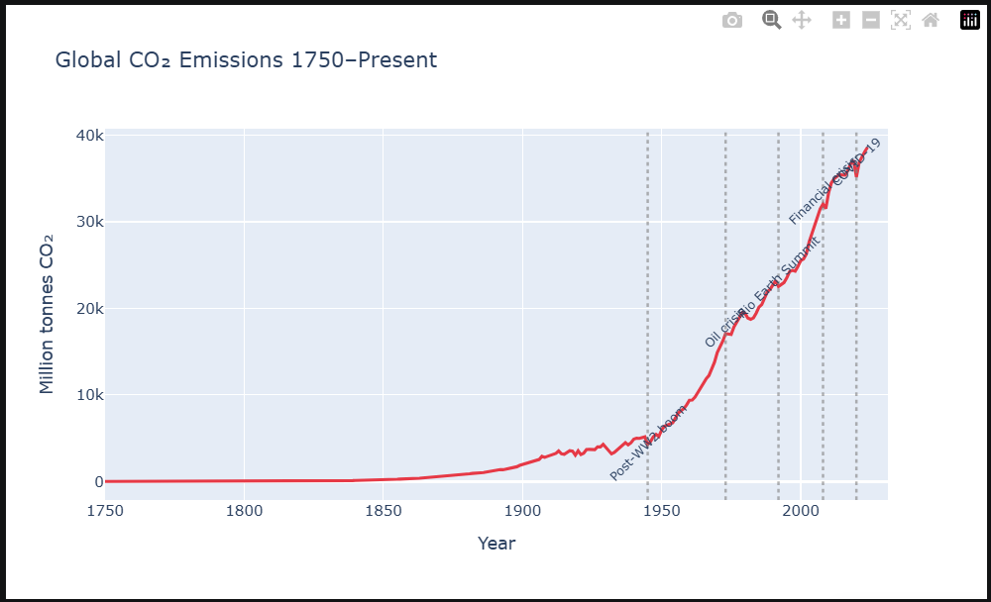
Based on the screenshot and the principles outlined in the sources, here is an extraction of insights and suggestions for visualizing them:

Insights Extracted from the Screenshot
The screenshot displays a timeline of global $CO_2$ emissions from 1750 to the present, revealing several key insights:
- Exponential Growth: Emissions remained nearly zero for over a century, beginning a slow rise in the late 1800s that turned into aggressive exponential growth in the mid-20th century.
- Impact of Global Events: Specific economic and health crises have caused visible temporary dips in the upward trend. These include the 1970s oil crisis, the 2008 financial crisis, and a sharp decline labeled for COVID-19 at the end of the timeline.
- Post-War Acceleration: The "Post-WW2 boom" is identified as a primary catalyst for the most dramatic and sustained increase in emissions.

Suggested Plots for Visualization
Depending on the specific story you want to tell with this data, several plots are recommended:
- Annotated Line Chart (Current Recommendation): The line chart is already highly effective for showing a continuous trend over a long period. The source material emphasizes that annotating interesting points directly on the graph (as seen in the screenshot with labels like "Financial crisis") is a powerful way to provide context and "tell a story" with data.
- Slopegraph: If you want to highlight the rate of change before and after the "Post-WW2 boom," a slopegraph would be an excellent choice. It can show both absolute values and the visual increase or decrease in the rate of change between two specific points in time.
- Smoothing (Moving Average): To focus on the long-term trajectory while reducing the "noise" of smaller yearly fluctuations, you could use a smoothed curve or a moving average. This would make the overarching trend even more apparent to the reader.
- Ridgeline Plot: If the dataset included a breakdown of emissions by region or country over these same years, a ridgeline plot would be ideal for comparing many distributions over time, as it scales well to large numbers of categories.

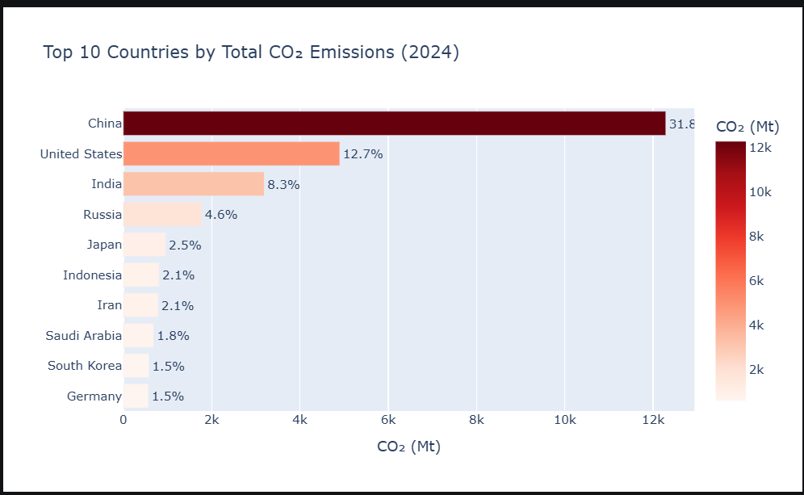
Based on the provided screenshot and the principles of data visualization detailed in the sources, here are the extracted insights and suggested plots for further visualization:

Insights Extracted from the Screenshot
- Extreme Concentration of Emissions: There is a massive disparity between the top emitters and the rest of the world. China’s emissions are significantly higher (31.8%) than any other nation, nearly tripling the emissions of the United States (12.7%).
- Rapid Drop-off: There is a sharp decline in emission levels after the top three countries (China, USA, and India). By the time the list reaches Japan (ranked 5th), the percentage has dropped to 2.5%.
- Redundant Visual Encoding: The current chart uses redundant encoding by using both bar length and a sequential color scale (light orange to dark red) to represent the same numerical value of $CO_2$ emissions. While this can provide a strong visual cue, the sources suggest that maximizing the "data-ink ratio" by avoiding unnecessary complexity is often more effective.

Suggested Plots for Visualization
- Pie Chart or Stacked Bar Chart (for Part-to-Whole Relations): Since the screenshot includes percentages (like 31.8%), these are likely fractions of a global total. To visualize these as a part-whole relationship, a pie chart or a stacked bar chart would be appropriate. This would help the viewer see exactly how much of the "global pie" these 10 countries consume.
- Treemap (for Hierarchical Proportions): If you wanted to categorize these countries by region (e.g., Asia, Americas, Europe), a treemap would be an excellent choice. It would use nested rectangles to represent the proportion of emissions per region, then per country within that region.
- Dot Plot (for Comparative Clarity): To minimize visual noise and focus strictly on the numeric values, a dot plot could replace the bars. This places a single dot along a scale for each country, which is particularly effective for comparing many categories without the "bulk" of bars.
- Slopegraph (for Visualizing Change Over Time): If you have data for these same 10 countries from a previous year, a slopegraph would be the ideal way to show the rate of change. It would clearly show whether emissions are rising or falling for each country and highlight which ones are increasing the fastest.
- Simple Text (for Focused Communication): If the primary goal is to highlight a single, shocking insight—such as China's dominance—the sources suggest using simple text. Making the number "31.8%" as prominent as possible with a few supporting words can be more impactful than a complex chart.

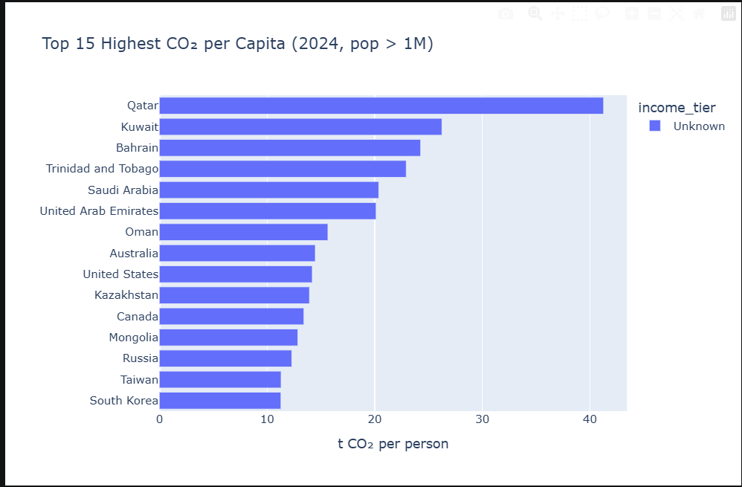
Based on the provided screenshot of the top 15 $CO_2$ emitters per capita in 2024, here are the extracted insights and suggested visualizations based on the principles in the sources:

Insights Extracted from the Screenshot
- Qatar’s Extreme Outlier Status: Qatar has the highest per capita emissions by a massive margin, exceeding 40 tonnes per person, which is significantly higher than the next highest country, Kuwait, at roughly 26 tonnes.
- Regional Concentration: The top six spots are almost exclusively occupied by Middle Eastern nations (Qatar, Kuwait, Bahrain, Saudi Arabia, and the United Arab Emirates), suggesting a strong regional trend likely tied to fossil fuel production and energy-intensive lifestyles.
- Significant Gap with Western Nations: While the United States, Australia, and Canada appear in the top 15, their per capita emissions (roughly 13–15 tonnes) are less than half of Qatar’s, illustrating a vast disparity even among high-emitting developed nations.
- Limited Category Information: The chart includes a legend for "income_tier," but all bars are currently coded as "Unknown," missing an opportunity to provide context on how national wealth relates to these emission levels.

Suggested Plots for Visualization
- Color-Coded Bar Chart (by Region): To highlight the regional trend, the bars should be encoded with distinct colors representing different geographic regions (e.g., Middle East, North America, East Asia). This would use the Gestalt principle of similarity to help the eye automatically group the Middle Eastern countries together.
- Dot Plot: To maximize the "data-ink ratio" and reduce visual clutter, a dot plot could replace the thick bars. This would allow the reader to focus strictly on the numeric position of each country along the scale without the visual "bulk" of the bars.
- Scatter Plot ($CO_2$ vs. GDP): Since the screenshot mentions an "income_tier" category, a scatter plot would be an excellent way to visualize the relationship between a country's economic wealth (GDP per capita) and its $CO_2$ per person. This could reveal if high emissions are a direct byproduct of wealth or if specific outliers like Qatar have unique industrial profiles.
- Cartogram: A cartogram could be used to distort the size of countries based on their per capita emissions. This would provide a striking geographic representation, making high-emitting but physically small countries like Qatar and Bahrain appear much larger than low-emitting nations.
- Annotated Chart: Adding annotations directly to the chart could "tell the story" behind the data. For example, a note explaining the specific industrial or environmental reasons for Qatar's high ranking would provide necessary context that the numbers alone cannot convey.

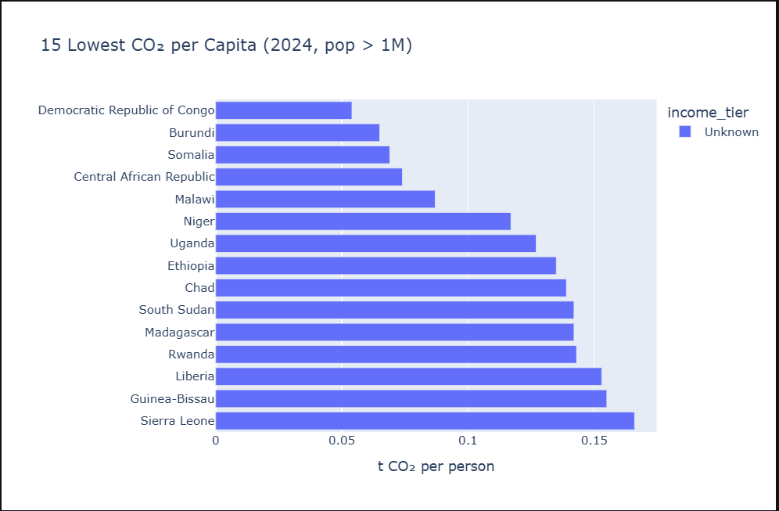
Based on the screenshot showing the 15 countries with the lowest $CO_2$ emissions per capita in 2024, here are the extracted insights and suggested plots for visualization:

Insights Extracted from the Screenshot
- Geographic Concentration (Sub-Saharan Africa): All 15 countries listed are located in Africa, predominantly in the Sub-Saharan region (e.g., Democratic Republic of Congo, Burundi, Somalia, and Sierra Leone). This suggests a strong regional trend where limited industrialization corresponds to a minimal carbon footprint.
- Extremely Low Absolute Values: The emissions for these nations are remarkably low, with the Democratic Republic of Congo at the bottom of the list with approximately 0.05 tonnes per person. Even the 15th country on the list, Sierra Leone, remains under 0.17 tonnes. To put this in perspective, these values are nearly 800 times lower than high-per-capita emitters like Qatar.
- Missing Economic Context: The chart includes a legend for "income_tier," but the data for every bar is currently marked as "Unknown". This identifies a gap in the data that, if filled, would likely show a strong correlation between low-income status and low emissions.

Suggested Plots for Visualization
- Choropleth Map or Cartogram: Since these countries are geographically clustered in Africa, a cartogram would be a striking way to visualize this. Distorting the size of the countries based on their per capita emissions would make these nations appear as tiny slivers compared to high-emitting developed nations, providing a powerful visual of global inequality.
- Scatter Plot ($CO_2$ vs. GNI): To address the "Unknown" income tier, a scatter plot comparing $CO_2$ per capita against Gross National Income (GNI) per capita would be highly effective. This would "enlighten" the reader by showing whether low emissions are a direct result of economic limitations.
- Dot Plot: To maximize the "data-ink ratio" and reduce visual clutter, a horizontal dot plot could replace the bars. By placing a simple dot at the appropriate location along the scale for each country, you avoid the "bulk" of bar lengths, which is particularly useful for such small quantitative values.
- Annotated Line/Trend Chart: If historical data is available, an annotated line chart could show the "evolution" of these countries' emissions over time. Adding annotations to explain specific events—such as conflict or economic shifts—would help "tell the story" behind the data.
- Compound Figure (Comparison): A compound figure combining this "Lowest 15" chart with a "Highest 15" chart (labeled A and B) would convey one overarching point: the extreme disparity in global carbon footprints. This approach breaks down complexity by revealing different facets of the global emissions story .

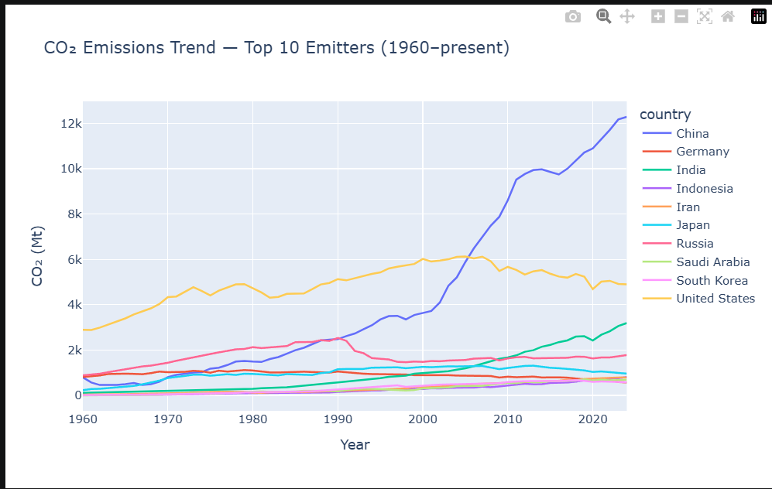
Based on the screenshot of global $CO_2$ emission trends from 1960 to the present, here are the extracted insights and suggested plots for further visualization based on the principles in the sources:

Insights Extracted from the Screenshot
- China’s Explosive Growth: China (dark blue line) transitioned from a relatively low emitter in 1960 to the world’s dominant emitter, showing exponential growth starting around 2000. By 2024, its emissions (exceeding 12,000 Mt) are more than double those of the next highest nation.
- The Overtaking of the United States: The United States (yellow line) was the top emitter for the first half of the timeline but was overtaken by China around 2005. Since roughly 2007, the U.S. has shown a gradual downward trend in emissions.
- India’s Steady Rise: India (teal line) has moved into a clear third-place position, showing consistent and steady growth while other major emitters like Russia, Japan, and Germany have remained flat or declined.
- Visual Clutter in Lower Emitters: The current chart suffers from "clutter" at the bottom of the Y-axis, where many lines (e.g., Iran, Saudi Arabia, Indonesia) overlap, making it difficult to distinguish individual trends for those nations.

Suggested Plots for Visualization
- Small Multiples (Faceting): The sources suggest using small multiples—arranging separate panels in a regular grid—to break down complexity. Giving each country its own small line chart would allow the reader to see the individual trajectories of lower emitters clearly without the lines overlapping.
- Slopegraph: To highlight the dramatic shift between specific eras (e.g., the year 2000 vs. 2024), a slopegraph would be ideal. It would show the relative increases and decreases for all 10 countries between two data points, making the rate of change visually immediate.
- Color to Highlight: Rather than coloring every line differently, you could use color as a tool to highlight a single story. For example, you could make China’s line a bold color and all others gray, forcing the audience to focus specifically on China’s dominance.
- Stacked Area Chart: To visualize the total volume of emissions from these top 10 countries combined, a stacked area chart would show how the "global total" has increased while simultaneously revealing each country's relative share of that total.
- Annotated Chart: Adding direct annotations to the graph—such as labeling the 2005 point where China surpassed the U.S.—helps "tell the story" and guides the audience toward the most important insights.
- Simple Text: If the goal is to communicate one shocking fact (e.g., that China's emissions are now over 12k Mt), the sources recommend using simple text. Making that specific number as prominent as possible with a few supporting words can be more impactful than a busy chart.

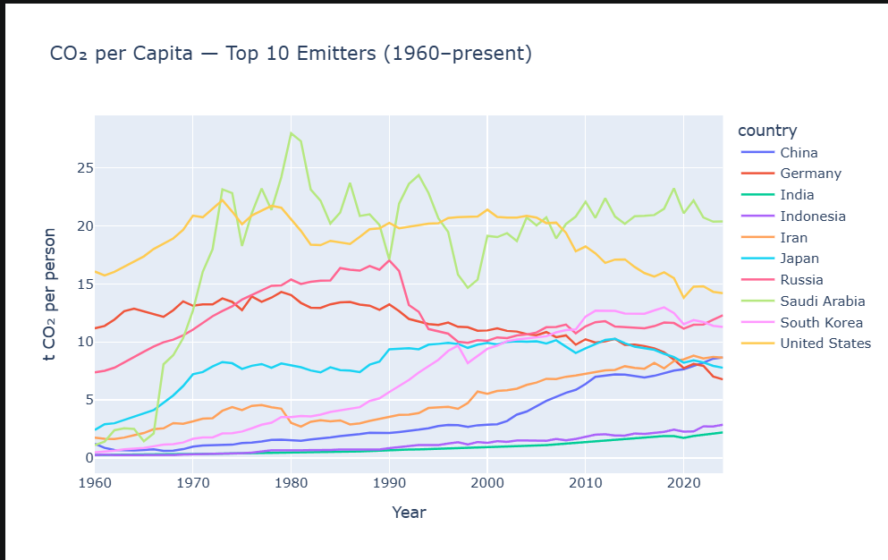
Based on the provided screenshot, here is an extracted insight and suggestions for alternative plots to visualize it:

Extracted Insight: Diverging Emission Trends
A significant insight from the data is the divergence in emission trends between established industrial economies and rapidly developing ones. While traditional high emitters like the United States and Germany have seen a steady decline in $CO_2$ per capita since their respective peaks (around 1970 for the US and 1990 for Germany), countries like China and South Korea have shown consistent growth over the same period, narrowing the gap with Western nations. Additionally, Saudi Arabia remains a volatile but prominent leader in per capita emissions.

Suggested Plots for Visualization
To more effectively communicate these insights and reduce the visual clutter of overlapping lines (often called "spaghetti charts"), the following plots are suggested:
- Slopegraph: If the goal is to show the relative increase or decrease between two specific points in time (e.g., 1990 vs. 2020), a slopegraph would be ideal. It would clearly highlight the rate of change for each country and the shifts in their relative rankings without the noise of year-to-year fluctuations.
- Small Multiples (Faceting): To allow readers to see each country's full historical trend clearly, the data could be broken into a grid of separate panels, one for each country. This eliminates the problem of overlapping lines while maintaining the ability to compare individual trends across the same time and value axes.
- Highlighting with Color: To emphasize the specific story of a single country (like China’s rise or the US’s decline), the visualization could use a highlight color for the target country while keeping the other lines in a neutral gray. This reduces cognitive load and directs the viewer's eye to the key point of interest.
- Ridgeline Plot: To show the distribution of emitters over time, a ridgeline plot could be used. This would allow for an easy comparison of the "shape" of each country's emission history in a vertically stacked arrangement that scales well for many groups.

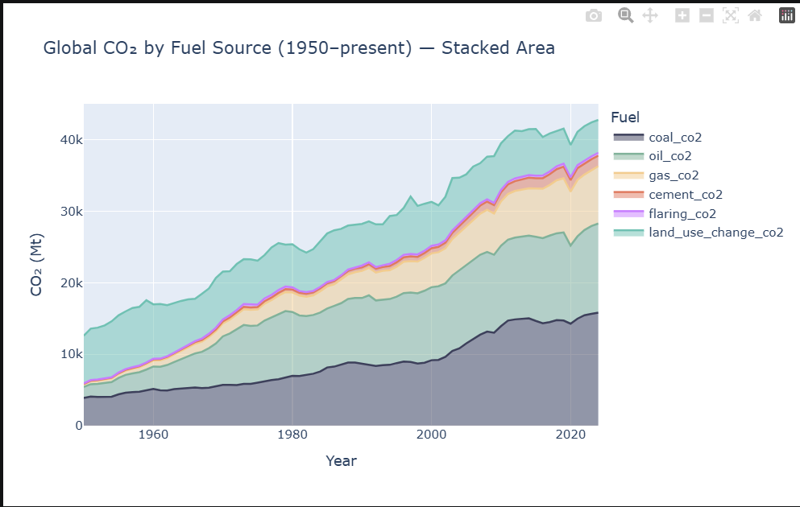
Based on the provided screenshot and the source material, here is an analysis of the insights and suggestions for alternative visualizations:

Insights Extracted from the Screenshot
The screenshot displays a Stacked Area Chart showing "Global CO2 by Fuel Source" from 1950 to the present. Key insights include:
- Rapid Growth in Total Emissions: Global CO2 emissions have seen a massive, nearly four-fold increase, rising from roughly 13,000 Mt in 1950 to over 40,000 Mt today.
- Shift in Emission Sources: In 1950, land use change (the top teal layer) represented a much larger proportion of total emissions. Over time, the growth has been driven primarily by fossil fuels (coal, oil, and gas), while land use emissions have remained relatively stable in absolute terms.
- Dominance of Coal and Oil: Coal (the bottom dark layer) consistently remains the largest single source of emissions throughout the period shown, followed closely by oil.
- Significant Recent Dips: There is a visible, sharp decline in total emissions around the year 2020, likely reflecting the global impact of the COVID-19 pandemic on industrial activity and travel.

Suggested Plots for Better Visualization
While the current stacked area chart is excellent for showing the total trend and broader shifts, it has limitations in comparing individual categories. Based on the sources, here are suggestions depending on the specific goal:
- To compare individual trends (Line Chart or Small Multiples): In a stacked plot, it is difficult to see the exact trend of a middle layer (like "gas" or "oil") because its baseline is constantly shifting.
  - Suggestion: Use a multi-line chart where each fuel source is its own line starting from the same zero baseline.
  - Alternative: Use Small Multiples (Faceting) to show each fuel source in its own separate panel, allowing the reader to see the individual growth rates clearly without interference.
- To emphasize shifting proportions (100% Stacked Area Chart): The current chart shows absolute values. To better visualize how the relative importance of each source has changed (e.g., the shrinking percentage of land use change vs. the rising percentage of coal).
  - Suggestion: Use a 100% Stacked Area Chart, which scales the total of every year to 100%.
- To highlight change between two points (Slopegraph): If the goal is to show how the hierarchy of fuel sources changed between 1950 and the present.
  - Suggestion: Use a Slopegraph to connect the percentage share of each fuel in 1950 to its share today, highlighting relative increases and decreases.
- To show nested categories (Tree Map): If you want to break down total emissions for a single recent year by both fuel type and perhaps regional source.
  - Suggestion: A Tree Map can effectively show proportions for a fixed point in time by nesting smaller rectangles (fuel sources) within larger ones (total emissions).

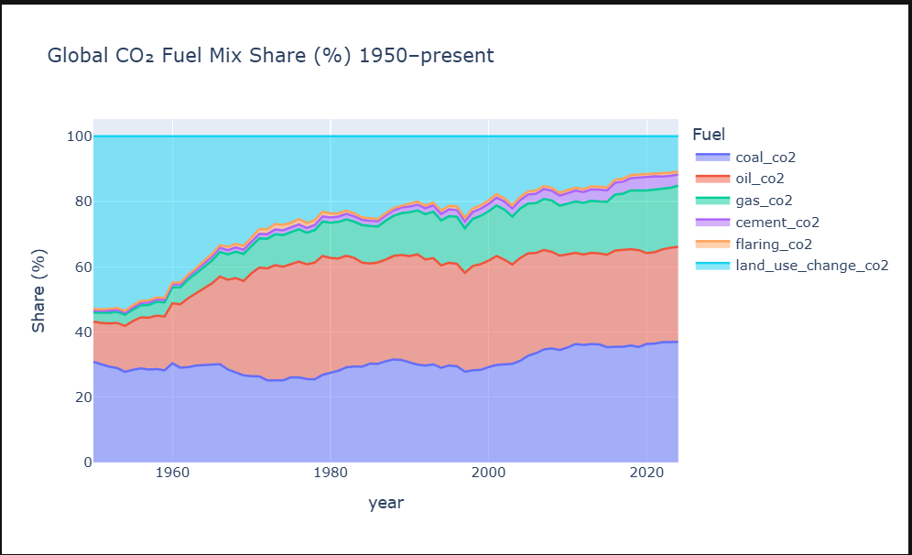
The screenshot provided shows a 100% Stacked Area Chart titled "Global $CO_2$ Fuel Mix Share (%) 1950–present". This type of visualization is used to show how individual categories contribute as proportions of a total over a continuous variable, such as time.

Key Insights Extracted
- Dramatic Shift from Land Use to Fossil Fuels: In 1950, land use change (the top light-blue area) accounted for a dominant portion of the global $CO_2$ mix, representing roughly half of the total emissions share. By the present day, its relative share has shrunk significantly, while fossil fuels have expanded to dominate the mix.
- Expansion of Oil and Gas: The share of oil (the orange area) saw its most rapid proportional growth between 1950 and approximately 1980. Similarly, natural gas (the teal-green area) has seen a steady, consistent increase in its share of the total mix over the entire period.
- Coal's Fluctuating but Persistent Share: While the total volume of emissions has changed, the proportional share of coal (the bottom dark-blue area) has remained relatively persistent, showing some fluctuations but ending at a share similar to its 1950 level.

Suggested Plots for Visualization
While the current stacked area chart is effective for showing the total proportional mix, other plots could highlight different aspects of the data more clearly:
- To compare individual trends (Small Multiples/Faceting): A major disadvantage of stacked charts is that it is difficult to compare categories that do not sit on the zero baseline because their baselines are constantly shifting.
  - Suggestion: Use Small Multiples (also called trellis plots or faceting), where each fuel source is shown in its own separate line chart with a fixed zero baseline. This would allow the reader to see the exact growth or decline rate of gas or oil without being influenced by the layers beneath them.
- To highlight the change between 1950 and Today (Slopegraph): If the goal is to focus specifically on how the hierarchy of fuel sources has changed between two points in time.
  - Suggestion: A Slopegraph can show the relative increase and decrease for each category between 1950 and the present. It would vividly illustrate how land use dropped in rank while gas and oil rose.
- To show the current proportional breakdown (Treemap or Sunburst): If the goal is to visualize the composition of emissions for just the most recent year.
  - Suggestion: A Treemap uses nested rectangles to represent proportions, which would be excellent for showing how fossil fuels as a "parent" category are further divided into coal, oil, and gas. Alternatively, a Sunburst Chart could show this hierarchy using concentric circles.
- To compare absolute volumes (Grouped Bar Chart): The screenshot only shows percentages (shares). To understand the scale of the increase in total $CO_2$.
  - Suggestion: A Grouped Bar Chart for specific decades (e.g., 1950, 1980, 2020) could show the actual metric tons of $CO_2$ for each fuel, allowing for comparison of both the mix and the total volume simultaneously.

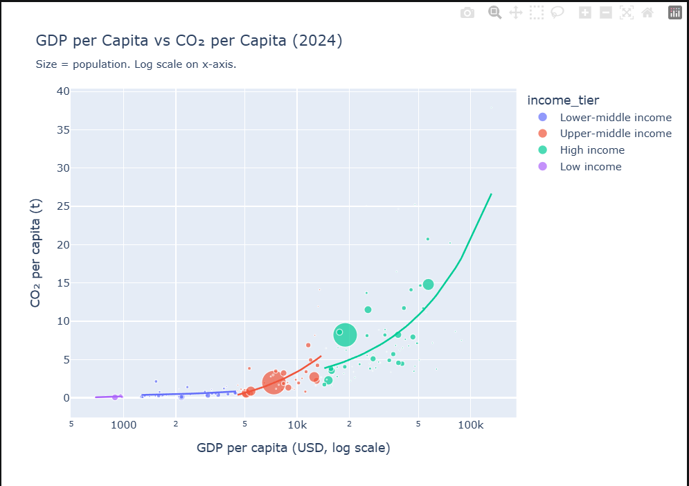
The screenshot provided is a Bubble Chart titled "GDP per Capita vs $CO_2$ per Capita (2024)," which uses a log scale for the x-axis. It visualizes the relationship between national wealth and carbon emissions, with bubble size representing population and color indicating income tier.

Key Insights Extracted
- Strong Positive Correlation: There is a clear positive relationship between a country's GDP per capita and its $CO_2$ emissions per capita; as nations become wealthier, their carbon footprint per person generally increases.
- Income Tier Segmentation: The data clusters significantly by income tier. Low-income countries (purple) are concentrated at the very low end of both scales, while High-income countries (teal) show the highest emissions and the greatest variance.
- Accelerating Emissions at Higher Wealth: The smoothing trend lines show that for High-income nations, the rate of increase in $CO_2$ emissions accelerates as wealth grows, shown by the steepening teal curve.
- Significant Outliers: Several high-income nations are extreme outliers, with $CO_2$ per capita reaching nearly 40 tonnes, far above the general trend line for their income group.
- Massive Population in Transition: Large bubbles (representing high-population countries) in the lower-middle (blue) and upper-middle (orange) tiers indicate that a vast portion of the global population lives in nations currently at a critical stage of industrial and economic growth.

Suggested Plots for Better Visualization
Depending on your specific goals, the following alternative plots could enhance interpretation:
- To address overlapping data (2D Histogram or Density Plot): Because there is significant overplotting in the lower-left corner where many countries cluster, individual points become hard to see.
  - Suggestion: A 2D Histogram or Density Plot could use color intensity to show where the highest "density" of countries lies, making the distribution in crowded areas clearer.
- To compare income tiers more clearly (Small Multiples): The current plot has multiple overlapping trend lines and colors that can be visually overwhelming.
  - Suggestion: Use Small Multiples (Faceting) to create four separate panels—one for each income tier. This allows the reader to focus on the unique distribution and trend of each wealth group without interference from others.
- To visualize global contribution (Treemap): The bubble chart shows per capita data, which can mask which countries are the largest total emitters.
  - Suggestion: A Treemap could show total national $CO_2$ emissions as the area of rectangles, nested within regions or income tiers, providing a "part-to-whole" perspective on global pollution.
- To linearize the relationship (Log-Log Plot): Currently, only the x-axis is on a log scale, resulting in exponential-looking curves.
  - Suggestion: Applying a log scale to both axes could potentially linearize the trend, making it easier to compare the "rate of change" across different income levels as a straight-line slope.

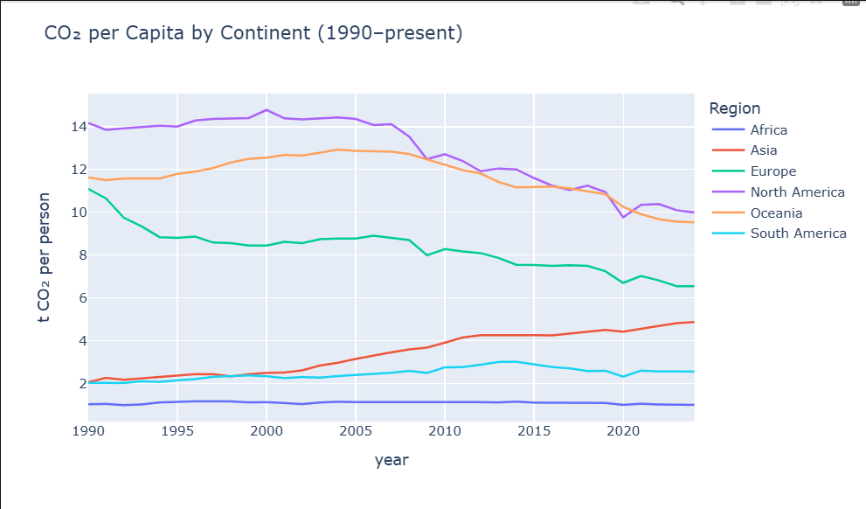
The screenshot provided is a multi-line chart titled "$CO_2$ per Capita by Continent (1990–present)," which tracks metric tons of carbon dioxide emitted per person across six global regions.

Key Insights Extracted
- Diverging Regional Trends: There is a clear "decoupling" of trends between continents. While North America and Europe have seen steady declines in per capita emissions since the mid-2000s, Asia has experienced a significant and consistent increase over the same period.
- Persistent High Emitters: Despite its significant drop from roughly 14 to 10 tonnes per person, North America remains the highest per capita emitter among the continents shown.
- Oceania’s Recent Decline: After maintaining high and relatively stable emissions for decades, Oceania began a noticeable downward trend around 2010.
- Low and Stable Regions: Africa consistently maintains the lowest carbon footprint per person, remaining stable at around 1 tonne throughout the 30-year period. South America shows a slight rise followed by stabilization.
- The 2020 Pandemic Dip: A sharp, synchronized "V-shaped" dip is visible across almost all regions around the year 2020, likely reflecting the global reduction in travel and industrial activity during the COVID-19 pandemic.

Suggested Plots for Visualization
While the current line chart is effective for showing continuous trends, the following alternatives could provide different perspectives:
- Slopegraph (for comparing two points in time): If the primary goal is to show the relative increase or decrease between the start (1990) and the end of the data (present), a Slopegraph would be ideal. It would clearly highlight Asia’s steep upward slope in contrast to the downward slopes of North America and Europe.
- Small Multiples (Faceting): If the goal is to focus on the unique "shape" of each continent's history without the distraction of overlapping lines, you could use Small Multiples. By placing each continent in its own small panel with the same y-axis scale, the reader can more easily extract individual meaningful insights without visual clutter.
- Heatmap: To highlight broader intensity trends over time, a Heatmap could map the $CO_2$ values onto colors. This would create a "grid" of years and continents where the shifting "heat" (color intensity) would vividly show the transition of emissions from the West to Asia.
- Cartogram: To see the data in a geographic context, a Cartogram could be used to distort a map based on per-capita emission values. This would visually emphasize which regions are "punching above their weight" in terms of pollution relative to their geographic size.

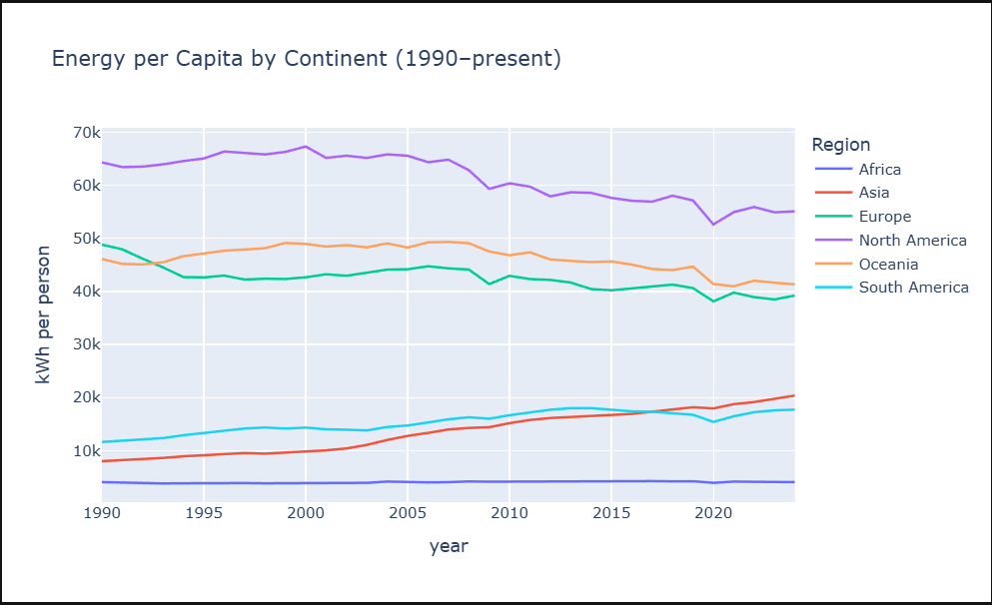
Based on the line chart provided in the screenshot, a primary insight is the divergent trajectory of energy consumption across different regions since 1990. While North America and Europe have seen a gradual decline in energy per capita, Asia has experienced the most significant and steady growth, more than doubling its consumption. In stark contrast, Africa remains at a near-stagnant, low level of energy use throughout the entire 30-year period.

Suggested Visualization: Slopegraph
To effectively highlight this insight, I suggest using a Slopegraph.
- Why it works: A slopegraph is specifically designed to show relative increases and decreases or differences across categories between two specific data points (e.g., 1990 vs. the present year).
- Visual Impact: It would provide a clear visual of the "rate of change," making it immediately obvious how Asia’s line slopes sharply upward while North America’s and Europe’s slope downward. This eliminates the visual "noise" of the intervening years and focuses the reader on the total magnitude of change for each continent.

Alternative: Horizontal Bar Plot (Percentage Change)
If the goal is to specifically rank the continents by their growth or decline, a horizontal bar plot showing the percentage change in energy consumption would be effective. This would allow for an easy comparison of quantitative values—ranking Asia as the leader in growth and North America as the leader in reduction—without the potential for overplotting found in multi-line charts.

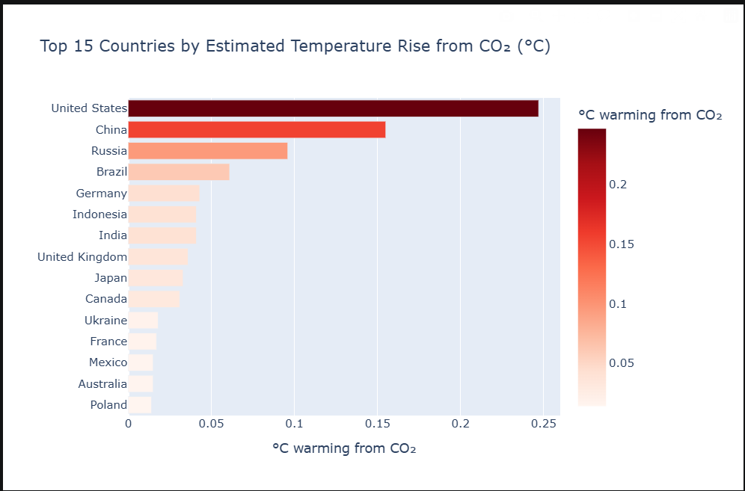
Based on the provided screenshot of the "Top 15 Countries by Estimated Temperature Rise from CO₂," several key insights and visualization alternatives can be identified.

Extracted Insights
- Disproportionate Impact of Global Leaders: A primary insight is the dominant contribution of the United States, which leads with an estimated temperature rise of approximately 0.25°C, significantly ahead of the second-highest contributor, China (~0.15°C).
- Rapid Decline in Responsibility: There is a sharp drop-off in estimated warming impact after the top three nations (US, China, and Russia). The bottom half of the top 15 list shows countries with relatively similar and much lower levels of impact, ranging from roughly 0.02°C to 0.04°C.
- Redundant Visual Encoding: The current visualization uses redundant encoding by mapping the same data values to both the length of the bars and a sequential color scale (light to dark red). The sources note that this can make a message more vivid and memorable.

Suggested Plots to Visualize the Data

1. Cartogram
To emphasize the geographic disproportion of CO₂ impact, a cartogram would be highly effective.
- Why it works: According to the sources, a cartogram transforms the area of map regions according to their attribute values.
- Visual Impact: By distorting the size of countries based on their contribution to temperature rise, the United States and China would appear massive compared to the rest of the world, visually dramatizing their responsibility for global warming.

2. Treemap
A treemap would be a strong alternative for comparing the proportional contribution of each country within the group.
- Why it works: Treemaps subdivide a rectangle into smaller rectangles whose areas represent proportions.
- Visual Impact: This would allow the viewer to see at a glance what fraction of the total warming caused by these top 15 countries is attributable to the US versus smaller contributors like Poland or Australia.

3. Dot Plot
If the goal is to provide a cleaner ranking that is easy to read, a horizontal dot plot is recommended.
- Why it works: The sources suggest using dots at appropriate locations along a scale to avoid the visual bulk of bar lengths.
- Visual Impact: A dot plot would more clearly highlight the large gaps (the "white space") between the US, China, and the other countries without the "ink" required for large bars, thereby focusing more on the exact position of each country on the warming scale.
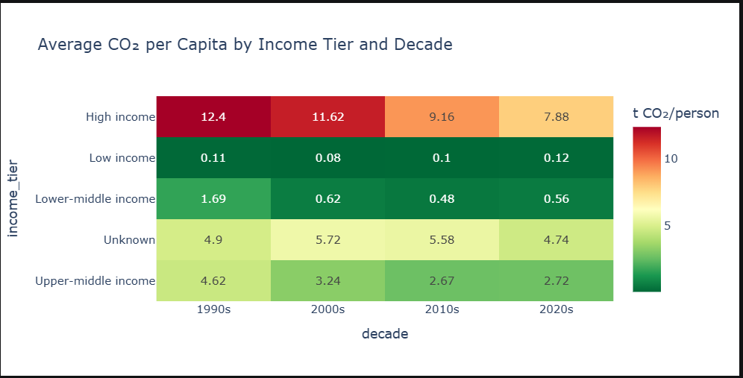
Based on the bubble chart titled "GDP per Capita vs CO₂ per Capita (2024)" provided in the screenshot, here is an extracted insight and a suggested visualization to enhance its impact.

Extracted Insight: Exponential CO₂ Growth in High-Income Nations
A primary insight is the non-linear, accelerating relationship between wealth and emissions within the "High income" tier. While low and middle-income countries show a relatively flat or gradual increase in CO₂ per capita as GDP grows, the teal trend line for high-income nations indicates that after a certain wealth threshold (roughly $15k–$20k GDP per capita), CO₂ emissions begin to rise much more sharply. This suggests that the "carbon cost" of marginal economic growth is significantly higher for the wealthiest nations compared to developing ones.

Suggested Plot: Small Multiples (Faceting)
To effectively visualize and compare these diverging trends, I suggest using Small Multiples (also known as a Trellis Plot).
- How it works: Instead of one crowded chart, you would create four separate, identical scatterplot panels—one for each income tier (Low, Lower-middle, Upper-middle, High).
- Why it works:
  - Reduces Visual Clutter: The current chart suffers from overlapping points, particularly in the middle-income tiers. The sources note that small multiples "subdivide space to enable comparison across multiple plots" without the noise of overplotting.
  - Clearer Trend Comparison: By giving each tier its own panel, the viewer can more easily see the unique "shape" of each group's development path. It would highlight that the "High income" curve is fundamentally different in nature—exponential rather than linear—compared to the flatter trajectories of the other groups.
  - Maintains Context: Because all panels use the same x and y axes, the viewer can still compare values across the different groups while focusing on the internal patterns of each one.

Alternative: Slopegraph
If your goal is to specifically highlight the rate of change (the "slope") of emissions for each group, a Slopegraph would be effective.
- Impact: By comparing the CO₂ per capita at the lowest GDP point versus the highest GDP point within each tier, a slopegraph would vividly show that the "High income" group has the steepest upward slope, reinforcing the message that their economic growth is the most carbon-intensive.

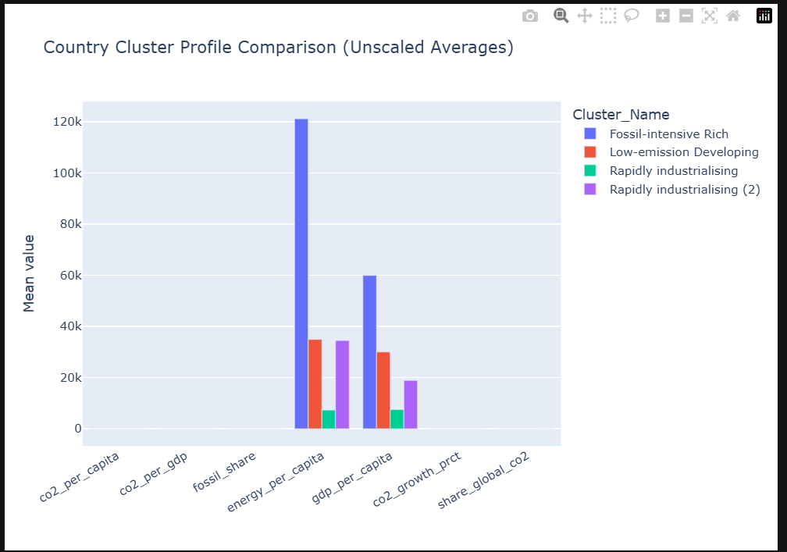
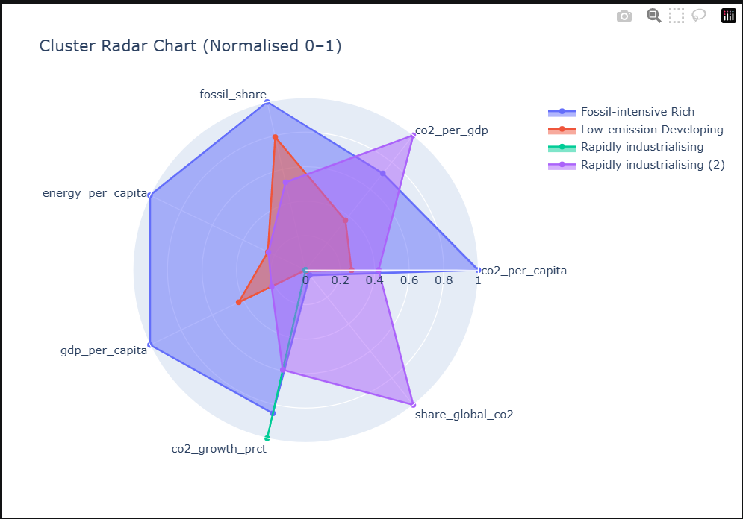
Based on the provided screenshot of the Cluster Radar Chart, here is an extracted insight and a suggested visualization to improve its clarity.

Extracted Insight: Per-Capita vs. Global Contribution Profiles
The most significant insight is the fundamental difference in emission "fingerprints" between wealthy and industrializing nations.
- The "Fossil-intensive Rich" cluster (blue) is characterized by high values across nearly all per-capita metrics: energy_per_capita, gdp_per_capita, and co2_per_capita. This shows a direct link between high individual wealth and high individual environmental impact.
- The "Rapidly industrialising" clusters (purple and teal) show a different profile. While their per-capita wealth is lower, they dominate in share_global_co2 and co2_growth_prct. This highlights that while individual citizens in these nations may consume less than those in "Rich" nations, the nations themselves are the primary drivers of total global emission volume and growth.

Suggested Plot: Small Multiples (Faceting)
While radar charts are useful for showing multi-dimensional "shapes," the current visualization suffers from overplotting, where the overlapping shaded areas make it difficult to see the exact profile of the smaller or thinner clusters, such as the teal "Rapidly industrialising" group.
- How it works: I suggest using Small Multiples (also known as faceting). This would involve creating four separate, smaller radar charts—one for each cluster—arranged in a grid.
- Why it works: According to the sources, small multiples "subdivide space to enable comparison across multiple plots" without the noise of overlapping data. By giving each cluster its own panel while keeping the axes identical, the viewer can clearly see the unique "shape" of each group’s impact without them being obscured by one another.

Alternative: Heatmap
To prioritize the precision of the normalized values (0 to 1), a Heatmap would be highly effective.
- How it works: Map the four clusters to rows and the seven metrics to columns.
- Visual Impact: Use color saturation to represent the normalized values (e.g., dark blue for 1, white for 0). This would allow the brain to "more quickly target the potential points of interest" across the different categories, providing a clean, tabular view of how these groups compare across all seven dimensions without the geometric distortion inherent in radar charts.

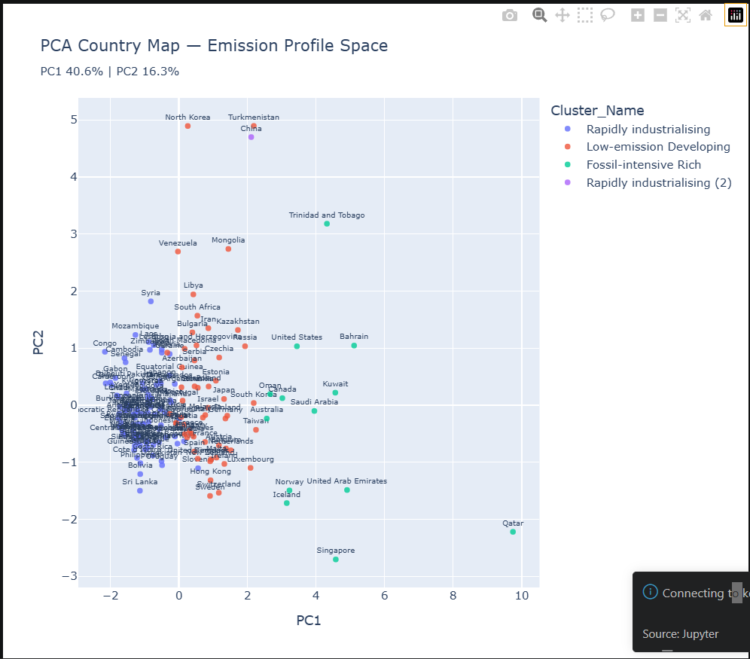
Based on the provided screenshot of the PCA Country Map — Emission Profile Space, here is an extracted insight and suggested visualizations to improve its effectiveness.

Extracted Insight: Strategic Stratification vs. Extreme Overplotting
A primary insight is the clear separation of the "Fossil-intensive Rich" cluster from the rest of the world. While countries like the United States, Norway, and Qatar are spread out and easily identifiable along the right side of the PC1 axis, the majority of the world's nations (represented by the "Rapidly industrialising" and "Low-emission Developing" clusters) are densely packed into the bottom-left corner.
This creates a significant overplotting problem. In this crowded region, individual country labels (such as Senegal, Cambodia, and Mozambique) overlap to the point of being illegible, making it impossible for the viewer to distinguish specific data points or understand the internal distribution of these groups.

Suggested Plots to Visualize the Data

1. Small Multiples (Faceting)
To address the visual clutter and allow for a clearer comparison of the four groups, I suggest using Small Multiples (also known as faceting).
- How it works: You would create four identical scatter plot panels—one for each cluster (e.g., one for "Fossil-intensive Rich," another for "Low-emission Developing," etc.).
- Why it works: According to the sources, small multiples "subdivide space to enable comparison across multiple plots". By giving each cluster its own dedicated panel while maintaining the same PC1 and PC2 axes, you would eliminate the interference caused by overlapping colors and labels. This would allow the dense developing clusters to be seen in isolation, potentially revealing internal patterns that are currently hidden.

2. 2D Histogram or Contour Density Plot
If the goal is to show where the "mass" of the global population of countries lies, a 2D Histogram or Density Plot would be highly effective.
- How it works: Instead of plotting every single country as a dot, the x–y plane is subdivided into small rectangles (bins) that are colored by the count of observations falling into them. Alternatively, contour lines can indicate regions of similar point density.
- Visual Impact: This approach "taps into the brain's visual processing capabilities" to show exactly how concentrated the countries are in that bottom-left corner. It would transform a "blob" of overlapping points into a clear "mountain" of density, making the global disparity in emission profiles much more vivid and memorable.

3. Partial Transparency and Jittering
If a single plot must be used, applying partial transparency and jittering would improve legibility.
- Impact: Adding transparency allows points that lie on top of one another to be identified by a darker shade. Adding a small amount of "jitter" (random noise) to the coordinates can spread the points out just enough to make overlapping labels more distinguishable without distorting the overall message of the PCA space.

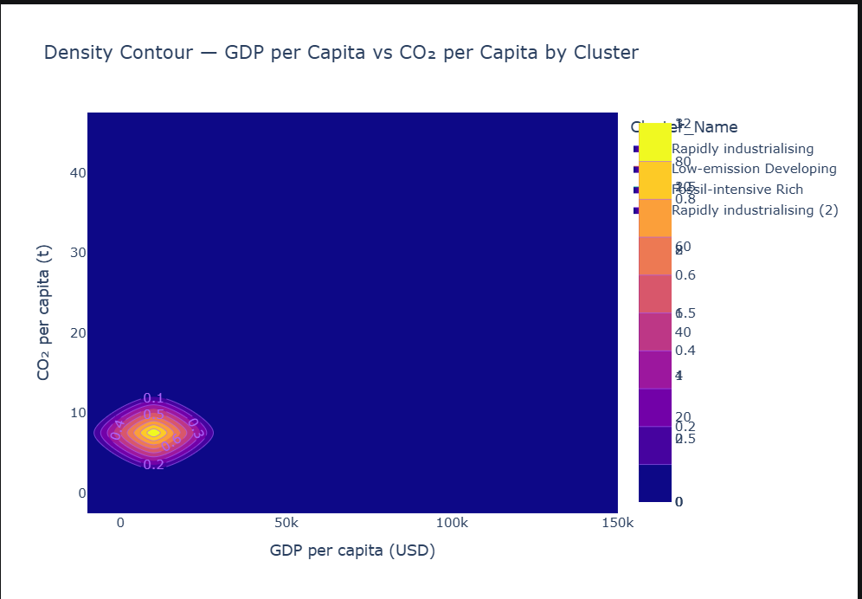
Based on the provided screenshot, the following insight can be extracted along with several suggested plot types for better visualization:

Extracted Insight
The Density Contour plot reveals that the vast majority of data points are extremely concentrated in the low-GDP and low-CO₂ emissions range (specifically under $25,000 GDP and 10 tons of CO₂ per capita). While the legend indicates several distinct groups like "Fossil-intensive Rich" and "Rapidly industrialising," their unique characteristics are currently obscured because they are all "squashed" into the bottom-left corner of the linear scale. This suggests a highly skewed distribution where a few wealthy or high-emitting outliers exist, but the "typical" country in this dataset has relatively low values for both metrics.

Suggested Plots for Visualization
To improve the clarity of this data and better distinguish the clusters, the sources suggest the following alternatives:
- Logarithmic Scale Plot: Because the data values are not linearly spaced and are heavily clustered at the low end, using logarithmic axes would be highly effective. A log-log plot would "expand" the dense region in the bottom-left, allowing you to see the variance and internal patterns of the countries that currently appear as a single solid "blob".
- Small Multiples (Faceting): Rather than overlapping all clusters in one panel, you can use small multiples to create a separate plot for each Cluster_Name arranged in a grid. This would allow for an easy comparison of the density shapes and relative heights of each group without them interfering with one another.
- Scatterplot with Partial Transparency and Jittering: If you want to see individual countries rather than just an abstract density estimate, a scatterplot is the standard choice. To handle the extreme overplotting shown in the dense region, you should apply partial transparency (so overlapping points appear darker) and a small amount of jittering to reveal the actual number of observations hidden in the center.
- Marginal Density Plot: You could combine a standard scatterplot with density plots in the margins. This would provide a detailed look at the relationship between individual countries while simultaneously showing the overall distribution of GDP and CO₂ independently along the top and side of the chart.
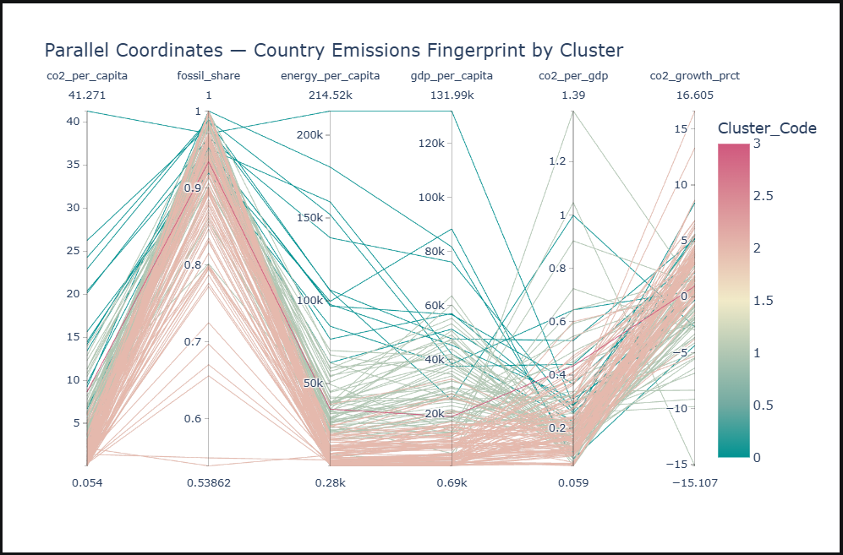
Based on the provided screenshot, the following insight and visualization suggestions can be extracted:

Extracted Insight
The Parallel Coordinates plot reveals a strong positive association between gdp_per_capita and energy_per_capita. In the visualization, the lines (representing individual countries) that reach the highest points on the GDP axis also tend to reach the highest points on the energy consumption axis. Furthermore, these same countries generally exhibit higher co2_per_capita. This suggests that wealthier nations, as defined by GDP, typically consume more energy and produce more CO2 emissions per person.

Suggested Plots for Visualization
To more effectively visualize and analyze this relationship, the sources suggest the following plot types:
- Scatterplot: This is the most straightforward plot for visualizing the association between two quantitative variables, such as GDP per capita versus CO2 per capita. It allows for a clear view of the tendency for heavier variables to correlate. To maintain the information from the original screenshot, you can use color to encode the Cluster_Code, allowing you to see how different groups of countries behave within that correlation.
- Bubble Chart: If you want to visualize three quantitative variables at once (e.g., GDP vs. CO2 with dot size representing energy_per_capita), a bubble chart is the appropriate choice. This would allow you to see if energy consumption is the driving force behind the GDP-Emissions link.
- Scatterplot Matrix: Since the original data contains at least six quantitative variables and is categorized by clusters, an all-against-all scatterplot matrix would be highly effective. This would allow you to see every pairwise association simultaneously and identify which specific variables are the strongest drivers for the distinct clusters and outliers seen in the teal and pink lines of the parallel coordinates plot .

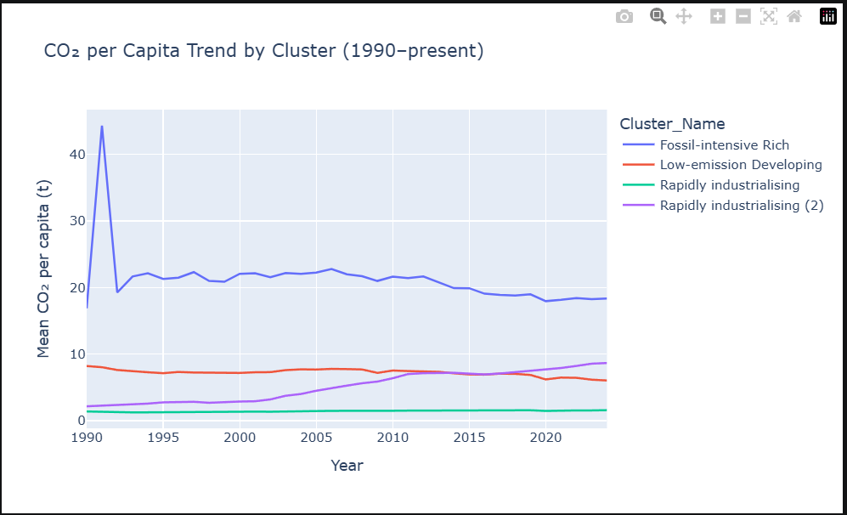
Based on the provided screenshot, several insights can be extracted regarding the CO₂ per capita trends among different country clusters since 1990:

Extracted Insights
- Growth in Industrializing Nations: The most significant trend is the steady upward trajectory of the "Rapidly industrialising (2)" cluster (purple line). Starting at very low levels in 1990, its mean CO₂ per capita has consistently increased, eventually surpassing the "Low-emission Developing" cluster around 2015.
- Declining High-Emitters: The "Fossil-intensive Rich" cluster (blue line) remains the highest emitter but shows a slow, long-term downward trend after stabilizing from a massive initial spike.
- Major Historical Outlier: There is a extreme, isolated spike in emissions for the "Fossil-intensive Rich" group around 1991, where values jumped to over 40 tons per capita before immediately dropping back to roughly 20 tons.
- Stagnant Clusters: The "Rapidly industrialising" cluster (teal line) has remained almost perfectly flat and at the lowest emission levels for over three decades.

Suggested Plots for Better Visualization
To enhance the communication of these specific insights, the following plot types are suggested by the sources:
- Small Multiples (Faceting): Because the high values and extreme spike of the "Fossil-intensive Rich" group compress the vertical scale for the other clusters, using small multiples would be more effective. By giving each cluster its own panel in a grid, you could more easily compare the relative shapes and heights of the trends without them overlapping or being "squashed" by outliers.
- Slopegraph: If the goal is to highlight how much each group has changed between 1990 and the present, a slopegraph is ideal. It would clearly show the absolute increase for industrializing nations versus the relative decrease for wealthy nations, emphasizing the rate of change between these two points in time.
- Annotated Line Chart with Strategic Highlighting: To tell a specific story—such as the rise of industrializing nations—you could use color to highlight only the "Rapidly industrialising (2)" line while making the other lines a neutral gray. Additionally, the 1991 spike should be directly annotated with text to provide the historical context that explains such an extreme outlier.
- Logarithmic Scale Plot: Given that the "Rich" cluster has emissions nearly 20 times higher than the "Developing" clusters, a logarithmic axis could be used. This would "expand" the lower portion of the scale, making the subtle increases and crossovers at the bottom of the chart much more visible.

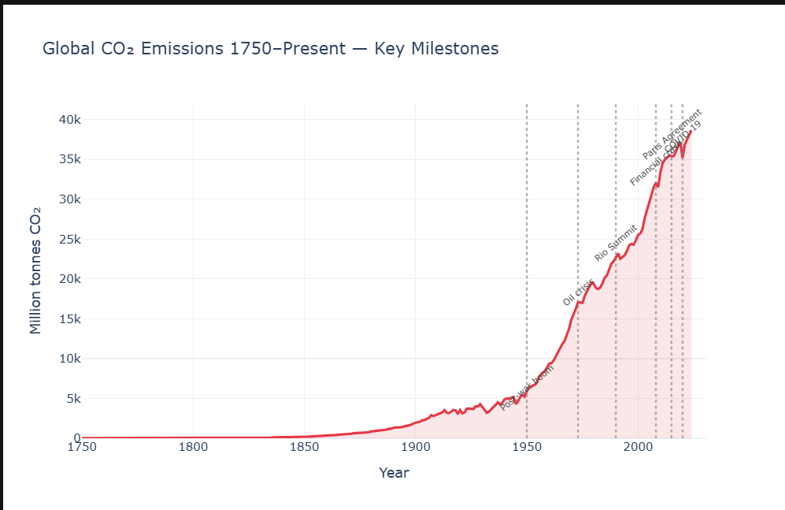
Based on the scatterplot matrix provided in the screenshot, the following insights can be extracted along with suggested plot types for better visualization:

Extracted Insights
- Strong Positive Correlation Between Wealth and Environmental Impact: There is a clear positive association between gdp_per_capita, energy_per_capita, and co2_per_capita. Countries that fall into the "Fossil-intensive Rich" cluster (blue points) are consistently positioned at the high end of both economic prosperity and emissions, while "Low-emission Developing" countries (orange points) are concentrated at the low end.
- Technological Adoption Linked to GDP: The plots show a steady upward trend between gdp_per_capita and internet_users_per_100, suggesting that as national wealth increases, the proportion of the population with internet access also grows significantly.
- Inverse Relationship Between Growth and Wealth: There appears to be a negative correlation between population_growth and gdp_per_capita. Wealthier nations generally exhibit lower rates of population growth compared to lower-income clusters.
- Distinct Cluster Grouping: The visualization facilitates the identification of distinct country clusters based on their developmental and environmental profiles.

Suggested Plots for Visualization
To more effectively communicate these specific insights, the sources suggest the following plot types:
- Scatterplot with Strategic Color Encoding: While the matrix provides an overview, a single, larger scatterplot focusing on two key variables (e.g., GDP vs. CO₂ emissions) would be more effective for showing the strength of the association. To maintain cluster information, you should continue using hue (color) to encode the different country groups, as this is an effective way to represent nominal categories.
- Bubble Chart: To visualize three quantitative variables simultaneously, a bubble chart is ideal. For instance, you could plot GDP per capita against CO₂ per capita, with the dot size representing energy_per_capita to show if energy use is the primary driver of emissions.
- Small Multiples (Faceting): To avoid the visual clutter of overlapping points from different clusters, you can use small multiples to create a separate scatterplot for each cluster. Arranging these in a grid allows for easy comparison of the unique trends within each group without them interfering with one another.
- Scatterplot with Partial Transparency and Jittering: In dense areas of the plot (such as the "Developing" cluster), points often overlap, hiding the true number of observations. Applying partial transparency allows darker shades to indicate high-density regions, and adding a small amount of jitter can reveal individual data points that have identical values.
- Marginal Density Plot: To see both the relationship between two variables and their individual distributions, you can combine a scatterplot with density plots in the margins. This provides a detailed look at the core correlation while simultaneously showing the peak density for each variable along the axes.

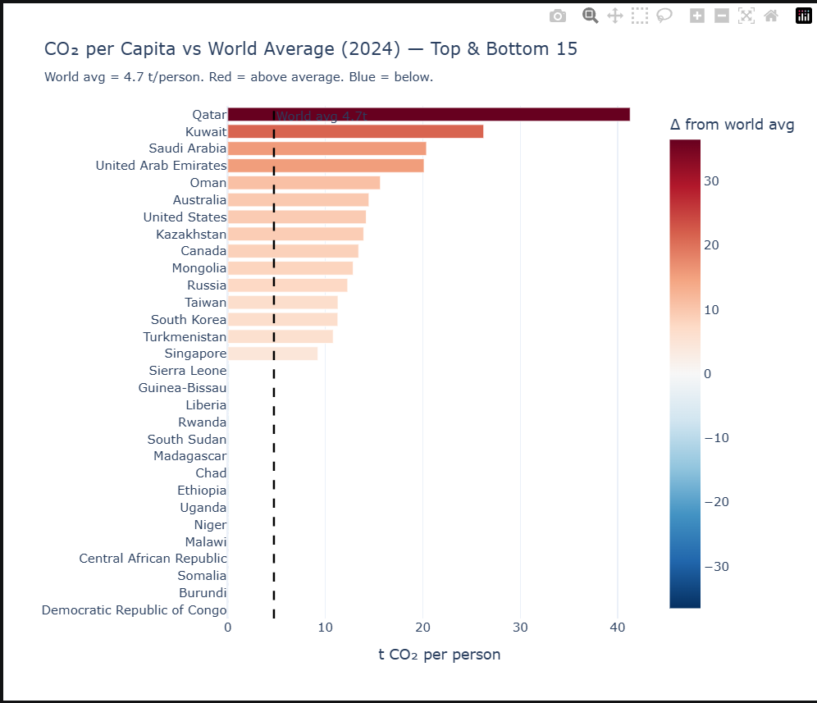
The screenshot displays a horizontal bar chart comparing the top and bottom 15 countries by $CO_2$ emissions per capita against a world average of 4.7 tonnes per person in 2024.

Extracted Insights
- Extreme Emission Disparity: There is a vast inequality between the highest and lowest emitters. Qatar is a significant outlier, emitting over 40 tonnes per person, which is nearly nine times the world average.
- Geographic and Economic Clustering: The top emitters are primarily concentrated in oil-producing nations (Qatar, Kuwait, Saudi Arabia, UAE) and wealthy, developed economies (Australia, United States, Canada).
- Negligible Emissions in Developing Nations: The bottom 15 countries, largely situated in Sub-Saharan Africa (e.g., Rwanda, Chad, Malawi, DRC), have emissions so low they are virtually invisible on a linear scale, showing a "zero" or near-zero bar length relative to the top emitters.
- Effective Use of Color Highlighting: The plot leverages color saturation (dark red for highest $\Delta$ from average) to provide visual cues that help the brain quickly target the most extreme points of interest.

Suggested Plot to Visualize the Data
While the current horizontal bar chart is effective for ranking, the linear scale fails to represent the data for the bottom 15 countries effectively. To better visualize this insight, the following is suggested:
- Dot Plot with a Logarithmic Scale:
  - Why: Ratios or data covering multiple orders of magnitude (from near-zero to 40+) are often obscured on a linear scale. A logarithmic axis would ensure that the differences between the low-emitting countries are visible and comparable, rather than appearing as flat lines at zero.
  - Implementation: Using a dot plot instead of bars (as seen in the Oceania GDP example) would avoid the issue of bar heights/lengths altogether, focusing the reader's attention on the specific position of each country along the scale.
- Cartogram or Choropleth Map:
  - Why: Maps are excellent for showing geographic trends. A cartogram could distort country sizes based on their per-capita emissions, providing a vivid and memorable representation of which regions "weigh" the most in terms of individual carbon footprints.
- Slopegraph (for Time Series):
  - If data from previous years were available, a slopegraph would be ideal to show whether these top and bottom countries are increasing or decreasing their emissions over time, highlighting the rate of change for each category.

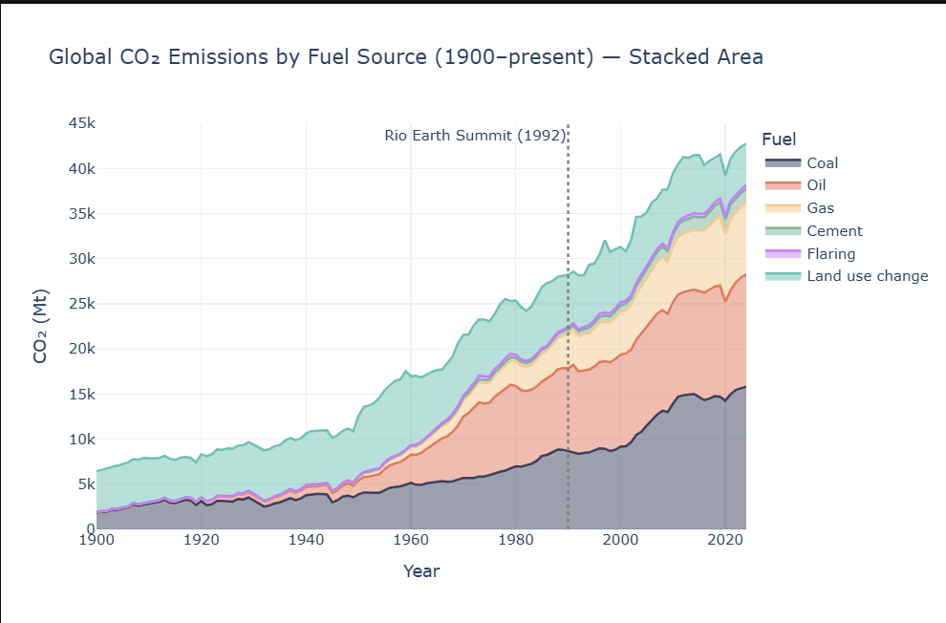
The screenshot provided is a Stacked Area Chart displaying global $CO_2$ emissions by fuel source from 1900 to the present, measured in Megatonnes (Mt).

Extracted Insights
- Massive Total Growth: Global $CO_2$ emissions have experienced an explosive upward trend, rising from roughly 5,000 Mt in 1900 to over 40,000 Mt in recent years.
- Dominance of Coal and Oil: Fossil fuels have largely displaced land-use changes as the primary emission drivers. Coal has emerged as the single largest contributor, showing a particularly sharp increase in the early 2000s.
- Limited Impact of International Summits: Despite the 1992 Rio Earth Summit (indicated by the dashed line), emissions did not plateau or decline; instead, they continued to climb significantly, driven by the expansion of coal, oil, and gas.
- Stability of Land Use Emissions: In contrast to the volatile and rapid growth of fossil fuels, emissions from "Land use change" have remained relatively stable in absolute volume throughout the century.

Suggested Plots to Visualize the Data
While the current stacked area chart is good for showing total volume, it has the disadvantage of shifting baselines, which makes it difficult to compare the exact trends of individual fuel sources. To better visualize these insights, the following plots are suggested:
- Small Multiples (Line Charts): By creating a grid of individual line charts (one for each fuel source), you can remove the "stacking" effect. This would allow a viewer to see the precise individual trajectory of coal versus land-use changes without their baselines being affected by other categories.
- Slopegraph: To emphasize the insight regarding the 1992 Rio Summit, a slopegraph could be used to compare two specific points in time: 1992 vs. the Present. This would vividly show the absolute value increase and the relative rate of change for each fuel category since the summit.
- Line Graph with Color Highlighting: To draw focus to the dominance of coal, you could use a line graph where the coal line is in a vivid, standing-out color, while the other categories are grayed out. This leverages color saturation to help the brain more quickly target the most significant point of interest.

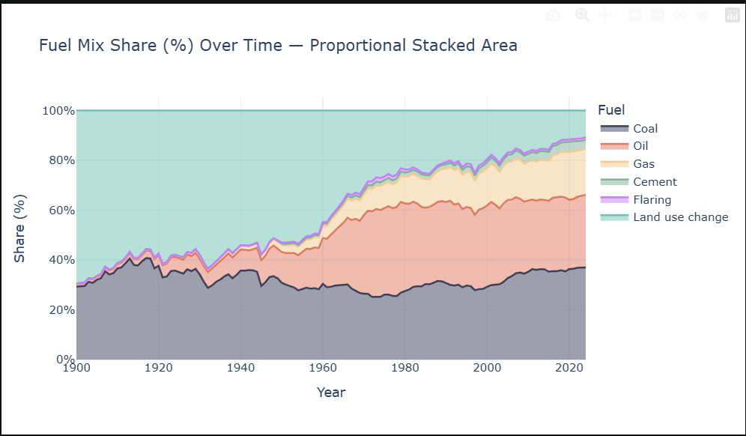
Based on the provided screenshot, the visualization is a proportional stacked area chart depicting the Fuel Mix Share (%) from 1900 to approximately 2024.

Insights Extracted from the Screenshot
- Dominance of Land Use Change in the Early 20th Century: In 1900, "Land use change" accounted for the vast majority of the fuel mix share, approximately 70%. By the 2020s, its share had significantly diminished to roughly 10%.
- Rapid Rise of Fossil Fuels: The combined share of Coal, Oil, and Gas grew from roughly 30% in 1900 to nearly 90% by 2020.
- The Post-1950 "Oil Boom": The share of Oil (the orange area) was negligible in 1900 but saw a rapid, steep increase starting around 1950, eventually stabilizing as a major component of the total share.
- Coal's Resilient Share: Unlike land use change, Coal (the bottom dark area) has remained a significant and relatively stable portion of the mix, hovering around 30-40% throughout the entire 120-year period.
- Emergence of Natural Gas: Significant growth in the share of Gas (the yellow area) began prominently after 1960.

Suggested Plots for Alternative Visualization
While the proportional stacked area chart is excellent for showing how parts of a whole change over time, it suffers from shifting baselines, making it difficult to compare the exact growth rates of individual middle categories like "Oil" or "Gas". Depending on your goal, the following plots are suggested:
- To compare exact shares at specific intervals: Use Side-by-side bar charts for snapshot years (e.g., 1900, 1950, 2020). This format allows for an easy visual comparison of relative proportions that is "nearly impossible" in stacked formats.
- To track the independent growth of each fuel type: Use multiple Line charts (possibly as small multiples). This avoids baseline distortion, allowing you to see if a specific fuel's growth is accelerating or stabilizing more accurately than a stacked area.
- To highlight the transition from land-based to industrial energy: Use a Stacked Bar chart with only two categories (e.g., "Land Use Change" vs. "All Other Sources"). The sources note that the problem of shifting internal bars "disappears if there are only two bars in each stack," making the transition point much clearer.
- To visualize the "shape" of adoption: A Ridgeline plot could effectively show the "evolution" of each fuel source over time, allowing for an easy comparison of density shapes and relative peak periods across the century.

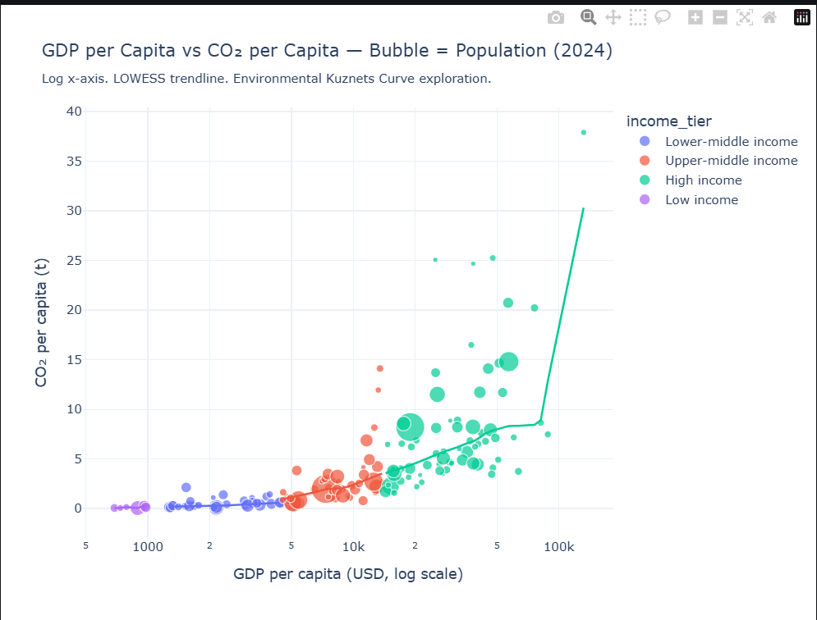
Based on the provided screenshot, which depicts a bubble chart correlating GDP per capita (on a log scale) with CO₂ emissions per capita, here are the extracted insights and suggested alternative plots for visualization.

Insights Extracted from the Screenshot
- Strong Positive Correlation: There is a clear overall trend showing that as GDP per capita increases, CO₂ emissions per capita also rise. This is highlighted by the LOWESS trendline.
- Income Tier Progression: Countries cluster distinctly by income tier along the x-axis, progressing from Low income (purple) to High income (green).
- Environmental Kuznets Curve (EKC) Deviation: While the chart aims to explore the EKC—a hypothesis that emissions fall after a certain wealth threshold—the trendline shows a sharp upward trajectory for the highest-income nations rather than a decline.
- High-Emission Outliers: Several high-income countries (green bubbles) are significant outliers, emitting well over 20 tonnes of CO₂ per capita, even when compared to other nations with similar GDPs.
- Population Distribution: The largest bubbles (representing the largest populations) are currently concentrated in the lower-middle and upper-middle income tiers, indicating that their future economic growth could have a massive impact on global emissions.

Suggested Plots for Alternative Visualization
While the bubble chart effectively shows three variables (GDP, CO₂, and Population), you could use the following plots to emphasize different aspects of the data:
- Small Multiples (Faceting by Income Tier): To reduce visual clutter and see the specific distribution within each wealth group, you could create four separate scatterplots in a regular grid. This "faceting" allows for a clearer view of individual country variations within their respective economic peers.
- Scatterplot with Marginal Density Plots: To better understand the distribution of each variable independently, you could add density estimates into the margins of the scatterplot. This would show exactly where the majority of countries fall in terms of CO₂ and GDP regardless of their correlation.
- 2D Contour Plot (Density Shading): Because several bubbles overlap (overplotting), a contour plot with shaded areas could be used. Shading regions with increasingly darker colors would provide a "stronger visual impression of increasing point density" where many countries have similar economic and emission profiles.
- Slopegraph (for Time-Series Insight): If you have data from two different years (e.g., 2000 vs. 2024), a slopegraph could show the "relative increases and decreases" in CO₂ per capita for each country over that period. This would quickly highlight which nations have successfully decoupled economic growth from carbon emissions.

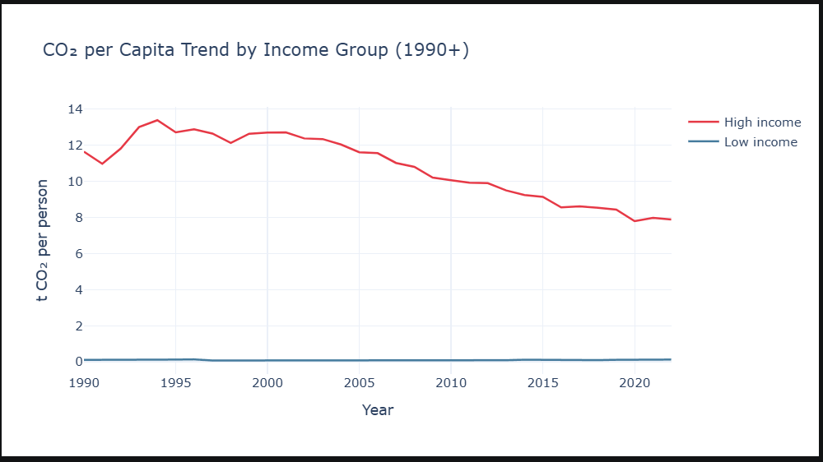
The provided screenshot shows a line chart titled "CO₂ per Capita Trend by Income Group (1990+)", comparing per capita emissions for high-income and low-income groups.

Insights Extracted from the Screenshot
- Massive Emissions Disparity: There is a stark and consistent gap between income levels. High-income groups started the 1990s emitting approximately 11–12 tonnes of CO₂ per person, while low-income groups emitted near-zero amounts.
- Peak and Steady Decline for High-Income Group: Emissions for high-income nations peaked in the mid-1990s (reaching nearly 14 tonnes per person) and have shown a consistent downward trend since then, dropping to roughly 8 tonnes by 2022.
- Stagnation in Low-Income Groups: The line for low-income countries remains virtually flat along the zero-baseline for the entire 30-year period, indicating no significant increase in per capita carbon footprints despite decades of global development.

Suggested Plots for Alternative Visualization
To improve the communication of this data, you could use the following alternative visualizations based on the principles in the sources:
- Logarithmic Scale Line Chart: In the current linear scale, the low-income group appears as a flat line, making it impossible to see any internal trends or growth. A logarithmic scale on the y-axis would reveal the "relative increases and decreases" for low-income nations that are currently invisible.
- Slopegraph: If the goal is to highlight the success of high-income nations in reducing emissions over time, a slopegraph comparing 1990 to 2022 would effectively show the "visual increase or decrease in rate of change" for each category.
- Annotated Line Chart: To provide better context, you could use text annotations directly on the graph to identify specific points of interest, such as the peak in the mid-90s or the percentage of total decline achieved by the high-income group.
- Small Multiples (Faceting): If the dataset included more income tiers (e.g., upper-middle and lower-middle), using small multiples would allow each group to have its own panel. This "faceting" would prevent the high-income data from visually overwhelming the others.

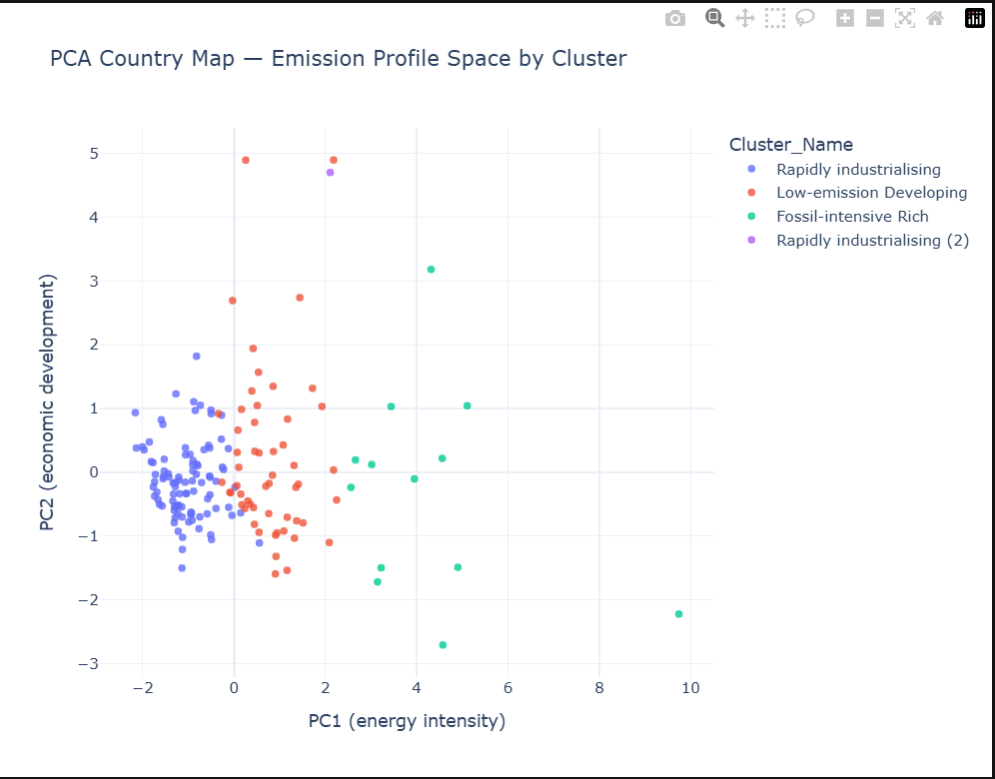
Based on the provided screenshot of the PCA Country Map, which plots countries in an "Emission Profile Space" based on Energy Intensity (PC1) and Economic Development (PC2), here are the extracted insights and suggested alternative visualizations.

Insights Extracted from the Screenshot
- Distinct Cluster Groupings: The countries are categorized into four distinct clusters based on their emission profiles. The "Rapidly industrialising" cluster (dark blue) is the most dense and is characterized by low energy intensity (ranging from -2 to 0).
- Energy Intensity Outliers: The "Fossil-intensive Rich" cluster (teal) is the most spread out along the x-axis, with one significant outlier showing an energy intensity score of nearly 10, far beyond any other country.
- Economic Development Variance: The "Low-emission Developing" cluster (orange) shows a wide range of economic development (PC2), with some countries scoring near -2 and others approaching 5, despite sharing similar energy intensity profiles.
- Significant Overplotting: In the lower-left quadrant (the "Rapidly industrialising" group), many data points overlap so closely that it is difficult to determine the exact number of countries or the true center of the distribution in that region.

Suggested Plots for Alternative Visualization
While the current scatterplot is a standard way to show PCA results, the following alternatives could enhance clarity based on the principles in the sources:
- Scatterplot with Partial Transparency or Jittering: To address the overplotting in the "Rapidly industrialising" cluster, applying partial transparency would allow overlapping points to appear as darker shades, indicating higher density. Alternatively, jittering (adding small amounts of random noise) could help reveal individual points that are currently hidden.
- 2D Contour Plot (Density Shading): Instead of just points, using a contour plot with shaded regions would provide a "stronger visual impression of increasing point density" toward the center of each cluster, making the distribution clearer for the dense blue and orange groups.
- Small Multiples (Faceting): To reduce visual clutter and compare the clusters more easily, you could use small multiples by creating a regular grid of four panels, one for each cluster. This "faceting" ensures each panel uses the same axis ranges, allowing for a direct comparison of the "shape" of each group.
- Marginal Density Plots: Adding density estimates into the margins of the scatterplot would allow you to see the independent distribution of "energy intensity" and "economic development" for each cluster simultaneously, helping to highlight where the majority of countries fall on each axis.
- 2D Histogram: You could subdivide the x-y plane into small rectangles and color them by the count of countries falling into each bin. This would turn the scatterplot into a heatmap-style grid, effectively highlighting broader trends in the data density.

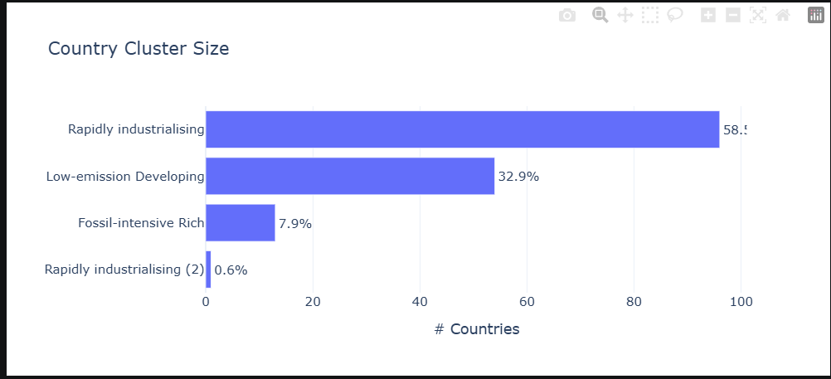
Based on the provided screenshot, which shows a horizontal bar chart titled "Country Cluster Size," here are the extracted insights and suggested alternative visualizations.

Insights Extracted from the Screenshot
- Dominance of the "Rapidly Industrialising" Group: This cluster is by far the largest, accounting for 58.5% of the total countries in the dataset.
- Significant Secondary Group: The "Low-emission Developing" cluster represents approximately one-third (32.9%) of the total.
- Minority Representation: The "Fossil-intensive Rich" (7.9%) and "Rapidly industrialising (2)" (0.6%) clusters make up a very small fraction of the global profile, totaling less than 10%.
- Inconsistent Visual Units: There is a discrepancy between the x-axis label, which indicates "# Countries" (absolute count), and the data labels on the bars, which are shown as percentages. This can lead to confusion regarding whether the axis scale refers to individual nations or a percentage of the total.

Suggested Plots for Alternative Visualization
Since the data represents parts of a whole (summing to 99.9%), the following plots are suggested based on the principles in the sources:
- 100% Stacked Bar Chart: To emphasize that these clusters together represent the entire global set, a single stacked bar would be more effective. This would visually demonstrate the "proportions as parts of the total" more intuitively than separate bars.
- Treemap: A treemap would be an excellent choice to visualize these proportions. It uses a large rectangle subdivided into smaller ones, where the area of each represents its percentage. This format is particularly good at showing the relative "size" of the clusters in a compact space.
- Dot Plot: If the primary goal is a fast and accurate comparison of the values, a dot plot is often more effective than a bar chart. It reduces visual noise and directs the audience's attention specifically to the data points (the percentages) rather than the area of the bars.
- Pie Chart (With Caution): While pie charts are often used for parts-to-whole data, the sources warn that they can make comparing relative shares "nearly impossible". However, with only four categories, a pie chart could still provide a quick "at-a-glance" view of the distribution if the labels are clear.
- Strategic Use of Color: Currently, all bars are the same color. You could use color as a tool to highlight the "Rapidly industrialising" cluster to vividly stand out against the rest, helping to tell a specific story about that group.

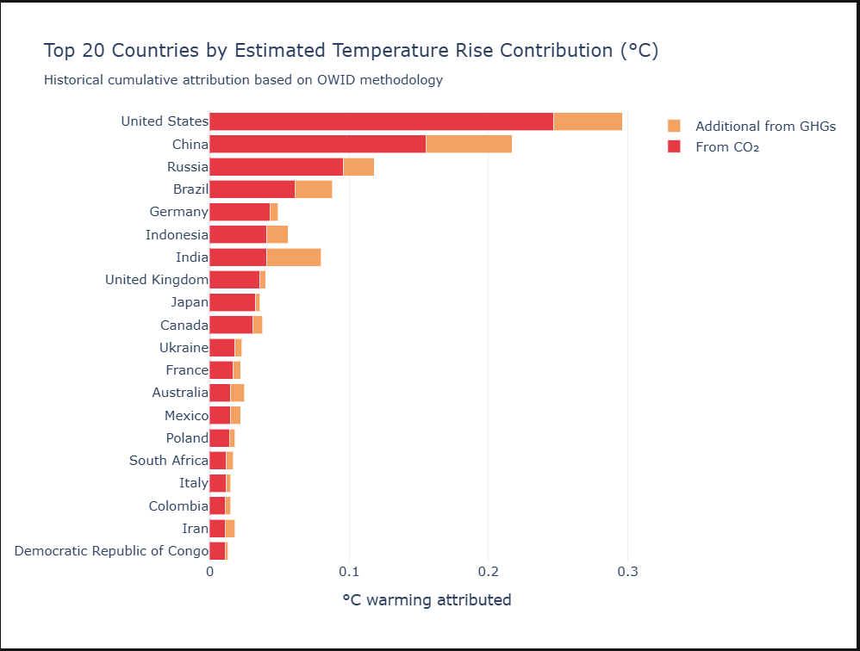
Based on the provided screenshot, here are the extracted insights and suggested alternative plots for visualization:

Insights from the Data
- The United States is the leading contributor to estimated temperature rise among the top 20 countries, with a historical cumulative attribution nearing 0.3°C.
- China follows as the second-largest contributor, with a total attributed warming of approximately 0.22°C.
- CO2 emissions are the primary driver of temperature rise for almost all the listed countries (represented by the red segments of the bars).
- Significant variation in GHG composition exists between countries. For example, while the majority of attributed warming for countries like the U.S., Russia, and Germany comes from CO2, countries like Brazil and India show a notably larger proportion of "Additional from GHGs" (orange segments) relative to their total contribution.

Suggested Plots for Visualization
While the current stacked bar chart is effective at showing the total attributed warming for each country, it has limitations. According to the sources, stacked bars make it difficult to compare the individual components (like "Additional from GHGs") across different countries because they do not share a common baseline.
Depending on your goal, you might consider these alternatives:
- Side-by-Side Bar Chart: If the goal is to compare the specific magnitudes of CO2 vs. other GHGs across different nations, side-by-side bars are superior. This arrangement gives each category a common baseline at zero, making it much easier for the eye to compare the orange segments across the list.
- Dot Plot: To provide a cleaner look at the ranking of total contributions, a dot plot could be used. This reduces "visual noise" compared to thick bars and allows for precise reading of values along the x-axis.
- 100% Stacked Bar Chart: If you want to focus specifically on the relative proportion of CO2 versus other GHGs for each country (regardless of their total contribution size), a 100% stacked bar chart would normalize all bars to the same length, highlighting the percentage breakdown for each.

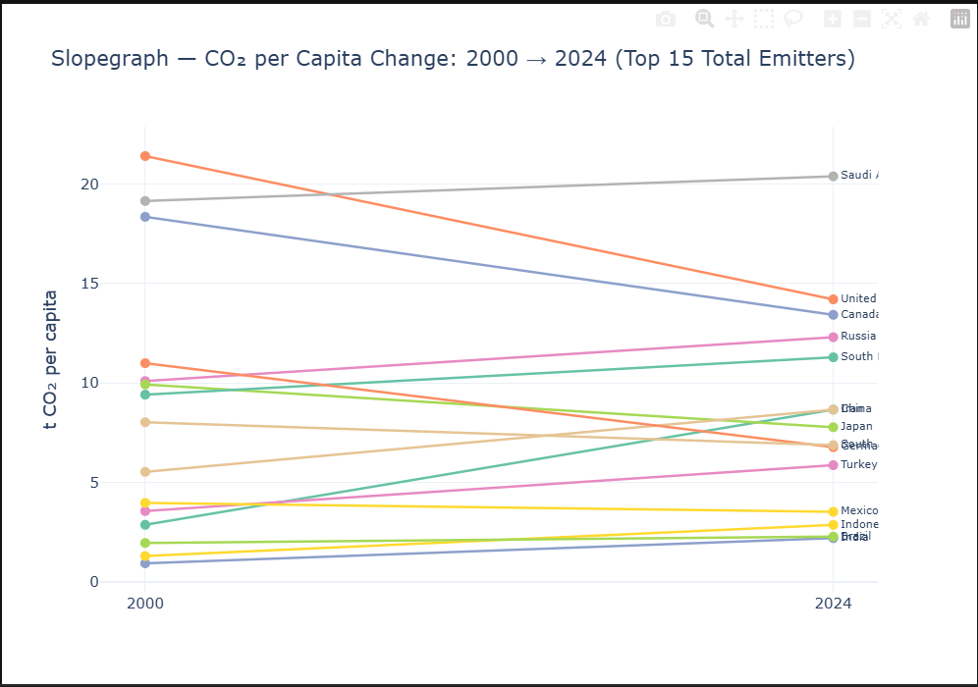
Based on the provided screenshot, here are the extracted insights and suggested alternative visualizations drawn from the sources.

Insights from the Data
- Significant Decreases in Developed Nations: The United States and Canada started with the highest per capita emissions in 2000 (above 18 t CO2) but have shown a sharp downward trajectory through 2024.
- Saudi Arabia's Rise to the Top: Unlike the other high-emitters from 2000, Saudi Arabia’s emissions increased over the period, making it the highest per capita emitter among the top 15 by 2024.
- Rapid Growth in Emerging Economies: China, India, and Indonesia show distinct upward slopes, reflecting steady increases in per capita CO2 emissions over the two-decade span.
- Diverging Global Trends: The plot reveals a clear "crossing" effect where many developing nations are increasing their footprint while traditional Western industrial powers are reducing theirs.

Suggested Plots for Visualization
While the current Slopegraph is an effective choice for showing relative increases/decreases and absolute values between two points in time, you could use these alternatives to enhance the story:
- Small Multiples (Faceting): The current chart suffers from some "spaghetti" overlap in the middle. According to the sources, you could use Small Multiples—arranging individual country plots in a regular grid—to allow the reader to see each nation's trend clearly without visual interference from others.
- Heatmap: If the primary goal is to highlight broader trends and emission intensity rather than precise values, a Heatmap would be excellent. Mapping the data values onto a color scale (e.g., darker for higher emissions) would make the divergence between regions immediately obvious to the eye.
- Diverging Bar Chart: To focus specifically on the magnitude of change, you could calculate the net difference (2024 value minus 2000 value) and plot it as a diverging bar chart. Countries that reduced emissions would have bars extending to the left (negative), and those that increased would extend to the right (positive), allowing for an easy ranking of "most improved" versus "most increased".
- Dumbbell Plot (Dot Plot variant): To reduce "visual noise" compared to crossing lines, a dot plot showing the 2000 and 2024 values connected by a thin line for each country would provide a cleaner look and allow for precise reading along the x-axis.

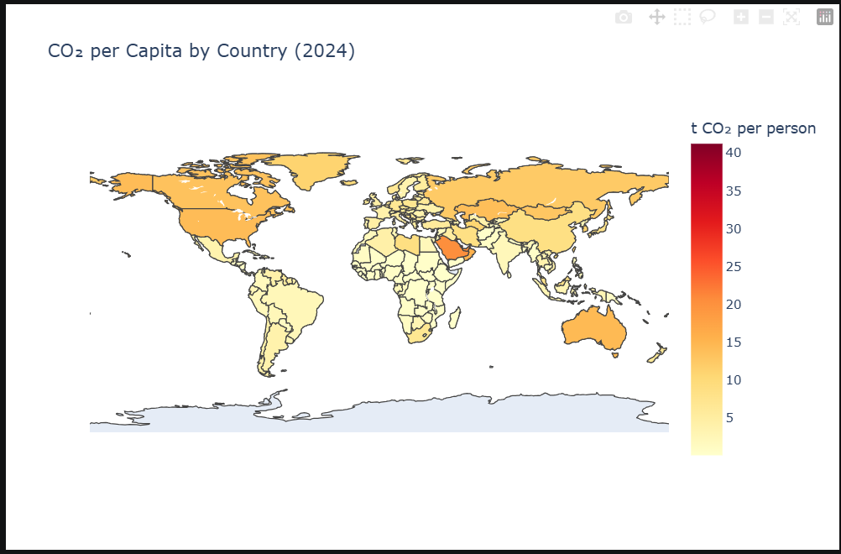
Based on the screenshot provided, the following insight and visualization suggestions can be extracted:

Extracted Insight
The screenshot is a choropleth map illustrating significant global inequality in $CO_2$ emissions per capita for the year 2024. A clear regional disparity exists:
- High Emissions: Nations in the Northern Hemisphere (USA, Canada, Russia), Australia, and major oil-producing regions in the Middle East (such as Saudi Arabia) show the highest per-capita emissions, indicated by darker orange and red shades.
- Low Emissions: In contrast, most of Africa, South America, and Southern Asia exhibit very low per-capita emissions, represented by light yellow shades.

Suggested Plot for Visualization
To more effectively communicate this insight, you should use a sorted horizontal bar plot or a dot plot:
- Sorted Horizontal Bar Plot: While the map is good for showing broad geographic trends, it makes it difficult to compare exact values or rank countries because of their differing physical sizes. A horizontal bar plot allows for a clear, direct comparison of quantitative values. Sorting the bars from highest to lowest emissions is essential to make the figure intuitive and meaningful.
- Dot Plot: As an alternative, a dot plot is particularly useful for comparing single quantitative values across categories (like countries). The sources suggest that dot plots can be superior to bars when you want to avoid issues with bar lengths and focus purely on the position of data points along a scale, such as with GDP or emissions data.
- Enhancing the Plot with Color: To add further depth, you could use a qualitative color scale to color the bars or dots by geographic region (e.g., North America, Africa, Middle East). This would allow the viewer to see both the individual country rankings and regional clusters simultaneously.
By moving from a map to a sorted bar or dot plot, you transform the data from a geographic overview into a clear ranking that highlights which specific nations are the highest per-capita contributors.

