**E-book-reader Web-app**

**Project Planning Report**

Team 3

Project: E-book-reader Web-app

Winter Semester

Vietnamese-German University

27th September 2021

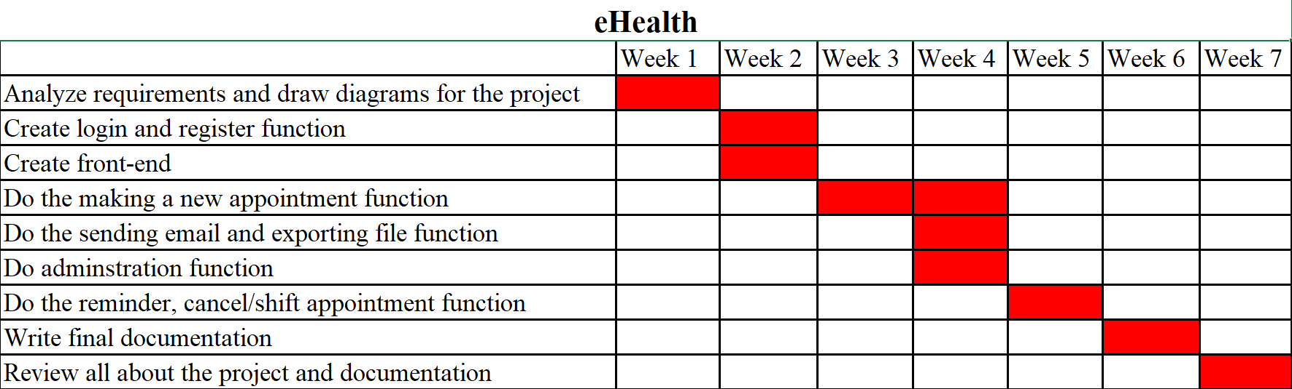

*12 February 2021*

Long Tran Phan Phuc

Team 3

Class: Project

Vietnamese-German University

Prof. Manuel Clavel

Frankfurt University of Applied Sciences

Dear Prof. Manuel Clavel,

Enclosed is our Project Planning Report for our class project, E-book-reader Web app,submitted to partially meet the requirements for ‘Project’ Subject.

This Report discusses the context for the project, gives a detailed description of the project in terms of software design, and addresses the feasibility of the project.

I appreciate the time you are taking to review this Report and hope that it meets your approval. If you have any further questions, feel free to contact me by e-mail: long.tranphanphuc@stud.fra-uas.de.

Sincerely yours,

Long Tran Phan Phuc

Team Leader

Vietnamese-German University

Winter Semester

Project

**Project Planning Report**

**for**

**E-book-reader Web-app**

Long Tran Phan Phuc (15124)

Quan Tran Trung (13886)

Trang Nguyen Vu Thuy (14852)

Hoang Tong Minh (10026)

Dat Nguyen Tat (13948)

Instructor: Prof. Manuel Clavel

Due date: 22nd October 2021

# Disclaimer

We declare that this report is a product of our own work, unless otherwise referenced. We also declare that all opinions, results, conclusions and recommendations are our own and may not represent the policies or opinions of Frankfurt University of Applied Sciences.

Long Tran Phan Phuc

15124

Team Leader

Quan Tran Trung

13886

Trang Nguyen Vu Thuy

14852

Hoang Tong Minh

10026

Dat Nguyen Tat

13948

Vietnamese-German University

Winter Semester

Project Course

# Abstract

E-book-reader Web-app

Team 3

The E-book-reader is a web application built with Java for back-end, with React JS for front-end and Sql for database, for the purpose of providing a graphical user interface with basic features for writers, readers to browse through a list of existing books to then create, edit and organize books (writers) as well as to select, read books (readers)

The system also includes an integrated database for data management, an interface for both writers and readers, table of contents for each chapter of books, changing font/size of text function and bookmarks for users to easily reading.

This project is a part of the Computer Science curriculum, evaluated and instructed by Prof. Manuel Clavel, and was carried out for us to collect firsthand experiences in Project programming, as well as implementation of a database and functionality.

Key words: Web Application, React JS, Java, Sql

# Table of Contents

Disclaimer 1

Abstract 2

Table of Contents 3

Acknowledgements 4

1. Introduction 1

1.1 Purpose 1

1.2 Audience 1

1.3 Project Scope 1

2. Planning 2

3. Quality Planning 3

4. Risk Management Planning 3

5. Project monitoring plan 4

6. Conclusion 5

# Acknowledgements

We would like to express my deep appreciation to the lecturers of Vietnamese-German University for their explanations and guidance on how to write technical reports, especially Prof. Manuel Clavel, the instructor of this project.

We would also like to thank all my friends and classmates for their suggestions and assistance during the writing of this report.

During the 1st week of this project, tasks were divided up as illustrated in the following table:

| Task | Involvement | | | | |
| --- | --- | --- | --- | --- | --- |
| Long | Quan | Trang | Hoang | Dat |
| Write documentation |  | x |  | x |  |
| User Interface (Front-end) | x |  | x |  | x |
| Design overall structure | x | x | x | x | x |
| Draw diagrams | x | x | x | x | x |
| Learn basis React JS | x | x | x | x | x |
| Render text | x |  | x |  | X |
|  |  |  |  |  |  |

# Introduction

## Purpose

This 1st-week Report for the Project, E-book-reader Web-app, is submitted for general planning and schedule of doing project and includes quality management, risk management and project monitoring plans, which can be upgraded, changed for the next 3 weeks.

## Audience

The intended audience of this document is the course instructor, Prof. Manuel Clavel, who will use it as the basic planning of our team project as well as partly determination of a portion of our grade for the class “Project”.

## Project Scope

This report provides a detailed description of the team planning, task involvement, schedule for the completion of the project and some other general aspects (risk/quality/monitoring management).

Not included in this report is the progress of doing project (which will mentions in week 2nd and 3rd, the detailed, completed whole web-app (in progress) as well as the final report (week 4th)

# Planning

Duration: 4 weeks (27th September, 2021 – 21st October, 2021)

* Week 1: PLANNING AND LEARNING
  + Duration: 27th September, 2021 – 3rd October, 2021
  + Create schedule for developing the web- app
  + Project planning:
    - Each 1 - 3 days, the team should have a meeting to assess progress.
  + Create homepage using React JS: 5 members (learn basics of React JS)
    - Homepage with title, name of the page, login button, and 2 buttons ("Author access", "Reader access")
    - Login address will be used to keep track of user

🡺 Acceptance test: properly display the homepage with correct user.

* + Create environment for author to CREATE a new book and EDIT unpublished book: 5 members (learn basics of React JS)
    - Editing interface is like Markdown and a preview interface: Markdown syntax preview

🡺 Acceptance test: authors can create and edit their unpublished books

* Week 2: DEVELOPE CREATE AND EDIT FEATURES
  + Duration: 4th October, 2021 – 10th October, 2021
  + Iteratively continue the work (homepage, edit interface for authors) from previous week (if any).
  + Create a database using SQL:
    - For storing user name
    - For storing published books
* Week 3: DEVELOPE FEATURE FOR PEOPLE TO READ BOOKS
  + Duration: 11th October, 2021 – 17th October, 2021
  + This feature is for any user to read published books
  + Technology: React JS (front-end), Java (back-end), Sql (database)
  + Number of members for this task: undecided
  + Acceptance test: users can use the features in the BASIC REQUIREMENTS
* Week 4: DEVELOPE and PRESENT FINAL PRODUCT
  + Duration: 18th October, 2021 – 22nd October, 2021
  + Fix bugs and finalize the web application.

# 3. Quality Planning

The design of the Web-app must satisfy all of the features that the users need to include:

* Interface for Writer/Author:
  + Creating (book) function
  + Editing function
  + Organizing (in chapters) function
* Interface for Reader/User:
  + Selecting (book) function
  + Changing font, size function
  + Copying text function
  + Table of contents (for book-chapter traversal)
  + Bookmark (and bookmark traversal)

Quality control:

* Closely following the basic features and comments provided by Prof. Manuel Clavel
* All team members should do tests for each feature, function after coding and overall test for the whole project (Writer aspect, Reader aspect, whole Web-app)

# 4. Risk Management Planning

Project risk:

* Risk in scheduling:
  + Cause by shortage of time, limit of knowledge about technology, focusing to much on optional/unimportant features
  + Result in delaying the planning of project
* Risk in technique/processing:
  + Cause by bugs, errors
    - Occur during coding or hide (maybe due to lack of knowledge, experiment of developers)
    - Occur due to adding optional features (may require lots of changes)
  + Cause by devices not satisfying or supporting the project
  + Result in delaying the planning, cannot run the web-app or run unexpectedly

Risk control:

* Finishing all basic feature (as requirement of Prof. Manuel Clavel) before adding optional feature
* Closely following the planning (create at 1st week)
* All members should know basically what to do in the project (React JS, Java, Sql)
* Asking Prof.Manuel Clavel for unclear parts

# Project monitoring plan

Week1:

* After 2-day learning and trying to do the project by Javascript, html, css, we change to React JS and node.js, which we think may be easier – for us – to do the project and run it expectedly

Week 2:

* Iteratively finishing the undone parts of 1st week
* Doing the feature: Create, Edit of Author/Writer part

Week 3 & Week 4: Based on the Progress of the first 2 weeks to consider the next monitoring plan.

# Conclusion

By the time we finished the Planning for the project, we have spent some time working together and gained more practical experience during the process (basically learn Javascript, html, css, React Js, etc). We also learnt how to be flexible and creative when facing problems as one team and one-week working together, especially when we learn a new programming language which can lay a good foundation for us in the future. Finally, we hope to receive more recommendations so as to make a better modification for our E-book-reader web application.