**Assignment 1 – Derivative Securities**

The assignment is to be done individually. Show your work thoroughly. Unless, it will be assumed that you did not solve it.

1. X is a standard normal distribution. Find the answer of E[log($x^{2}$)] upto six digits of precision.

**When number of simulations is 108, E[log()] = -1.27085.**

1. X is a binary random draw which is either u = 1.1 or d = 0.9 with equal probability. X_i is an independent draw from X. Plot the histogram of $\sqrt{N}\left(\frac{1}{N}\sum_{i}{X_{i}}-E\left(X\right)\right)$ for N=10, 100, 1000 by simulating 30000 realizations.

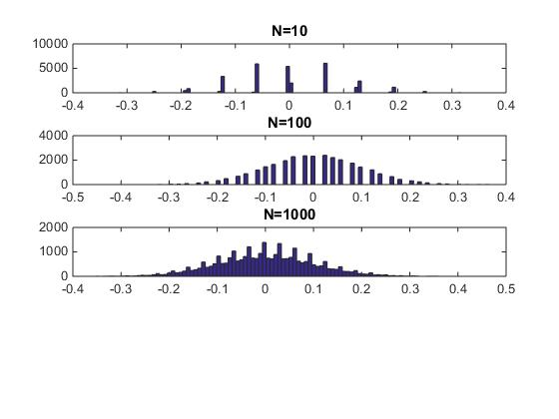

1. Let u=10% and d=-10%. $S_{0}$, today’s stock price, is 1. T is the total number of periods. Assume that $S_{t+1}=S_{t}exp⁡(u/√T)$ with 50% probability $S_{t+1}=S_{t}exp⁡(d/√T)$ with 50% probability. Plot the histogram of realized $S_{T}$ and log($S_{T}$) for T=2,10,100,1000,10000 by simulating $S_{T}$ 30000 times for each T.

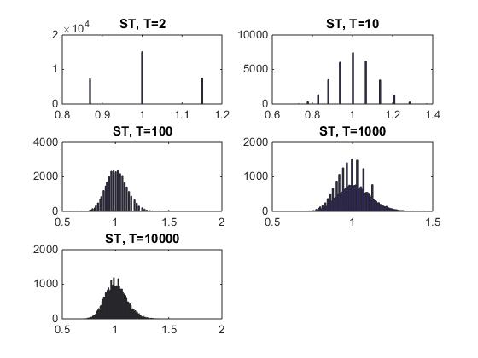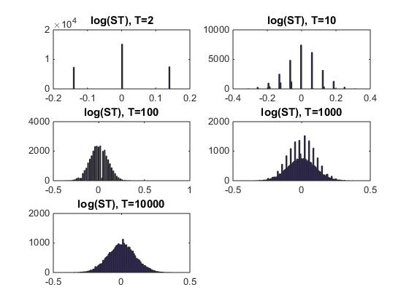

**Appendix**

**Matlab Code**

%% 1.1

sample_size = 10^8;

a = log(normrnd(0,1,[1, sample_size]).^2);

digits(2);

E = mean(a);

sprintf('%0.5f', E)

%% 1.2

N_Max = 1000;

Number_of_Simulation = 30000;

N_under_consideration = [10 100 1000];

Uniform_Draw = rand(N_Max,Number_of_Simulation);

Binomial_Draw = 0.9 + 0.2*( Uniform_Draw > 0.5);

Sum_Binomial_Draw = cumsum( Binomial_Draw );

N = cumsum( ones(N_Max,1) );

N = N*ones(1,Number_of_Simulation);

sqrt_N = sqrt(N);

Boosted_Sample_Mean = sqrt_N .* (Sum_Binomial_Draw ./ N - 1);

figure(2)

subplot(4,1,1)

hist( Boosted_Sample_Mean( N_under_consideration(1),: ),100 );

title('N=10')

subplot(4,1,2)

hist( Boosted_Sample_Mean( N_under_consideration(2),: ),100 );

title('N=100')

subplot(4,1,3)

hist( Boosted_Sample_Mean( N_under_consideration(3),: ),100 );

title('N=1000')

%% 1.3

Number_of_Simulation = 30000;

T = [2 10 100 1000 10000];

result = zeros(length(T), length(Number_of_Simulation));

logResult = zeros(length(T), length(Number_of_Simulation));

for t=1:length(T)

for s=1:Number_of_Simulation

p = 1.0;

for i=1:T(t)

if rand() > 0.5

p = p * exp(0.1 / sqrt(T(t)));

else

p = p * exp(-0.1 / sqrt(T(t)));

end

end

result(t,s) = p;

logResult(t,s) = log(p);

end

end

figure;

subplot(3,2,1)

hist(result( 1,: ), 100);

title('ST, T=2')

subplot(3,2,2)

hist(result( 2,: ), 100);

title('ST, T=10')

subplot(3,2,3)

hist(result( 3,: ), 100);

title('ST, T=100')

subplot(3,2,4)

hist(result( 4,: ), 100);

title('ST, T=1000')

subplot(3,2,5)

hist(result( 5,: ), 100);

title('ST, T=10000')

figure;

subplot(3,2,1)

hist(logResult( 1,: ), 100);

title('log(ST), T=2')

subplot(3,2,2)

hist(logResult( 2,: ), 100);

title('log(ST), T=10')

subplot(3,2,3)

hist(logResult( 3,: ), 100);

title('log(ST), T=100')

subplot(3,2,4)

hist(logResult( 4,: ), 100);

title('log(ST), T=1000')

subplot(3,2,5)

hist(logResult( 5,: ), 100);

title('log(ST), T=10000')