**Assignment 3 – Derivative Securities**

**Quan Zhou**

The assignment is to be done individually. Show your work thoroughly and post your MATLAB code to t-square. Unless, it will be assumed that you did not solve it.

1. The stock follows the GBM as where μ=0.05,σ=0.25. And, the risk free rate is 3% (annualized continuously compounded yield). You are the CEO of the company whose stock is the underlying asset. You know that the company will compensates you with the squared price of the stock value, which is $1,000 currently. You are worried about the risk of your compensation. With the underlying stock and the following two options, construct the zero-investment portfolio such that if you hold the portfolio in addition to your compensation plan, you can erase the delta and gamma risk of your aggregate portfolio - including the compensation plan.
   1. Available options : Call with K=1200, T=1 and Put with K=1600, T=3

Plot the value of hedged portfolio as a function of stock price along with your original compensation plan.

**The zero-investment portfolio consists of -506.6 shares of stocks, -2012 shares of call option and 1155.2 shares of put option.**

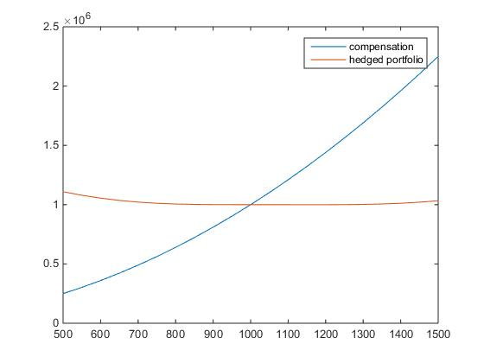

1. The stock follows the GBM as where $μ=0.05, σ=0.25$. And, the risk free rate is 3% (annualized continuously compounded yield). Find the value of American put option with T=0.5 when S_0=100 for different level of K=S_0*exp( $σ\sqrt{T}*(-2:0.1:5))$ and find the critical level of K* such that if K > K*, it is optimal to exercise the American put option right now.

**The price of American put option is always greater or equal to the payoff today. Otherwise, there exists arbitrage opportunity. It is optimal to exercise the option if the price, which is the expected payoff, is identical to today’s payoff. K* = 132.69.**