**Assignment 5 – Derivative Securities**

The assignment is to be done individually. Post your answer and matlab code to t-square.

1. Mixture of Normal Distribution:

Consider two cdfs of A. the equal mixture of N(0,0.5) and N(0,1.5) and B. the standard normal N(0,1). Find the two critical values where the cdfs of those two distribution are crossed. Relate the result into the observation of skewed implied volatility with the stochastic volatility for stock price process.

**The two critical values are 1.6529 and -1.6529 where cdf(A) = cdf(B). The plot of A and B is shown as below.**

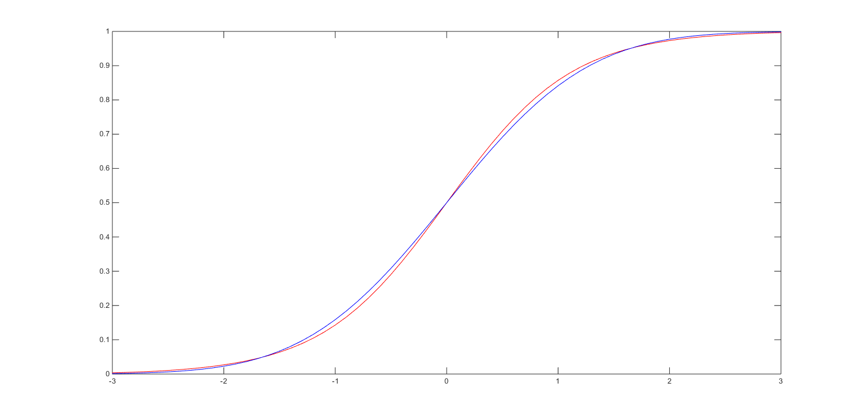

**N(0, 1) can be considered as the real distribution and 0.5*(N(0, 0.5) + N(0, 1.5)) is the distribution we estimated with stochastic volatility. For OTM call option, stock prices are underestimated, so implied volatility is greater than true volatility.**

1. Leverage effect

One of the reason for the negative correlation between the stock price and the volatility is due to the fact that the stock is implicitly the call option on the performance of the firm. To see why this happens, consider the elasticity of call option defined as $\frac{\frac{∂C}{∂S}S}{C}$ = $\frac{\frac{∂C}{C}}{\frac{∂S}{S}}$, which shows the relative price change of option to the price change of stock. In the Black-Scholes model with r=0.03 and $σ=0.30$. Plot the elasticity of call option with K=100 and T=1 as a function of the underlying asset price. Relate the pattern of option elasticity to the leverage effect.

**The plot of elasticity is shown as below.**

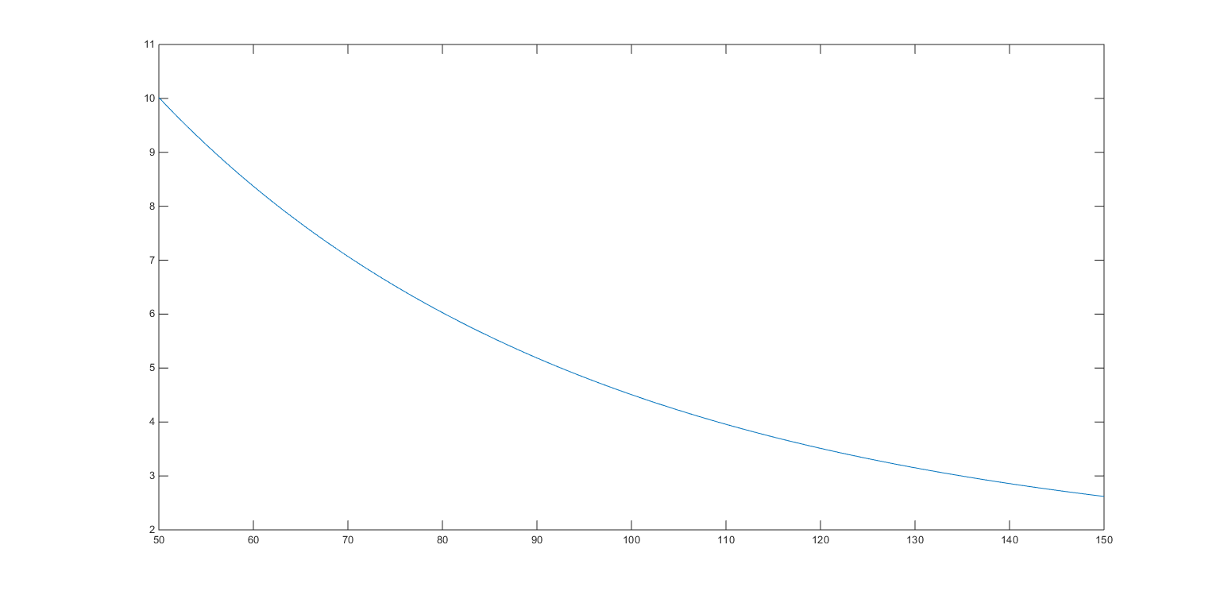

**Elasticity decreases as stock price increases. This means as stock price increases, 1% change in stock price will cause less percentage change in option price and lower price will have higher volatility.**