**Quiz 5 – Derivative Securities**

Submit your answer to t-square.

1. Consider the following cashflow after 1 year.

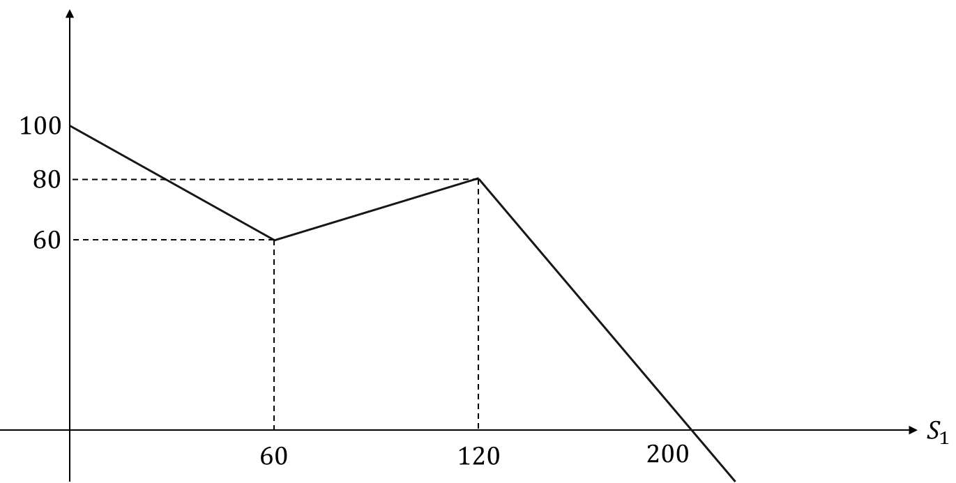

In addition, you have the following information about call options:



Today’s stock price is 150 and the risk free rate over the next 1 year is 10%.

* 1. What is the price of the above cashflow?

**Let A, B, C denote the call options with K=60, 120, 200 respectively, and x, y, z denote number of shares to replicate the given cashflow.**

**If S1 = 120, the payoff of A and B are 0. We have z*(200-120) = 80. So z = 1.**

**If S1 = 60, the payoff of A is 0. We have y*(120-60) + z*(200-60) = 60. So y = -4/3.**

**If S1 = 0, we have x*60+y*120+z*200 = 100. So x = 1.**

**So the price is x*140 + y * 80 + z *5 = 59.**

* 1. What is the delta of the value of the above cashflow?

**According to the replicating portfolio, the delta is 1*0.9+(-4/3 * 0.5) + 1*0.2 = 0.43.**