**Ex08-Report**

Quan Zhou

1. 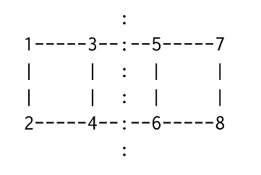The hypergraph is shown as below. There are 2 hyperedges cut by this partition, which are *e5* and *e6.*

e3 e5 e7

e1 e4 e9 e10

e2 e6 e8

|  |  |  |  |  |  |  |  |  |  |  |
| --- | --- | --- | --- | --- | --- | --- | --- | --- | --- | --- |
|  | 1 | 2 | 3 | 4 | 5 | 6 | 7 | 8 | 9 | 10 |
| 1 | x |  | x |  |  |  |  |  |  |  |
| 2 | x | x |  |  |  |  |  |  |  |  |
| 3 |  |  | x | x | x |  |  |  |  |  |
| 4 |  | x |  | x |  | x |  |  |  |  |
| 5 |  |  |  |  | x |  | x |  | x |  |
| 6 |  |  |  |  |  | x |  | x | x |  |
| 7 |  |  |  |  |  |  | x |  |  | x |
| 8 |  |  |  |  |  |  |  | x |  | x |