**Numerical Method hw1**

Quan Zhou

$$f\left(x\right)=(x-1)(x-2)(x-3)(x-4)$$

1. Find five iterative functions.
$$g_{1}\left(x\right)=x-0.8f(x)$$

$$g_{2}\left(x\right)=x+1.1f(x)$$

$$g_{3}\left(x\right)={(x}^{4}-10x^{3}+35x^{2}+24) / 50$$

$$g_{4}\left(x\right)=\sqrt{\left(-x^{4}+10x^{3}+50x-24\right)/ 35}$$

$$g_{5}\left(x\right)=x-\frac{f\left(x\right)}{f^{'}(x)}$$

2. Compute the table.

The table below is obtained through Matlab.

|  |  |  |  |  |  |
| --- | --- | --- | --- | --- | --- |
| x | g1(x) | g2(x) | g3(x) | g4(x) | g5(x) |
| 0.99 | -Inf | 2.72571 | 1 | 1.949102 | 1 |
| 1.01 | 2 | Inf | 1 | 1.939217 | 1 |
| 1.99 | 2 | Inf | 1.000005 | 1.999443 | 2 |
| 2.01 | 2 | 2.72571 | 2.978898 | 2.000568 | 2 |
| 2.99 | 2 | 2.72571 | 2.999997 | 2.93418 | 3 |
| 3.01 | 2 | 3.20722 | 3.000003 | 3.067043 | 3 |
| 3.99 | -Inf | 3.20722 | 3.000824 | 3.999866 | 4 |
| 4.01 | -Inf | Inf | NaN | 4.000129 | 4 |
| 0.5 | -Inf | Inf | 1 | 1.970074 | 1 |
| 1.5 | 2 | Inf | 1 | 1.979689 | 1 |
| 2.5 | 2 | 2.72571 | 2.999769 | 2.058289 | NaN |
| 3.5 | 2 | 3.20722 | 3.000129 | 3.978951 | 4 |

1. Discuss whether x* =1, 2, 3, 4 are points of attraction.

The plots of ${g_{1}^{'}(x),g}_{2}^{'}\left(x\right), g_{3}^{'}\left(x\right), g_{4}^{'}\left(x\right), g_{5}^{'}(x)$ are as follows.

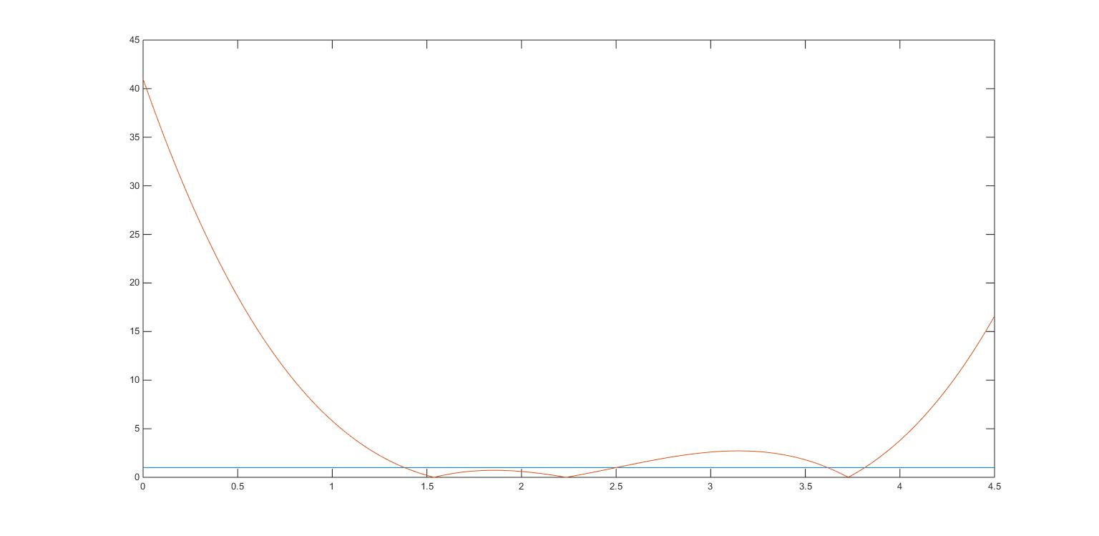

Fig1. $g_{1}^{'}(x)$

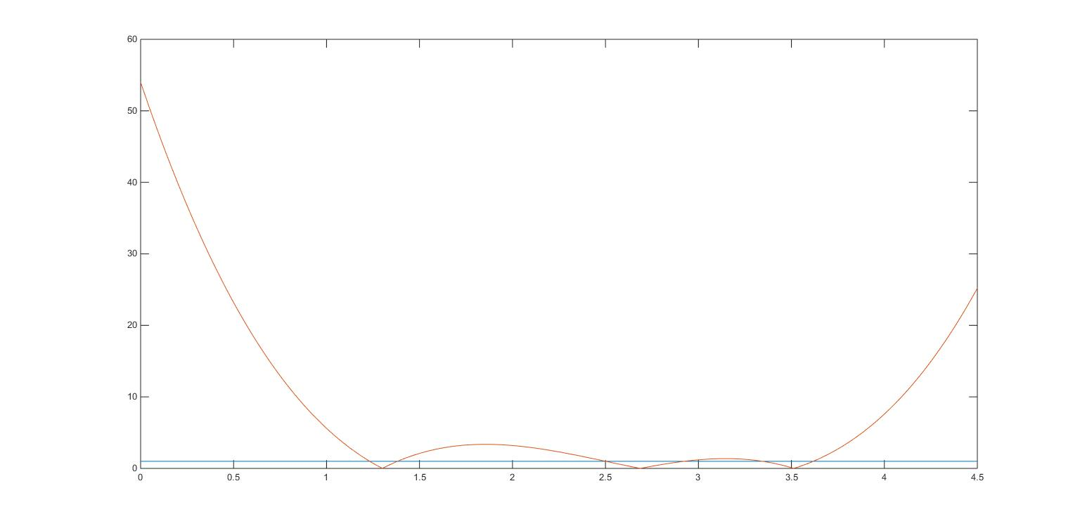

Fig2. $g_{2}^{'}(x)$

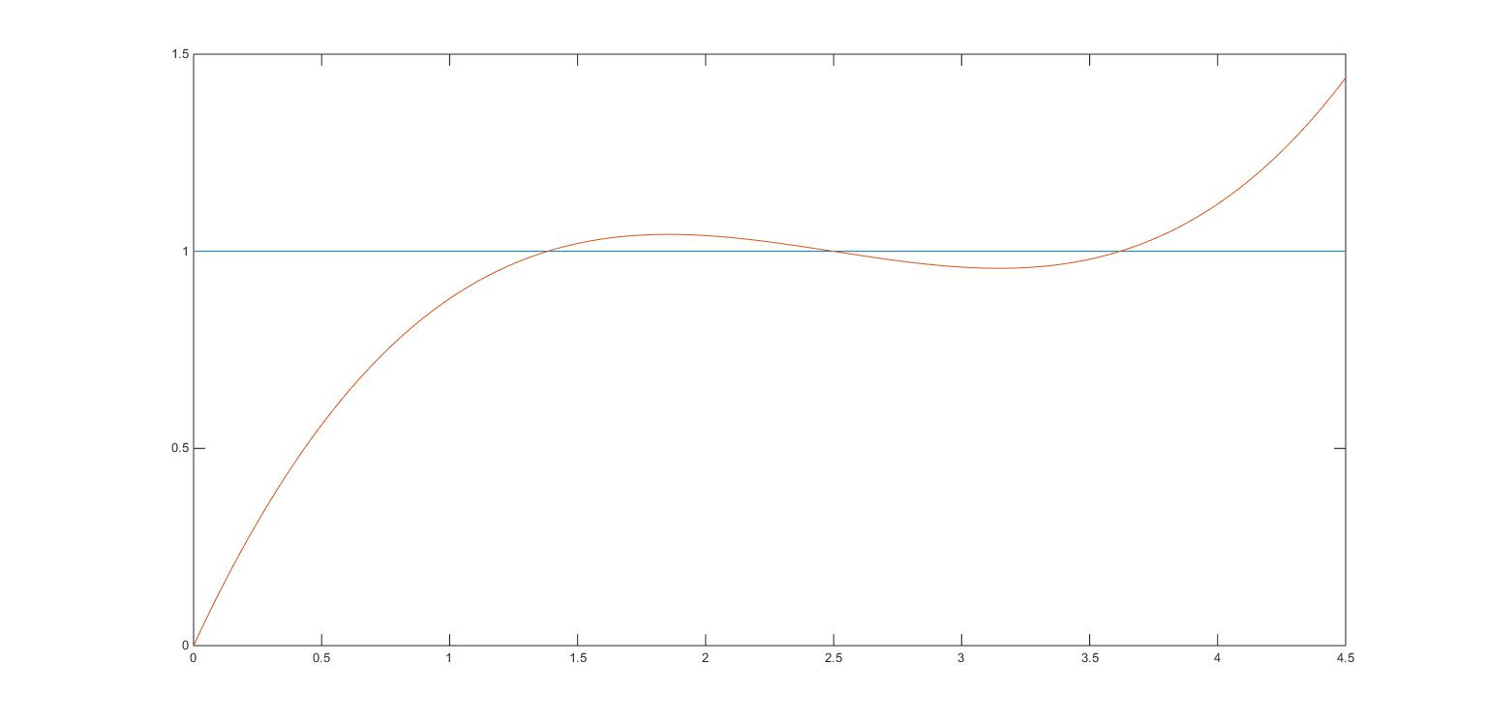

Fig3. $g_{3}^{'}(x)$

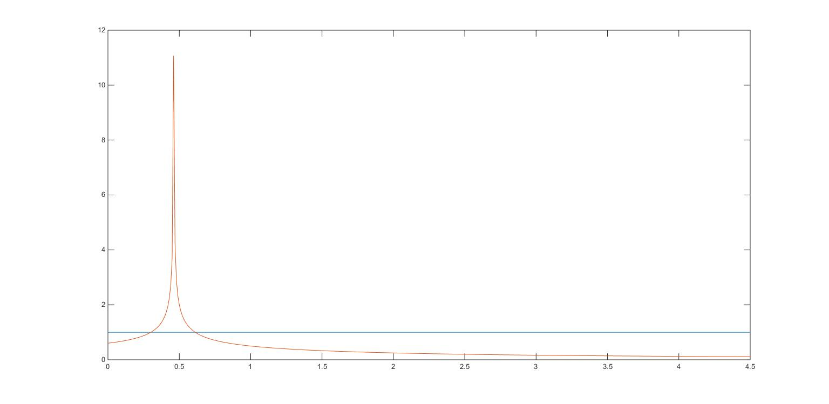

Fig4. $g_{4}^{'}(x)$

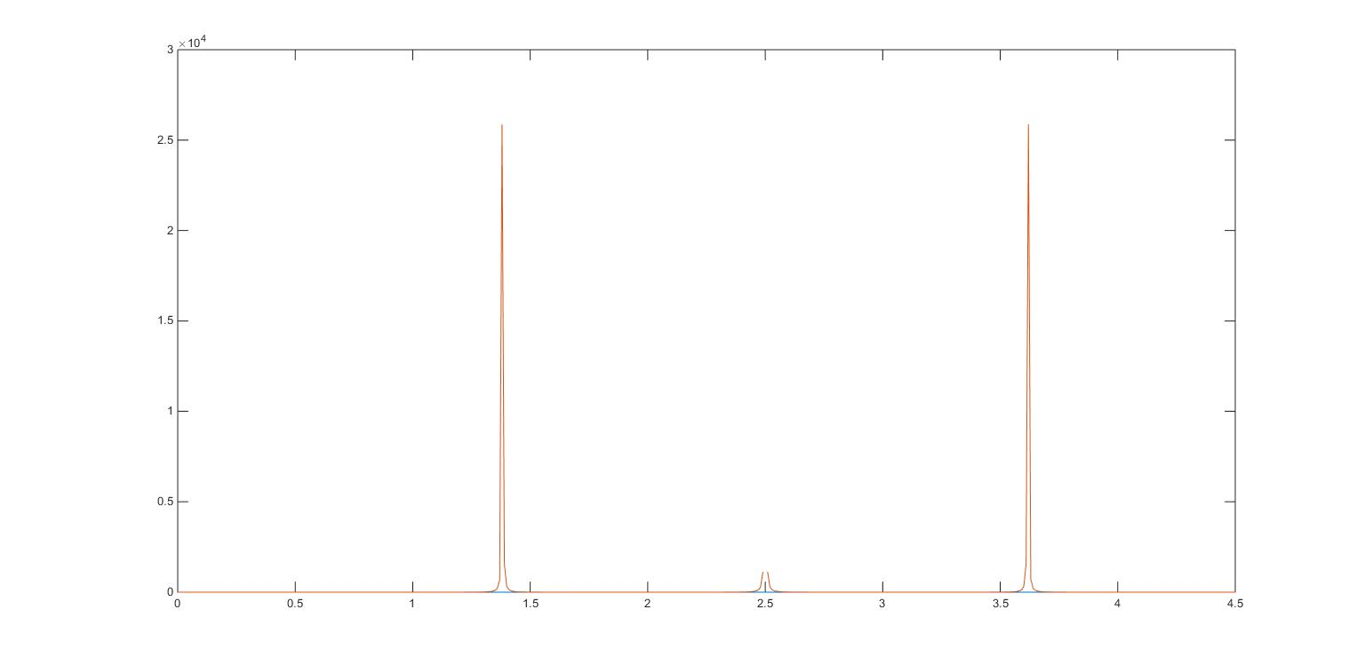

Fig5. $g_{5}^{'}(x)$

According to the condition for x to be a point of attraction:

1) For g1(x), x = 2 is the only point of attraction.

2) For g2(x), there is no point of attraction.

3) For g3(x), x = 1 and x = 3 are points of attraction.

4) For g4(x), x = 1, x = 2, x = 3 and x = 4 are all points of attraction.

5) For g5(x), x = 1, x = 2, x = 3 and x = 4 are all points of attraction.

**Appendix: Matlab code**

**Iterative Solver:**

*x = [0.99; 1.01; 1.99; 2.01; 2.99; 3.01; 3.99; 4.01; 0.5; 1.5; 2.5; 3.5];*

*gx = [x,x,x,x,x];*

*for i = 1:200*

*fx = (gx - 1) .* (gx - 2) .* (gx - 3) .* (gx - 4);*

*g1_n = gx(:, 1) - 0.8 * fx(:, 1);*

*g2_n = gx(:, 2) + 1.1 * fx(:, 2);*

*g3_n = (gx(:, 3).^4 - 10*gx(:, 3).^3 + 35*gx(:, 3).^2 + 24) ./ 50;*

*g4_n = ((-gx(:, 4).^4 + 10*gx(:, 4).^3 + 50*gx(:, 4) - 24) ./ 35).^0.5;*

*fp_n = 4*gx(:, 5).^3 - 30*gx(:, 5).^2 + 70*gx(:, 5) - 50;*

*g5_n = gx(:, 5) - fx(:, 5) ./ fp_n;*

*gx = [g1_n, g2_n, g3_n, g4_n, g5_n];*

*end;*

*gx*

**Point of Attraction:**

*x = 0:0.01:4.5;*

*% y0 = 1*

*y0 = x.^0;*

*fx = (x - 1) .* (x - 2) .* (x - 3) .* (x - 4);*

*fpx = 4*x.^3 - 30*x.^2 + 70*x - 50;*

*fp2x = 12*x.^2 - 60*x + 70;*

*% yn = gn'*

*y1 = abs(1 - 0.8 * fpx);*

*y2 = abs(1 + 1.1 * fpx);*

*y3 = abs((4*x.^3 - 30*x.^2 + 70*x)/50);*

*y4 = abs(0.5 * ((-x.^4 + 10*x.^3 + 50*x - 24) ./ 35).^(-0.5));*

*y5 = abs(1 - (fpx.^2 - fx .* fp2x) ./ fpx.^2);*

*% plot*

*plot(x, y0);*

*hold on;*

*plot(x, y1);*

*figure;*

*plot(x, y0);*

*hold on;*

*plot(x, y2);*

*figure;*

*plot(x, y0);*

*hold on;*

*plot(x, y3);*

*figure;*

*plot(x, y0);*

*hold on;*

*plot(x, y4);*

*figure;*

*plot(x, y0);*

*hold on;*

*plot(x, y5);*