24127186, 24127518, 24127136, 24127137

User Interface and User Experience Design

Screen Diagram

[Draw a screen diagram illustrating the relationships and transitions between the screens]
[List the screens]
Seq | Screen | Description
5.1 | Landing | Entry screen where users sign up or log in via Google or GitHub OAuth. Displays the platform branding, sponsor logos, and supported browsers before routing authenticated users into the main dashboard.
5.2.1 | Interviewee’s Booking | Lets interviewees search and browse mentors/interviewers grouped by role (e.g. Back-end, Front-end, Data Engineer), view a mentor's full profile, and book an interview slot by selecting a date, time slot, and uploading a CV, followed by payment confirmation via Stripe.
5.2.2 | Interviewee’s Mock Interview | Allows interviewees to start a simulated interview session—likely AI-driven or scenario-based — to practice answering role-specific questions in a timed, structured format before a real booked interview.
5.2.3 | Interviewee’s Self Practice | Provides a library of practice questions or exercises the interviewee can work through independently, without a live interviewer, to prepare for common technical or behavioral interview topics.
5.2.4 | Interviewee’s CV Assessment | Lets the interviewee upload their CV and select a target position; the system analyzes it and returns an overall score, a match score against the position, layout feedback, and section-by-section feedback (experience, skills, education, projects).
5.2.5 | Interviewee’s Feedback | Displays a list of the interviewee's finished interview sessions and lets them submit a star rating and written comment for each mentor/session; submitted sessions are marked as done and removed from the pending list.
5.2.6 | Interviewee’s Booking History | Shows a chronological list of the interviewee's past and upcoming bookings, including status (pending, in progress, done, cancelled), interviewer, date/time, and links to meeting details or receipts.
5.3.1 | Interviewer’s Dashboard | Central overview screen for interviewers showing upcoming sessions, pending booking requests, and summary statistics.
5.3.2 | Interviewer’s Requests | Lists incoming booking requests from interviewees awaiting the interviewer's confirmation, allowing the interviewer to accept, decline, or reschedule each request.
5.3.3 | Interviewer’s Calendar | A calendar view where the interviewer manages their availability, blocks out unavailable time slots, and views confirmed sessions across days/weeks/months.
5.3.4 | Interviewer’s Profile | Lets the interviewer edit their public profile — bio, work experience, languages, hourly/session fee — the same information shown to interviewees in the Booking screen's profile popup.
5.3.5 | Admin account management | Disable account, user statistics, interviewer rating statistics for commission.

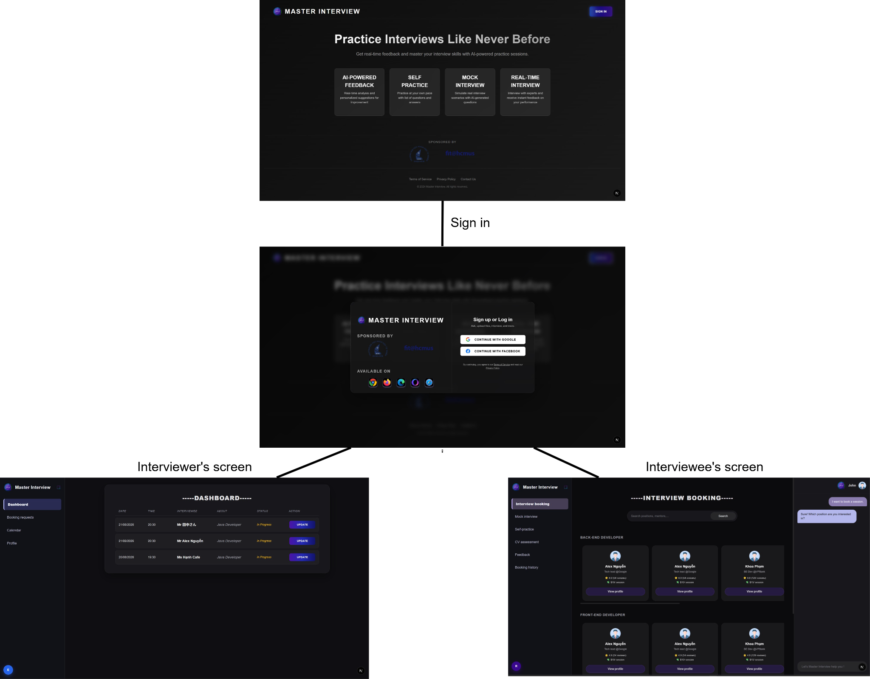

5.1 Landing

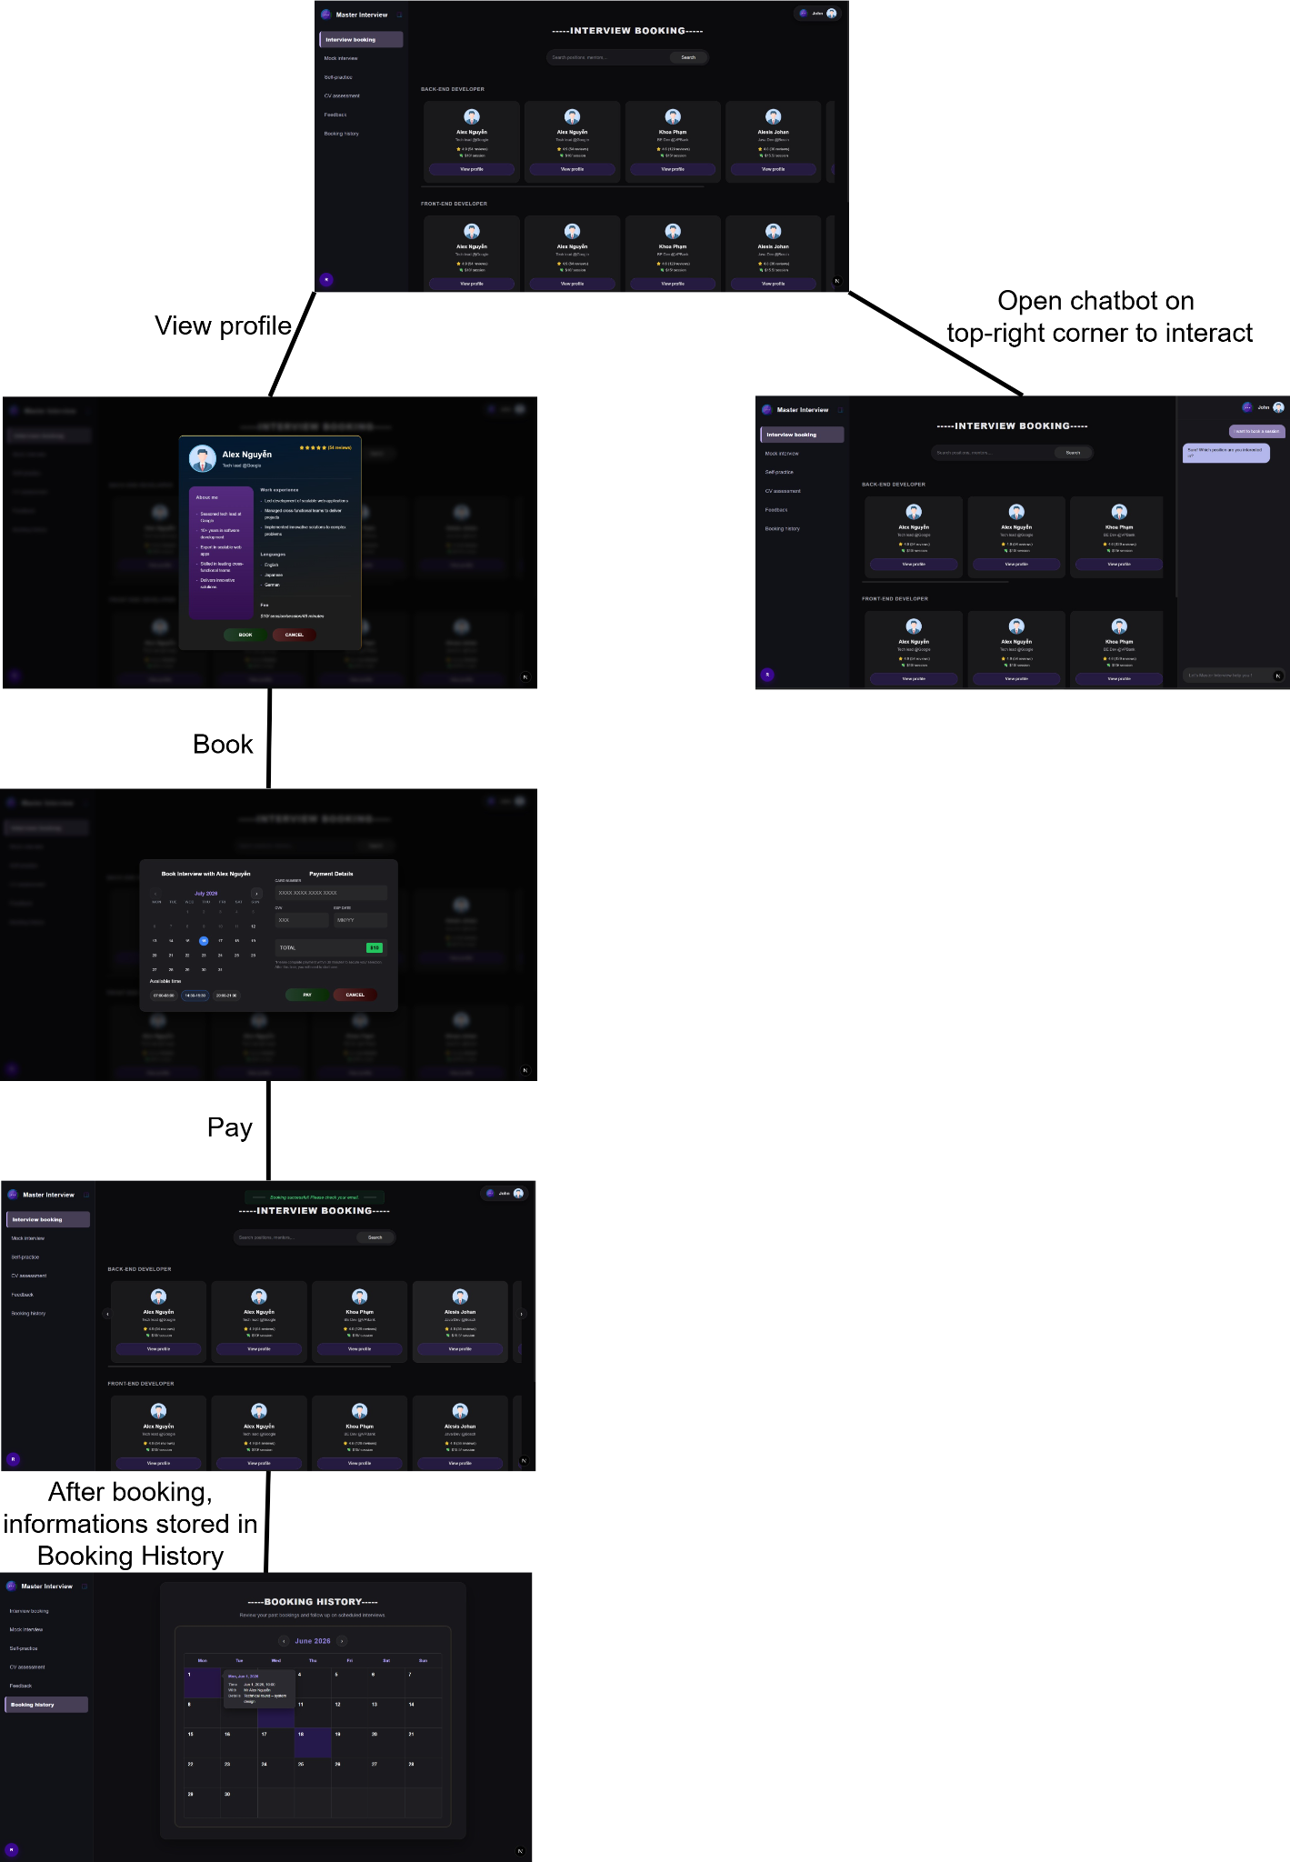
5.2.1 Booking
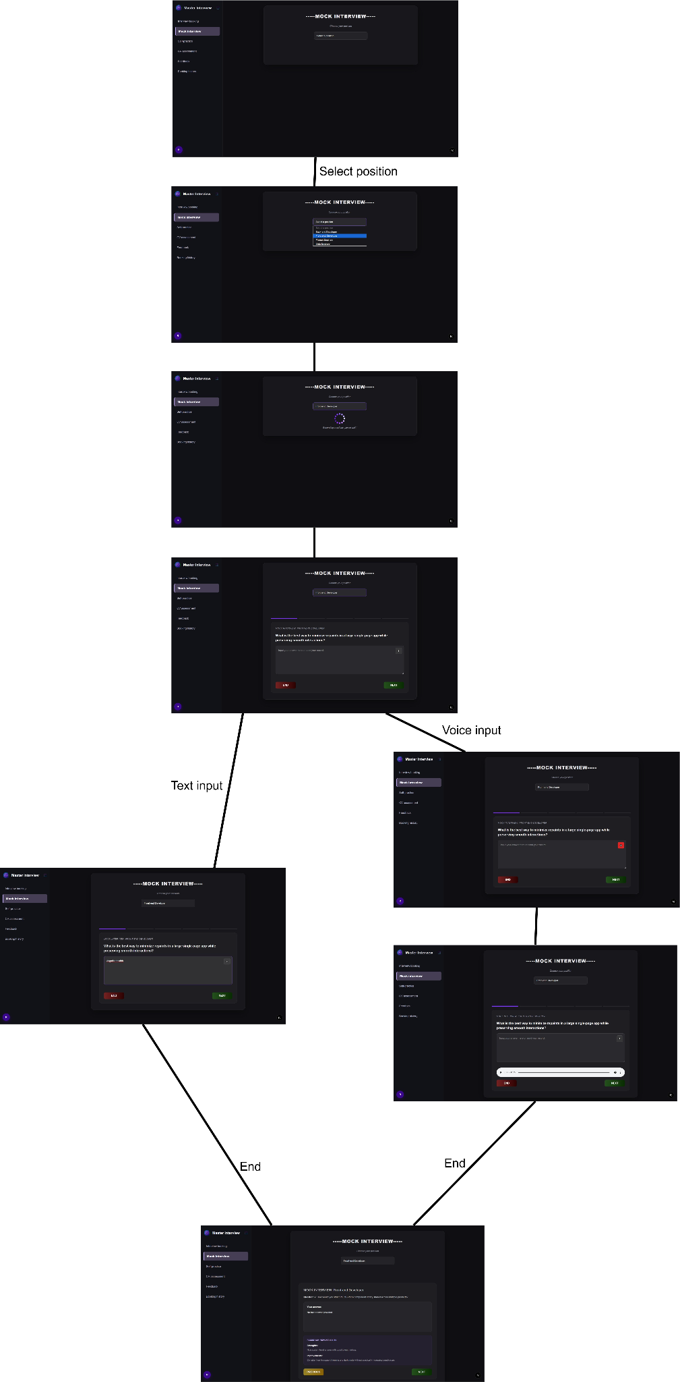
5.2.2 Mock Interview
5.2.3 Self Practice
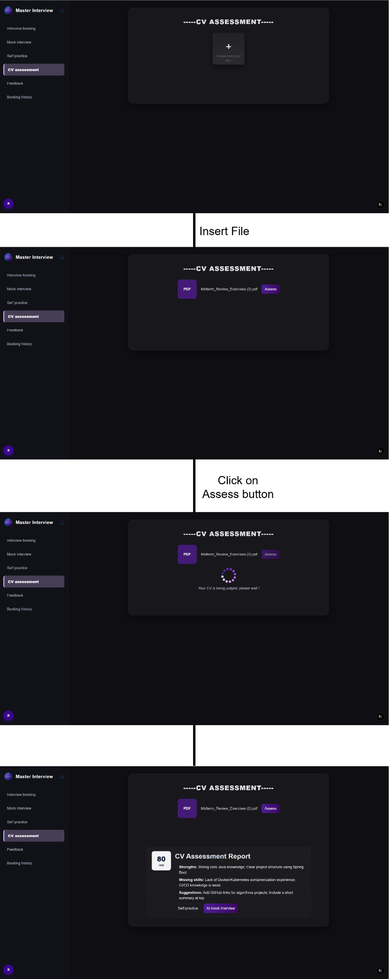
5.2.4 CV Assessment

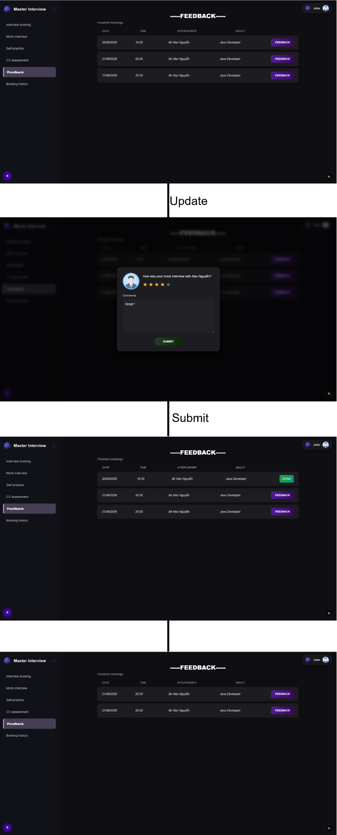
5.2.5 Feedback
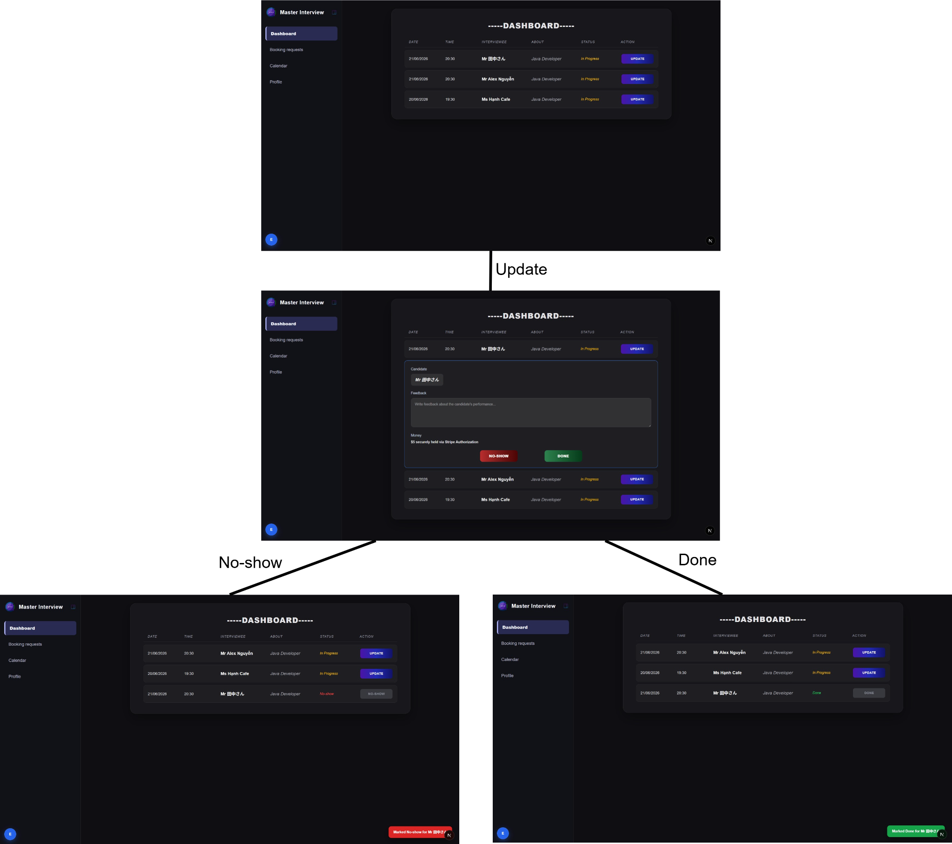
5.3.1 Dashboard
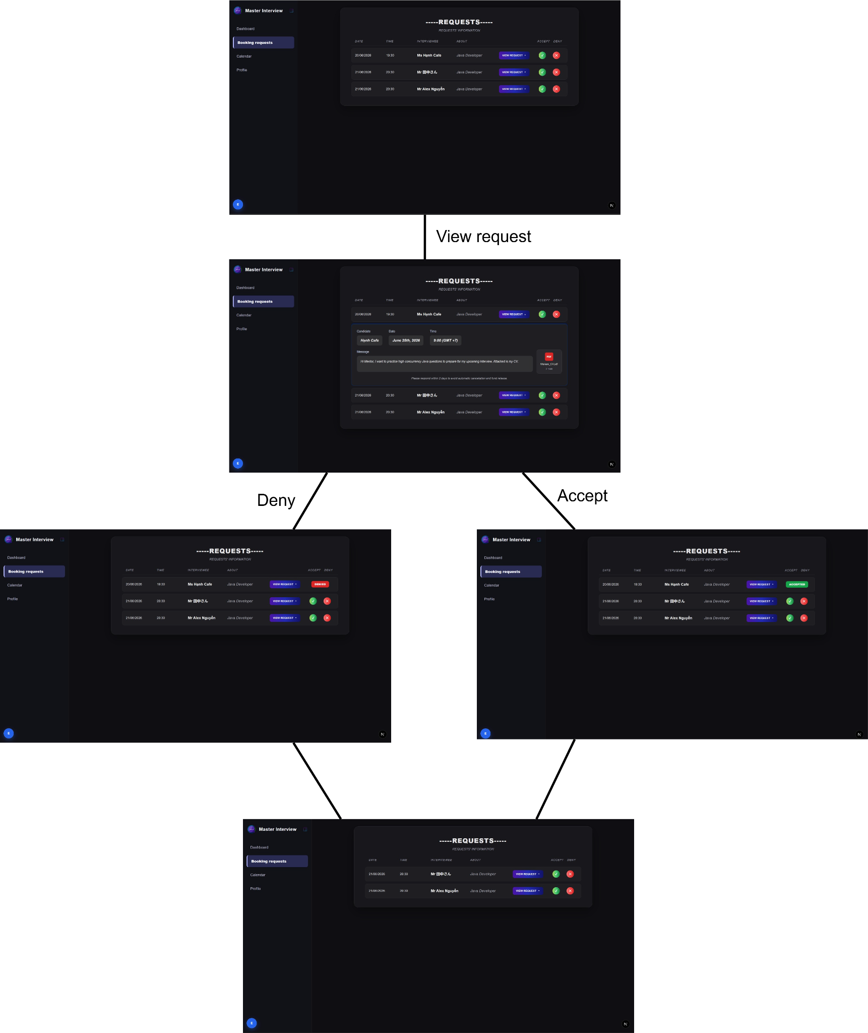
5.3.2 Requests
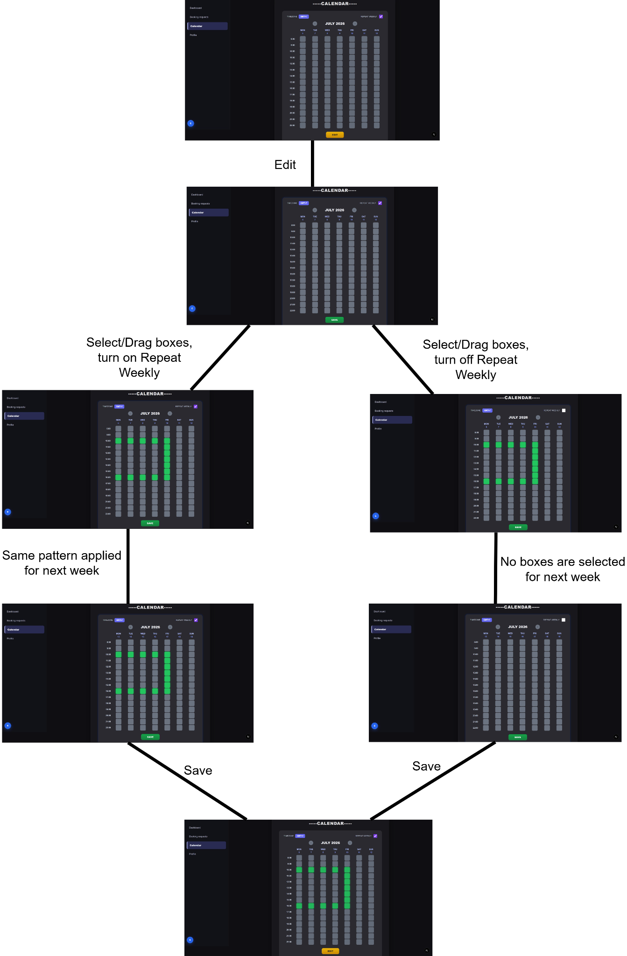
5.3.3 Calendar
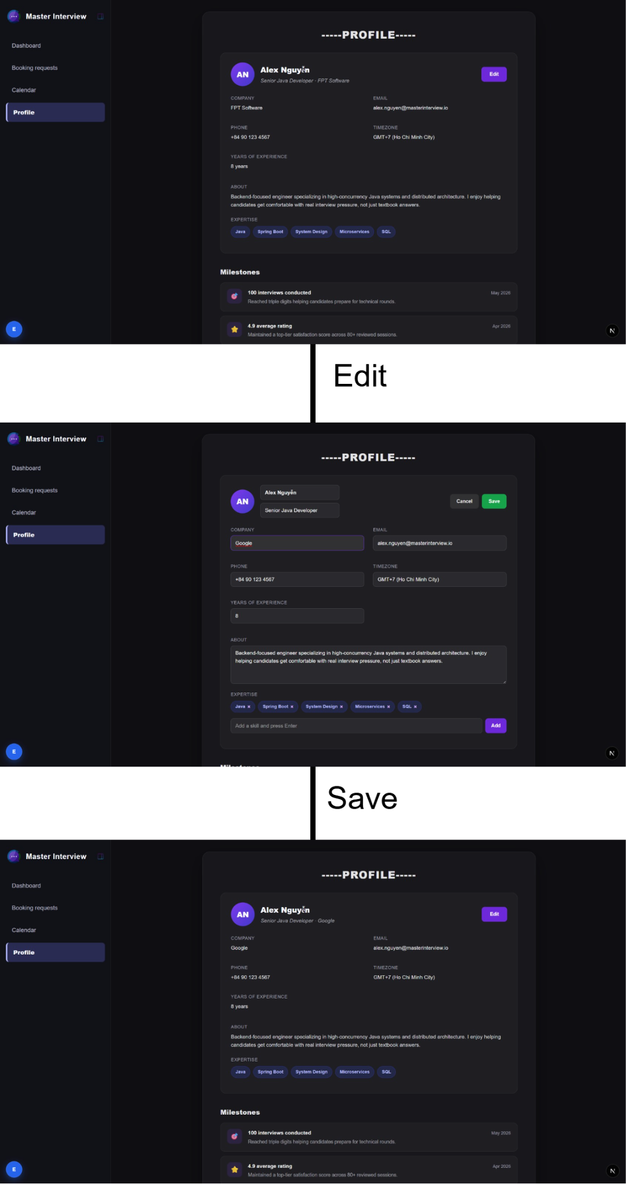
5.3.4 Profile

ép interviewer hoạt dong bang tien thuong. Admin phai chi tiet hon,

