B1:

-- b1--

SELECT

a,b,c,

CASE

WHEN a = b AND b = c THEN 'Tam giác đều'

WHEN a = b OR b = c OR a = c THEN 'Tam giác cân'

WHEN a + b > c AND a + c > b AND b + c > a THEN 'Tam giác'

ELSE 'Không phải tam giác'

END AS kq

FROM

triangle;

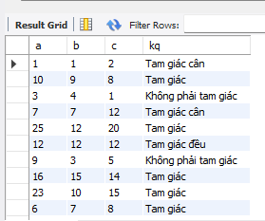

B2:

SELECT id, productname, quantity, price

FROM product

ORDER BY quantity \* price DESC

LIMIT 1 OFFSET 1;

