Instructions for Using the Springer Nature Word Template
Author Name¹, Author Name², Author Name³, Author Name⁴
¹Department, Institution, City, Country
²Department, Institution, City, Country
³Department, Institution, City, Country
⁴Department, Institution, City, Country
This is a sample chapter note. This is an optional feature which you may for instance use to dedicate the chapter to someone or to acknowledge equal authorship.
A motto is a brief statement or phrase that captures the essence or main idea of a chapter. This is an optional feature.
Abstract This user manual provides instructions on how to use the Springer Nature Word template effectively. It is intended as a guide for Springer Nature book and chapter authors in understanding how the template functions. This user guide has been prepared in the form of a sample chapter which at the same time explains the different features offered by this tool.
Keywords Manual, Instructions, User Guide, Word Template, Springer Nature

Introduction
This document is designed to help authors prepare their manuscript with all necessary structures. The template contains predefined formats for all the essential elements in the manuscript. These formats can be easily applied using mouse clicks and are compatible with both Windows and Mac. This documentation provides a step-by-step instruction for using the template.
The Word template has been designed as a tool to help Springer Nature authors to prepare their manuscripts in a well-structured format which can easily be converted into XML. The XML format is the basis for displaying the content on various electronic platforms and for transforming it into the final typeset layout according to Springer Nature’s style specifications.

Getting Started
Open Word and in the File menu, click on Options. Click on Trust Center and then on Trust Center Settings. Click on Macro Settings and choose “Disable all Macros with notification”, then press OK twice. Exit Word. The following ordered list summarizes the necessary steps to start working with the template:
- Open Word
- Make changes in the Trust Center Settings
- Close Word
- Open the template
- Once you have completed these steps, a tab labelled “Styling” will be displayed in the menu bar as shown in the following screenshot (→ Fig. 1).

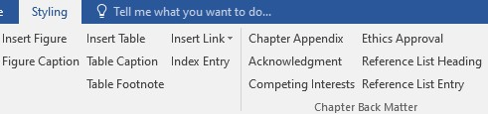
Fig. 1 Screenshot showing the Word menu, highlighting the “Styling” option

Elements in the “Styling” Tab
The “Styling” tab is divided into five sections:
- Styling
- Chapter Header
- Chapter Body
- Chapter Back Matter
- Extras
The features of the various elements available in these sections are explained in detail below.
For each element, a short explanation is also available in the template itself and can be seen when hovering over the specific element with the mouse (this feature is currently only available in Windows).
The elements included in the sections: Chapter Header, Chapter Body and Chapter Back Matter can be used to style new content as well as to render existing content in a defined style.
In order to insert new text in a specific style, position the cursor on a new line in the document, choose the element you want to use from the toolbar by clicking on it, and then start typing.
If you want to style existing text, mark the relevant content, and then click on the respective element in the toolbar.

Styling
The section “Styling” contains the following option:
Delete Format: If you have applied some styling that you wish to correct, first remove the applied formatting by selecting the respective text and then clicking on “Delete Format” (→ Fig. 2). You can then apply the correct styling.

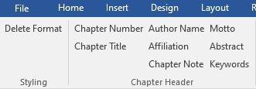
Fig. 2 Screenshot displaying the Styling option, which includes a “Delete Format” function

Chapter Header
The section “Chapter Header” contains the following elements which cover the header part of the chapter manuscript (→ Fig. 3).

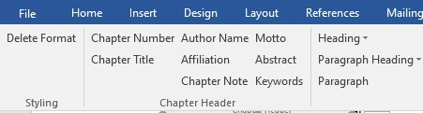
Fig. 3 Screenshot showing the available elements in the Chapter Header section

Chapter Number This element is optional and should only be used if the chapters in the book are numbered. If a chapter number has been inserted, subsequent sections will be numbered automatically. In this user guide, no chapter number has been inserted. When the “Chapter Number” option is selected, a dialog box appears prompting you to enter the chapter number. Click “Ok” to confirm or “Cancel” to proceed without entering a number (→ Fig. 4).

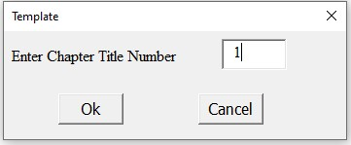
Fig. 4 This option allows you to include the chapter number

Chapter Title In this manual, you can see the chapter title “Instructions for Using the Springer Nature Word Template” displayed as the first item on the first page.
Author Name Author names are required in edited works. Please make sure to provide the first and last name(s) of all chapter (co-)author(s) in correct spelling. In this manual, a sample structure for several author names has been inserted on the first page below the chapter title.
Affiliation For each chapter (co-)author, at least one correct and complete affiliation must be provided. In this manual, you can see the sample structure for affiliations on the first page below the author names.
Chapter Note This is an optional element which can be used to provide information concerning the complete chapter, e.g. to dedicate the chapter to someone or to state that two co-authors have contributed equally to the work. In this manual, you can see the sample chapter note on the first page below the affiliations.
Motto This is an optional element which can be used to include a motto for the chapter. In this manual, you can see the sample text displayed right-aligned as a motto on the first page above the abstract.
Abstract Chapter abstracts are strongly encouraged. They will appear online on Springer Nature Link and other sites and will be freely accessible. In this manual you can see a sample abstract on the first page. The run-in heading “Abstract” will automatically be inserted upon choosing this element.
Keywords Keywords may be required. If you are unsure, please check with your editor. If keywords are to be provided for your chapter, please supply 5-10 keywords. In this manual, the sample keywords “Manual”, “Instructions”, “User Guide”, “Word Template” and “Springer Nature” have been inserted on the first page. The run-in heading “Keywords” will automatically be inserted upon choosing this element.

Chapter Body
The section “Chapter Body” contains all the elements necessary in the main body of the chapter (→ Fig. 5).

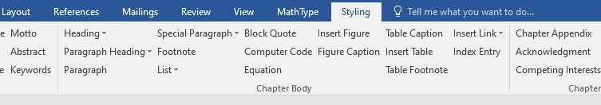
Fig. 5 Screenshot showing the available elements in the Chapter Body section

Heading This menu offers two options for managing heading styles.
- Numbered heading: Use this to insert headings with sequential numbers. The following heading levels are available: Heading 1, Heading 2, Heading 3, Heading 4, and Heading 5. The levels must be used as a hierarchy, where Heading 1 is the highest level of section. Never skip a heading level, i.e. a heading level 2 should only be inserted if a heading level 1 is already present, etc.
- Unnumbered heading: Use this to insert headings without numbers. The following heading levels are available: Heading 1, Heading 2, Heading 3, Heading
4, and Heading 5. The levels must be used as a hierarchy, where Heading 1 is the highest level of section. Never skip a heading level, i.e. a heading level 2 should only be inserted if a heading level 1 is already present, etc.

Paragraph Heading The menu includes three options for handling paragraph titles. Two of these options are run-in headings, i.e., the text runs on in the same line after the heading. These run-in headings are presented as bold or bold italic. Examples are listed below for your reference:
Style 1 To apply Style 1, select the entire paragraph and choose the “Paragraph” option. Then, select only the run-in heading and select “Style 1” from the “Paragraph Heading” menu. This will format the run-in heading in bold.
Style 2 To apply Style 2, select the entire paragraph and choose the “Paragraph” option. Then, select only the run-in heading and select “Style 2” from the “Paragraph Heading” menu. This will format the run-in heading in bold italic.
Style 3
Only Style 1 and Style 2 are true run-in-headings. For Style 3, the text will start in a new line. To apply Style 3, select the entire paragraph and choose the “Paragraph” option. Then, select only the heading and select “Style 3” from the “Paragraph Heading” menu. This will format the heading in bold and move the following text to the next line.

Paragraph This option is used to style the paragraph text with a standard first-line indent.
Special Paragraph A didactic element is a component within a piece of work that primarily aims to teach or instruct. Eight styling choices for didactic elements are available in this menu. They are listed below for your reference. Each didactic element must finish with an End Tag (see "End Tag" description below).
Example This example demonstrates how to add an “Example” element as a distinct didactic feature that stands out from the main content. When you select the “Special Paragraph” option and choose “Example”, the heading “Example” will be automatically inserted if it is not already present. According to the default settings, an “End Tag” will be automatically included after the first paragraph. If the “Example” consists of two or more paragraphs, please include an “End Tag” manually as described below.
Definition This example demonstrates how to add a “Definition” element as a distinct didactic feature that stands out from the main content. When you select the “Special Paragraph” option and choose “Definition”, the heading “Definition” will be automatically inserted if it is not already present. According to the default settings, an “End Tag” gets automatically included after the first paragraph. If the “Definition” consists of two or more paragraphs, please include an “End Tag” manually as described below.
Warning This example demonstrates how to add a “Warning” element as a distinct didactic feature that stands out from the main content. When you select the “Special Paragraph” option and choose “Warning”, the heading “Warning” will be automatically inserted if it is not already present. According to the default settings, an “End Tag” gets automatically included after the first paragraph. If the “Warning” consists of two or more paragraphs, please include an “End Tag” manually as described below.
Overview This example demonstrates how to add an “Overview” element as a distinct didactic feature that stands out from the main content. When you select the “Special Paragraph” option and choose “Overview”, the heading “Overview” will be automatically inserted if it is not already present. According to the default settings, an “End Tag” gets automatically included after the first paragraph. If the “Overview” consists of two or more paragraphs, please include an “End Tag” manually as described below.
Important This example demonstrates how to add an “Important” element as a distinct didactic feature that stands out from the main content. When you select the “Special Paragraph” option and choose “Important”, the heading “Important” will be automatically inserted if it is not already present. According to the default settings, an “End Tag” gets automatically included after the first paragraph. If the “Important” consists of two or more paragraphs, please include an “End Tag” manually as described below.
Question This example demonstrates how to add a “Question” element as a distinct didactic feature that stands out from the main content. When you select the “Special Paragraph” option and choose “Question”, the heading “Question” will be automatically inserted if it is not already present. According to the default settings, an “End Tag” gets automatically included after the first paragraph. If the “Question” consists of two or more paragraphs, please include an “End Tag” manually as described below.
Legal This example demonstrates how to add a “Legal” element as a distinct didactic feature that stands out from the main content. When you select the “Special Paragraph” option and choose “Legal”, the heading “Legal” will be automatically inserted if it is not already present. According to the default settings, an “End Tag” gets automatically included after the first paragraph. If the “Legal” consists of two or more paragraphs, please include an “End Tag” manually as described below.
End Tag An end tag is automatically inserted after the first paragraph of a didactic element as it is automatically assumed to consist of only one paragraph. If, however, a didactic element should span multiple paragraphs, not just one, mark the end of the last paragraph manually with an “End Tag” by clicking on this option in the “Special Paragraph” menu. This will insert a bookmark to clearly define the didactic element’s end.

Footnote Place your cursor where you want the footnote reference to appear in your text. Select the Footnote option, this will create a superscript number in your text and open a footnote area at the bottom of the page or document. Type the desired content within the footnote area.
List This menu offers three options to customize the appearance of your lists.
1. Ordered List: An ordered list is a numbered list, which displays items in numerical order, with each item preceded by a number and a tab.
• Unordered List: An unordered list is an unnumbered list, which displays items preceded by bullet points and a tab.
– Sublist: To create a sublist within a list, simply place your cursor within the paragraph you want to turn into a sublist. Then, navigate to the “List” menu and select the “Sublist” option. This will automatically indent the paragraph, marking it as a sublist item with a dash symbol.
Block Quote A block quote is a long quotation that is visually separated from the surrounding text. Here is an example of a block quote in the template:
It is typically formatted with a larger indent on both the left and right sides, and may also use a different font or font size. To create a block quote, use the “Block Quote” option.
Computer Code Source code can be written in any programming language. Use the “Computer Code” option to format code snippets. For example,
def find_largest(numbers): largest_number = numbers[0] for number in numbers: if number > largest_number: largest_number = number return largest_number
Equation Equations can be presented in two ways: inline in running text, or displayed on a separate line. Displayed equations can be either numbered or unnumbered.
- Inline equations: These appear naturally within the text flow, similar to regular words. To insert an inline equation, position your cursor at the desired location and select the “Equation” option. This will embed a Microsoft Equation Editor directly into your text.
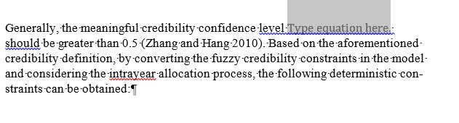
- Displayed equations: These equations are presented on separate lines. They can be either numbered or unnumbered, depending on your preference. To insert a displayed equation, position your cursor at the desired location and select the “Equation” option. This will open a Microsoft Equation Editor for you to input your equation.
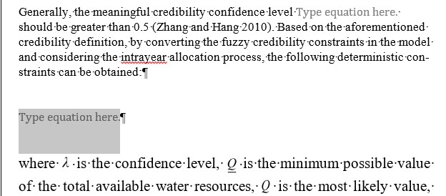

√𝑎𝑎²+𝑏𝑏² (1)

Insert Figure To insert a figure, use the “Insert Figure” option. This allows you to browse and select an image from your computer to place within your document. Figure Caption To add a figure caption, use the “Figure Caption” option. This will automatically insert “Fig.” in bold, followed by a space. Then, type the figure number in bold after “Fig.” and add the caption text after another space (not in bold). Please include the caption underneath the figure.
Table Caption To add a table caption, use the “Table Caption” option. This will automatically insert “Table” in bold, followed by a space. Then, type the table number in bold after the space, and add the caption text after another space (not in bold). Please include the caption above the table.
Insert Table If you want to include a table from another Word document, please place the table below the table caption. If you are incorporating a table from an Excel file, please copy the content from the Excel sheet and insert it into the document below the table caption.
To add a new table, click the “Insert Table” option. This will open a window where you can choose the desired number of rows and columns. Once you've made your selection, click “OK” to create the table (→ Fig. 6).
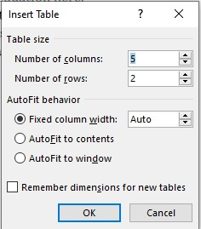
Fig. 6 A feature to add a table to the document
Table Footnote To insert a table footnote, position your cursor where you want the footnote reference to appear within the table cell. Then, select the “Table Footnote” option. This will insert a superscript footnote indicator in both the table cell and the designated footnote area directly underneath the table.
Table 1 Sample table counting some elements of a manuscript
Manuscript Elements | Number | Citation in Text
Figures | 9 | Yes
Tables | 1 | Yes
Equationsª | 1 | Yes
ªSample table footnote

Insert Link To insert a citation, use the “Insert Link” option.
- Table Link: To cite a table in your text, use the “Table Link” option. This will automatically insert a red arrow followed by a space. After the arrow, type the table citation, for example: → Table 1.
- Figure Link: To cite a figure in your text, use the “Figure Link” option. This will automatically add a red arrow followed by a space. After the arrow, type the figure citation, for example → Fig. 1.
- Equation Link: To cite an equation in your text, use the “Equation Link” feature. This will automatically insert parentheses, within which you can enter the equation number. For example, you would write “Eq. (1)” to refer to equation number 1.
- Reference Citation (Name Year): When referencing a source within your text using the “name year” format, select the “Reference Citation (Name Year)” option. This will automatically insert parentheses, allowing you to easily add the citation. For instance, you would write “(Author 2024)”. Please use either Name Year citation or numbered citation throughout the chapter/book.
- Reference Citation [Number] To cite sources using numbered references within your text, choose the “Reference Citation (Number)” option. This will automatically add square brackets, making it simple to insert citations. For example, you would write “[1, 2]” to reference sources numbered 1 and 2. Please use either Name Year citation or numbered citation throughout the chapter/book.
- Section Heading Cross-References To reference a specific section within your chapter, use the “Section Heading Cross-References” option. This will automatically insert a red arrow followed by a space. After the arrow, type the section citation, for example: → Section 2.
- Chapter Cross-References To reference a specific chapter within your text, use the “Chapter Cross-References” option. This will automatically insert a red arrow followed by a space. After the arrow, type the chapter citation, for example: → Chapter 2.
Index Entry To insert an index entry, position your cursor at the desired location within the text. Select the “Index Entry” option to open a dialog box. Here, you can specify index term details and mark the entry.

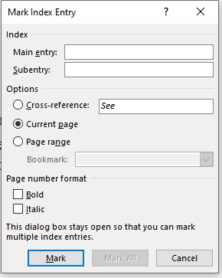

Chapter Back Matter
The section “Chapter Back Matter” contains the following elements which cover the Back Matter part of the chapter manuscript (→ Fig. 7).

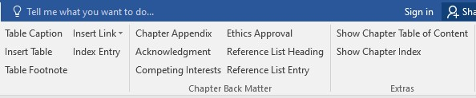
Fig. 7 Screenshot showing the available Back Matter elements
The Chapter Back Matter section contains options to style references, appendix, acknowledgments and declarations (see samples below).
In edited works, a declaration of competing interests is required for each chapter. Ethics approval must only be included in contributions on primary studies with humans or with animals. In authored works, the declarations should be included in the Book Front Matter.
Appendix An appendix is a supplementary section at the end of a chapter that contains additional information relevant to the chapter's content but is not essential for understanding the main text. The numbering of tables, figures, and equations in the appendix section continues on from that in the main text. Selecting the “Chapter Appendix” option will conveniently add the heading “Appendix” for you. If there is only one heading, retain it as “Appendix”, but adjust it to the relevant number (“Appendix 1”, “Appendix 2”, etc.) if there are more than one.
Acknowledgments In the Acknowledgments section, you can express your appreciation to those who supported your research and writing. Selecting the “Acknowledgment” option will conveniently add the heading “Acknowledgments” for you.
Competing Interests Please declare any competing interests in the context of your chapter. The following sentences can be regarded as examples: This study was funded by [X] [grant number X]. [Author A] has a received research grant from [Company W]. [Author B] has received a speaker honorarium from [Company X] and owns stock in [Company Y]. [Author C] is a member of [committee Z]. The authors have no conflicts of interest to declare that are relevant to the content of this chapter. Selecting the “Competing Interests” option will conveniently add the heading “Competing Interests” for you.
Ethics Approval If your chapter includes primary studies with humans, please declare the adherence of ethical standards. Example text: This study was performed in line with the principles of the Declaration of Helsinki. Approval was granted by the Ethics Committee of University B (Date.../No. ...). In addition, for human participants, authors are required to include a statement that informed consent (to participate and/or to publish) was obtained from individual participants or parents/guardians if the participant is minor or incapable. If animals are studied, authors should make sure that the legal requirements or guidelines in the country and/or state or province for the care and use of animals have been followed or specify that no ethics approval was required. Selecting the “Ethics Approval” option will conveniently add the heading “Ethics Approval” for you.
Reference List Heading The References section is placed at the end of the document to list all cited sources. Selecting the “Reference List Heading” option will conveniently add the heading “References” for you.
Reference List Entry To format a reference list entry, select the desired text and choose the “Reference List Entry” option. A dialog box will appear. If using numbered citations, check the corresponding box and click “Ok”. For name-year citations, simply click “Cancel” (→ Fig. 8). A sample list of references has been added at the end of this manual.
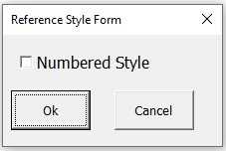
Fig. 8 An option to choose a numbered style for references, allowing for automatic insertion of numbers in the reference list

Extras
The section “Extras” contains elements that allow you to check the Table of Contents and Index (→ Fig. 9).

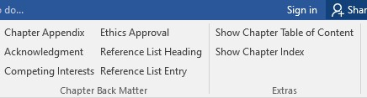
Fig. 9 Additional styling elements can be found in the Extras menu

- Show Chapter Table of Contents: This option generates an overview of the chapter structure, listing its headings and subheadings. Please note that a Chapter Table of Contents is normally not included in chapters.
- Show Chapter Index: This option generates a list of index terms included within the chapter. A Chapter Index is generally not included.
Both functions allow you to check your input. Please delete both Chapter Table of Contents and Chapter Index before submitting the manuscript.

References
Aaron M (1999) The future of genomics. In: Williams H (ed) Proceedings of the genomic researchers, Boston, 1999
Adorno TW (1966) Negative Dialektik. Suhrkamp, Frankfurt. English edition: Adorno TW (1973) Negative dialectics (trans: Ashton EB). Routledge, London
Babichev SA, Ries J, Lvovsky AI (2002) Quantum scissors: teleportation of single-mode optical states by means of a nonlocal single photon. Preprint at https://arxiv.org/abs/quantph/0208066
Brown B, Aaron M (2001) The politics of nature. In: Smith J (ed) The rise of modern genomics, 3rd edn. Wiley, New York, p 234–295
Chung S-T, Morris RL (1978) Isolation and characterization of plasmid deoxyribonucleic acid from Streptomyces fradiae. Paper presented at the 3rd international symposium on the genetics of industrial microorganisms, University of Wisconsin, Madison, 4–9 June 1978
Doe J (1999a) Title of subordinate document. In: The dictionary of substances and their effects. Royal Society of Chemistry. Available via DIALOG. http://www.rsc.org/dose/ title of subordinate document. Accessed 15 Jan 1999
Doe J (1999b) Title of preprint. http://www.uni-heidelberg.de/mydata.html. Accessed 25 Dec 1999
Doe J (1999c) Trivial HTTP, RFC2169. ftp://ftp.isi.edu/in-notes/rfc2169.txt. Accessed 12 Nov 1999
Doe J (2000) Title of supplementary material. http://www.privatehomepage.com. Accessed 22 Feb 2000
International Anatomical Nomenclature Committee (1966) Nomina anatomica. Excerpta Medica, Amsterdam
ISSN International Centre (2006) The ISSN register. http://www.issn.org. Accessed 20 Feb 2007
Major M et al (2007) Recent developments. In: Jones W (ed) Surgery today. Springer, Dordrecht (in press)
Marikhin VY, Myasnikova LP (1977) Nadmolekulyarnaya struktura polimerov (The supramolecular structure of polymers). Khimiya, Leningrad
Mod Genomics J (1998) Rodent genes. Mod Genomics J 14(6):126–233
Norman LO (1998) Lightning rods. US Patent 4,379,752, 9 Sept 1998
Ozkaya G et al (2018) Three-dimensional motion capture data during repetitive overarm throwing practice. figshare https://doi.org/10.6084/m9.figshare.c.4017808
Saito Y, Hyuga H (2007) Rate equation approaches to amplification of enantiomeric excess and chiral symmetry breaking. Top Curr Chem. https://doi.org/10.1007/128_2006_108
Saunders DS (1976) The biological clock of insects. Sci Am 234(2):114–121
Schmidt H (1989) Testing results. In: Hutzinger O (ed) Handbook of environmental chemistry, vol 2E. Springer, Heidelberg, p 111
Slifka MK, Whitton JL (2000) Clinical implications of dysregulated cytokine production. J Mol
Med 78:74–80. https://doi.org/10.1007/s001090000086
Smith SE (1976) Neuromuscular blocking drugs in man. In: Zaimis E (ed) Neuromuscular junction. Handbook of experimental pharmacology, vol 42. Springer, Heidelberg, pp 593–660
Smith J (ed) (1998) Rodent genes. Mod Genomics J 14(6):126–233
Smith J, Brown B (eds) (2001) The demise of modern genomics. Blackwell, London
Smith J, Jones M Jr, Houghton L et al (1999) Future of health insurance. N Engl J Med 965:325– 329
South J, Blass B (2001) The future of modern genomics. Blackwell, London
Trent JW (1975) Experimental acute renal failure. Dissertation, University of California
Wolf GH, Lehman P-F (1976) Atlas der Anatomie, vol 4/3, 4th edn. Fischer, Berlin
Zowghi D et al (1996) A framework for reasoning about requirements in evolution. In: Foo N, Goebel R (eds) PRICAI’96: topics in artificial intelligence. 4th Pacific Rim conference on artificial intelligence, Cairns, August 1996. Lecture notes in computer science (Lecture notes in artificial intelligence), vol 1114. Springer, Heidelberg, p 157

