Lab 3: About all Components
Building a ReactJS application with a user interface that requires the user to input a list of questions and answer options for each question. Display the questions and answer options to the user and check whether the user has selected the correct or incorrect answer.

Create Components
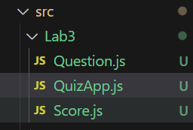

Create a main Component to manage the entire Quiz application:
- Create a Component named 'QuizApp'.
- In this Component, you can use state variables to store information such as the current question, selected answer options, and score.
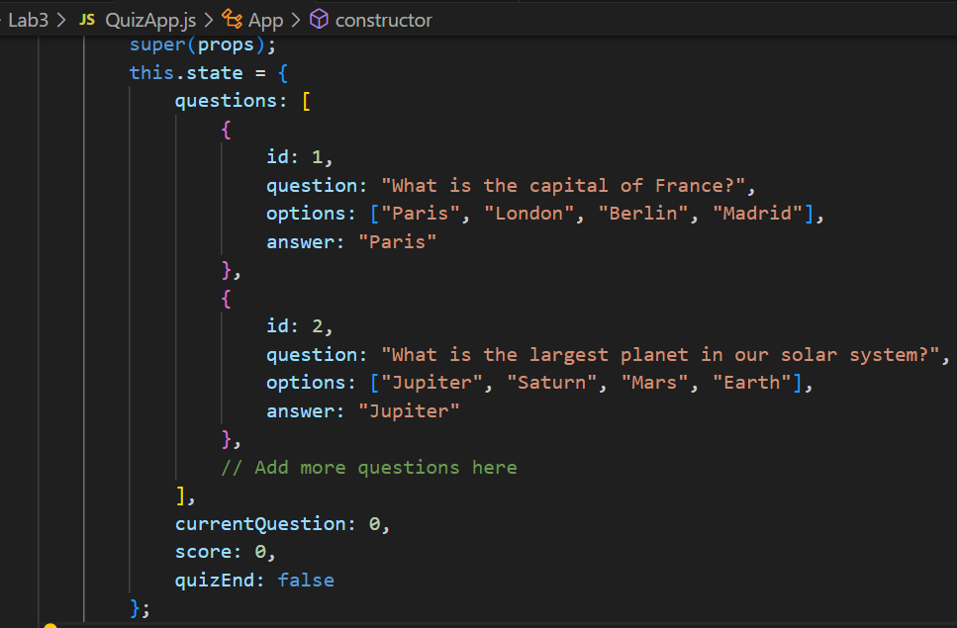
- Use methods to handle events such as selecting an answer, checking the answer, and moving to the next question.

Create a child Component to display the question and answer options to the user:
- Create a Component named 'Question' or any desired name.
- In this Component, you can pass props such as the question, list of answer options, and the selected answer.
- Use methods to handle events such as selecting an answer and submitting the answer.

Create a child Component to display the user's result after completing the Quiz:
- Create a Component named 'Result' or any desired name.
- In this Component, you can pass props such as the user's score.
- Display the user's result and provide options such as replaying or sharing the result.

Check the answer
- When the user selects an answer option, check if that answer is correct or incorrect.
- If the answer is correct, increase the user's score.
- Move to the next question by incrementing the current question counter.

Display the result
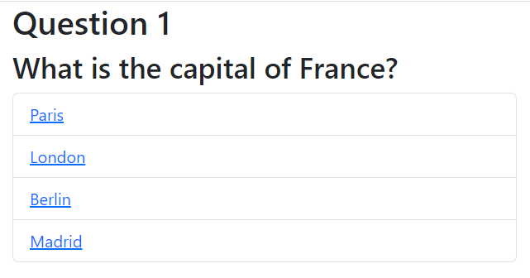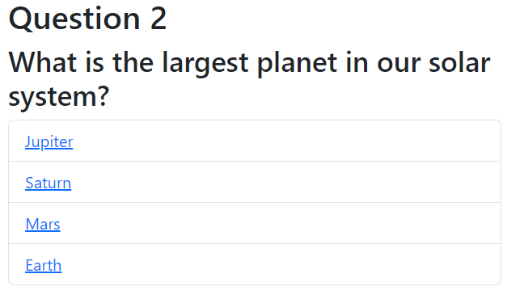
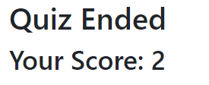
When the user completes the Quiz, display the final result and the user's score.
Use a child Component to display the result and score.

