4. Singular value decomposition (SVD)
According to the user-item rating matrix, the sparsity is high (98,47%). In other words, the number of empty cells over the number of cells with data and this may affect the calculation process.
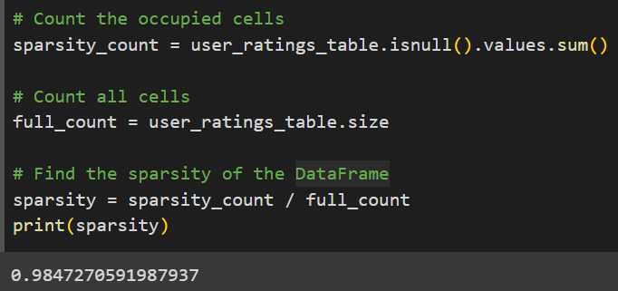
To solve this problem, I use SVD, a form of matrix factorization to reduce the number of dimensions of the data without losing much information.
SVD is a method for identifying and ordering the dimensions along which data points exhibit the most variation. This ties in to the way of viewing SVD, which is that once we have identified where the most variation is, it’s possible to find the best approximation of the original data points using fewer dimensions. Hence, SVD can be seen as a method for data reduction. (Baker, 2005)

