MVP Weekly Report - VetBook

1. Weekly Overview
This week focused on a major UX/UI overhaul for the Android application and the integration of PayOS for seamless appointment payments.

2. Admin Web Achievements
Successfully implemented the management dashboard and service monitoring tools.

Admin Dashboard
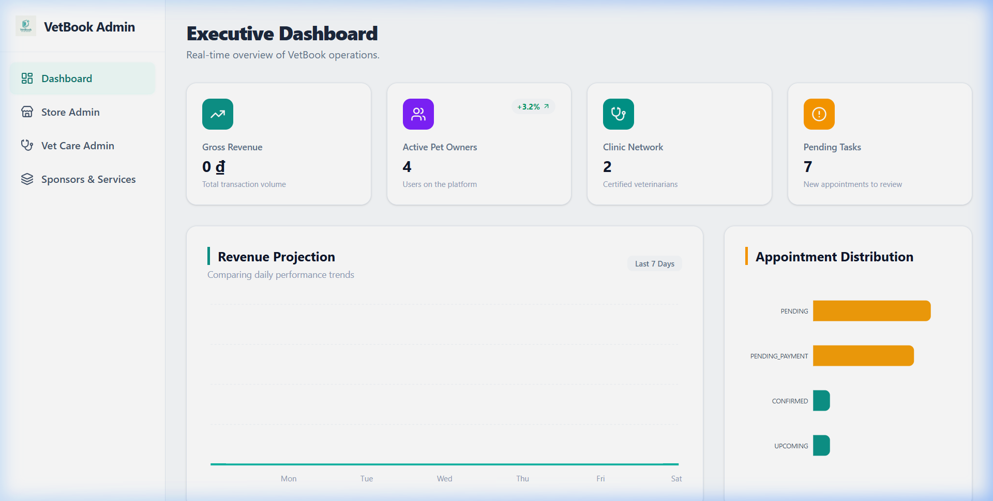
Figure: Admin Dashboard Interface

Admin Products
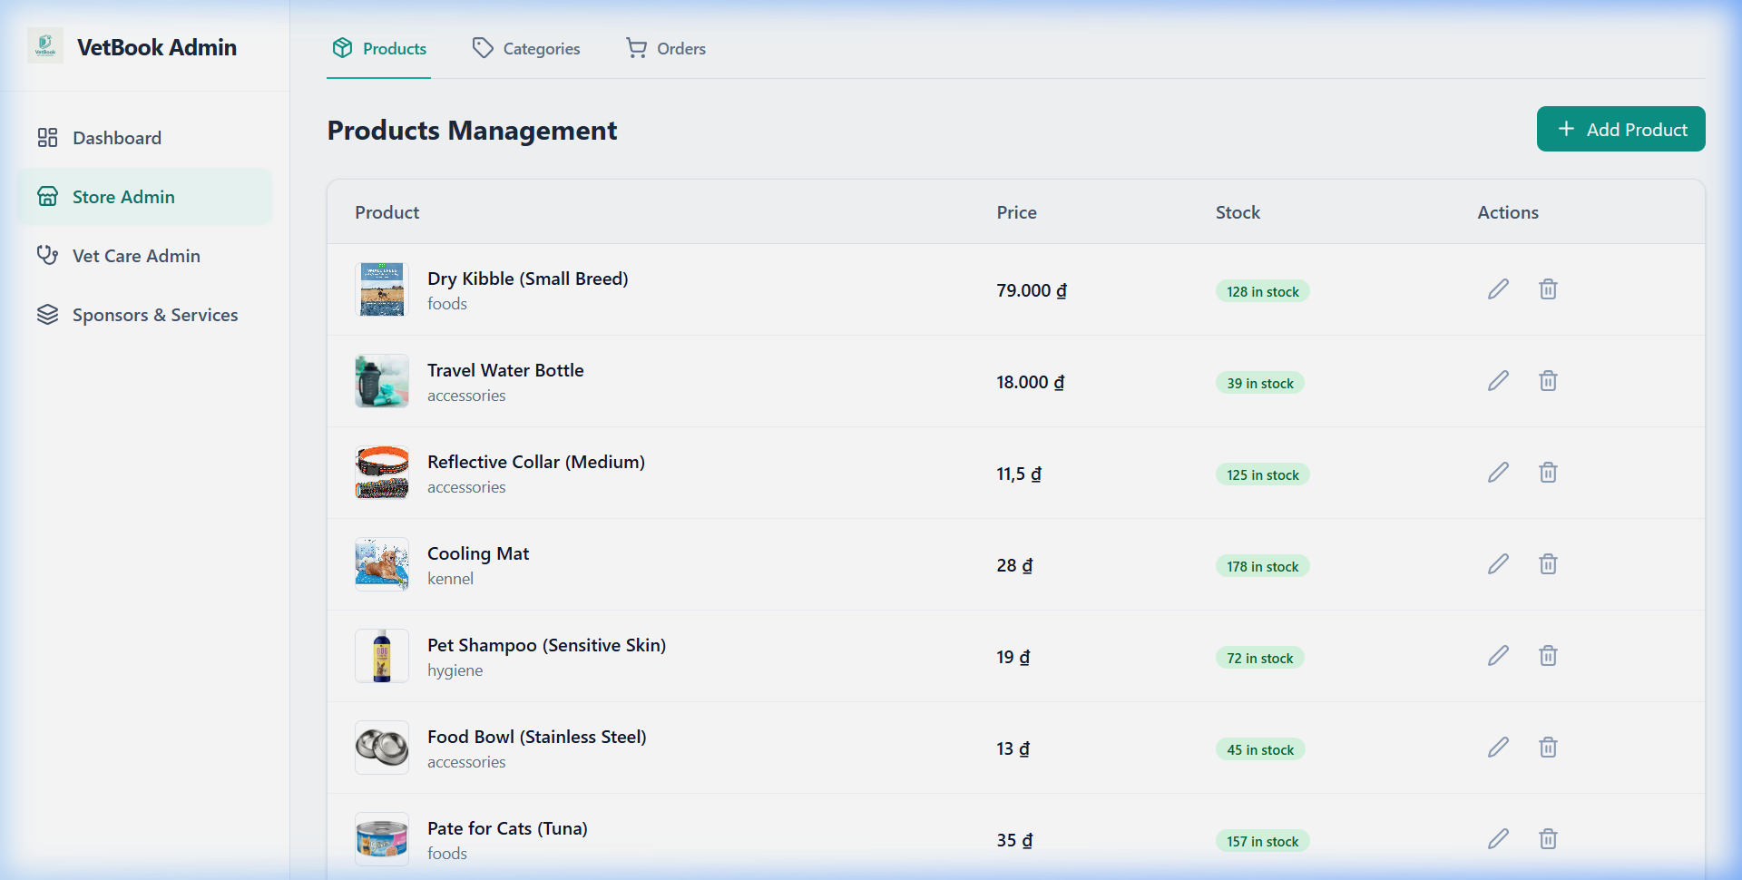
Figure: Admin Products Interface

Admin Clinics
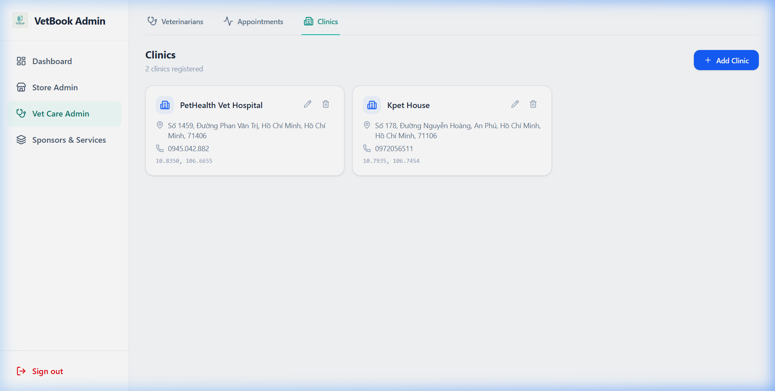
Figure: Admin Clinics Interface

Admin Services
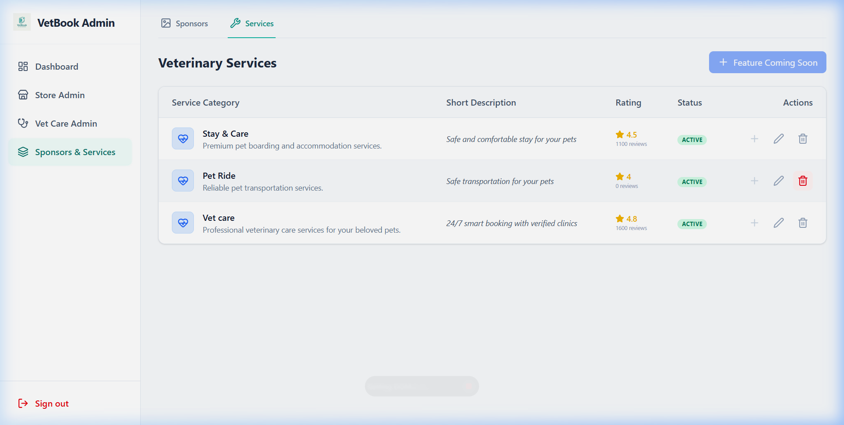
Figure: Admin Services Interface

3. Android App Achievements
- Complete UX/UI overhaul with premium teal branding.
- Secure PayOS integration for appointment bookings.
- DeepLink Handler for automatic post-payment redirection.
- Refined pet management and profile screens.

3.1 Mobile App Screenshots
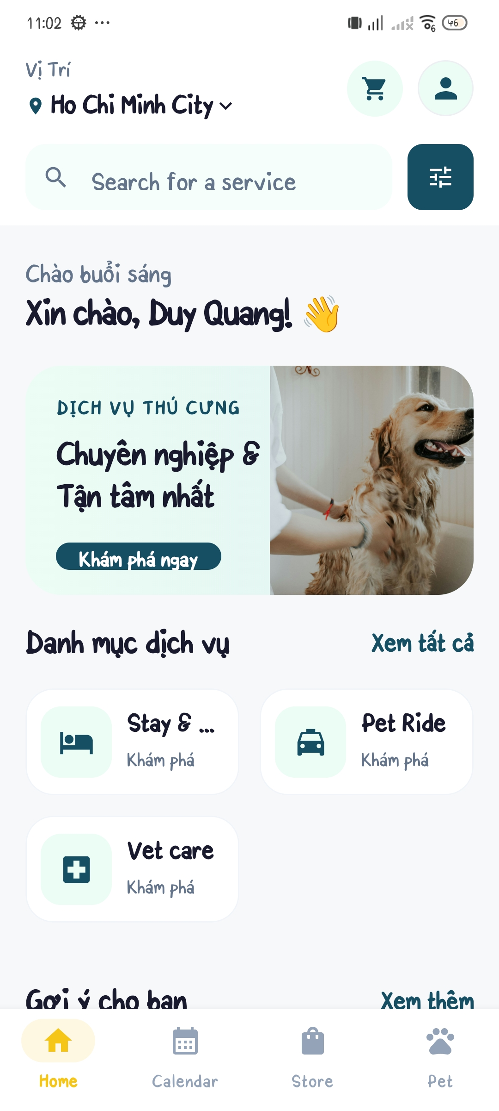 | 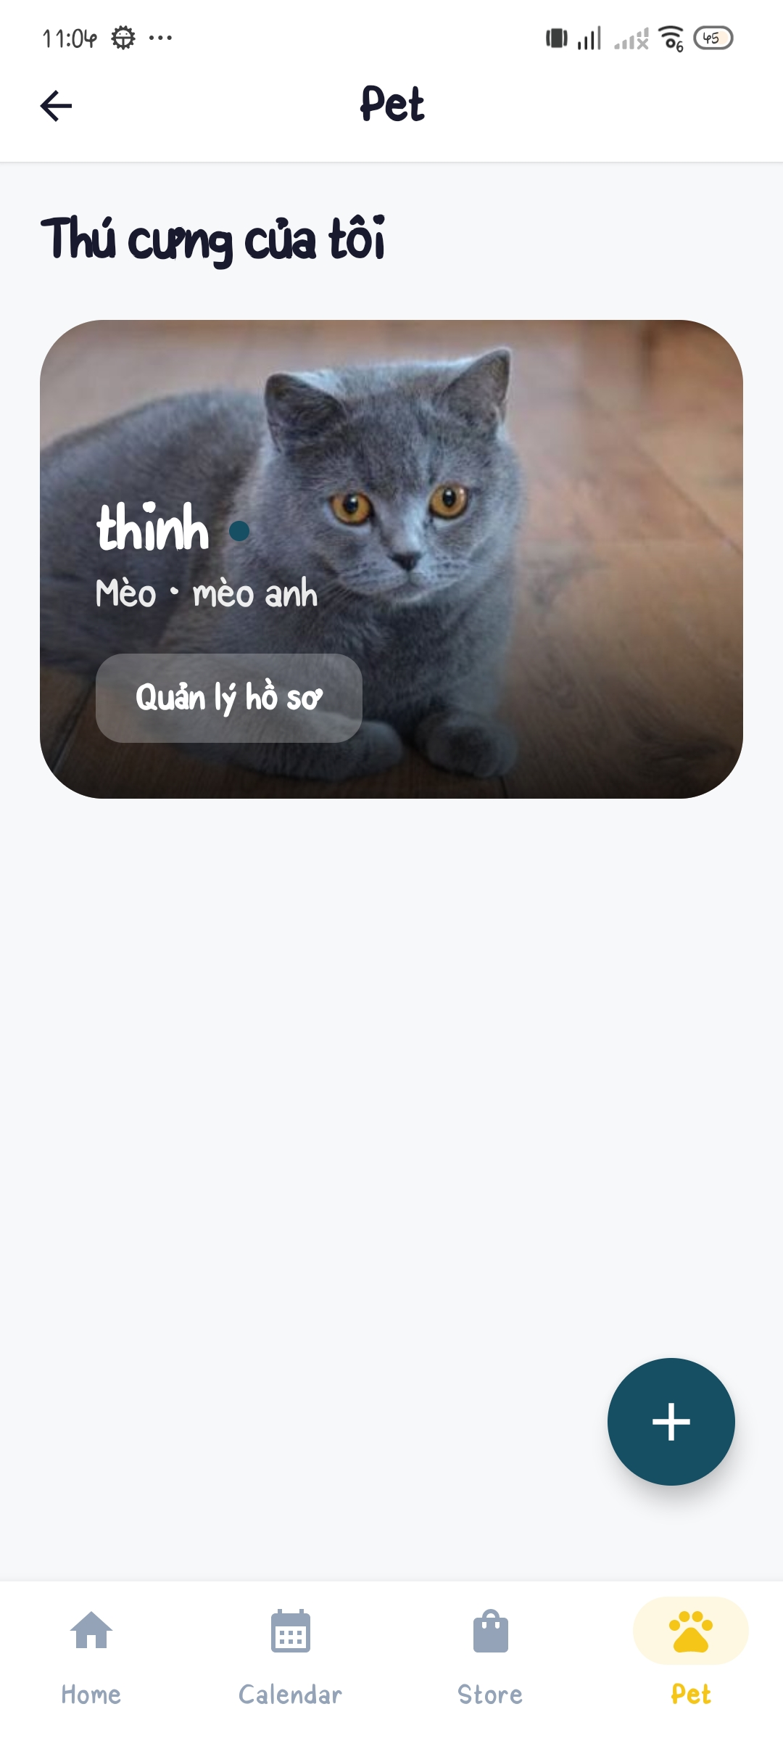
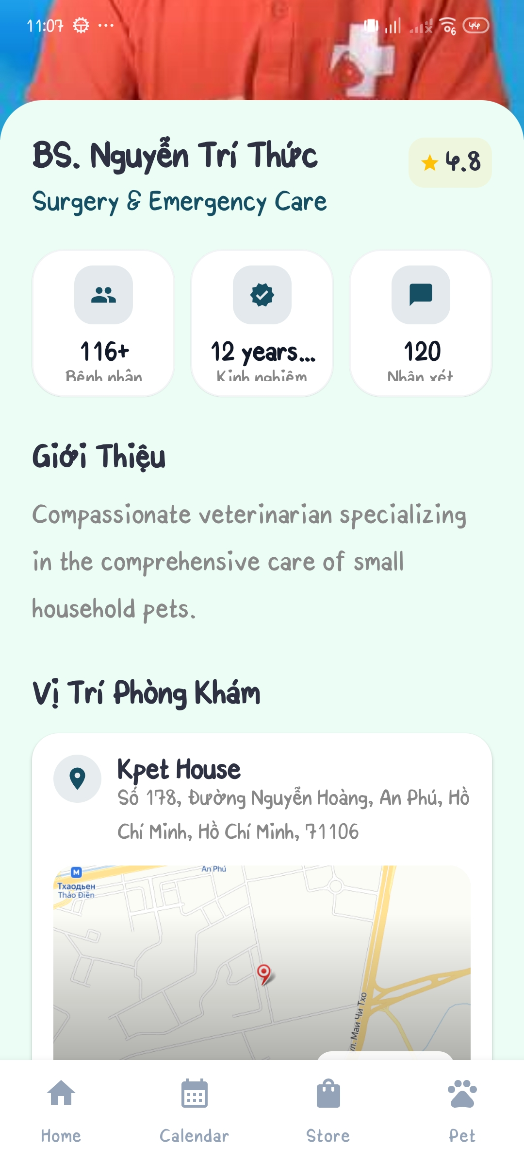 | 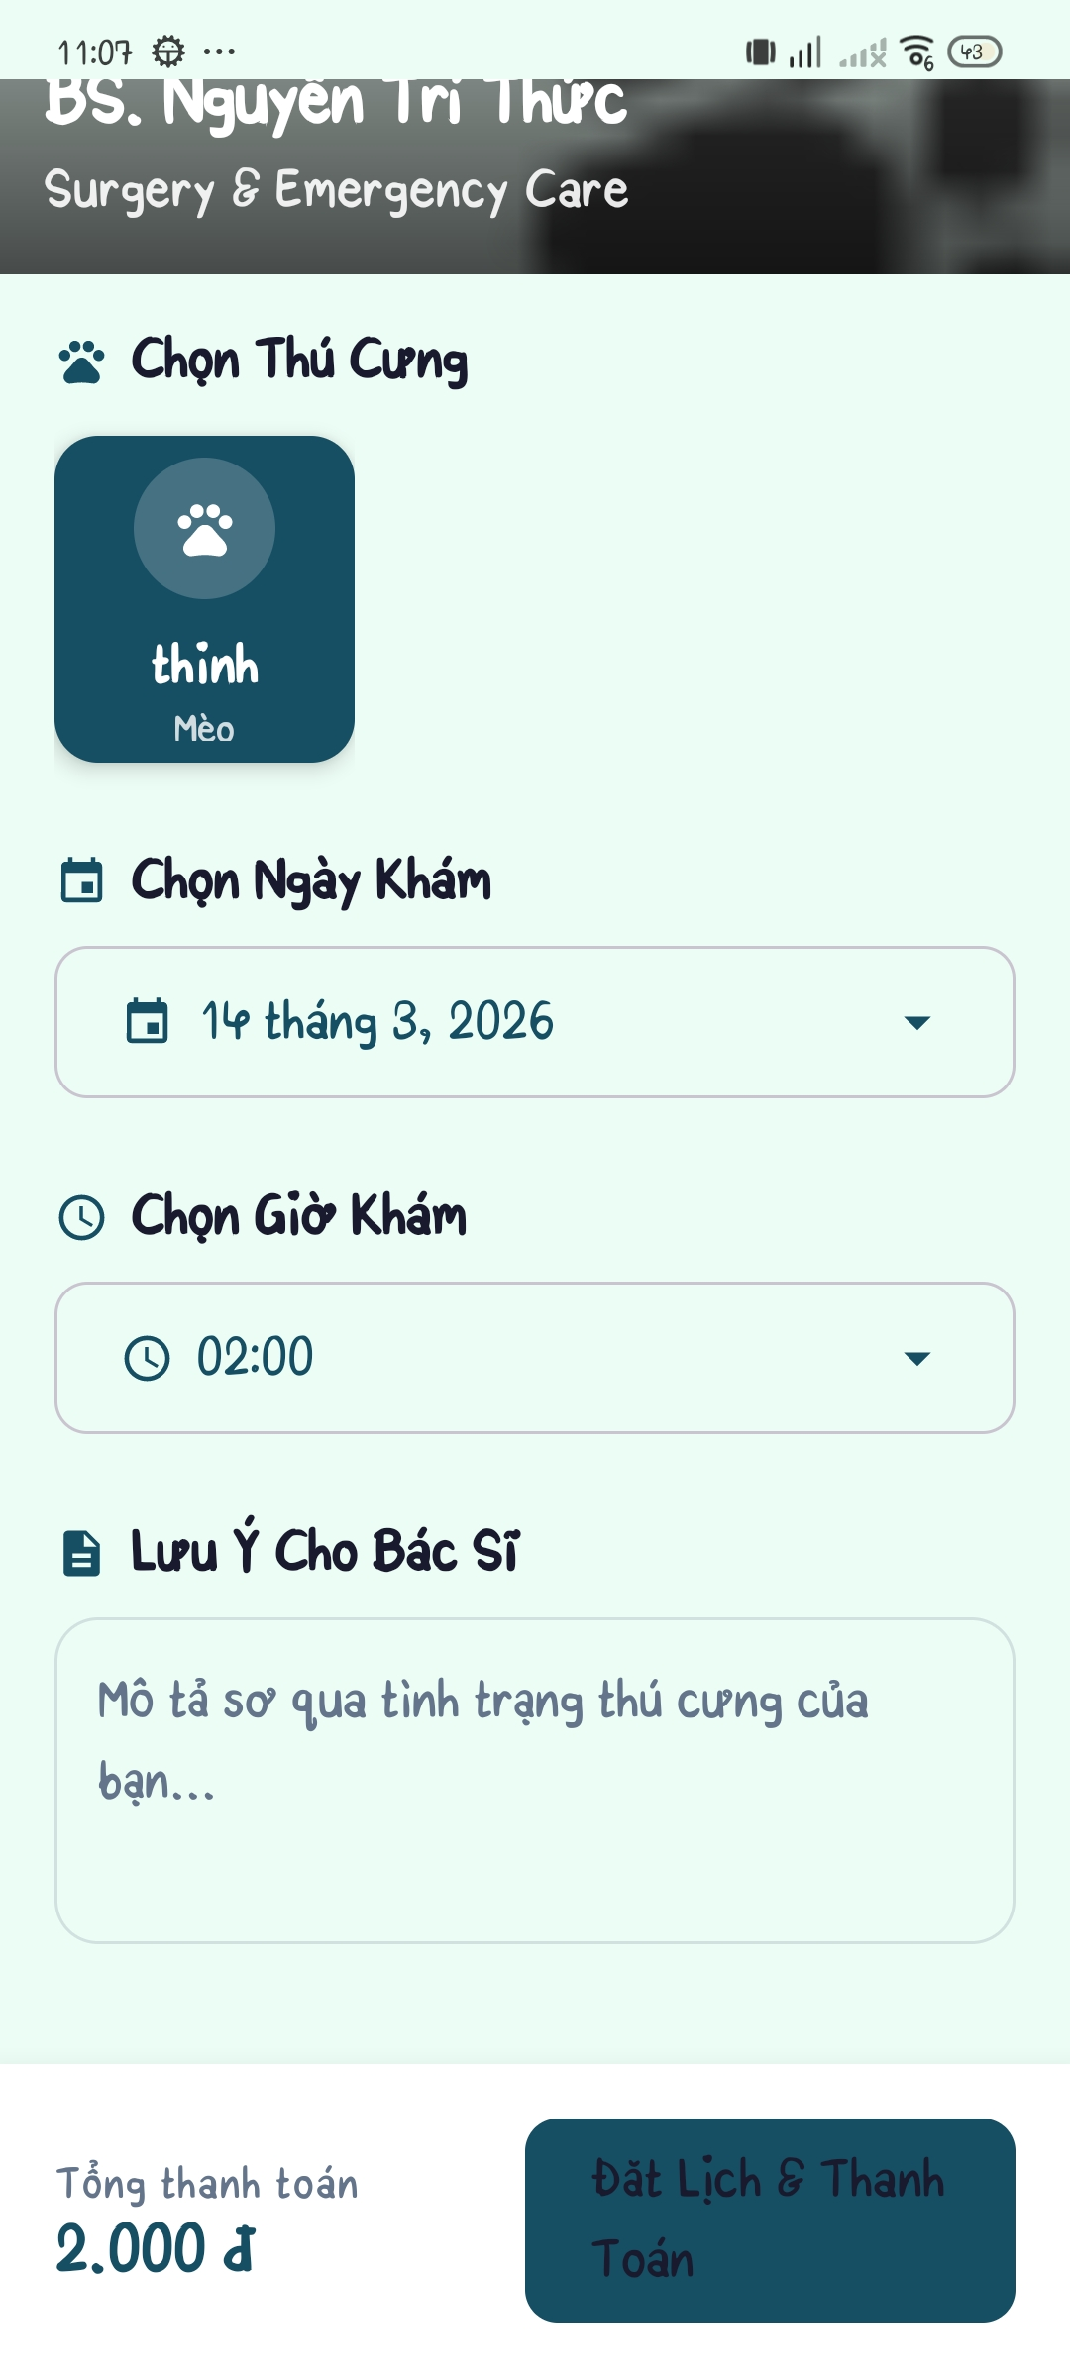
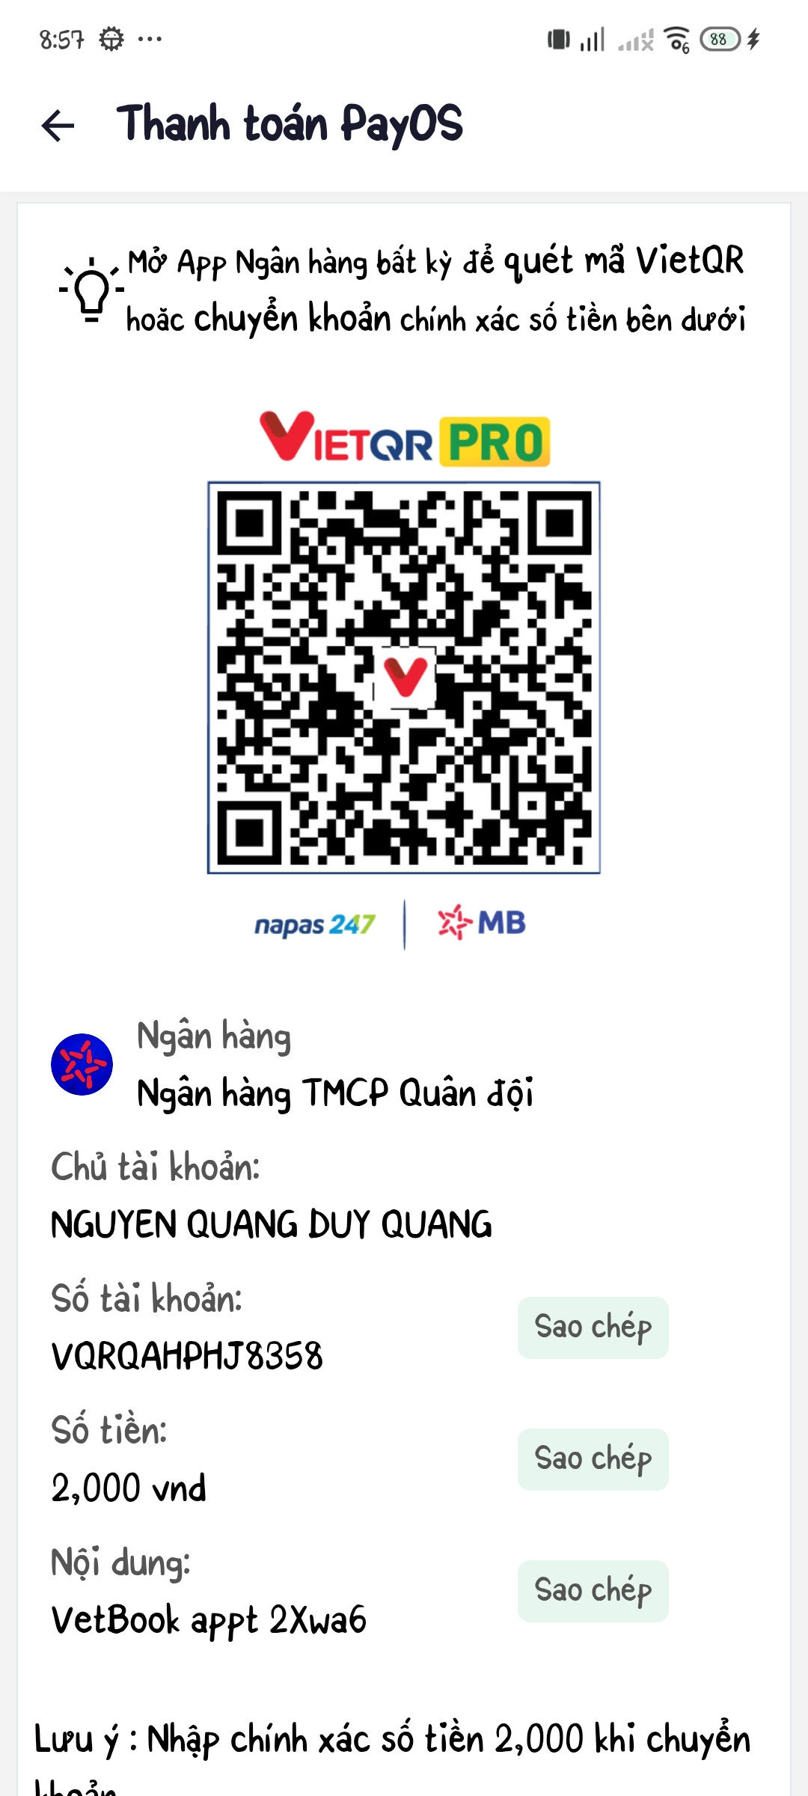 | 