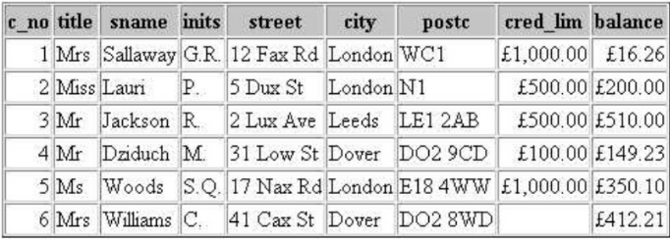  
Ex1

Query 1:

Sname(σcred_lim >500) (customer)



Query 2:

Sname(σcred_lim >500 ^ city=”london”) ( customer)



Ex2

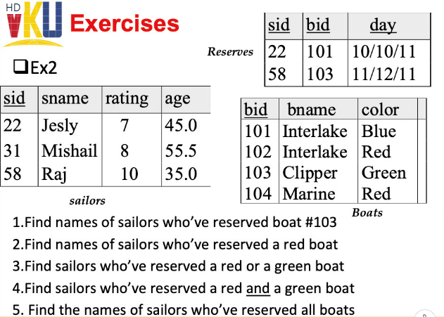

Query1:



Query2:

Nobody

Query3:



Query4:

Nobody

Query5:

Nobody