Multi-Representation SER Architecture Report
Updated with detailed feature explanation and comparison against Ahmed, Chowdhury, and Lee & Nadeem
Main conclusion
Our current model improves over the strongest previous dual-view model on combined_random and combined_strict_no_tess, but it is still far below the >90% reference papers because those papers use much stronger augmentation, tuned deep/recurrent ensembles, richer feature engineering, and random/single-dataset protocols that are not clearly strict speaker-aware.

1. Our proposed architecture
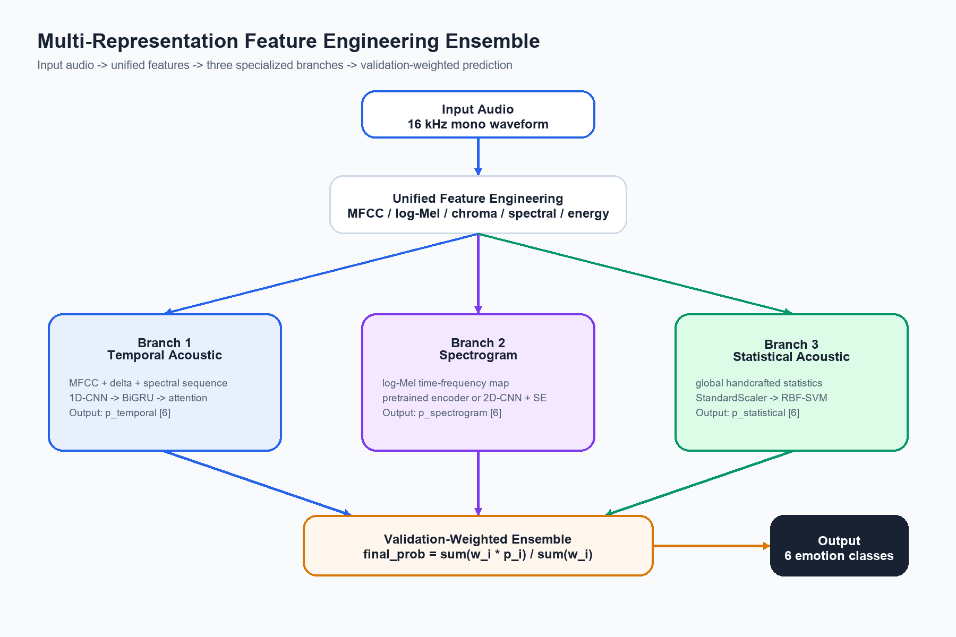
Our model: unified feature engineering -> temporal branch, pretrained spectrogram branch, statistical branch -> validation-weighted ensemble.
Input: normalized 16 kHz mono speech audio. Output: probability distribution over six common emotions: neutral, happy, sad, angry, fear and disgust.
The model extracts three complementary representations from the same audio: a temporal sequence, a spectrogram/pretrained embedding representation, and a global statistical vector. Each representation is handled by a model family that matches its shape.

2. Feature sets used in our model
Feature group | Used by branch | Meaning | Why it matters
MFCC + delta + delta-delta | Temporal branch and stats branch | Timbre/spectral envelope and its first/second temporal derivatives. | Emotion changes are often expressed through changing tone, articulation and vocal color.
RMS / energy | Temporal branch and stats branch | Frame-level or clip-level loudness/intensity. | Angry/happy often have stronger energy; sad/neutral often lower energy.
ZCR | Temporal branch and stats branch | Rate of waveform sign crossing. | Indicates voiced/unvoiced texture and harshness.
Spectral centroid/bandwidth/rolloff/contrast | Temporal branch and stats branch | Brightness, spread, high-frequency concentration and peak-valley contrast. | Captures spectral texture linked to tense, sharp or soft speech.
Chroma STFT/CQT/CENS | Stats branch | Harmonic/pitch-class structure. | Adds pitch/harmonic information not fully captured by MFCC.
Log-Mel spectrogram | Spectrogram branch | 2D time-frequency energy map. | Matches CNN/pretrained spectrogram encoders and captures local spectral patterns.

3. Branch-by-branch processing steps
Branch | Input shape/concept | Processing blocks | Output | Function
Temporal acoustic | [B, 132, T] frame sequence | 1D-CNN -> BiGRU -> attention pooling -> dense classifier | p_temporal [B, 6] | Learns local and long-term temporal emotion cues.
Spectrogram/pretrained | Waveform or log-Mel representation | Audio pretrained spectrogram encoder; fallback 2D-CNN + SE attention | p_spectrogram [B, 6] | Learns time-frequency acoustic patterns and uses pretrained audio knowledge when available.
Statistical acoustic | [B, D] engineered vector | StandardScaler -> RBF-SVM | p_statistical [B, 6] | Uses global clip-level acoustic summary similar to classical feature engineering.
Final ensemble | Three probability vectors | Validation macro-F1 weighted average | p_final [B, 6] | Trusts stronger validation branches more while keeping complementary signals.

4. Our results versus strongest dual-view model
Protocol | Our acc | Our macro-F1 | Best dual-view | Dual acc | Dual macro-F1 | Delta macro-F1
combined_random | 73.32% | 73.50% | dual_bigru | 72.03% | 72.08% | +1.42 pts
combined_strict_no_tess | 59.86% | 59.68% | dual_bigru | 55.50% | 55.29% | +4.38 pts
single_CREMA-D | 66.07% | 65.83% | dual_bigru | 60.43% | 60.55% | +5.28 pts
single_RAVDESS | 75.47% | 75.19% | dual_attention | 76.10% | 75.63% | -0.43 pts
single_SAVEE | 76.19% | 71.51% | dual_attention | 76.19% | 75.59% | -4.08 pts
single_TESS | 100.00% | 100.00% | dual_attention | 100.00% | 100.00% | +0.00 pts

5. Our results versus reference papers
Dataset/protocol | Our current best comparable result | Ahmed et al. | Chowdhury et al. | Lee & Nadeem | Interpretation
combined_random | 73.32 acc / 73.50 macro-F1 | - | - | - | Our combined_random is improved over dual-view but not paper-level because references mostly report single-dataset/random augmented settings.
combined_strict_no_tess | 59.86 acc / 59.68 macro-F1 | - | - | - | This is harder and closer to generalization. References do not clearly provide the same strict speaker-aware protocol.
CREMA-D single | 66.07 acc / 65.83 macro-F1 | 90.47 acc | 95.10 acc | 89.31 acc | Large gap. References use stronger augmentation and heavier/tuned architectures.
RAVDESS single | 75.47 acc / 75.19 macro-F1 | 95.62 acc | 97.83 acc | 99.23 acc | Large gap. Need stronger augmentation and CNN-LSTM/GRU/BiLSTM-style modeling.
SAVEE single | 76.19 acc / 71.51 macro-F1; temporal branch alone reaches 80.55 macro-F1 | 93.22 acc | 97.02 acc | 97.49 acc | Our ensemble hurts SAVEE compared with temporal branch; adaptive ensemble/best-branch selection is needed.
TESS single | 100.00 acc / 100.00 macro-F1 | 99.46 acc | 100.00 acc | 99.82 acc | TESS is easy in both our work and references. It should not dominate conclusions.

6. Why the reference papers are much higher
- They use stronger augmentation. Ahmed reports that augmentation raises accuracy by 3% to 32%, especially on SAVEE and CREMA-D. Lee & Nadeem show RAVDESS jumping from 46.52% to 99.23% after MFCC plus augmentation. Chowdhury also uses noise, pitch and time-stretch augmentation.
- Their protocols are not clearly strict speaker-aware. The papers report 80-20 split, cross-validation or single-dataset benchmarks, but do not clearly state speaker-aware or original-audio group split after augmentation. This makes direct comparison with strict protocols unsafe.
- They use heavier or better-tuned architectures. Ahmed trains three models and ensembles them; Chowdhury uses stacked BiLSTM and DeepCRF with about 16M trainable parameters; Lee & Nadeem adds attention to 1D-CNN.
- They use feature engineering more aggressively. Chowdhury explicitly uses 190 engineered features, while our statistical branch is still a relatively simple RBF-SVM branch and not yet a deep sequence model over engineered features.
- They often report accuracy, sometimes weighted average accuracy, while we emphasize macro-F1. Macro-F1 is stricter when class imbalance exists.
Fair reporting recommendation
In the report, compare our model to references in two layers: paper-comparable random/augmented results for benchmarking, and strict no-leakage results for academic honesty. Do not claim the >90% papers are directly comparable unless their split and augmentation pipeline are matched.

7. Next implementation direction
Next experiment | Inspired by | Expected benefit | Important rule
Train-only augmentation: noise, pitch, time stretch | Ahmed, Chowdhury, Lee & Nadeem | Reduce overfit and improve small datasets like SAVEE/RAVDESS. | Split first, augment train only.
CNN-LSTM/CNN-GRU ensemble | Ahmed et al. | Combine local CNN features with long-term recurrent context. | Use validation weights and compare each component.
190 engineered features + PCA optional | Chowdhury et al. | Strengthen statistical/engineered branch. | Report feature dimensions and avoid data leakage in scaler/PCA.
BiLSTM or DeepCRF-like structured head | Chowdhury et al. | Model sequential dependencies more explicitly. | Keep a simpler fallback if TensorFlow Addons/CRF is unavailable.
Channel/spatial attention over MFCC | Lee & Nadeem | Let model reweight informative feature channels and time regions. | Add ablation without attention.

8. Sources
Ahmed et al. 2021: An Ensemble 1D-CNN-LSTM-GRU Model with Data Augmentation for Speech Emotion Recognition. https://arxiv.org/abs/2112.05666
Chowdhury et al. 2025: A Novel Hybrid Deep Learning Technique for Speech Emotion Detection using Feature Engineering. https://arxiv.org/abs/2507.07046
Lee & Nadeem 2025: Toward Efficient Speech Emotion Recognition via Spectral Learning and Attention. https://arxiv.org/abs/2507.03251

