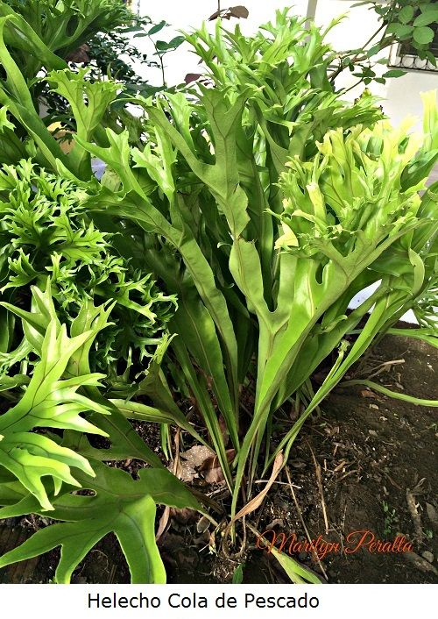

Scientific name: Fern, class Polypodiopsida (dương xỉ)

**LIGHT:**

Although most ferns grow in moist, shady places like forest floors, this does not mean that they need no light. Their normal situation in the wild is dappled light, and if the light level in the home is too low, you will see poor growth and yellowing fronds. Give your ferns a position near a window that gets morning or late afternoon sun, and keep the ferns away from strong sunlight, especially during the summer. Direct sunlight will make them lose their leaves or turn their fronds yellow. You can keep your ferns in dim light as long as you give them regular breaks in bright light. They can be given artificial light, but this should be from a special gardening bulb or a fluorescent strip. Ordinary light bulbs generate too much heat.

.

**WATERING:**

Most ferns like an evenly moist soil with regular waterings. Allowing the soil to dry out between waterings stresses these plants.

Bushy ferns can be difficult to water. Try using a watering can with a long spout to direct the water to the center of the plant. Water generously, until it drains out of the bottom of the pot.

**SOIL:**

You also need to provide the right compost. Most ferns are forest or woodland plants and have tender, delicate roots adapted to the light forest soil, which is rich in leaf mold and decayed vegetable matter. The right compost must be free draining so that the roots never get waterlogged. A compost that contains peat or a fibrous peat substitute with plenty of sand is best. The compost should never be allowed to dry out, which may mean watering the plant a little every single day in a warm, dry atmosphere.

**FERTILIZING:**

You also need to provide the right compost. Most ferns are forest or woodland plants and have tender, delicate roots adapted to the light forest soil, which is rich in leaf mold and decayed vegetable matter. The right compost must be free draining so that the roots never get waterlogged. A compost that contains peat or a fibrous peat substitute with plenty of sand is best. The compost should never be allowed to dry out, which may mean watering the plant a little every single day in a warm, dry atmosphere.

**Temperature and Humidity:**

An individual fern’s place of origin and adaptability will determine how high or low of a temperature the fern needs. Most ferns don’t like cold. Those ferns from tropical regions truly appreciate 60-70 F (15-21 C.). Those from more temperate regions enjoy temperatures between 50-60 F. (10-16 C).

All ferns love moisture and should be given humid conditions. In living rooms and family rooms, stand their pots on trays of damp pebbles or clay granules. Ferns also love being misted at regular intervals with tepid, soft water unless the humidity of the whole room is kept high through the use of a humidifier.