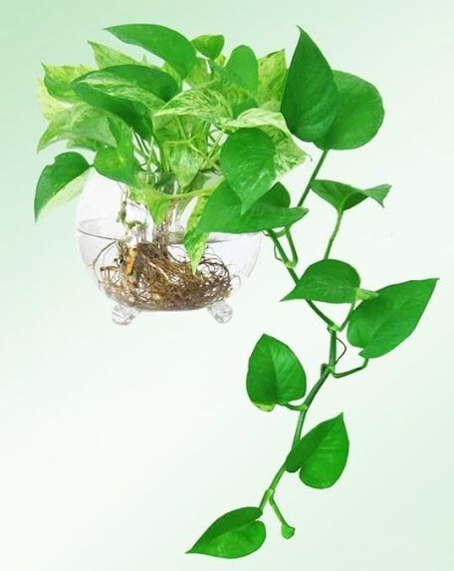

Scientific name: Pothos, Epipremnum aureum (trầu bà )

**LIGHT:**

Low light to bright light. No direct sun, which will burn foliage. Although pothos will tolerate low light, it will have more leaves and better variegation if kept in bright light. Long spaces between leaves indicate pothos is not getting enough sunlight. This plant thrives under fluorescent light, making it an ideal office plant.

.

**WATERING:**

Allow the top 1-in (2.5 cm) of soil to dry between waterings. Use a pot with a drainage hole to prevent soggy soil. Overwatering will cause leaves to turn yellow and fall off.

**SOIL:**

Good-quality all-purpose potting mix

**FERTILIZING:**

Feed every 2 weeks spring through fall with a balanced water-soluble fertilizer diluted by half. In winter, feed monthly.

**Humidity:**

Average room (around 40% relative humidity) or higher. Brown leaf tips are caused by dry air. Discover easy ways to [raise the humidity](https://www.guide-to-houseplants.com/humidity.html) for your house plants.

**Temperature and Humidity:**

Average to warm 65-80°F/18-27°C year-round.

Average room (around 40% relative humidity) or higher. Brown leaf tips are caused by dry air. Discover easy ways to [raise the humidity](https://www.guide-to-houseplants.com/humidity.html) for your house plants.