Họ và Tên: Nguyễn Quang Minh
Lớp 11_THMT
MSSV: 1150080105
Bài Lab 1

- Tạo dự án đơn giản với Android Studio
MainActivity.java

package com.example.firstprogram;
import android.os.Bundle;
import android.widget.Button;
import android.widget.EditText;
import android.widget.TextView;
import androidx.appcompat.app.AppCompatActivity;
public class MainActivity extends AppCompatActivity {
EditText txtX, txtY;
TextView txtResult;
Button btnPlus;
@Override
protected void onCreate(Bundle savedInstanceState) {
super.onCreate(savedInstanceState);
setContentView(R.layout.activity_main); // trỏ tới layout có id txtX, txtY, txtResult, btnPlus
initControl();
btnPlus.setOnClickListener(v -> {
int x = safeParse(txtX.getText().toString());
int y = safeParse(txtY.getText().toString());
int result = x + y;
txtResult.setText(String.valueOf(result));
});
}
private void initControl() {
txtX = findViewById(R.id.txtX);
txtY = findViewById(R.id.txtY);
txtResult = findViewById(R.id.txtResult);
btnPlus = findViewById(R.id.btnPlus);
}
private int safeParse(String s) {
try { return Integer.parseInt(s.trim()); }
catch (Exception e) { return 0; }
}
}

Activity_main.xml

<?xml version="1.0" encoding="utf-8"?>
<LinearLayout xmlns:android="http://schemas.android.com/apk/res/android"
xmlns:tools="http://schemas.android.com/tools"
android:layout_width="match_parent"
android:layout_height="match_parent"
android:orientation="vertical"
android:weightSum="10"
tools:context=".MainActivity">
<EditText
android:id="@+id/txtX"
android:layout_width="match_parent"
android:layout_height="0dp"
android:layout_weight="1"
android:gravity="center"
android:inputType="number"
android:hint="Nhập X"/>
<EditText
android:id="@+id/txtY"
android:layout_width="match_parent"
android:layout_height="0dp"
android:layout_weight="1"
android:gravity="center"
android:inputType="number"
android:hint="Nhập Y"/>
<TextView
android:id="@+id/txtResult"
android:layout_width="match_parent"
android:layout_height="0dp"
android:layout_weight="1"
android:gravity="center"
android:text="@string/result"
android:textSize="18sp"/>
<LinearLayout
android:layout_width="match_parent"
android:layout_height="48dp"
android:orientation="horizontal"
android:weightSum="5">
<Button
android:id="@+id/btnPlus"
android:layout_width="0dp"
android:layout_height="match_parent"
android:layout_weight="1"
android:text="@string/plus"
android:textColor="@color/white"
android:textStyle="bold"
android:textSize="16sp"
android:background="@drawable/btn_square_purple"
android:minWidth="0dp"
android:minHeight="0dp"
android:padding="0dp"/>
<View
android:layout_width="0dp"
android:layout_height="match_parent"
android:layout_weight="4"/>
</LinearLayout>
<View
android:layout_width="match_parent"
android:layout_height="0dp"
android:layout_weight="6"/>
</LinearLayout>

Strings.xml

<resources>
<string name="app_name">Máy Tính</string>
<string name="result">Kết quả</string>
<string name="plus">+</string>
</resources>

Tạo nút btn_square_purple.xml

<?xml version="1.0" encoding="utf-8"?>
<shape xmlns:android="http://schemas.android.com/apk/res/android">
<solid android:color="#6A5ACD"/>
<corners android:radius="0dp"/>
</shape>

Kết quả
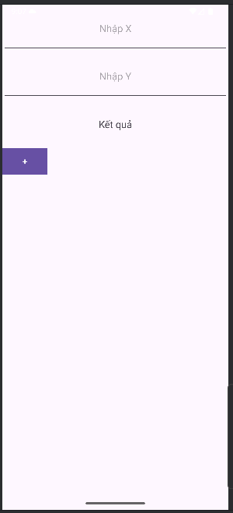
- Bài 1
MainActivity.java

package com.example.firstprogram;
import android.os.Bundle;
import android.widget.Button;
import android.widget.EditText;
import android.widget.TextView;
import androidx.appcompat.app.AppCompatActivity;
public class MainActivity extends AppCompatActivity {
EditText txtX, txtY;
TextView txtResult;
Button btnPlus, btnMinus, btnMul, btnDiv;
@Override
protected void onCreate(Bundle savedInstanceState) {
super.onCreate(savedInstanceState);
setContentView(R.layout.activity_main);
initControl();
wireEvents();
}
private void initControl() {
txtX = findViewById(R.id.txtX);
txtY = findViewById(R.id.txtY);
txtResult = findViewById(R.id.txtResult);
btnPlus = findViewById(R.id.btnPlus);
btnMinus = findViewById(R.id.btnMinus);
btnMul = findViewById(R.id.btnMul);
btnDiv = findViewById(R.id.btnDiv);
}
private void wireEvents() {
btnPlus.setOnClickListener(v -> showResult(safeParse(txtX), safeParse(txtY), '+'));
btnMinus.setOnClickListener(v -> showResult(safeParse(txtX), safeParse(txtY), '-'));
btnMul.setOnClickListener(v -> showResult(safeParse(txtX), safeParse(txtY), '*'));
btnDiv.setOnClickListener(v -> showResult(safeParse(txtX), safeParse(txtY), '/'));
}
private double safeParse(EditText et) {
String s = et.getText().toString().trim();
if (s.isEmpty() || s.equals(".") || s.equals("-") || s.equals("-."))
return 0;
try { return Double.parseDouble(s); }
catch (Exception e) { return 0; }
}
private void showResult(double x, double y, char op) {
double res;
switch (op) {
case '+': res = x + y; break;
case '-': res = x - y; break;
case '*': res = x * y; break;
case '/':
if (y == 0) { txtResult.setText("Không thể chia cho 0"); return; }
res = x / y; break;
default: res = 0;
}
if (res == Math.rint(res)) {
txtResult.setText(String.valueOf((long) res));
} else {
txtResult.setText(String.valueOf(res));
}
}
}

Activity_main.xml

<?xml version="1.0" encoding="utf-8"?>
<LinearLayout xmlns:android="http://schemas.android.com/apk/res/android"
xmlns:tools="http://schemas.android.com/tools"
android:layout_width="match_parent"
android:layout_height="match_parent"
android:orientation="vertical"
android:weightSum="10"
tools:context=".MainActivity">
<EditText
android:id="@+id/txtX"
android:layout_width="match_parent"
android:layout_height="0dp"
android:layout_weight="1"
android:gravity="center"
android:hint="Nhập X"
android:inputType="numberDecimal|numberSigned" />
<EditText
android:id="@+id/txtY"
android:layout_width="match_parent"
android:layout_height="0dp"
android:layout_weight="1"
android:gravity="center"
android:hint="Nhập Y"
android:inputType="numberDecimal|numberSigned" />
<TextView
android:id="@+id/txtResult"
android:layout_width="match_parent"
android:layout_height="0dp"
android:layout_weight="1"
android:gravity="center"
android:text="@string/result"
android:textSize="18sp" />
<LinearLayout
android:layout_width="match_parent"
android:layout_height="48dp"
android:orientation="horizontal"
android:weightSum="4">
<Button
android:id="@+id/btnPlus"
android:layout_width="0dp"
android:layout_height="match_parent"
android:layout_weight="1"
android:text="@string/plus"
android:textColor="@android:color/white"
android:textStyle="bold"
android:background="@drawable/btn_square_purple"
android:minWidth="0dp" android:minHeight="0dp" android:padding="0dp" />
<Button
android:id="@+id/btnMinus"
android:layout_width="0dp"
android:layout_height="match_parent"
android:layout_weight="1"
android:text="@string/minus"
android:textColor="@android:color/white"
android:textStyle="bold"
android:background="@drawable/btn_square_purple"
android:minWidth="0dp" android:minHeight="0dp" android:padding="0dp" />
<Button
android:id="@+id/btnMul"
android:layout_width="0dp"
android:layout_height="match_parent"
android:layout_weight="1"
android:text="@string/mul"
android:textColor="@android:color/white"
android:textStyle="bold"
android:background="@drawable/btn_square_purple"
android:minWidth="0dp" android:minHeight="0dp" android:padding="0dp" />
<Button
android:id="@+id/btnDiv"
android:layout_width="0dp"
android:layout_height="match_parent"
android:layout_weight="1"
android:text="@string/div"
android:textColor="@android:color/white"
android:textStyle="bold"
android:background="@drawable/btn_square_purple"
android:minWidth="0dp" android:minHeight="0dp" android:padding="0dp" />
</LinearLayout>
<View
android:layout_width="match_parent"
android:layout_height="0dp"
android:layout_weight="6" />
</LinearLayout>

Strings.xml

<resources>
<string name="app_name">Máy Tính</string>
<string name="result">Kết quả</string>
<string name="plus">+</string>
<string name="minus">-</string>
<string name="mul">*</string>
<string name="div">/</string>
</resources>

Kết quả
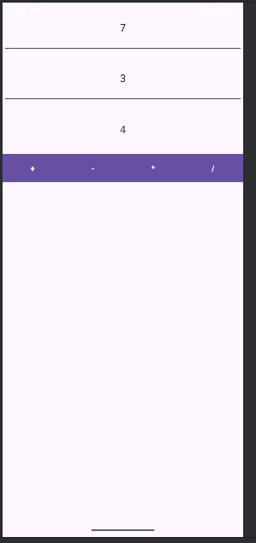
- Bài 2
MainActivity.java
package com.example.firstprogram;
import android.os.Bundle;
import android.widget.Button;
import android.widget.TextView;
import androidx.appcompat.app.AppCompatActivity;
import java.util.Random;
public class MainActivity extends AppCompatActivity {
private TextView tvRandom;
private Button btnRandom;
private final Random rnd = new Random();
@Override
protected void onCreate(Bundle savedInstanceState) {
super.onCreate(savedInstanceState);
setContentView(R.layout.activity_main);
tvRandom = findViewById(R.id.tvRandom);
btnRandom = findViewById(R.id.btnRandom);
btnRandom.setOnClickListener(v -> {
int value = rnd.nextInt(100);
tvRandom.setText(String.format("%02d", value));
});
}
}

Activity_main.xml
<?xml version="1.0" encoding="utf-8"?>
<LinearLayout xmlns:android="http://schemas.android.com/apk/res/android"
android:layout_width="match_parent"
android:layout_height="match_parent"
android:orientation="vertical"
android:background="#F7F1FF"
android:padding="16dp">
<TextView
android:id="@+id/tvRandom"
android:layout_width="match_parent"
android:layout_height="0dp"
android:layout_weight="1"
android:gravity="center"
android:text="00"
android:textColor="#F44336"
android:textSize="72sp"
android:textStyle="bold" />
<Button
android:id="@+id/btnRandom"
android:layout_width="match_parent"
android:layout_height="56dp"
android:text="@string/random_number"
android:textAllCaps="true"/>
</LinearLayout>

Strings.xml
<resources>
<string name="app_name">Randomly</string>
<string name="random_number">RANDOM NUMBER</string>
</resources>

Kết quả
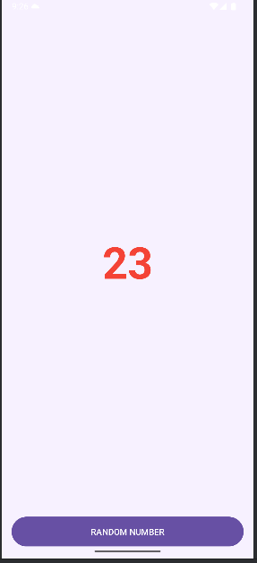
MainActivity.java
package com.example.firstprogram;
import android.os.Bundle;
import android.widget.Button;
import android.widget.TextView;
import androidx.appcompat.app.AppCompatActivity;
import java.util.Random;
public class MainActivity extends AppCompatActivity {
private TextView tvDice;
private Button btnRoll;
private final Random rnd = new Random();
private static final char[] DICE = {'\u2680','\u2681','\u2682','\u2683','\u2684','\u2685'};
@Override
protected void onCreate(Bundle savedInstanceState) {
super.onCreate(savedInstanceState);
setContentView(R.layout.activity_main);
tvDice = findViewById(R.id.tvDice);
btnRoll = findViewById(R.id.btnRoll);
btnRoll.setOnClickListener(v -> rollOnce());
tvDice.setOnClickListener(v -> rollOnce());
}
private void rollOnce() {
int face = rnd.nextInt(6); // 0..5
tvDice.setText(String.valueOf(DICE[face]));
}
}

Activity_main.xml
<?xml version="1.0" encoding="utf-8"?>
<LinearLayout xmlns:android="http://schemas.android.com/apk/res/android"
android:layout_width="match_parent"
android:layout_height="match_parent"
android:orientation="vertical"
android:background="#F7FDFB"
android:padding="16dp">
<TextView
android:id="@+id/tvDice"
android:layout_width="match_parent"
android:layout_height="0dp"
android:layout_weight="1"
android:gravity="center"
android:text="⚄"
android:textSize="500sp" />
<TextView
android:id="@+id/tvHint"
android:layout_width="match_parent"
android:layout_height="wrap_content"
android:gravity="center"
android:text="@string/tap_to_roll"
android:textSize="14sp"
android:padding="8dp" />
<Button
android:id="@+id/btnRoll"
android:layout_width="match_parent"
android:layout_height="56dp"
android:text="@string/roll_dice"
android:textAllCaps="true"/>
</LinearLayout>

Strings.xml
<?xml version="1.0" encoding="utf-8"?>
<resources>
<string name="app_name">Randomly</string>
<string name="random_number">RANDOM NUMBER</string>
<string name="roll_dice">ROLL THE DICE</string>
<string name="tap_to_roll">Tap to roll the dice</string>
</resources>

Kết quả
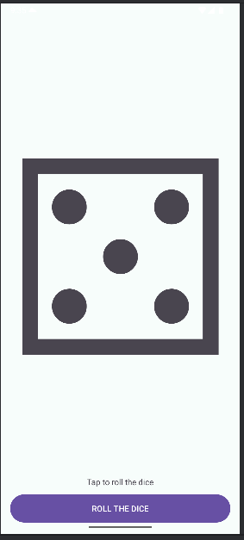
Lab2
Bài 1
MainActivity.java
package com.example.animalsound;
import android.os.Bundle;
import android.widget.Button;
import androidx.appcompat.app.AppCompatActivity;
import android.content.Intent;
public class MainActivity extends AppCompatActivity {
@Override
protected void onCreate(Bundle savedInstanceState) {
super.onCreate(savedInstanceState);
setContentView(R.layout.activity_main);
findViewById(R.id.btnOpenSplash).setOnClickListener(
v -> startActivity(new Intent(this, M000ActSplash.class)));
}
}

M000ActSplash.java
package com.example.animalsound;
import android.content.Intent;
import android.os.Bundle;
import android.os.Handler;
import android.os.Looper;
import android.view.View;
import android.widget.ImageView;
import androidx.appcompat.app.AppCompatActivity;
import androidx.core.content.ContextCompat;
import java.util.Random;
public class M000ActSplash extends AppCompatActivity {
private final int[] COLORS = {
R.color.bg_indigo, R.color.bg_green, R.color.bg_pink, R.color.bg_orange
};
private final int[] ICONS = {
R.drawable.ic_cat, R.drawable.ic_dog, R.drawable.ic_owl
};
@Override
protected void onCreate(Bundle savedInstanceState) {
super.onCreate(savedInstanceState);
setContentView(R.layout.m001_act_splash);
View root = findViewById(R.id.splashRoot);
ImageView img = findViewById(R.id.imgAnimal);
Random r = new Random();
root.setBackgroundColor(ContextCompat.getColor(this, COLORS[r.nextInt(COLORS.length)]));
img.setImageResource(ICONS[r.nextInt(ICONS.length)]);
new Handler(Looper.getMainLooper()).postDelayed(
() -> startActivity(new Intent(this, MainActivity.class)), 1500
);
}
}

Activity_main.xml
<?xml version="1.0" encoding="utf-8"?>
<LinearLayout xmlns:android="http://schemas.android.com/apk/res/android"
android:layout_width="match_parent"
android:layout_height="match_parent"
android:gravity="center"
android:orientation="vertical"
android:padding="24dp">
<Button
android:id="@+id/btnOpenSplash"
android:layout_width="match_parent"
android:layout_height="wrap_content"
android:text="Open Splash (Bài 1)" />
</LinearLayout>

Colors.xml
<?xml version="1.0" encoding="utf-8"?>
<resources>
<color name="bg_indigo">#424FB7</color>
<color name="bg_green">#2E7D32</color>
<color name="bg_pink">#FF4081</color>
<color name="bg_orange">#F57C00</color>
</resources>

m001_act_splash.xml
<?xml version="1.0" encoding="utf-8"?>
<LinearLayout xmlns:android="http://schemas.android.com/apk/res/android"
android:id="@+id/splashRoot"
android:layout_width="match_parent"
android:layout_height="match_parent"
android:gravity="center"
android:orientation="vertical">
<ImageView
android:id="@+id/imgAnimal"
android:layout_width="128dp"
android:layout_height="128dp"
android:src="@drawable/ic_penguin" />
<TextView
android:layout_width="wrap_content"
android:layout_height="wrap_content"
android:layout_marginTop="10dp"
android:text="Animal sound"
android:textColor="@android:color/white"
android:textSize="24sp" />
</LinearLayout>

AndroidManifest.xml
<?xml version="1.0" encoding="utf-8"?>
<manifest xmlns:android="http://schemas.android.com/apk/res/android">
<application
android:allowBackup="true"
android:icon="@mipmap/ic_launcher"
android:roundIcon="@mipmap/ic_launcher_round"
android:label="@string/app_name"
android:supportsRtl="true"
android:theme="@style/Theme.App">
<activity
android:name=".M000ActSplash"
android:noHistory="true"
android:theme="@style/Full_Screen"
android:exported="true">
<intent-filter>
<action android:name="android.intent.action.MAIN" />
<category android:name="android.intent.category.LAUNCHER" />
</intent-filter>
</activity>
<activity android:name=".MainActivity" />
</application>
</manifest>

themes.xml
<resources>
<style name="Theme.App" parent="Theme.Material3.DayNight.NoActionBar" />
<style name="Full_Screen" parent="Theme.MaterialComponents.DayNight.NoActionBar" />
</resources>

string.xml
<resources>
<string name="app_name">AnimalSound</string>
</resources>

Kết Quả
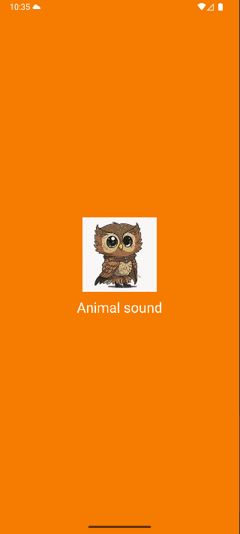
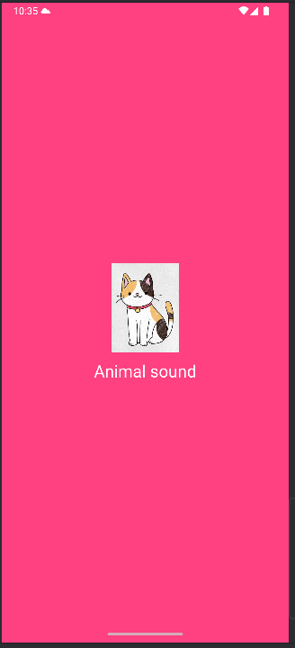
Bài 2
M000ActSplash.java
package com.example.animalsound;
import android.content.Intent;
import android.os.Bundle;
import android.os.Handler;
import android.os.Looper;
import android.view.View;
import android.widget.ImageView;
import androidx.appcompat.app.AppCompatActivity;
import androidx.core.content.ContextCompat;
import java.util.Random;
public class M000ActSplash extends AppCompatActivity {
private final int[] COLORS = {
android.R.color.holo_blue_light,
android.R.color.holo_green_light,
android.R.color.holo_orange_light,
android.R.color.holo_red_light
};
private final int[] ICONS = {
R.drawable.ic_cat,
R.drawable.ic_dog,
R.drawable.ic_owl,
R.drawable.ic_penguin
};
@Override
protected void onCreate(Bundle savedInstanceState) {
super.onCreate(savedInstanceState);
setContentView(R.layout.m001_act_splash);
View root = findViewById(R.id.splashRoot);
View loading = findViewById(R.id.loadingRoot);
ImageView img = findViewById(R.id.imgAnimal);
Random r = new Random();
root.setBackgroundColor(ContextCompat.getColor(this, COLORS[r.nextInt(COLORS.length)]));
img.setImageResource(ICONS[r.nextInt(ICONS.length)]);
new Handler(Looper.getMainLooper()).postDelayed(() -> {
loading.setVisibility(View.GONE);
startActivity(new Intent(this, MainActivity.class));
}, 1500);
}
}

m001_act_splash.xml
<?xml version="1.0" encoding="utf-8"?>
<FrameLayout xmlns:android="http://schemas.android.com/apk/res/android"
android:id="@+id/splashRoot"
android:layout_width="match_parent"
android:layout_height="match_parent"
android:gravity="center"
android:background="#121212">
<LinearLayout
android:layout_width="match_parent"
android:layout_height="match_parent"
android:gravity="center"
android:orientation="vertical">
<ImageView
android:id="@+id/imgAnimal"
android:layout_width="128dp"
android:layout_height="128dp"
android:src="@drawable/ic_penguin" />
<TextView
android:layout_width="wrap_content"
android:layout_height="wrap_content"
android:layout_marginTop="10dp"
android:text="Animal sound"
android:textColor="@android:color/white"
android:textSize="24sp" />
</LinearLayout>
<include layout="@layout/item_loading" />
</FrameLayout>

item_loading.xml
<?xml version="1.0" encoding="utf-8"?>
<LinearLayout xmlns:android="http://schemas.android.com/apk/res/android"
android:id="@+id/loadingRoot"
android:layout_width="match_parent"
android:layout_height="match_parent"
android:background="#80000000"
android:gravity="center"
android:orientation="vertical">
<ProgressBar
style="?android:attr/progressBarStyleLarge"
android:layout_width="60dp"
android:layout_height="60dp"
android:indeterminate="true"
android:indeterminateTint="@android:color/white"/>
<TextView
android:layout_width="wrap_content"
android:layout_height="wrap_content"
android:layout_marginTop="8dp"
android:text="Loading..."
android:textColor="@android:color/white"/>
</LinearLayout>

Kết Quả
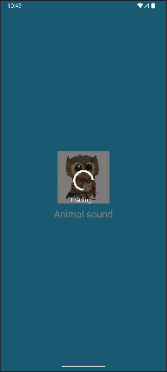
Bài 3
MainActivity.java
M000ActSplash.java
Activity_main.xml
Colors.xml
m001_act_splash.xml
AndroidManifest.xml
themes.xml
string.xml
Kết Quả
Bài 4
MainActivity.java
M000ActSplash.java
Activity_main.xml
Colors.xml
m001_act_splash.xml
AndroidManifest.xml
themes.xml
string.xml
Kết Quả

