BDRPC187

DANANG SOFTWARE CORPORATION

SOFTECH APTECH

− 🙣🕮🙡 −



**PROJECT**

**GYM MANAGEMENT**

**APPLICATION**

**Instructor : Mr. Nguyen Duc Thao**

**Group : 2**

**Members : Trần Xuân Quang**

**Nguyễn Khắc Quang Thuận**

**Mai Sơn Tùng**

**Phạm Khắc Quang**

**Danang, December 10th, 2019**

Gym Management

|  |  |
| --- | --- |
| Group 2 | |
| Group Member | Trần Xuân Quang  Nguyễn Khắc Quang Thuận  Mai Sơn Tùng  Phạm Khắc Quang |
| Instructor | Mr. Nguyen Duc Thao |

**TEACHER’S EVALUATION**

………………………………………………………………………………………………………………………………………………………………………………………………………………………………………………………………………………………………………………………………………………………………………………………………………………………………………………………………………………………………………………………………………………………………………………………………………………………………………………………………………………………………………………………………………………………………………………………………………………………………………………………………………………………………………………………………………………………………………………………………………………………………………………………………………………………………………………………………………………………………………………………………………………………………………………………………………………………………………………………………………………………………………………………………………………………………………………………………………………………………………………………………………………………………………………………………………………………………………………………………………………………………………………………………………………………………………………………………………………………………………………………………………………………………………………………………………………………………………………………………………………………………………………………………………………………………………………………………………………………………………………………………………………………………………………………………………………………………………………………………………………………………………………………………………………………………………………………………………………………………………………………………………………………………………………………………

**Table of Contents**

I. ACKNOWLEDGEMENTS 6

II. RATIONALE 6

III. INTRODUCTION 6

IV. TARGETS AND OBJECTS OF THE RESEARCH 7

1. Research Targets 7

2. Research Objects 7

V. PROBLEM DEFINITION 7

VI. THE TECHNOLOGY USED 8

1. Tools used 8

2. Language Used 8

VII. REQUIREMENT ATTRIBUTES 8

1.Critical Use Case Specification 8

2. Use case Diagram 15

3. Entity Relationship Diagram 17

4. Table 18

4.1 Employees Table 18

4.2 Role Table 18

4.3 Salary Table 19

4.4 Register Table 19

4.5 Customer Table 20

4.6 Category Product Table 20

4.7 Product Name Table 21

4.8 Provider Table 21

4.9 Product Details Table 22

4.10 Leftover Product Table 23

4.11 Selling Product Table 24

4.12 Device Name Table 24

4.13 Device Provider Table 25

4.14 Device Table 25

4.15 Debt Customer Table 26

5. View 26

5.1 Customer registration view 26

5.2 View_SanPham 27

5.3 View_ThietBi 28

5.4 View_DoanhThuSanPham 29

5.5 View_DoanhThuKhachHang 30

5.6 View_CongNoKhachHang 30

VIII. IMAGE OF THE SOFTWARE

1 Login form 31

2 The main software interface 31

3 Change password form 32

4 Sell product 32

5 User mannagement 33

6 Customer mannagement 33

7 Product mannagement 34

8 Equipment mannagement 34

9 Statistics of revenue from product 35

10 Revenue statistics from customers 35

11 Statistics of liabilities from customers 36

12 Statistics on employee salaries 36

13 Detailed statistics employees 37

14 Help information board 37

IX. CONCLUSION 38

1 Conclude 38

TABLE OF DIVISION WORKING FROM THE MEMBERS OF THE GROUP 39

REFERENCES 40

I. ACKNOWLEDGEMENTS

First, we would like to thank the teachers who helped us make a successful project. Especially Mr. Nguyen Duc Thao was very enthusiastic to help us complete software projects. Thanks for the time he has "debug" or fix wrong for us, and teach us things unknown, help us to better understand and develop skills over the code for us to finish software the most successful way. Without the guidance of the teacher, then we think we will not be able to complete this software.

Although we have made many attempts, because of the limited time, the practice could not be able to avoid the mistakes and deficiencies. We hope teachers can consider and ignore our errors or deficiencies. And finally, we would like to offer many thanks to all our friends for their valuable suggestions and constructive feedbacks.

II. RATIONALE

In the world in general and in Vietnam in particular, information technology has to become a leading industry, an indispensable science and technology in life. The application of information technology to the social domains such as management, information, economics ... has created these applications are essentially alternative to manual management, minimizing the use of human resources in management, increasing efficiency, saving costs, time and effort.

When people all over the world have become so much concerned aout their health and diet, it is obvious that they continually seek out for gyms. So the application was created to make management easier and more efficient

III. INTRODUCTION

Gym Management is a system for computerizing the management of user for such tasks as management of customer lists, sell products, gym manager managemen, ...

IV. TARGETS AND OBJECTS OF THE RESEARCH

1. Research Targets

The main objective of the project is to create a gym management system to solve the difficulties in the management activities for the purpose of minimizing the use of human resources in management, increasing efficiency, saving costs, time and effort.

2. Research Objects

Our main objects are gym users and gym manager.

V. PROBLEM DEFINITION

1. Login

2. Account Management

3. Selling Category

4. Statistic

5. Customer Information Management

6. Product Management

7. Device Management

8. Salary Management

9. Finding Function

10. Change Password

11. Recovery Password

VI. THE TECHNOLOGY USED

1. Tools used

Eclipse , SQL Server 2014

2. Language Used

Java,SQL

VII. REQUIREMENT ATTRIBUTES

1.Critical Use Case Specification

|  |  |  |  |
| --- | --- | --- | --- |
| USE CASE SPECIFICATION | | | |
| Use-case No. | UC01 | Use-case Version | 1.0 |
| Use-case Name | Login | | |
| Purpose:  To manage account allows users to log into the management system  Input:  User login to the management system by entering the required fields and push button “Login”.  Output:  User who log on to the system successfully, it will show up the Admin Frame if account role is admin,Main Frame if account role is member. | | | |

|  |  |  |  |
| --- | --- | --- | --- |
| USE CASE SPECIFICATION | | | |
| Use-case No. | UC02 | Use-case Version | 1.0 |
| Use-case Name | Account Management | | |
| Purpose:  Allow users to add, edit, delete the user of system.  Input:  User will add a customer by entering the required fields, select admin or user and push button “Add”  User will delete a customer by choose user in the list and push button “Delete”  User will edit information of a customer by choosing the user, then entering the required fields and push button “Edit”  Output:  User add a product, it will notify the user that has add successfully or not.  User delete a product, it will notify the user that has deleted successfully or not.  User edit a product, it will notify the user that has edit successfully or not. | | | |

|  |  |  |  |
| --- | --- | --- | --- |
| USE CASE SPECIFICATION | | | |
| Use-case No. | UC03 | Use-case Version | 1.0 |
| Use-case Name | Selling Category | | |
| Purpose:  Input:  Output: | | | |

|  |  |  |  |
| --- | --- | --- | --- |
| USE CASE SPECIFICATION | | | |
| Use-case No. | UC04 | Use-case Version | 1.0 |
| Use-case Name | Statistic | | |
| Purpose:  Allow users to statistic benefit from customer.  Input:  User choose the the time to statistic from when to when.  User choose the pakage (how many months).  User press “Find”.  Output:  User will see information if the data exists in the database corresponding the days and the pakage user choosed.  User will see nothing if the data didn’t exist in the database corresponding the days and the pakage user choosed. | | | |

|  |  |  |  |
| --- | --- | --- | --- |
| USE CASE SPECIFICATION | | | |
| Use-case No. | UC05 | Use-case Version | 1.0 |
| Use-case Name | Customer Information Management | | |
| Purpose:  Allow users to add, delete, edit information of customer.  Input:  User will add a customer by entering the required fields and push button “Add”  User will delete a customer by choose customer in the list and push button “Delete”  User will edit information of a customer by choosing the customer, then entering the required fields and push button “Edit”  Output:  User add a customer, it will notify the user that has add successfully or not.  User delete a customer, it will notify the user that has deleted successfully or not.  User edit a customer, it will notify the user that has edit successfully or not. | | | |

|  |  |  |  |
| --- | --- | --- | --- |
| USE CASE SPECIFICATION | | | |
| Use-case No. | UC06 | Use-case Version | 1.0 |
| Use-case Name | Product Management | | |
| Purpose:  Allow users to add, delete, edit information about product which sells to customer  Input:  User will add a product by entering the required fields and push button “Add”  User will delete product by choose product in the list and push button “Delete”  User will edit product by choosing the product, then making changes and push button “Edit”  Output:  User add a product, it will notify the user that has add successfully or not.  User delete a product, it will notify the user that has deleted successfully or not.  User edit a product, it will notify the user that has edit successfully or not. | | | |

|  |  |  |  |
| --- | --- | --- | --- |
| USE CASE SPECIFICATION | | | |
| Use-case No. | UC07 | Use-case Version | 1.0 |
| Use-case Name | Device Management | | |
| Purpose:  Allow users to add, delete, edit information about device for customer using.  Input:  User will add a device by choosing the device, entering the required fields and push button “Add”  User will delete device by choose the device in the list and push button “Delete”  User will edit device by choosing the device, then making changes and push button “Edit”  Output:  User add a product, it will notify the user that has add successfully or not.  User delete a product, it will notify the user that has deleted successfully or not.  User edit a product, it will notify the user that has edit successfully or not. | | | |

|  |  |  |  |
| --- | --- | --- | --- |
| USE CASE SPECIFICATION | | | |
| Use-case No. | UC08 | Use-case Version | 1.0 |
| Use-case Name | Salary Management | | |
| Purpose:  Allow users to see and find the salary about employees.  Input:  User choose the the time to find information from when to when.  User choose the role (admin/member/all)  User press “Find”.  Output:  User will see information if the data exists in the database corresponding the days and the role user choosed.  User will see nothing if the data didn’t exist in the database corresponding the days and the role user choosed. | | | |

|  |  |  |  |
| --- | --- | --- | --- |
| USE CASE SPECIFICATION | | | |
| Use-case No. | UC09 | Use-case Version | 1.0 |
| Use-case Name | Finding function | | |
| Purpose:  Allow users to add, delete, edit information of subject.  Input:  User will add a subject by entering the required fields and push button “Add”  User will delete a subject by choose subject in subject list and push button “Delete”  User will edit information of a subject by entering the required fields and push button “Edit”  Output:  User add a subject, it will notify the user that has add successfully or not.  User delete a subject, it will notify the user that has deleted successfully or not.  User edit a subject, it will notify the user that has edit successfully or not. | | | |

|  |  |  |  |
| --- | --- | --- | --- |
| USE CASE SPECIFICATION | | | |
| Use-case No. | UC10 | Use-case Version | 1.0 |
| Use-case Name | Change Password | | |
| Purpose:  Allow users change password  Input:  User change password by entering the required fields include: user name, current password,new password and push button “Change”  Output:  System will notify the user that has changed successfully or not. | | | |

|  |  |  |  |
| --- | --- | --- | --- |
| USE CASE SPECIFICATION | | | |
| Use-case No. | UC11 | Use-case Version | 1.0 |
| Use-case Name | Recovery Password | | |
| Purpose:  Allow users recovery password.  Input:  User recovery password by entering the required fields include: user name, email,secret code and push button “Submit”  Output:  If these info user has type is right,the system will send password to user’s email | | | |

2. Use case Diagram

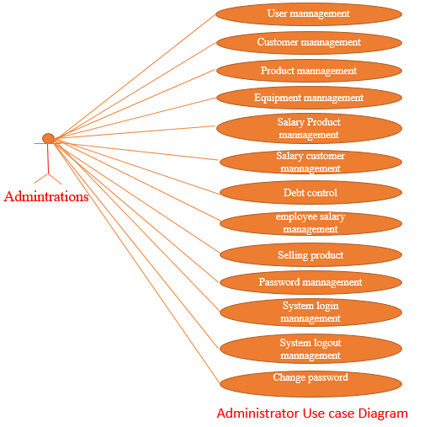

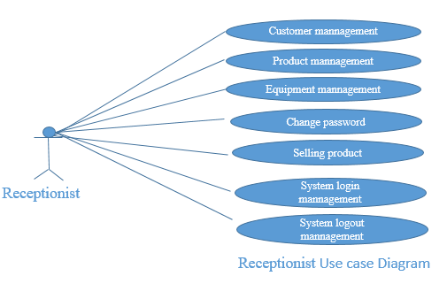

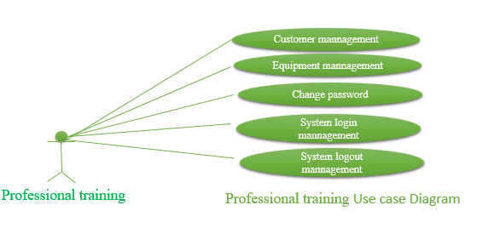

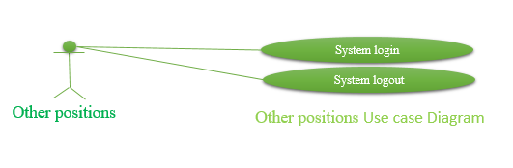

3. Entity Relationship Diagram

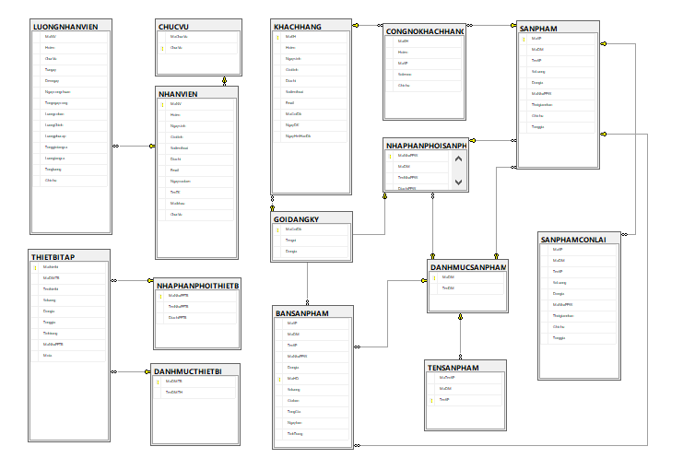

4. Table

4.1 Employees Table

|  |  |  |  |  |  |
| --- | --- | --- | --- | --- | --- |
| **NHANVIEN** | | | | | |
| **Key** | **Field Name** | **Data Type** | **Length** | **Null** | **Description** |
| Primary | MaNV | varchar | 10 |  | ID of employee |
|  | Hoten | varchar | 50 |  | Name |
|  | Ngaysinh | date |  |  | Date of birth |
|  | Gioitinh | bit |  |  | Sex |
|  | Sodienthoai | int |  |  | Phone Number |
|  | Diachi | varchar | 50 |  | Address |
|  | Email | varchar | 30 |  | Email |
|  | Ngayvaolam | date |  |  | Date begin working |
|  | TenTK | varchar | 30 |  | Account name |
|  | Matkhau | varchar | 30 |  | Password |
| Foreign | ChucVu | varchar | 20 |  | Role |

4.2 Role Table

|  |  |  |  |  |  |
| --- | --- | --- | --- | --- | --- |
| **CHUCVU** | | | | | |
| **Key** | **Field Name** | **Data Type** | **Length** | **Null** | **Description** |
|  | MaChucVu | varchar | 20 |  | ID of role |
| PRIMARY | ChucVu | varchar | 20 |  | Role |

4.3 Salary Table

|  |  |  |  |  |  |
| --- | --- | --- | --- | --- | --- |
| **LUONGNHANVIEN** | | | | | |
| **Key** | **Field Name** | **Data Type** | **Length** | **Null** | **Description** |
| Foreign | MaNV | varchar | 10 |  | ID of employee |
|  | Hoten | varchar | 50 |  | Name |
|  | ChucVu | varchar | 20 |  | Role |
|  | Tungay | date |  |  | From date |
|  | Denngay | date |  |  | To date |
|  | Ngaycongchuan | int |  |  | Date plus |
|  | Tongngaycong | int |  |  | Total of date working |
|  | Luongcoban | float |  |  | Basic Salary |
|  | LuongChinh | float |  |  | Salary |
|  | Luongphucap | float |  | yes | Difficult Salary |
|  | Tonggiotangca | float |  | yes | Total bonus |
|  | Luongtangca | float |  | yes | Salary bonus |
|  | Tongluong | float |  |  | Total all |
|  | Ghichu | nvarchar | 200 | yes | Description |

4.4 Register Table

|  |  |  |  |  |  |
| --- | --- | --- | --- | --- | --- |
| **GOIDANGKY** | | | | | |
| **Key** | **Field Name** | **Data Type** | **Length** | **Null** | **Description** |
| Primary | MaGoiDk | varchar | 20 |  | ID of Register |
|  | Tengoi | varchar | 50 |  | Name of Register |
|  | Dongia | int |  |  | Unit price |

4.5 Customer Table

|  |  |  |  |  |  |
| --- | --- | --- | --- | --- | --- |
| **KHACHHANG** | | | | | |
| **Key** | **Field Name** | **Data Type** | **Length** | **Null** | **Description** |
| Primary | MaKH | varchar | 10 |  | ID of Customer |
|  | Hoten | varchar | 50 |  | Name Customer |
|  | Ngaysinh | date |  |  | Date of birth |
|  | Gioitinh | bit |  |  | Sex |
|  | Diachi | varchar | 50 | yes | Address |
|  | Sodienthoai | int |  | yes | Phone Number |
|  | Email | varchar | 30 | yes | Email |
| FOREIGN | MaGoiDk | varchar | 20 |  | ID of Register |
|  | NgayDK | date |  |  | Date Register |
|  | NgayHetHanDk | date |  |  | Date expire |

4.6 Category Product Table

|  |  |  |  |  |  |
| --- | --- | --- | --- | --- | --- |
| **DANHMUCSANPHAM** | | | | | |
| **Key** | **Field Name** | **Data Type** | **Length** | **Null** | **Description** |
| Primary | MaDM | varchar | 10 |  | ID of Category |
|  | TenDM | varchar | 50 |  | Name of Category |

4.7 Product Name Table

|  |  |  |  |  |  |
| --- | --- | --- | --- | --- | --- |
| **TENSANPHAM** | | | | | |
| **Key** | **Field Name** | **Data Type** | **Length** | **Null** | **Description** |
|  | MaTenSP | varchar | 10 |  | ID of Product |
| Foreign | MaDM | varchar | 10 |  | ID of Category |
| Primary | TenSP | varchar | 30 |  | Product Name |

4.8 Provider Table

|  |  |  |  |  |  |
| --- | --- | --- | --- | --- | --- |
| **NHANPHANPHOISANPHAM** | | | | | |
| **Key** | **Field Name** | **Data Type** | **Length** | **Null** | **Description** |
| Primary | MaNhaPPSS | varchar | 10 |  | ID of Provider |
| Foreign | MaDM | varchar | 10 |  | ID of Category |
|  | TenNhaPPSS | varchar | 50 |  | Date of Birth |
|  | DiachiPPSS | nvarchar | 50 |  | Address of Provider |

4.9 Product Details Table

|  |  |  |  |  |  |
| --- | --- | --- | --- | --- | --- |
| **SANPHAM** | | | | | |
| **Key** | **Field Name** | **Data Type** | **Length** | **Null** | **Description** |
| Primary | MaSP | varchar | 10 |  | ID of Product |
| Foreign | MaDM | varchar | 10 |  | ID of Category |
| Foreign | TenSP | varchar | 30 |  | Product Name |
|  | SoLuong | int |  |  | Quantity |
|  | Dongia | float |  |  | Unit price |
| Foreign | MaNhaPPSS | varchar | 10 |  | ID of Provider |
|  | Thoigiannhan | date |  |  | Time receive |
|  | Ghichu | varchar | 200 | yes | Note |
|  | Tonggia | float |  |  | Total All |

4.10 Leftover Product Table

|  |  |  |  |  |  |
| --- | --- | --- | --- | --- | --- |
| **SANPHAMCONLAI** | | | | | |
| **Key** | **Field Name** | **Data Type** | **Length** | **Null** | **Description** |
| Foreign | MaSP | varchar | 10 |  | ID of Product |
|  | MaDM | varchar | 10 |  | ID of Category |
|  | TenSP | varchar | 30 |  | Product Name |
|  | SoLuong | int |  |  | Quantity |
|  | Dongia | float |  |  | Unit price |
|  | MaNhaPPSS | varchar | 10 |  | ID of Provider |
|  | Thoigiannhan | date |  |  | Time receive |
|  | Ghichu | varchar | 200 | yes | Note |
|  | Tonggia | float |  |  | Total All |

4.11 Selling Product Table

|  |  |  |  |  |  |
| --- | --- | --- | --- | --- | --- |
| **BANSANPHAM** | | | | | |
| **Key** | **Field Name** | **Data Type** | **Length** | **Null** | **Description** |
| Foreign | MaSP | varchar | 10 |  | ID of Product |
| Foreign | MaDM | varchar | 10 |  | ID of Category |
|  | TenSP | varchar | 30 |  | Product Name |
| Foreign | MaNhaPPSS | varchar | 10 |  | ID of Provider |
|  | Dongia | float |  |  | Unit price |
| Primary | MaHD | varchar | 10 |  | ID of selling product |
|  | Thoigiannhan | date |  |  | Date Receive |
|  | SoLuong | int |  |  | Quantity |
|  | Giaban | float |  |  | Price |
|  | Tonggia | float |  |  | Total All |
|  | Ngayban | date |  |  | Date Sell |
|  | TinhTrang | varchar | 20 |  | Status |

4.12 Device Name Table

|  |  |  |  |  |  |
| --- | --- | --- | --- | --- | --- |
| **DANHMUCTHIETBI** | | | | | |
| **Key** | **Field Name** | **Data Type** | **Length** | **Null** | **Description** |
| Primary | MaDMTB | varchar | 10 |  | ID of Device Name |
|  | TenDMTB | varchar | 50 |  | Device Name |

4.13 Device Provider Table

|  |  |  |  |  |  |
| --- | --- | --- | --- | --- | --- |
| **NHANPHANPHOITHIETBI** | | | | | |
| **Key** | **Field Name** | **Data Type** | **Length** | **Null** | **Description** |
| Primary | MaNhaPPTB | varchar | 10 |  | ID of Provider |
|  | TenNhaPPTB | varchar | 50 |  | Name of Provider |
|  | DiachiPPTB | varchar | 50 |  | Address of Provider |

4.14 Device Table

|  |  |  |  |  |  |
| --- | --- | --- | --- | --- | --- |
| **THIETBITAP** | | | | | |
| **Key** | **Field Name** | **Data Type** | **Length** | **Null** | **Description** |
| Primary | Mathietbi | varchar | 10 |  | ID of Device |
| Foreign | MaDMTB | varchar | 10 |  | ID of Device Name |
|  | Tenthietbi | varchar | 50 |  | Device Name |
|  | SoLuong | int |  |  | Quantity |
|  | Dongia | int |  |  | Unit Price |
|  | Tonggia | int |  |  | Totall all |
|  | Tinhtrang | varchar | 20 |  | Status |
| Foreign | MaNhaPPTB | varchar | 20 |  | ID of Provider |
|  | Mota | varchar | 200 | yes | Description |

4.15 Debt Customer Table

|  |  |  |  |  |  |
| --- | --- | --- | --- | --- | --- |
| **CONGNOKHACHHANG** | | | | | |
| **Key** | **Field Name** | **Data Type** | **Length** | **Null** | **Description** |
| Primary | MaKH | varchar | 10 |  | ID of Customer |
|  | Hoten | varchar | 50 |  | Name |
|  | MaSP | varchar | 10 |  | ID of Product |
|  | Sotienno | int |  |  | Debt money |
|  | Ghichu | nvarchar | 200 | yes | Note |

**5. View**

5.1 Customer registration view

|  |  |  |  |  |  |
| --- | --- | --- | --- | --- | --- |
| **VIEW_DANGKIKHACHHANG** | | | | | |
| **Key** | **Field Name** | **Data Type** | **Length** | **Null** | **Description** |
|  | MaKH | varchar | 10 |  | ID of Customer |
|  | Hoten | varchar | 50 |  | Name |
|  | Ngaysinh | date |  |  | Date and birth |
|  | Gioitinh | bit |  |  | Dender |
|  | MaGoiDk | Varchar | 10 |  | Note |
|  | Tengoi | Varchar | 10 |  | Package |
|  | NgayDK | date |  |  | Date Register |
|  | NgayHetHanDk | date |  |  | Date expire |
|  | Sodienthoai | int |  |  | Number phone |
|  | Diachi | varchar | 50 | yes | Address |
|  | Email | varchar | 30 | yes | Email |

5.2 View_SanPham

|  |  |  |  |  |  |
| --- | --- | --- | --- | --- | --- |
| **VIEW_SANPHAM** | | | | | |
| **Key** | **Field Name** | **Data Type** | **Length** | **Null** | **Description** |
|  | MaSP | varchar | 10 |  | ID of Product |
|  | MaDM | varchar | 10 |  | ID of Category |
|  | TenDM | varchar | 50 |  | Name of Category |
|  | TenSP | varchar | 30 |  | Product Name |
|  | MaNhaPPSS | varchar | 10 |  | ID of Provider |
|  | TenNhaPPSS | varchar | 50 |  | Date of Birth |
|  | SoLuong | int |  | yes | Quantity |
|  | Dongia | float |  |  | Unit price |
|  | Thoigiannhan | date |  |  | Time receive |
|  | Ghichu | varchar | 200 | yes | Note |
|  | Tonggia | float |  | yes | Total All |

5.3 View_ThietBi

|  |  |  |  |  |  |
| --- | --- | --- | --- | --- | --- |
| **VIEW_THIETBI** | | | | | |
| **Key** | **Field Name** | **Data Type** | **Length** | **Null** | **Description** |
|  | Mathietbi | varchar | 10 |  | ID of Device |
|  | MaDMTB | varchar | 10 |  | ID of Device Name |
|  | TenDMTB | varchar | 50 |  | Device Name |
|  | Tenthietbi | varchar | 50 |  | Device Name |
|  | SoLuong | int |  | yes | Quantity |
|  | Dongia | int |  | yes | Unit Price |
|  | Tonggia | int |  | yes | Totall all |
|  | Tinhtrang | varchar | 20 |  | Status |
|  | MaNhaPPTB | varchar | 10 |  | ID of Provider |
|  | TenNhaPPTB | varchar | 50 |  | Name of Provider |
|  | Mota | varchar | 200 | yes | Description |

5.4 View_DoanhThuSanPham

|  |  |  |  |  |  |
| --- | --- | --- | --- | --- | --- |
| **VIEW_DOANHTHUSANPHAM** | | | | | |
| **Key** | **Field Name** | **Data Type** | **Length** | **Null** | **Description** |
|  | MaHD | varchar | 10 |  | ID of selling product |
|  | MaSP | varchar | 10 |  | ID of Product |
|  | MaDM | varchar | 10 |  | ID of Category |
|  | TenDM | varchar | 50 |  | Name of Category |
|  | TenSP | varchar | 30 |  | Product Name |
|  | Dongia | float |  |  | Unit price |
|  | SoLuong | int |  | yes | Quantity |
|  | Giaban | float |  |  | Price |
|  | Tonggia | float |  |  | Total All |
|  | Ngayban | date |  |  | Date Sell |
|  | TinhTrang | varchar | 20 |  | Status |
|  | MaNhaPPTB | varchar | 10 |  | ID of Provider |
|  | TenNhaPPTB | varchar | 50 |  | Name of Provider |

5.5 View_DoanhThuKhachHang

|  |  |  |  |  |  |
| --- | --- | --- | --- | --- | --- |
| **VIEW_DOANHTHUKHACHHANG** | | | | | |
| **Key** | **Field Name** | **Data Type** | **Length** | **Null** | **Description** |
|  | Hoten | varchar | 50 |  | Name |
|  | MaGoiDk | varchar | 20 |  | ID of Register |
|  | Tengoi | varchar | 50 |  | Name of Register |
|  | Dongia | int |  | yes | Unit price |
|  | NgayDK | date |  |  | Date Register |
|  | NgayHetHanDk | date |  |  | Date expire |

5.6 View_CongNoKhachHang

|  |  |  |  |  |  |
| --- | --- | --- | --- | --- | --- |
| **VIEW_CONGNOKHACHHANG** | | | | | |
| **Key** | **Field Name** | **Data Type** | **Length** | **Null** | **Description** |
|  | MaKH | varchar | 10 |  | ID of Customer |
|  | Hoten | varchar | 50 |  | Name |
|  | MaSP | varchar | 10 |  | ID of Product |
|  | TenSP | varchar | 30 |  | Name of Product |
|  | Sotienno | int |  |  | Debt money |
|  | Ghichu | nvarchar | 200 | yes | Note |

VIII. IMAGE OF THE SOFTWARE

1. **Login form**

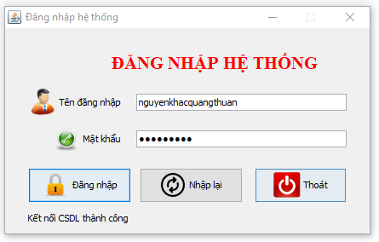

1. **The main software interface**

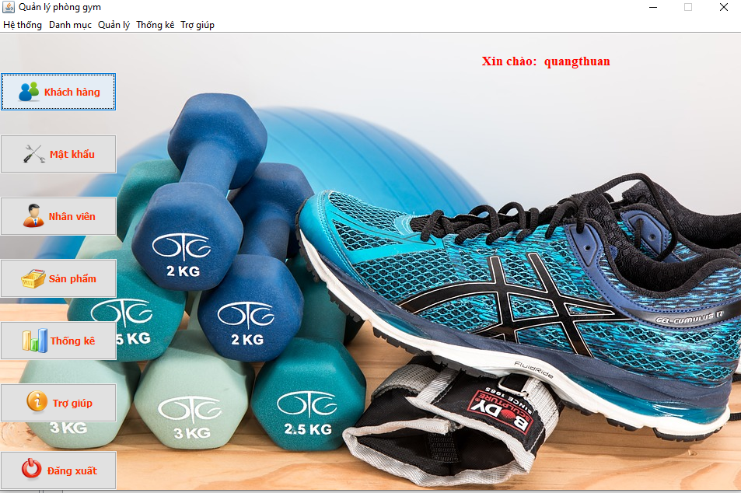

1. **Change password form**

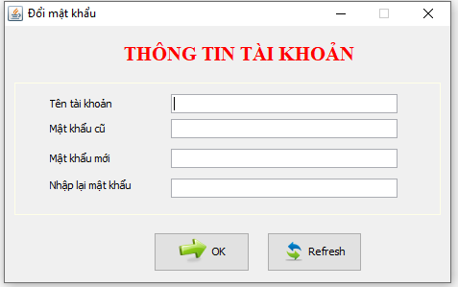

1. **sell products**

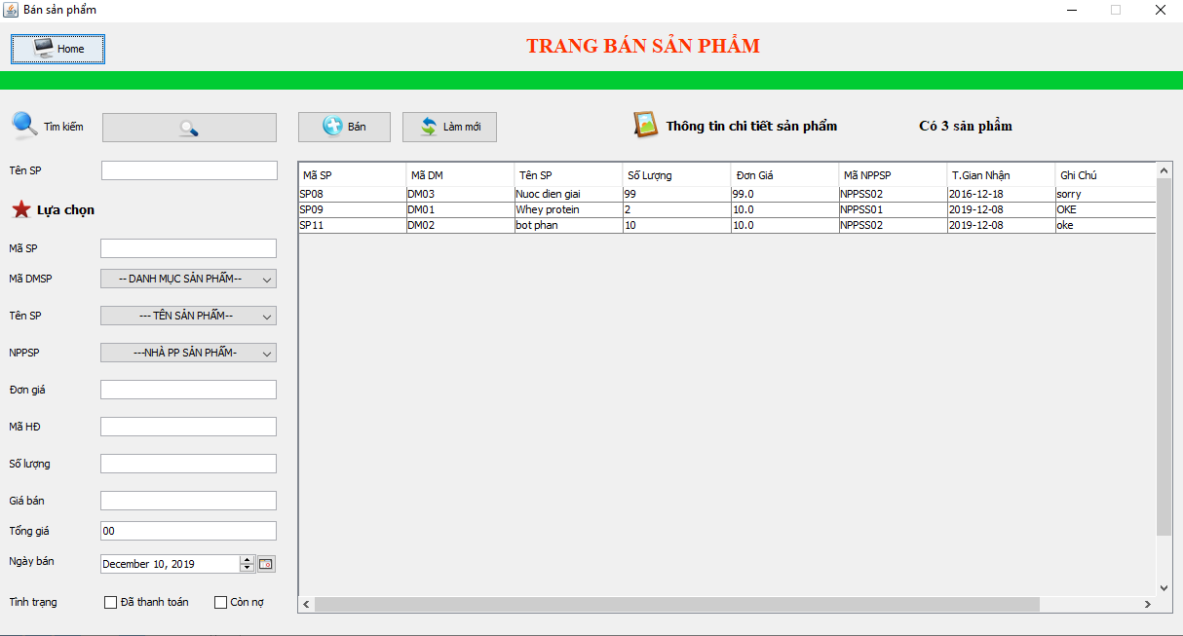

1. **User management**

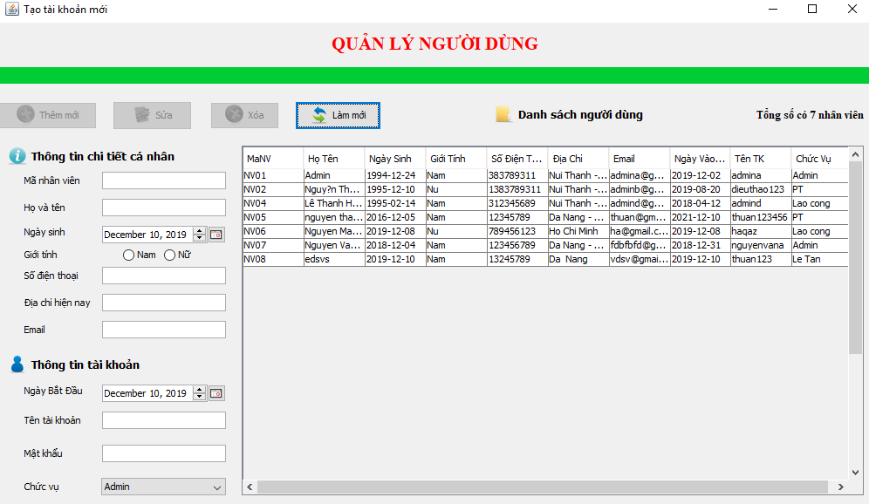

1. **Customer management**

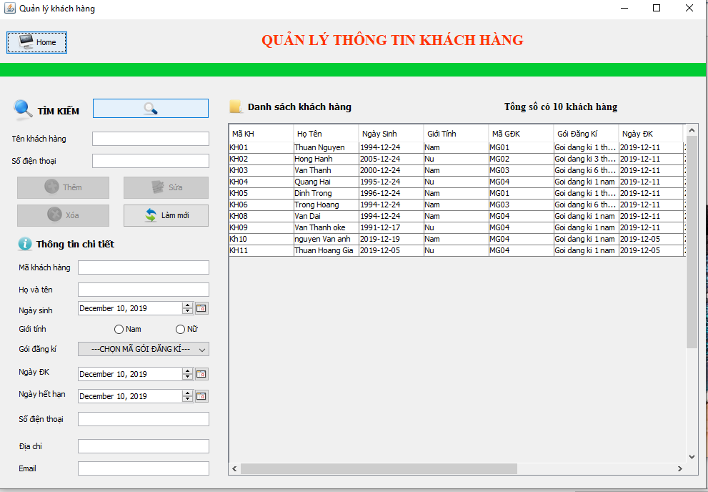

1. **Product Management**

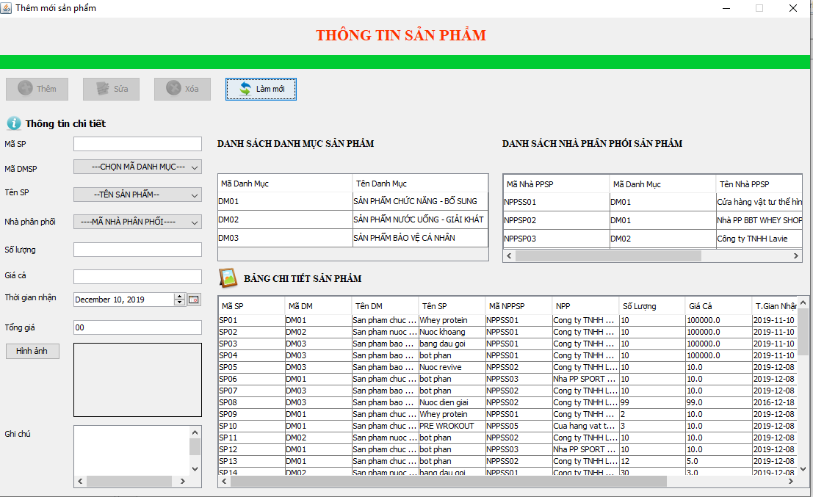

1. Equipment management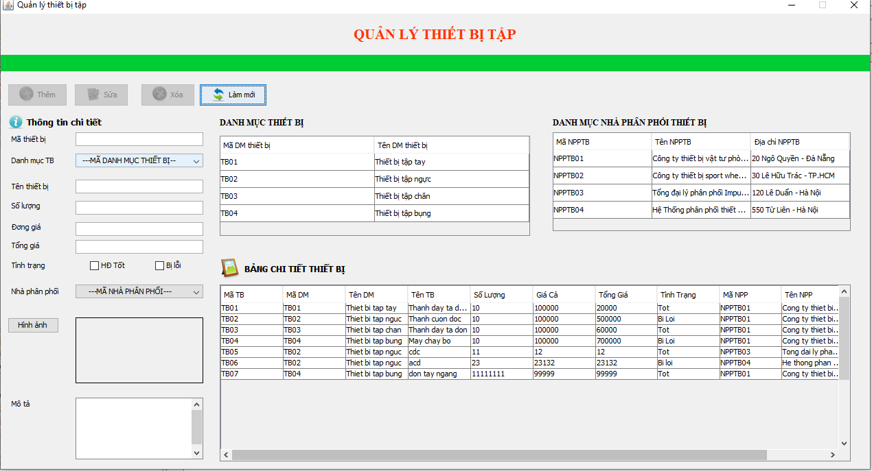

9. Statistics of revenue from products

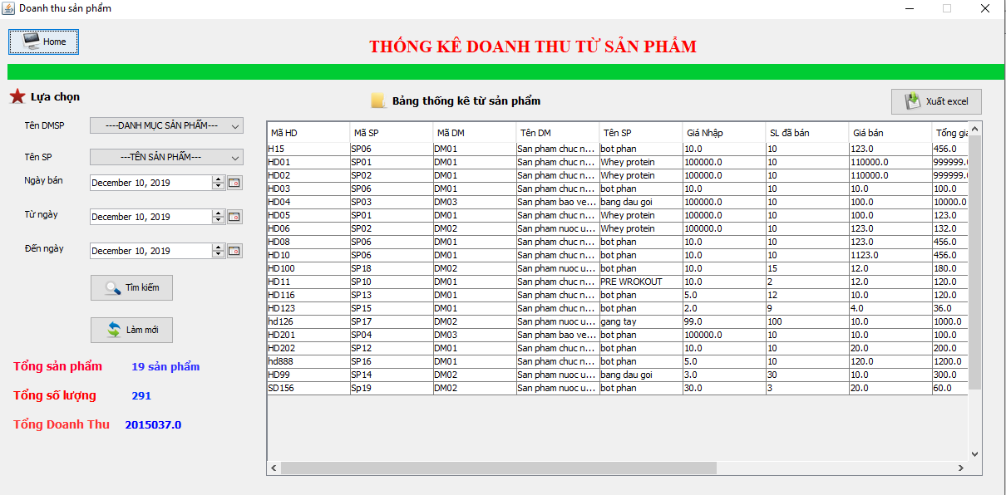

10. Revenue statistics from customers

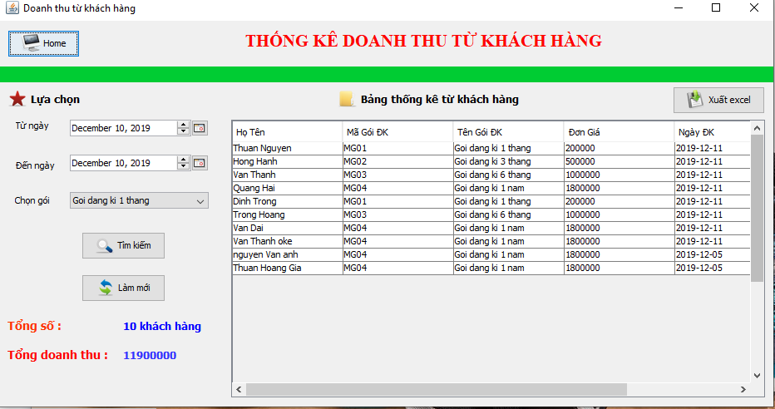

11. Statistics of liabilities from customers

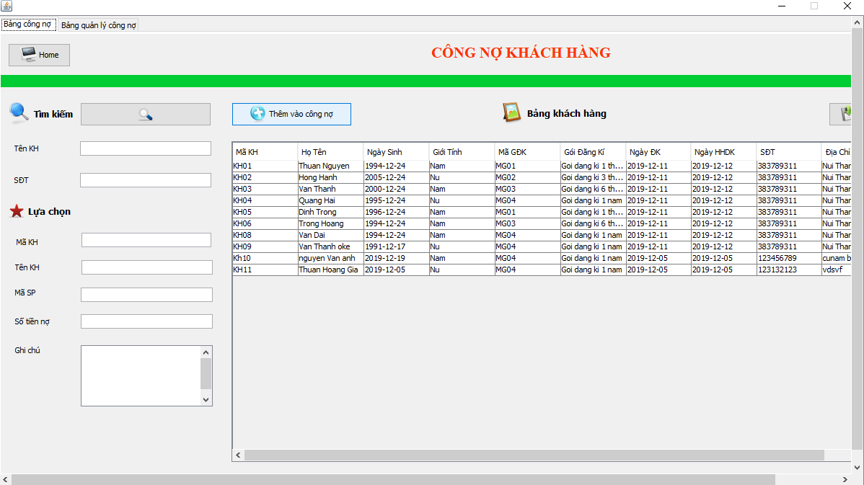

12. Statistics on employee salaries

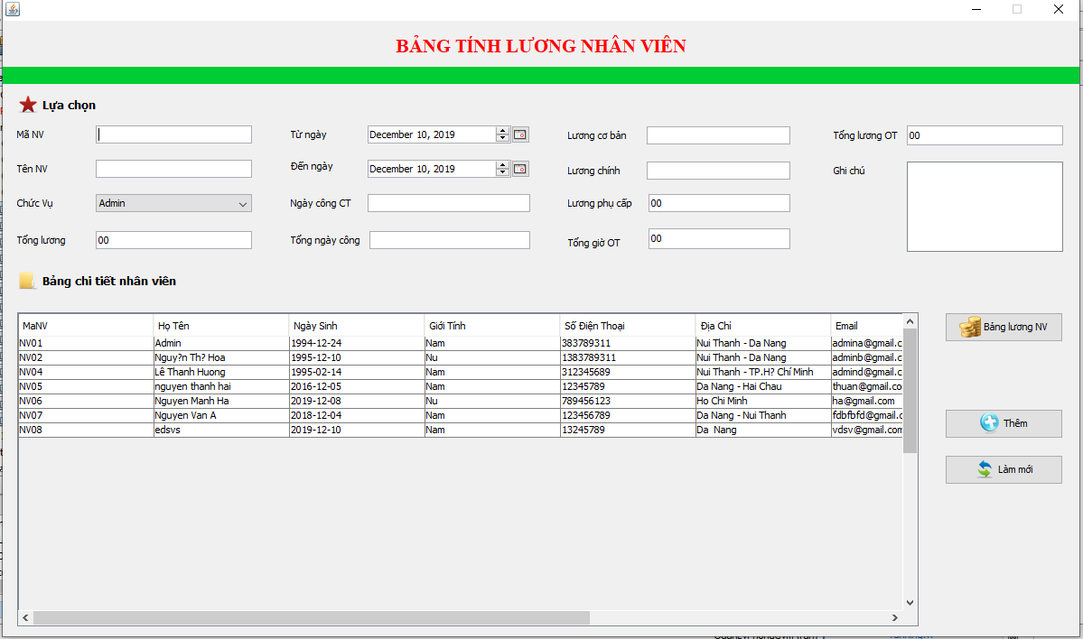

13. Detailed statistics employees

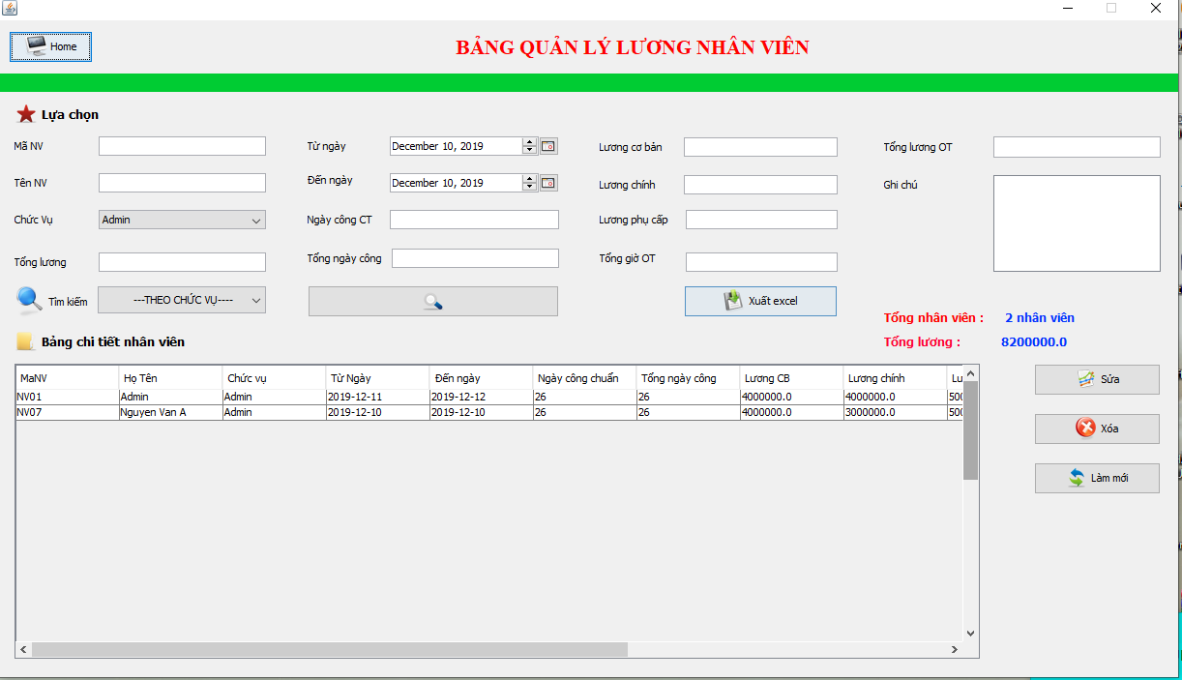

14. Help information board

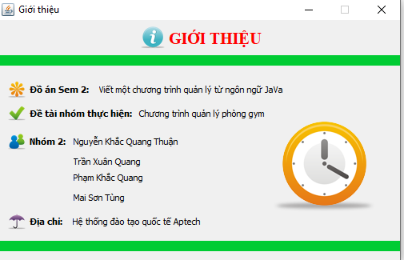

IX. CONCLUSION

**1. Conclude**

To complete the 1st semester project, deliver the results as well as the products, our team has divided the specific tasks, as well as always trying to work and learn to develop and complete the products. good. However, due to lack of knowledge as well as work and completion, there are still some errors that cannot be completed correctly. The team will continue to complete the product to perfect and improve the components of the gym management software.

**PROS:**

* Have all basic function as the requirement
* Know how to develop a java application

**CONS:**

* Need more functions.
* Interface need to improves.

**TABLE OF DIVISION WORKING FROM THE MEMBERS OF THE GROUP**

|  |  |
| --- | --- |
| Member’s name | Mission |
| Nguyen Khac Quang Thuan | * Up ideas for management * Division of work in groups * Database design for the application * Interface design for the application * Implement the functions of the program * Perform text file presentation |
| Mai Son Tung | * Up ideas for management * Perform text file presentation * Implement some code in the program |
| Tran Xuan Quang | * Up ideas for management * Implement some code in the program |
| Pham Khac Quang | * Up ideas for management * Implement some code in the program |

**REFERENCES**

**A. REFERENCES VIETNAMESE**

**B. REFERENCES ENGLISH**

**C. REFERENCES WEBSITE**

[1] https://www.w3schools.com/

[2] https://viettuts.vn/

[3] https:// v1study.com/