**APTECH INTERNATIONAL**

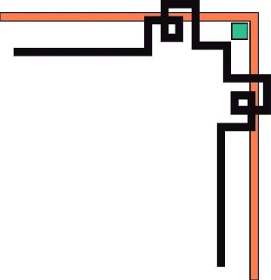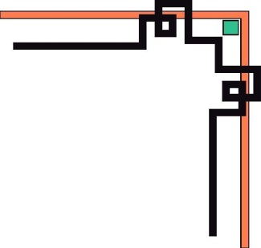

**EDUCATION TRAINING SYSTEM**

**SUBJECTS: THESIS SEM 1**

**--------------🙖🙐✰🙖🙐-------------**

**THESIS SEM 1**



**WEBSITE DESIGN FOR JEWELRY SHOP**

MEMBER: Nguyễn Khắc Quang Thuận

Lê Hoàng Luật

Trần Xuân Quang

Phạm Khắc Quang

CLASS: BATCH 152

TEACHER: Nguyễn Hồ Long Hải

Dà Nang in June 2019

**APTECH INTERNATIONAL**



**EDUCATION TRAINING SYSTEM**

**SUBJECTS: THESIS SEM 1**

**--------------🙖🙐✰🙖🙐-------------**

**THESIS SEM 1**



**WEBSITE DESIGN FOR JEWELRY SHOP**

MEMBER: Nguyễn Khắc Quang Thuận

Lê Hoàng Luật

Trần Xuân Quang

Phạm Khắc Quang

CLASS: BATCH 152

TEACHER: Nguyễn Hồ Long Hải

Dà Nang in June 2019

**ACKNOWLEDGMENT**

We would like to sincerely acknowledge the kindness of all the people who have given moral support and helped us make a successful project.

We wish to express our deep gratitude to the Project Team at the Head Office, who guided and helped us. Particular thanks to Mr. Nguyễn Hồ Long Hải who gave me instruction.

without the instructions you gave us, we would not have finished our project. Again, we sincerely thank you for all your hardwork. We also would like to express our great gratitude to all the student members of our center (Softech Aptech)..

Although we have made many attempts, because of the limited time, the practice could not be able to avoid the mistakes and omissions. We hope that the Project Team at the Head Office will consider and evaluate our project. And finally, we would like to thank all our friends for their valuable suggestions and constructive feedbacks.

*Sincerely thank!*

Da Nang, day june 2019

Group member

**Group 1**

# MENU

COVER PAGE...............................................................................................................

ACKNOWLEDGMENT

MENU

LIST OF IMAGE

SUMMARY OF THEMES

CHAPTER 1: THEORETICAL OVERVIEW 1

1. Overview 1

2. Target and object on the research 1

2.1. Research Targets**.** ……… 1

2.2. Research Objects. 1

3. Problem definition 2

3.1. Homepage 2

3.2. Contact page. 2

3.3. Category page 2

3.4. Item details page. 2

3.5. Shopping cart 3

3.6. Footer page 3

4. Project planing 3

4.1. Inception Phase 3

4.2. Elaboration Phase 3

4.3. Specific plan 4

CHAPTER 2: DETAILS AND DEMO PRODUCTS 5

1. State of main interfcace 5

1.1. Demo 5

2. Home 6

2.1. Demo 6

2.2 Images from products 7

3. Product iteam 8

3.1. Demo 8

3.2 Images from products 9

4. Product details 9

4.1. Demo 9

4.2 Images from products 11

5. About 12

5.1. Demo 12

5.2 Images from products 13

6. Contact 14

6.1. Demo 14

6.2 Images from products 15

7. Sign up 16

7.1. Images from products 16

8. Login 17

8.1. Images from products 17

9. Cart

9.1. Images from products 18

CHAPTER 3: DETAILS AND DEMO PRODUCTS 19

1. conclude 19

**TABLE OF DIVISION WORKING FROM THE MEMBERS OF THE GROUP**

……………………………………………………………………………………. 20

REFERENCES 21

LIST OF IMAGE

**Image 1**: *Image state of main interfcace .* 5

**Image 2**: *demo home image* 6

**Image 3**: *detail home image* 7

**Image 4**: *demo detail product image* 8

**Image 5**: *detail product image* 9

**Image 6:** *demo* *detail product image*10

**Image 7**: *Real images from the product* 11

[**Image 8:** *demo images from the*]. 12](#_Toc500970738)

**Image 9:** *Real images from the produc* 13

**Image 10**: *Real images from the product* 15

**Hình 11:** *Real images from the product* 16

**Image 12:** *Real images from the product* 17

**Image 13**: *Real images from the product* 18

**RATIONALE**

* *Research situation of the topic*

Today, the demand for our fashion has becoome much higher. Besides it, the fashion products also significantly increased. However, providers are currently operating their businesses through a number of popular social networks like Facebook, Instagram, Twitter, Zalo. Only a few people have built their specialized sites, however, none of these sites as a fully functional e-commerce website. This has made our team a chance to be recognized not to come in and build e-commerce platform of our own to achieve a large number of customers.

Being able to access to a good source of manufactures of these products reassures our team confidence in implementing the project. Moreover, all team members express passion in this area, and each of team members possesses necessary skills and knowledge that are required to deploy the project, including but not limited to the following skills and knowledge: programming, marketing, managing, goods selecting and purchasing…

All in all, the project is initiated and rolled out because there is a great demand for the products, the capability and belief of our team in building ecommerce website to provide these products to customers nationwide..

# 

# CHAPTER 1: THEORETICAL OVERVIEW

## Overview

Elctionic Commerce (e-commerce) applications support the interaction between different parties participating in a commerce transaction via the network, as well as the management of the data involved in the process.

The increasing importance of e-commerce is apparent in the study conducted by reseaechers at the GVU (Graphics,visualization, and Usability ) Center at the Georgia Institute of Technology. In their summary of the findings from the eighth survey, the researchers report that “e-commerce is taking off both in term of the number of users 2 shopping as well as the total amount people are spending via Internet based transactions”..

Over three quarter of the 10,000 respondents report having purchassed items online. The most cited reason for using the wed for personal shopping was convenience (65%), followed by availability of vendor information (60%), no pressure from sales person (55%) and saving time (53%). Although the issue of security remains the primary reasons why more people do not purchase terms online, the GVA survey also indicates that faith in the security of e-commerce is increasing. As more people gain confidence in current encryption technologies, more and more users can be expected to frequently purchase items online.

The products are divided into many categoris based on customer demand like.

Throught a web brower you can search for a product, later you may find essential information about tech as well as purchase the item you need and finally purchase using a payment mothod of your choice. At checkout time, the items in the shopping cart will be presented as an order. At that time, more information will be needed to complete the transaction. Usually, the customer will be asked to fill or select a billing address, shipping address, a shipping option, and payment information such as credit card number. A e-mail notification is sent to the custumer as soon the order is placed.

This application is developed using HTM L5, CSS3, Jquery, Bootstrap…

## Target and object on the research

* 1. **Research Targets**

The main objective of the project is to create a jewelry shop online allows the user to select and purchase items based on your interests, style, color. The selected items are displayed in a tabular format and the user can order their items online through credit card payment, ATM transfer or using Internet banking service rendered by banks

* 1. **Research Objects**

Our major customers are all people, who love new technology products.

## Problem definition

Jewelry shop is an online wed application where the customer can purhase cellphonel Laptop, tablet online. Through a web browser the customers can search for a fashion item by its name, style and categoty, later can add to the shopping cart and finally purchase using his account details, or new customers can set up an account very quickly. They should give the details of their name, contact number and shipping address. The user can also give feedback to an item by giving ratings on a score of five.

* 1. **Homepage**

This the very first page users will see when they type in the website address and hit enter button. It will display all the main categories and sub-categories and will have a search keyword option to search for the required item. The home page also runs 3 images slide of the most popular items. *Also in the body there are bestseller and sade off. Ect*

Homepage provides an option for user to join our mailing list to receive information about product, all product into their cart, search the product which they are looking for.

Homepage footer shows information of our shop, FAQ.

* 1. **Contact page**

The page shows map of our physical storewith detailed diretion. Also, thers is a form where user can type in their information an topic that they want to be consulted with.

The page lets everyone contact us with question or for assistance as well as given us feedback by entering their personal informtion, and their shopping experience. The page helps collect opinions of customers, hence helps us improve our website..

Footer remains the same as of the homepage.

* 1. **Category page**

Each category page shows list of items belonging to that category. The items are listed with item’s profile image, name, and price. The “ add to cart” button is also available for each item in case user wants to select a specitec item and put it in the shopping cart. User can easily navigate to an item detailed page by clicking button quickview.

Toward the left is navigation bar, which show catefories vertically for user ‘s conveniences. This allows flexible accessing to a specific category.

* 1. **Item details page**

Item details page is one of the most important parts of the website, if the user want to buy clothes, the most important thing they look for are datails and prices, and closed- look images of products. This page will show name, price, placeof origin, description, sizes, color, and images of each item. User’s feedback is included in this page.

* 1. **Shopping cart**

Cart is an indispensable part of any online store. Users can always, select items and put in their shopping cart without having to check out right away, items selected in the shopping cart will remain there until they are out of stock or user procced to check out.

* 1. **Footer page**

Page footer is a synthesis of the page to introdice our company amd support information. Support group holds rule for buyers, shopping guides, FAQs. This section helps users find answers for their questions as well as how to place orders or contact us.

## Project planing

* 1. **Inception Phase**

The inception phase will define all the project’s requirements. This phase will include the production of a vision document, a Project Plan, .Vision document will include the project’s requirements and overview. It includes overview of the project, its purpose, goals, risks, constraints, and direction.

It gives a listing of the main requirements and their respective. Use cae models to illustrante the functionality. Project Plan will detail the phases, iterations, and milestones that will comprise the project. It will include a timeline for the project for completing this project. It includes the Architecture Elaboration Plan will define the activities and actions that must be accomplished before the Architecture Presentation.

Project plan describes the required documentation,standards and conventions test tracking and problem reporting,and tools used during the project .The plan will also identify the set of quality metries used to assess product reliability. Demonstration of at least one executable prototype is required.Projects with a graphical user interface will include an executable prototype of the user interface.This phase will be complete once supervisory committee has approved all the above work.

* 1. **Elaboration Phase**

The elaboration phase defines the project’s architecture.This phase will include the production of revisions to the project Plan and the vision document,an architecture design plan,a formal specification,test plan,formal technical inspection and architecture prototype.Revision of Vision document will be an updated version to provide a complete representation of all requirements.

These requirements will be ranked according to importance,and a set of critical requirements identified.Appropriate changes that were suggested by the teacher and members at the end of phase one will also be updated in the updated version of vision document.Revision of project plan will include updated timeline estimate for the project .It also includes the implementation plan which will define the activities and actions that must be accomplished during implementation..

* 1. **Specific plan**

In total we have about one month to build Japanese online fashion store,But in the firest month,we have done the following tasks according to plan.

# CHAPTER 2: DETAILS AND DEMO PRODUCTS

1. **State of main interfcace**
   1. **Demo**

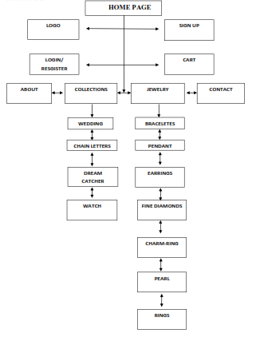*images 1:.Image state of main interfcace*

1. **Home**

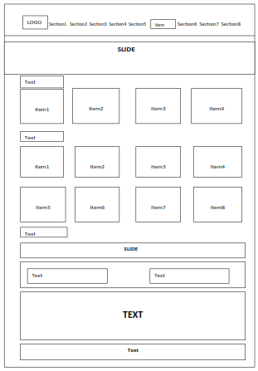**2.1 Demo**

*Images 2:.* *demo home image*

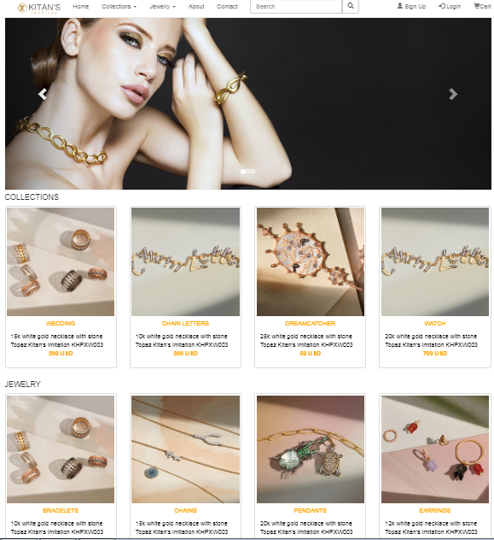**2.2 Images from products**

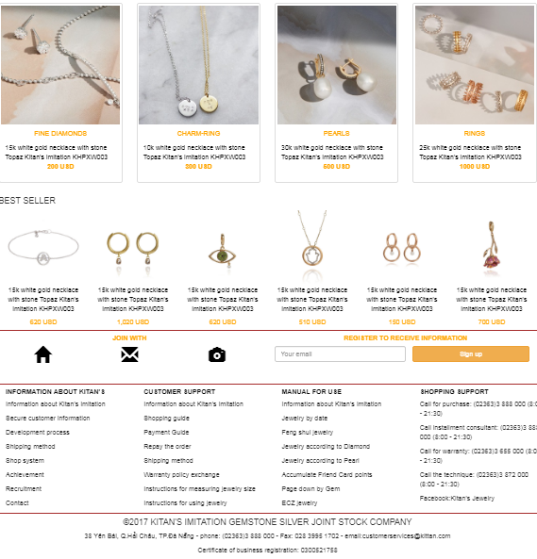*Images 3:.* *detail home image*

1. **Product iteam**
   1. **Demo**

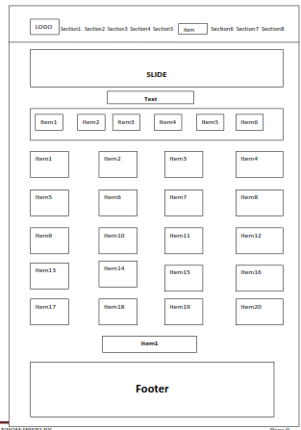

*Images 4:.* *demo detail product image*

* 1. ***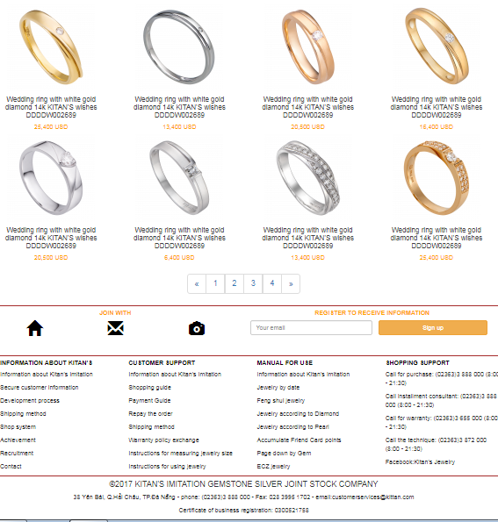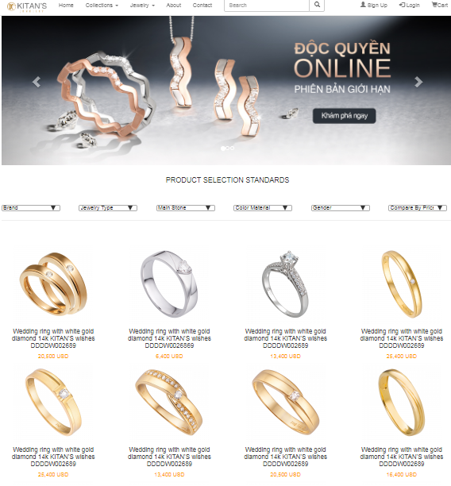* Images from products**

*Images 5:.* *detail product image*

1. **Product details**
   1. **Demo**

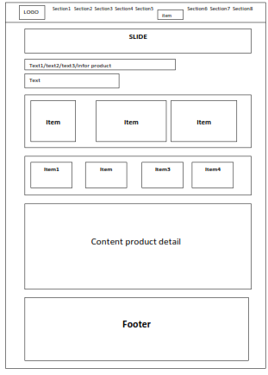*Images 6: demo* *detail product image*

* 1. **Images from products**

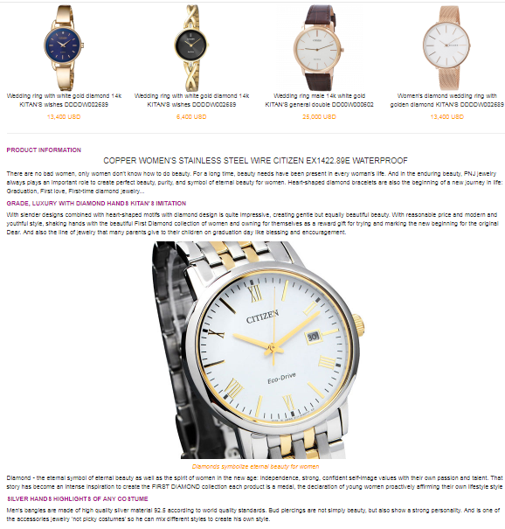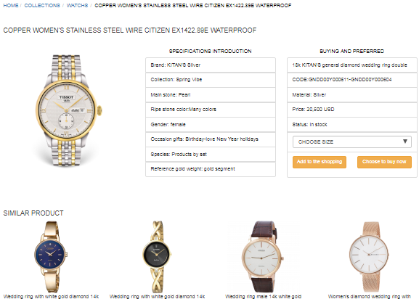

*Images 6:.* *Real images from the product*

1. **About**
   1. 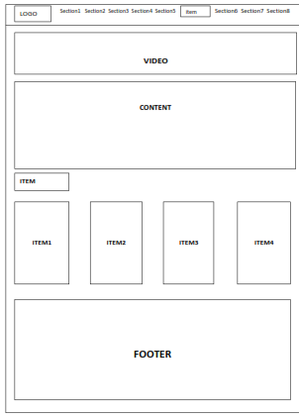 **Demo**

*Images 7: demo images from the product*

* 1. **Images from products**

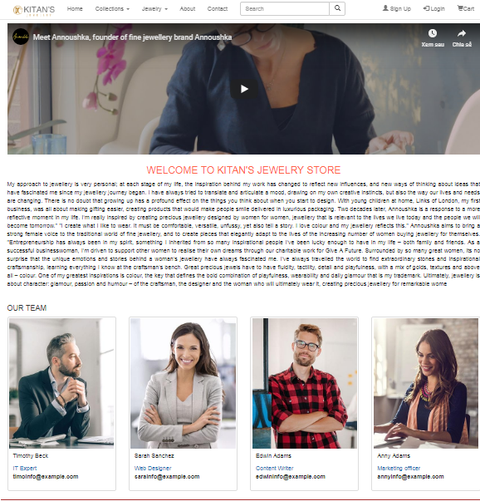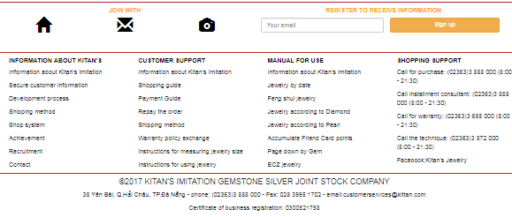

*Images 8:.* *Real images from the product*

1. **Contact**
   1. 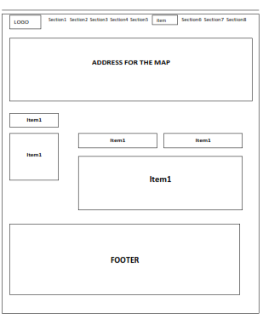 **Demo**

*Images 9:.* *Demo images from the product*

* 1. 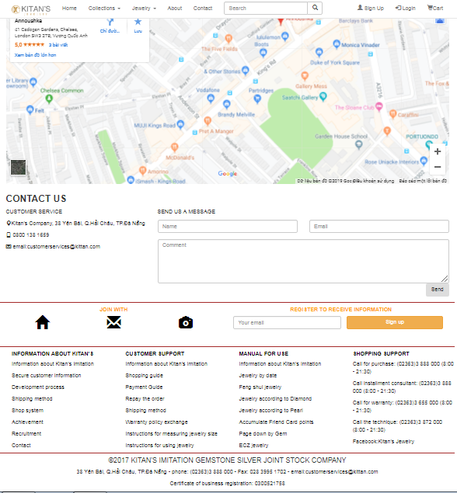 **Images from products**

*Images 10:.* *Real images from the product*

1. **Sign up**
   1. 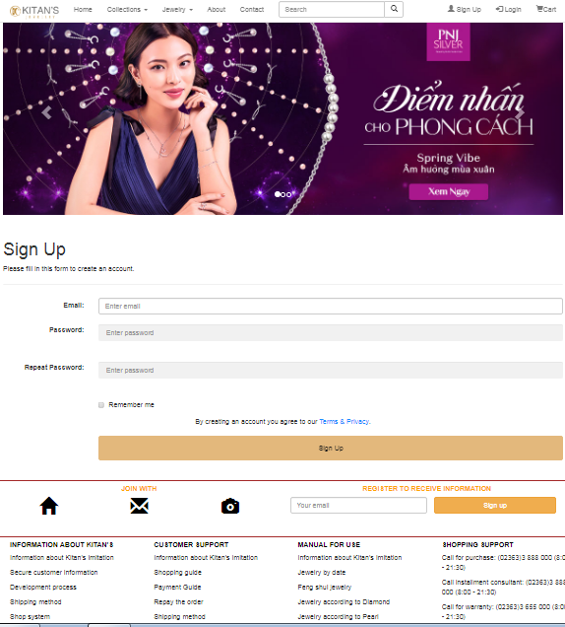 **Images from products**

*Images 10:.* *Real images from the product*

1. **Login**

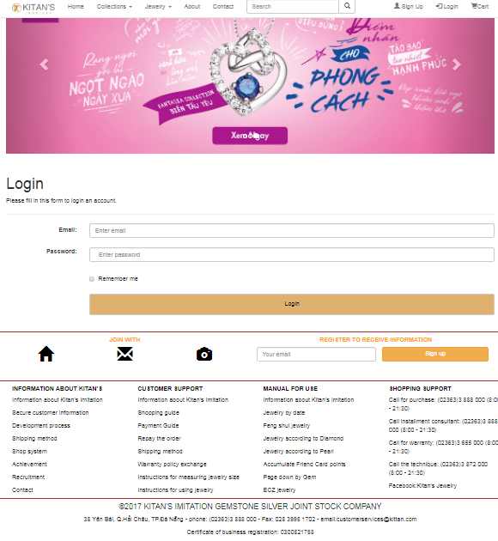**8.1 Images from products**

*Images 11:.* *Real images from the product*

1. **Cart**

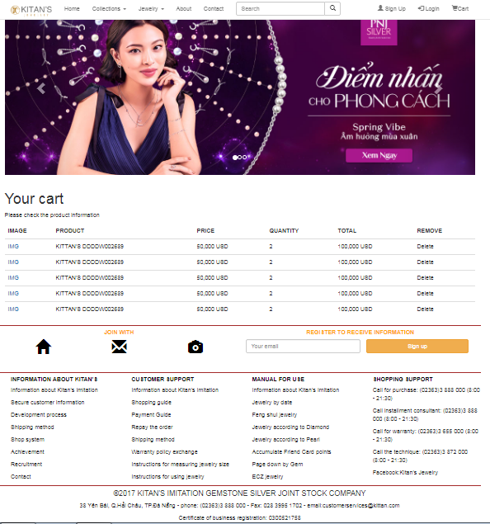**9.1 Images from products**

*Images 12:.* *Real images from the product*

# CHAPTER 3: DETAILS AND DEMO PRODUCTS

**1. conclude**

To complete the project sem 1, give the results as well as the products, our team has divided specific tasks, as well as always trying to work and learn to develop and complete good products. there. However, due to not much knowledge as well as at work and completion, there are still some errors that cannot be completed properly. The team will continue to complete the product to the most complete and improve the components of the site in the web.

**TABLE OF DIVISION WORKING FROM THE MEMBERS OF THE GROUP**

|  |  |
| --- | --- |
| Member’s name | Mission |
| Nguyen Khac Quang Thuan | * Division of work in groups * Layout design for web pages (header - footer) * Interface design for product detail page * Pour json for pages |
| Le Hoang Luat | * Layout design for web pages (header - footer) * Designer interface for wedding and collection pages * Interface design for about page |
| Tran Xuan Quang | * Layout design for web pages (header - footer) * Design interface for home page * Interface design for contact |
| Pham Khac Quang | * Layout design for web pages (header - footer) * Design interface for login page - sign up - cart |

# REFERENCES

1. **REFERENCES VIETNAMESE**

**B. REFERENCES ENGLISH**

**C. REFERENCES WEBSITE**

[1] https://www.w3schools.com/

[2] https://angularjs.org/

[3] https://getbootstrap.com/