LAB 04: NOSQL DATABASES WITH MONGODB
Course | SDN302 - Server-side Development with NodeJS, Express and MongoDB
Lab | Lab 04: NoSQL Databases with MongoDB
Related slot / slides | Slot 3.2 (NoSQL Database with MongoDB

1. Objectives
After completing this lab, students are able to:
- Explain serialization and the characteristics of NoSQL databases.
- Use MongoDB Shell (mongosh) and MongoDB Compass to manage data.
- Perform CRUD operations and advanced queries in MongoDB.

2. Prerequisites and tools
- MongoDB Community Server or a free MongoDB Atlas cluster, and MongoDB Compass.
- Lab 3 completed.

3. Case study
All labs are built around one running case study: BookNest Online Bookstore. Each lab extends the project you built in the previous lab, so keep your source code in one Git repository with one folder per lab (lab01, lab02, ...).

4. Requirements

Requirement 1. Prepare the database and sample data (20%)
- Create a database named booknest with the collections books, authors and categories.
- Insert at least ten books with insertMany, each containing title, price, quantity, publishedYear, category and an array of tags.
- Insert at least three authors and three categories.
- Show the same data in MongoDB Compass and export one collection to JSON.
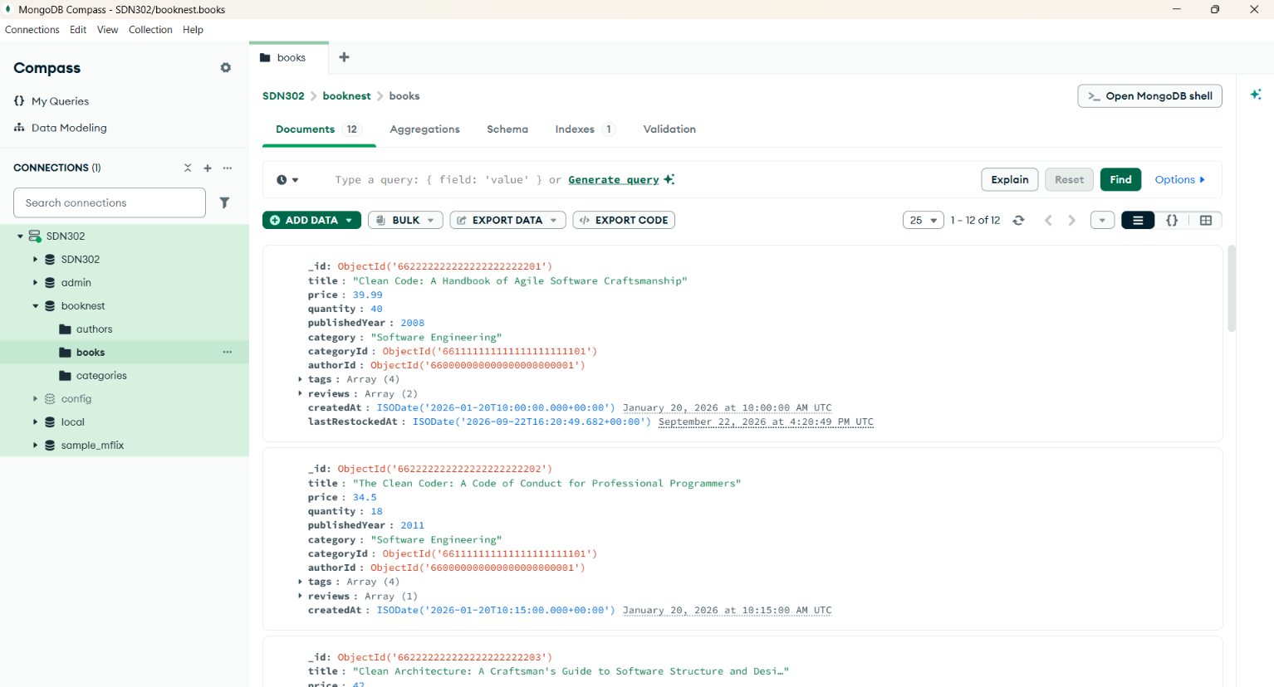

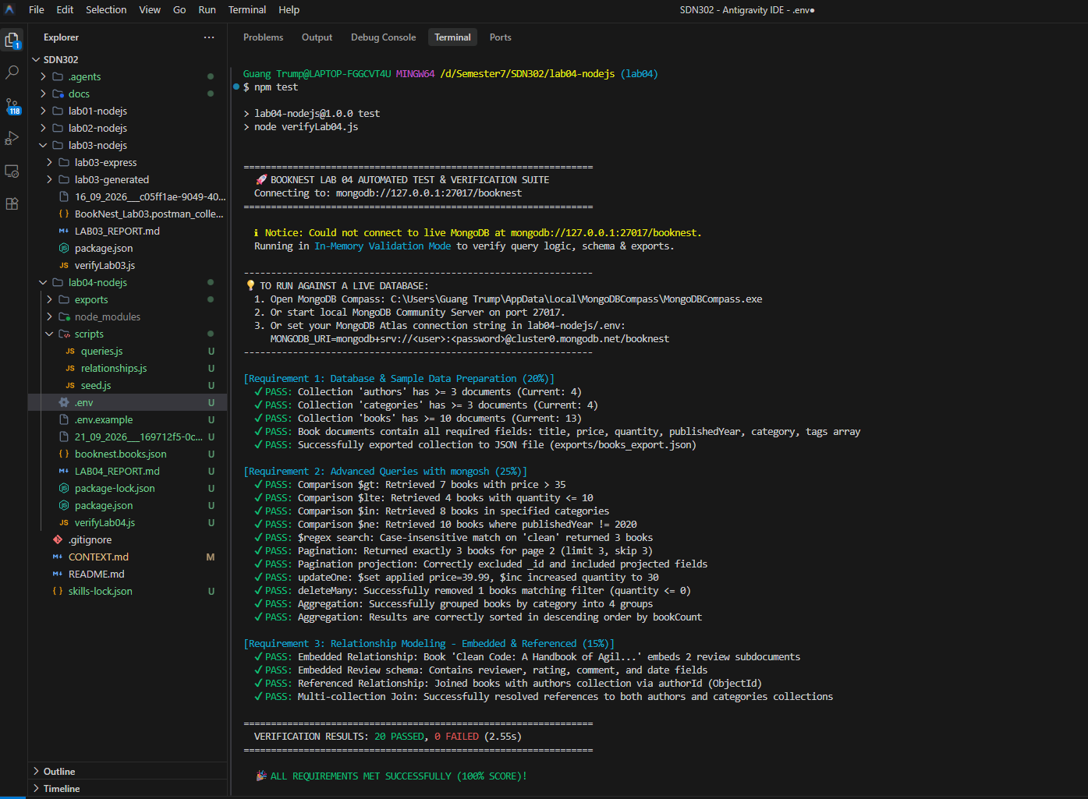
Requirement 2. Query the data with mongosh (25%)
- Write queries using the comparison operators $gt, $lte, $in and $ne.
- Use $regex to search books whose title contains a given keyword, case-insensitively.
- Apply projection, sort, skip and limit to return page 2 with 3 books per page.
- Use updateOne with $set and $inc, and deleteMany with a filter.
- Write one aggregation pipeline that counts the books per category and sorts the result descending.

Requirement 3. Model the relationships between collections (15%)
- Draw the data model of BookNest with the three collections and their relationships.
- Implement one embedded relationship (for example the reviews of a book) and one referenced relationship (book to author) using ObjectId.
- Explain in a short paragraph when you would choose embedding and when referencing.

