- Install git and create a GitHub account

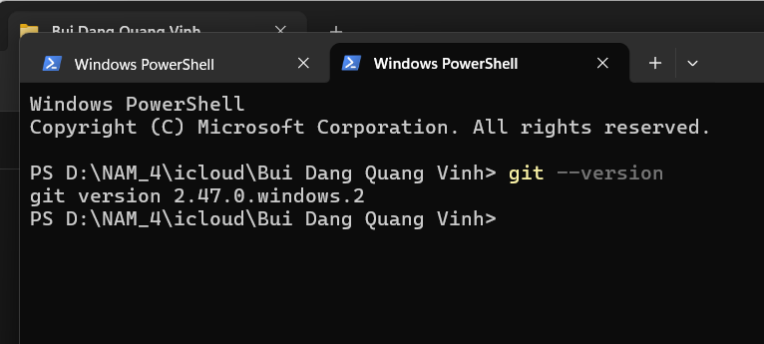
- Create a local git repository
- Open command propt and create a new folder MyFirstRepo
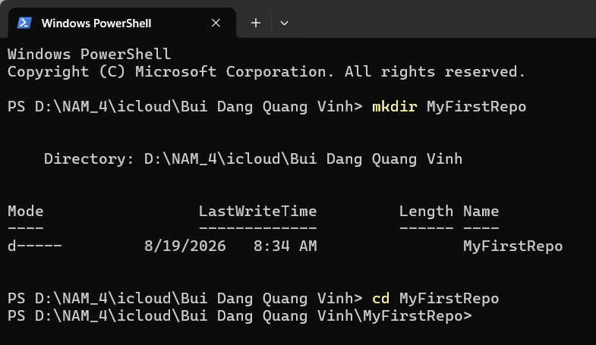
- Initializing the Git Repository using the “git init” command

