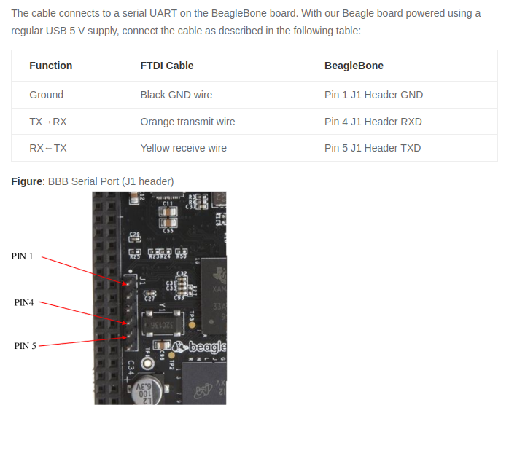
1. CHECK dev/ttyUSB0
Connect Pins for uart logs like this

Then:
+ groups → check whether dev/ttyUSB0 is in which group
+ ‘newgrp dialout’ or ‘sudo usermod -aG dialout $USER’
+ ‘id’ → check $USER in dialout?
→ Access dev/ttyUSB0

2. CHECK uart-USB adapter

- First check loopback
+ Connect TX pin to RX one
+ minicom -D dev/ttyUSB0 -b 115200, ctrlA+O → Serial port setup → disable both hardware+software flow
+ Check by type ‘A’, then ‘A’ appeared on screen

