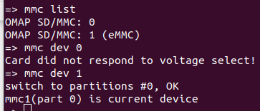

mmc list → check all devices card on board
+ dev 0 (SD card) → fail inserted
+ dev1 (eMMC) → ok

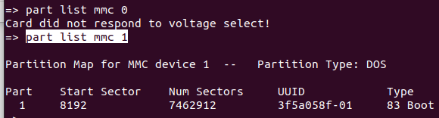
part list mmc 1 → list partitions on dev

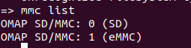

If SD card is dected → ‘SD’ is appeared
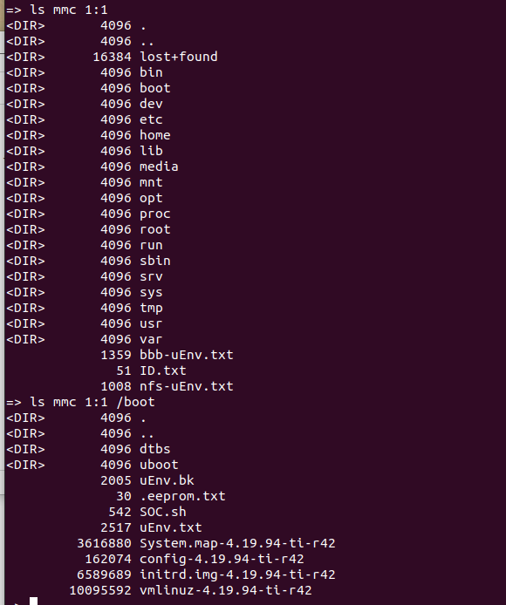
ls mmc 1:1 → Check content on device 1 – partititon1
ls mmc 1:1 /boot

