1. Check partition offset

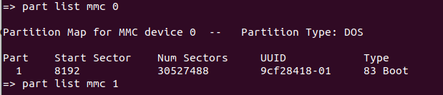
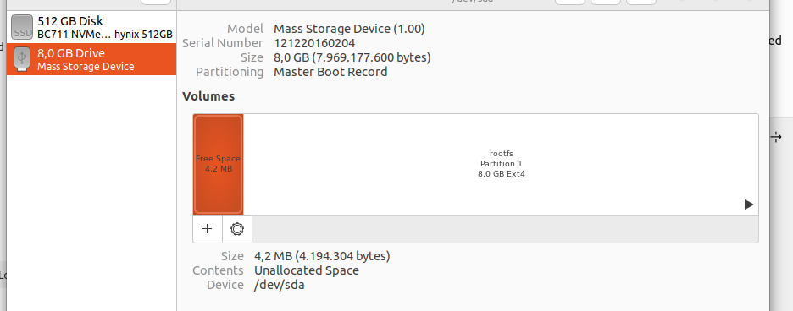
Ext4 filesystem (type 83) partition starts at 8192*512 = 4.194.304
→ 4.194.304 bytes are reserved at first
→ All stuff are handled from 4.194.304 offset

2. Check valid filesystem

The ext4 primary superblock begins 1024 bytes from the beginning of the partition.

The signature begins 56 bytes from the beginning of the The ext4 primary superblock (0x438 from the beginning of the partition).

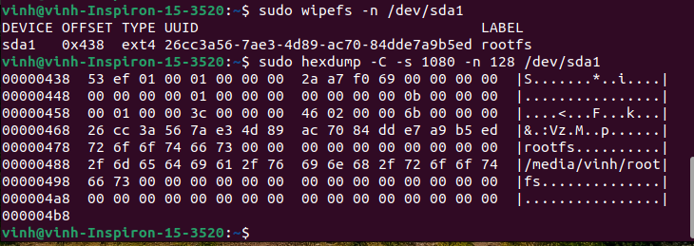
At offset 0x438 (1080) with 128 bytes

53 ef → ext4 signature
26 cc 3a 56 7a e3 4d 89 ac 70 84 dd e7 a9 b5 ed → 26cc3a56-7ae3-4d89-ac70-84dde7a9b5ed
72 6f 6f 74 66 73 00 00 → rootfs
=> Valid signature for the filesystem, u-boot can read

