1. Assign “usb0” interface:
=== On BBB:
sudo nano /etc/modprobe.d/g_ether.conf
options g_ether dev_addr=02:bb:bb:00:00:01 host_addr=02:bb:bb:00:00:02
(02:bb:bb:00:00:01 is MAC of BBB, 02:bb:bb:00:00:02 is MAC on PC -> enx02bbbb000002)
+ cat /sys/module/g_ether/parameters/dev_addr -> 02:bb:bb:00:00:01
+ cat /sys/module/g_ether/parameters/host_addr -> 02:bb:bb:00:00:02

// Ensure the kernel recognizes the new options
sudo depmod -a

// reboot

=== On PC:
sudo nano /etc/udev/rules.d/70-persistent-net.rules
SUBSYSTEM=="net", ACTION=="add", ATTR{address}=="02:bb:bb:00:00:02", NAME="usb0"
(If enx02bbbb000002 is matched -> assign usb0)

sudo udevadm control --reload-rules
sudo udevadm trigger

2. Assign “usb0” interface:
=== On BBB:

sudo nano /etc/systemd/network/usb0.network

[Match]
Name=usb0

[Network]
Address=192.168.137.2/24
Gateway=192.168.137.1

sudo systemctl enable systemd-networkd
sudo systemctl restart systemd-networkd

// check
ip addr show usb0

=== On PC:
sudo nano /etc/systemd/network/usb0.network

[Match]
Name=usb0

[Network]
Address=192.168.137.1/24

sudo systemctl enable systemd-networkd
sudo systemctl restart systemd-networkd

// check
ip addr

3. Enable NAT on PC:
# Enable IP Forwarding Temporarily
sudo sysctl -w net.ipv4.ip_forward=1

sudo nano /etc/sysctl.conf -> uncomment 'net.ipv4.ip_forward=1'
sudo sysctl -p # save and apply

=====
# Add IPTables Rule for NAT
sudo iptables -t nat -A POSTROUTING -o wlp1s0 -j MASQUERADE

# Allow Forwarding
sudo iptables -A FORWARD -i usb0 -o wlp1s0 -j ACCEPT

======================== SSH ======================
On PC:
- sudo apt install libatomic1 → for SSH on VS code
- ssh-keygen -R 192.168.137.2 → remove old pub keys in ~/.ssh/known_hosts
- If not using ‘ssh-keygen’:
+ If the key matches → Ok
+ If the key differs → X connect → ‘ssh-keygen…’ to remove old hosr key
+ If no entry exists → SSH normally asks whether you trust the new host key

On BBB:
- Consider to remove ~/vscode-server if SSH on VS code doen’t get right

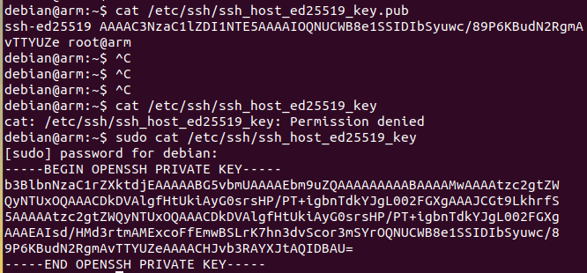
→ Check pub + priv key on BBB in /etc/ssh

