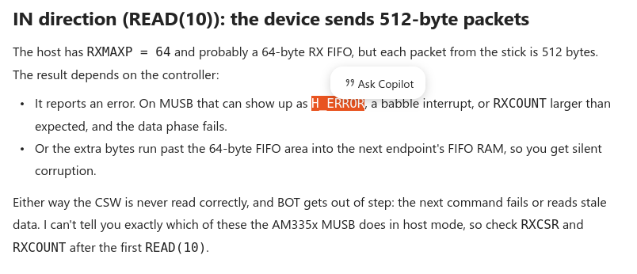
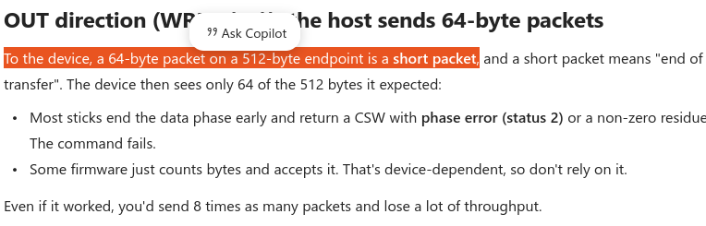
→ Device thinks host ends transfer

→ Re-check wMaxPacketSize

