
HỌC VIỆN CÔNG NGHỆ BƯU CHÍNH VIỄN THÔNG
KHOA CÔNG NGHỆ THÔNG TIN 1
—————–o0o——————


ASSIGNMENT REPORT
Electronics E-Commerce Information System

Giảng viên hướng dẫn | : PGS. TS. Trần Đình Quế
Họ và tên sinh viên | : Nguyễn Vũ Quang
Mã sinh viên | : B23DCVT363
Lớp | : E23TTNT02
Nhóm | : 03

Hà Nội – 2026

CONTENTS
PART 1. REQUIREMENTS IDENTIFICATION 2
1.1 Business Context and Requirement Baseline 2
1.2 Business Activity Analysis 2
1.3 Current Problems and Problem Tree 3
1.4 Stakeholders, Goals and Needs 3
1.5 Information Analysis 4
1.6 System Scope, Boundary and Context 5
1.7 Detailed Information Flows 6
1.8 Functional Requirements 7
1.9 Non-Functional Requirements 8
1.10 Requirement Prioritization (MoSCoW) 9
PART 2. REQUIREMENTS ANALYSIS 10
2.1 Actor Analysis 10
2.2 Use Case Identification 10
2.3 UML Use Case Model and Relationships 11
2.4 Detailed Use Case Specifications 11
2.5 Activity Diagrams 14
2.6 Requirement Traceability Matrix 19
2.7 Requirement Validation 21
PART 3. AI IN E-COMMERCE: INTELLIGENT SEARCH AND RECOMMENDATION 22
3.1 AI Integration Scope and Business Justification 22
3.2 AI-Enabled Product Search 22
3.3 Compatible Product Recommendation System 23
3.4 Shared Data Requirements and Service Interactions 25
3.5 Non-Functional Requirements and Quality Controls 25
3.6 Failure, Exception, Cold-Start and Human Review 26
3.7 Evaluation and Requirements Traceability 27
3.8 Validation and Implementation Readiness 27
PART 4. SYSTEM DESIGN 28
4.1 Class Diagram in Analysis 28
4.2 Data Model and Database Design 29
4.3 Class Diagram in Design 32
4.4 Layered Architecture: Classes and Relationships 33
4.5 Illustrative Code Mapping from Design 34
PART 5. CODING AND PROJECT USER INTERFACES 38
5.1 Project Structure and Implementation Mapping 38
5.2 Key Code Paths 38
5.3 SQLite Persistence 40
5.4 Build and Run 41
5.5 User Interface Screens 41
5.6 Implementation Evidence, Limitations and Verification 48
5.7 Design-to-Implementation Assessment 48
Appendix A. Verification Evidence and Limitations 49
A.1 Build and regression evidence 49
A.2 Proposed measurement and acceptance protocol 49
A.3 Implementation mapping, catalogue provenance and data limits 49
A.4 SQLite constraints and proposed versus implemented controls 50
A.5 Requirement Implementation Status 50
A.6 Limitations and Further Work 51
References 53

PART 1. REQUIREMENTS IDENTIFICATION
This chapter defines the TechZone business context, stakeholders, operational problems and system requirements.

1.1 Business Context and Requirement Baseline
TechZone Shop is a teaching scenario. Business outcomes such as conversion, returns and average order value are objectives rather than measured results.
TechZone Shop is a B2C electronics retailer with centralized warehousing, selling computers, smartphones, components and peripherals. Its operations require detailed technical specifications, Serial/IMEI tracking, compatibility checks and electronic warranties.
Business objectives are to increase revenue and Average Order Value (AOV), improve technically valid product discovery, replace spreadsheet-based operations, and improve retention through tracking and electronic warranties.
The system covers catalogue search, compatible-accessory recommendations, inventory, checkout/payment, fulfillment, and warranty management. AI search must respect verified manufacturer specifications.

1.2 Business Activity Analysis
The business process covers product discovery, cart management, order processing, payment, fulfillment, warranties and reporting.
- Product Browsing & Specification Search: Customers query the catalog using specialized technical filters such as processor sockets, RAM speed, form factor, or display refresh rates. AI-enabled search may improve the interpretation and ranking of such queries, but explicit specification filters remain authoritative.
- Technical Specification Comparison: Prospective buyers evaluate multiple hardware variants side-by-side to verify electrical and physical compatibility.
- Shopping Cart Management: Customers curate items, apply promotional discount vouchers, and review subtotal calculations prior to checkout.
- Order Processing: The system validates item availability, records customer shipping information, and prepares invoices.
- Payment Verification: The system interfaces with third-party payment gateways to execute credit card, bank transfer, or e-wallet transactions securely.
- Inventory & Serial/IMEI Allocation: Warehouse staff inspect physical units, scan individual barcode/QR identifiers, and bind unique Serial/IMEI codes to order records.
- Shipping & Dispatch Management: Items are packaged, consignment notes are created, parcels are handed over to logistics carriers, and tracking numbers are synchronized.
- Feedback & Technical Inquiry (After-sales Support): Customers submit verified product reviews, report hardware malfunctions, or request warranty repairs.
- Sales & Inventory Reporting: Transactional records are aggregated into analytical summaries for store management regarding revenue, bestsellers, and stock velocity.
The order and fulfillment process comprises the following stages; Figure 5 summarizes the checkout activity at the analysis level.
1. Order Placement: The customer submits the order after selecting a delivery method and payment channel.
2. Availability and Specification Verification: Validate SKU quantities, technical attributes and mandatory compatibility before requesting payment.
3. Stock Reservation and Payment Authorization: Create a pending order intent, atomically reserve sellable stock, and request provider authorization using an idempotency key.
4. Order Confirmation and Exception Handling: Verified authorization confirms the order and queues picking. A definitive decline cancels the intent and releases the reservation; an unknown outcome remains pending reconciliation without confirmation or blind release.
5. Physical Unit Allocation (Serial/IMEI Binding): After order confirmation, warehouse staff scan unique Serial/IMEI numbers against the correct order items.
6. Inventory Reconciliation & Packaging: Transfer reserved quantities to allocated, record scanned units and pack the parcel without a second available-stock deduction.
7. Logistics Handover: The parcel is handed to the shipping provider and an active tracking code is generated.
8. Real-Time Status Synchronization: The system updates the order status to “Shipped” and shares tracking milestones with the customer.
9. Delivery & Warranty Registration: Upon delivery confirmation, the electronic warranty is automatically activated for the recorded Serial/IMEI numbers.
Stock reservation reduces available-to-sell quantities; subsequent Serial/IMEI allocation transfers reserved units to allocated stock without a second deduction (FR14).

1.3 Current Problems and Problem Tree
Five operational problems are identified:
- Inventory Inconsistencies and Serial Misallocations: Standalone spreadsheets for unit-level Serial/IMEI tags cause inventory discrepancies, overselling, and incorrect hardware dispatch.
- Poor Discovery of Compatible Components: Keyword-only search cannot evaluate complex technical relationships such as socket types, RAM bus speeds, and PSU wattage, leading to cart abandonment and frequent returns.
- Delayed Order Tracking and Warranty Inquiries: Fulfillment and warranty data are fragmented across local files, forcing customers to contact support to verify status.
- Manual Reporting and Inaccurate Demand Forecasting: Cross-department manual aggregation delays management reporting and contributes to stockouts or overstocking.
- Fragmented Customer and Support Records: Repair history is detached from purchase and warranty records, making claim verification slow and error-prone.

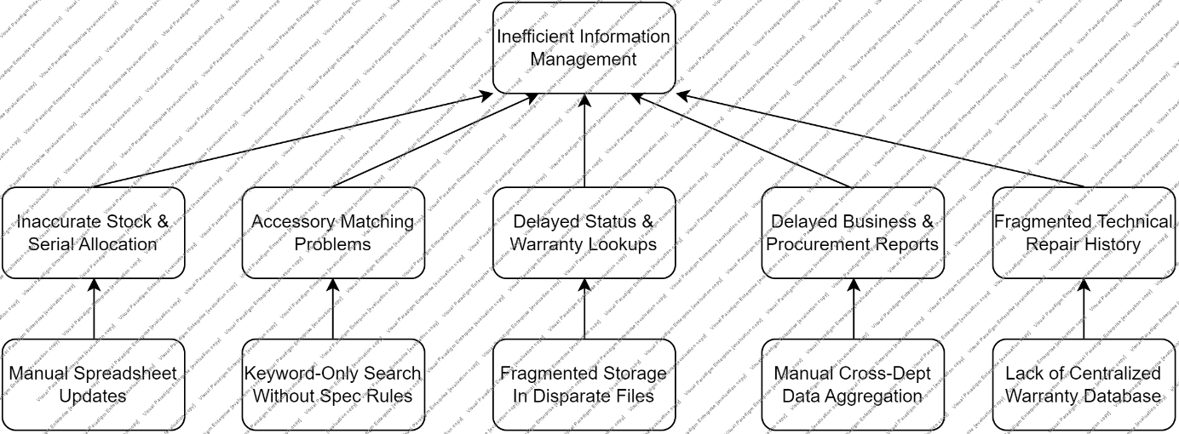
Figure 1. Problem Tree for TechZone Shop.

1.4 Stakeholders, Goals and Needs
TechZone stakeholders include internal staff (Store Manager, Sales Staff, Warehouse Staff, Technical Support Staff, System Administrator) and external parties (Customer, Electronics Supplier, Payment Provider, Delivery Provider).
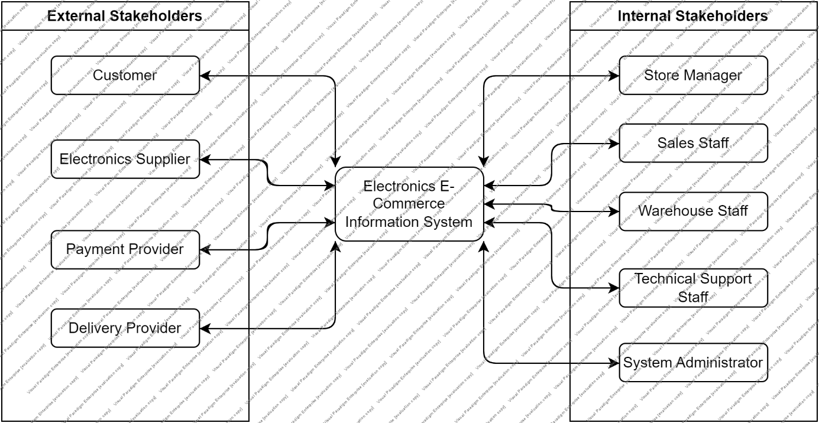
Figure 2. Stakeholder Map for TechZone Shop.

Stakeholder | Need | Reason / Justification
Customer | Discover and verify compatible hardware components. | Keyword-only search lacks technical specification rules and contributes to incompatible purchases, cart abandonment, and returns.
Customer | Track order and shipment status in real time. | Fragmented fulfillment data otherwise forces customers to contact support manually.
Customer | Access and activate electronic warranty records seamlessly. | Digital proof of warranty must remain tied to the purchase and Serial/IMEI record.
Store Manager | Obtain real-time sales, revenue, and inventory reports. | Manual cross-department aggregation delays reporting and weakens replenishment decisions.
Sales Staff | Verify order configurations and real-time stock availability instantly. | Fragmented data causes overselling, cancellations, and delivery delays.
Warehouse Staff | Allocate exact Serial/IMEI numbers using barcode/QR scanning. | Manual spreadsheet updates create inventory inconsistencies and wrong physical-unit dispatch.
Warehouse Staff | Receive automated digital picking lists. | Digital picking reduces manual data entry and streamlines fulfillment.
Technical Support Staff | Validate warranty eligibility instantly using Serial/IMEI records. | Centralized warranty and repair history reduces verification and repair turnaround time.
System Administrator | Manage role-based access and system health logs. | Centralized operations require access control, backup, audit, and integrity safeguards.
Electronics Supplier | Receive automated purchase orders and demand forecasts. | Automated exchanges support timely replenishment of high-demand components.
Payment Provider | Exchange secure encrypted payment payloads and tokens. | Secure authorization and rapid financial reconciliation are required.
Delivery Provider | Synchronize electronic shipping manifests and package tracking. | Automated tracking replaces manual status updates and supports door-to-door visibility.
Table 1. Stakeholder Needs Analysis.
Customers require both specification-based search and optional compatible-accessory suggestions. Catalogue attributes and compatibility rules remain under administrator control.

1.5 Information Analysis
TechZone produces, consumes, stores and exchanges the following information:
- Information Produced: Electronic VAT invoices, unit-level pick/pack manifests with recorded Serial/IMEI, electronic warranty certificates (E-warranty tickets), dispatch notifications with tracking numbers, and automated inventory turnover and sales reports.
- Information Consumed: Manufacturer hardware datasheets, customer registration and delivery profiles, real-time clickstream and specification search queries, and payment settlement tokens from external gateways.
- Information Stored: Customer accounts, product specifications and configuration matrices, sales orders, unit-level Serial/IMEI inventory registers, warranty maintenance records, and product reviews.
- Information Exchanged: Payment authorization payloads with financial gateways, electronic shipping manifests with logistics carriers, and purchase orders with hardware suppliers.
- Product Specifications & Serial: Produced/maintained by System Administration and Warehouse Staff; used by Customers and Sales Staff; stored in the database to enable detailed multi-parameter filtering and accurate unit-level allocation.
- Order & Payment Details: Produced through Customer and Payment Gateway interactions; used by Sales Staff and Warehouse Staff; stored in the database to validate transactions and authorize warehouse dispatch.
- Warranty & Maintenance Logs: Produced by the System and Technical Support Staff; used by Customers and Technical Support; stored to track device warranty coverage and maintenance history by Serial/IMEI.
- Behavioral & Search Data: Produced from permitted search, view, click, cart and purchase interactions; used by both AI Search and Compatible Recommendation Services for relevance assessment, contextual ranking and quality monitoring. Data collection must follow access-control, privacy and retention constraints.
- Sales & Inventory Reports: Produced by the Information System; used by the Store Manager through management dashboards to support inventory reordering and business decisions.

1.6 System Scope, Boundary and Context
The system covers catalogue/specifications, unit-level inventory, orders/payments, shipping, warranty/RMA, AI discovery and reporting.
Inside the system boundary, six core functional modules are defined:
- Technical Product & Catalog Management: multi-dimensional hardware specifications, variant configurations, and compatibility matrices.
- Unit-Level Serial/IMEI & Inventory Control: real-time stock registers, automated picking lists, barcode/QR scanning, and stockout threshold alerts.
- Order Processing & E-Invoicing: order intake, automated billing, packaging verification, and cancellation handling.
- Electronic Warranty & RMA Management: digital warranty ticket generation, repair log maintenance, and claims verification tied to Serial/IMEI records.
- AI-Enabled Search and Compatible Accessory Recommendation Services: interpret product queries, retrieve and rank eligible catalogue candidates, and suggest technically compatible accessories. Both operate inside the information-system boundary, subject to verified attributes, current inventory and service-quality constraints.
- Management & Business Reporting: automated sales summaries, revenue metrics, stock turnover ratios, and demand projections.
Outside the boundary are the human and system actors that exchange information with the system: Customer, Store Manager, Sales Staff, Warehouse Staff, Technical Support Staff, System Administrator, Payment Provider, Delivery Provider, and Electronics Supplier.
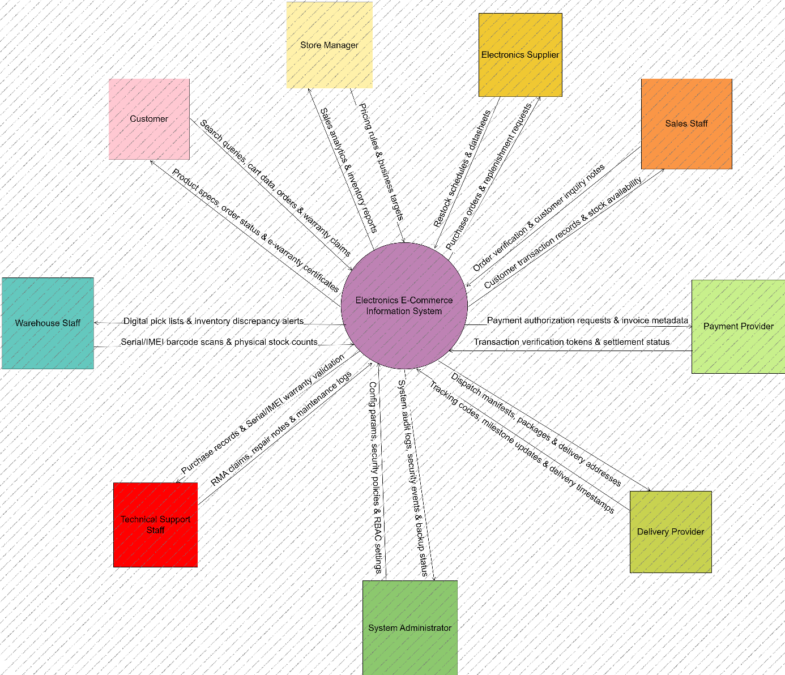
Figure 3. Comprehensive System Context Diagram (DFD Level 0).

Figure 3 shows exchanges for search/catalogue data, payments, delivery tracking, Serial/IMEI scans, warranties, reporting, security administration and supplier restocking.
Boundary interpretation. AI Search and Recommendations are internal services, not additional external actors.

1.7 Detailed Information Flows
The inbound and outbound information flows for each actor refine the exchanges in Figure 3.
Customer ↔ System
Inbound Data Flows: Account credentials, multi-parameter search/filter queries, shopping cart modifications, checkout and shipping information, product reviews, and warranty lookup requests.
Outbound Data Flows: Real-time product specifications, stock status, order confirmation receipts, tracking updates, and electronic warranty certificates. Where enabled, results also include semantically ranked product choices with enforced technical filters and available explanatory attributes.
Payment Provider ↔ System
Inbound Data Flows: Payment verification tokens, digital transaction status codes, and reconciliation logs.
Outbound Data Flows: Encrypted transaction payloads, payable totals, customer billing data, and unique order reference IDs.
Delivery Provider ↔ System
Inbound Data Flows: Consignment tracking codes, package transit status, delivery exception alerts, and proof-of-delivery timestamps.
Outbound Data Flows: Electronic shipping manifests, package weights/dimensions, recipient shipping addresses, and declared values.
Electronics Supplier ↔ System
Inbound Data Flows: Manufacturer datasheets, supply lead times, catalog updates, and restock confirmations.
Outbound Data Flows: Automated purchase orders, restocking demand forecasts, and return-to-vendor (RTV) requests.
Store Manager ↔ System
Inbound Data Flows: Promotional rules, pricing adjustments, inventory replenishment thresholds, and sales targets.
Outbound Data Flows: Aggregated sales reports, revenue trends, inventory turnover metrics, and stockout warnings.
Warehouse Staff ↔ System
Inbound Data Flows: Barcode/QR scan inputs of unique Serial/IMEI numbers, physical stock adjustment counts, and package status.
Outbound Data Flows: Digital picking lists, warehouse bin assignments, and packing manifests.
Technical Support Staff ↔ System
Inbound Data Flows: Warranty claim assessments, repair history notes, component replacement logs, and RMA status updates.
Outbound Data Flows: Historical purchase records, device warranty validation status by Serial/IMEI, and customer contact data.
Sales Staff ↔ System
Inbound Data Flows: Manual order updates, customer consultation notes, and order verification requests.
Outbound Data Flows: Customer transaction histories, catalog datasheets, and live inventory levels.
System Administrator ↔ System
Inbound Data Flows: Role-Based Access Control (RBAC) configurations, system security parameters, and integration API settings.
Outbound Data Flows: System audit trails, security event notifications, API traffic metrics, and database backup verification logs.

1.8 Functional Requirements
Table 2 specifies 22 functional requirements using testable system actions.
ID | Category | Requirement | Priority
FR01 | Account | The system shall allow customers to register a personal account. | M
FR02 | Account | The system shall allow customers to securely authenticate to access their profiles. | M
FR03 | Product | The system shall allow customers to search for products using multi-dimensional technical specifications (e.g., socket types, RAM speed). | M
FR04 | Product | The system shall allow customers to compare multiple hardware variants side-by-side to verify physical compatibility. | S
FR05 | Product | The system shall allow administrators to configure granular multi-dimensional hardware specifications. | M
FR06 | AI Services | The system shall capture customer interactions, including specification queries and cart additions. | M
FR07 | AI Services | The system shall recommend ranked, technically compatible accessories matching the primary hardware in the active session; the inference latency shall meet NFR02. | S
FR08 | Cart | The system shall allow customers to add selected hardware components to a shopping cart. | M
FR09 | Cart | The system shall calculate the total value of the shopping cart, including any applied promotional discounts. | M
FR10 | Order | The system shall validate hardware availability and specification compatibility before confirming the checkout process. | M
FR11 | Order | The system shall allow customers to place an order after recording their shipping information. | M
FR12 | Order | The system shall generate an electronic sales order and dispatch a confirmation notification to the customer. | M
FR13 | Inventory | The system shall allow warehouse staff to bind specific unique Serial/IMEI numbers to confirmed orders via barcode/QR scanning. | M
FR14 | Inventory | The system shall update real-time stock counts automatically after a physical unit is allocated to an order. | M
FR15 | Inventory | The system shall notify the store manager when inventory stock levels drop below defined replenishment thresholds. | S
FR16 | Payment | The system shall request secure transaction authorization from external third-party payment gateways. | M
FR17 | Payment | The system shall record the payment verification token returned by the external payment provider. | M
FR18 | Shipping | The system shall generate electronic shipping manifests and consignment notes for logistics handover. | M
FR19 | Shipping | The system shall synchronize order statuses with real-time transit milestones provided by the delivery provider. | S
FR20 | Warranty | The system shall automatically activate the electronic warranty for recorded Serial/IMEI numbers upon delivery confirmation. | M
FR21 | Warranty | The system shall allow technical support staff to verify warranty eligibility against registered Serial/IMEI records during RMA processes. | M
FR22 | Reporting | The system shall generate real-time aggregated sales and inventory turnover reports for store managers. | M
Table 2. Functional Requirement Catalogue.
AI-specific requirements refine UC01 (search) and UC12 (recommendations) in Part 3.

1.9 Non-Functional Requirements
Table 3 defines performance, security, usability, reliability, availability and integrity requirements.
ID | Category | Requirement
NFR01 | Performance | The system shall return normal product-specification search results within 3 seconds under normal operating conditions.
NFR02 | Performance | The AI-enabled compatible accessory recommendation service shall serve candidate accessories with an online inference latency of no more than 200 ms.
NFR03 | Security | The system shall enforce Role-Based Access Control (RBAC) so only authenticated users access personal data and only authorized staff access management data.
NFR04 | Security | The system shall transmit secure encrypted payment payloads to the external Payment Provider.
NFR05 | Usability | The system shall provide consistent navigation across major customer pages.
NFR06 | Usability | The system shall support rapid barcode and QR scanning interfaces for warehouse staff.
NFR07 | Availability | The system should be available 99.9% of the time throughout normal business operations.
NFR08 | Reliability | The system shall preserve confirmed order information and electronic warranty certificates after successful transaction processing.
NFR09 | Scalability | The system architecture should support an increasing number of products and scale to handle up to 1,000 concurrent users.
NFR10 | Maintainability | The system shall use modular components to support future maintenance, upgrades, and API integrations.
NFR11 | Data Integrity | The system shall prevent an order from being confirmed when required product information is invalid or stock is zero.
NFR12 | Data Integrity | The system shall strictly bind one unique Serial/IMEI code to exactly one physical unit in the database to prevent duplication.
Table 3. Non-Functional Requirement Catalogue.
NFR01 addresses end-to-end search response time; NFR02 addresses recommendation inference latency.

1.10 Requirement Prioritization (MoSCoW)
Table 4 groups requirements by MoSCoW priority.
Priority | Scope Interpretation
Must Have | Technical-specification search; availability/configuration validation; secure digital payment; barcode/QR Serial/IMEI binding; automatic e-warranty activation; core order/account/inventory processing; mandatory FR22 sales and inventory reporting.
Should Have | AI semantic search (with core specification search remaining mandatory); AI-driven compatible accessory recommendation with ≤200 ms inference; real-time shipping synchronization; stock threshold alerts; advanced analytics beyond the mandatory FR22 reporting baseline and repair-history support.
Could Have | Verified-review sentiment analysis and automated supplier replenishment purchase orders if resources permit.
Won't Have (current scope) | Physical transit/route planning of logistics partners and internal financial settlement mechanisms inside external payment/banking networks.
Table 4. MoSCoW Prioritization.

PART 2. REQUIREMENTS ANALYSIS
This chapter derives the actor, use-case and activity models from the requirements.

2.1 Actor Analysis
Actors are roles or external systems that interact directly with TechZone.
Actor | Direct interaction with the system
Customer | Searches multi-parameter technical specifications, manages cart, submits orders, tracks deliveries, and looks up e-warranties.
Store Manager | Accesses management dashboards, reviews aggregated sales/inventory reports, configures pricing/promotional rules, and monitors stock turnover.
Sales Staff | Verifies order details, reviews customer transaction histories, and accesses live inventory for customer consultation.
Warehouse Staff | Uses barcode/QR scanning to allocate Serial/IMEI numbers, adjusts stock counts, and retrieves digital picking lists.
Technical Support Staff | Validates warranty eligibility, updates repair logs, and processes RMA claims.
System Administrator | Configures RBAC, manages integrations/APIs, and reviews security/audit information.
Payment Provider | Receives encrypted transaction payloads and returns authorization status/tokens.
Delivery Provider | Receives shipping manifests and sends package tracking/status and proof-of-delivery updates.
Electronics Supplier | Receives restocking purchase orders and provides catalog/specification and supply-lead-time updates.
Table 5. Actor Analysis.
AI Search, Recommendation and Cart/Inventory Validation are internal services, not UML actors.

2.2 Use Case Identification
ID | Use Case Name | Primary Actor | Category
UC01 | Browse & Filter by Technical Specs | Customer | Product
UC02 | Compare Product Specs | Customer | Product
UC03 | Manage Shopping Cart | Customer | Cart
UC04 | Place Order / Checkout | Customer | Order
UC05 | Track Order & Delivery Status | Customer | Order
UC06 | Lookup E-Warranty & Request RMA | Customer | Support
UC07 | Submit Product Review | Customer | Review
UC08 | Validate Cart & Inventory | Customer (via UC04) | Order
UC09 | Process Digital Payment | Customer (via UC04); Payment Provider supports | Payment
UC10 | Scan & Allocate Serial/IMEI | Warehouse Staff | Inventory
UC11 | Manage Inventory Levels | Warehouse Staff | Inventory
UC12 | Recommend Compatible Accessories | Customer (via UC01/UC04) | Product/Order
UC13 | Generate Sales & Inventory Analytics | Store Manager | Reporting
UC14 | Manage User Roles & System Configurations | System Administrator | Administration
UC15 | Consult & Verify Order | Sales Staff | Order
UC16 | Process E-Warranty & Repair Log | Technical Support Staff | Support
UC17 | Synchronize Shipping Status | Delivery Provider | Shipping
UC18 | Sync Restock Schedule & Specs | Electronics Supplier | Inventory
Table 6. Use Case Catalogue.
UC08 and UC09 support checkout (UC04); physical-unit allocation (UC10) starts independently after order confirmation.

2.3 UML Use Case Model and Relationships
Figure 4 presents the actors, use cases and their include/extend relationships.
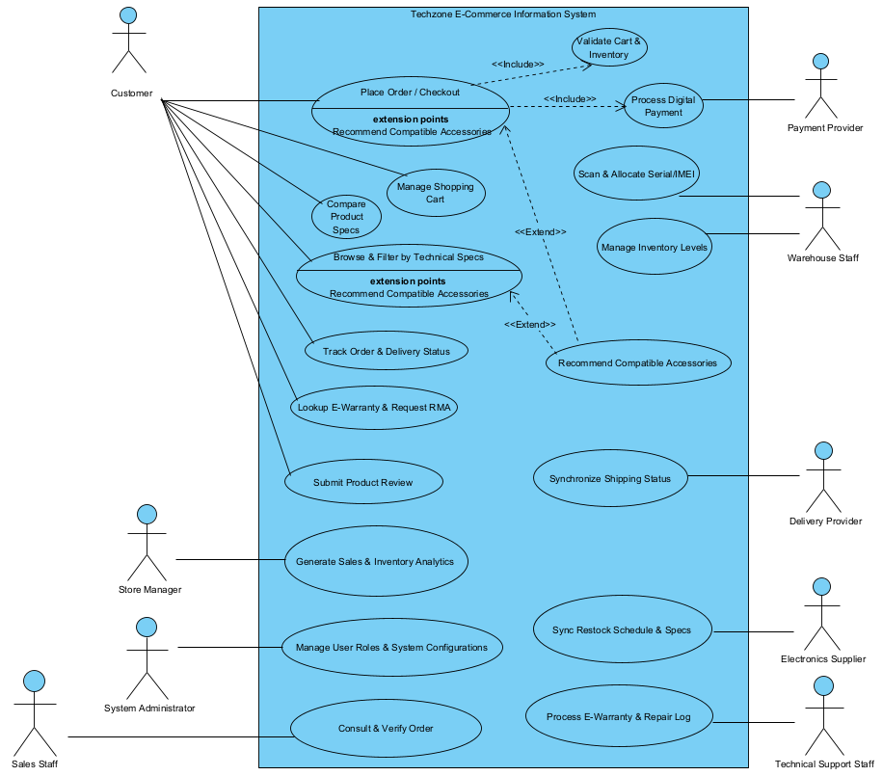
Figure 4. Use-case and actor overview with checkout dependencies.

- Place Order / Checkout <<Include>> Validate Cart & Inventory: verify required availability and compatibility before payment.
- Place Order / Checkout <<Include>> Process Digital Payment: obtain secure provider authorization.
- UC10 Scan & Allocate Serial/IMEI is independent of checkout and has a CONFIRMED-order precondition; it is not an include relationship.
- Recommend Compatible Accessories <<Extend>> Browse & Filter by Technical Specs: offer suggestions when compatibility information exists.
- Recommend Compatible Accessories <<Extend>> Place Order / Checkout: optionally suggest valid cross-sell items before confirmation.

2.4 Detailed Use Case Specifications
The following tables specify five representative use cases.

2.4.1 UC04 — Place Order / Checkout
Element | Description
Use Case ID | UC04
Use Case Name | Place Order / Checkout
Primary Actor | Customer
Supporting Actors | Payment Provider (simulated in the prototype). Physical allocation is handled separately by Warehouse Staff in UC10.
Goal | Customer wants to securely purchase selected hardware products and accessories.
Trigger | Customer selects “Checkout” from the shopping cart interface.
Preconditions | The Customer has a non-empty shopping cart and initiates checkout. Product and stock data are accessible for real-time validation. Payment is not requested until the cart and required details have been checked.
Postconditions | Successful authorization: a confirmed order is recorded, available inventory is updated, picking is queued and a confirmation receipt is displayed. Unavailable stock or unsuccessful/unresolved payment does not produce a confirmed order. Physical Serial/IMEI allocation follows separately in UC10.
Main Success Scenario | 1. Customer initiates checkout; the system validates cart contents against real-time stock and required compatibility.  2. If items are available, the system calculates the total, including applicable taxes and shipping fees.  3. The system optionally evaluates cart items and recommends compatible hardware.  4. Customer provides or confirms shipping details and selects a digital payment method.  5. The system requests authorization from the Payment Provider.  6. The Payment Provider approves the transaction and the system verifies approval.  7. As depicted in Figure 5, the system creates the order record, updates available inventory and queues physical picking.  8. The system displays the order confirmation receipt. Warehouse Staff subsequently performs independent UC10.
Alternative Flows | Out-of-stock or invalid cart: notify the Customer and return to cart modification and validation. Payment rejected: notify the Customer, request an alternative payment method and repeat the authorization path. Recommendations are optional and do not block checkout.
Exceptions | If the provider response is missing or unresolved, payment remains pending reconciliation. Any recheck must be idempotent and based on a verified provider result.
Business Rules | The detailed design reserves stock before authorization. Approval confirms the order without a second deduction; decline releases the reservation, and an unresolved outcome retains it pending reconciliation. Physical Serial/IMEI allocation is an independent UC10 activity.

2.4.2 UC01 — Browse & Filter by Technical Specs
Element | Description
Use Case ID | UC01
Use Case Name | Browse & Filter by Technical Specs
Primary Actor | Customer
Supporting Actors | None
Goal | Customer aims to find specific hardware components by applying granular technical filters.
Trigger | Customer inputs a query or selects technical attributes such as socket type, RAM speed, or PSU wattage.
Preconditions | The system catalog is populated with product specifications and variant matrices.
Postconditions | The system displays a filtered list of hardware matching the technical criteria.
Main Success Scenario | 1. Customer navigates to the hardware catalog.  2. Customer selects technical parameters (e.g., LGA 1700 socket, DDR5 compatibility).  3. System queries the catalog database using the selected attributes.  4. System displays a paginated list of matching products.  5. Customer selects a product and views its detailed datasheet.  AI Enhancement: when enabled, semantic query interpretation improves candidate retrieval and relevance ranking before the same technical filters and result presentation steps.
Alternative Flows | No Match Found: the system displays “No results found” and suggests relaxing filter constraints.  AI Search Unavailable: the system shall continue with baseline keyword and manufacturer-specification filtering without relaxing mandatory compatibility constraints.
Exceptions | Database connection timeout prevents retrieval of catalog data.
Business Rules | Search results must accurately reflect the multi-dimensional technical attributes defined by the manufacturer.

2.4.3 UC03 — Manage Shopping Cart
Element | Description
Use Case ID | UC03
Use Case Name | Manage Shopping Cart
Primary Actor | Customer
Supporting Actors | None
Goal | Customer wants to review, update quantities, or remove selected hardware before finalizing the purchase.
Trigger | Customer clicks “Add to Cart” or opens the cart view.
Preconditions | Customer is browsing the digital storefront.
Postconditions | The shopping cart accurately reflects the customer’s desired items and quantities.
Main Success Scenario | 1. Customer clicks “Add to Cart” for a specific hardware variant.  2. System validates whether the requested quantity is in stock.  3. System adds the item and updates the cart subtotal.  4. Customer navigates to the cart overview.  5. Customer modifies quantity or removes an item.  6. System instantly recalculates and displays the subtotal.
Alternative Flows | Requested Quantity Exceeds Stock: system restricts input to maximum available stock and notifies the customer.
Exceptions | Customer session expires, causing cart data to be lost if it is not persistently stored.
Business Rules | The system must calculate accurate subtotals based on current pricing and configuration variants.

2.4.4 UC10 — Scan & Allocate Serial/IMEI
Element | Description
Use Case ID | UC10
Use Case Name | Scan & Allocate Serial/IMEI
Primary Actor | Warehouse Staff
Supporting Actors | None
Goal | Warehouse staff binds a unique physical hardware identifier to a confirmed digital order.
Trigger | Warehouse staff receives a digital picking manifest for a confirmed order.
Preconditions | The order is CONFIRMED, required payment authorization is verified (capture/settlement is handled according to the selected payment contract), reserved units exist for each requested SKU, and warehouse dispatch has not yet occurred.
Postconditions | The order record is permanently linked to specific Serial/IMEI numbers, enabling future warranty tracking.
Main Success Scenario | 1. Warehouse Staff views the digital picking list.  2. Staff locates the hardware in warehouse bins.  3. Staff scans the barcode/QR code on the product box.  4. System validates that the Serial/IMEI matches the correct SKU.  5. System binds the Serial/IMEI to the customer’s purchase record.  6. System marks the item as “Packed” and generates a dispatch manifest.
Alternative Flows | Mismatched SKU: if the scanned serial belongs to another variant, the system rejects the scan and alerts staff to pick the correct item.
Exceptions | Unreadable barcode or variant mismatch: reject the scan without changing the reservation. Rescan or authorize manual handling; audit completeness requires verification against the actual implementation.
Business Rules | A scanned Serial/IMEI must uniquely identify an available physical unit whose variant matches the reserved OrderItem. Assigning the same unit to two active order lines is forbidden; only after successful scanning may reserved quantity become allocated quantity. Warehouse dispatch requires all mandatory units to be verified.

2.4.5 UC06 — Lookup E-Warranty & Request RMA
Element | Description
Use Case ID | UC06
Use Case Name | Lookup E-Warranty & Request RMA (Return Merchandise Authorization)
Primary Actor | Customer
Supporting Actors | Technical Support Staff
Goal | Customer wants to verify device warranty coverage and initiate a repair or replacement request.
Trigger | Customer enters the device Serial/IMEI number into the warranty portal.
Preconditions | The electronic warranty was previously activated upon delivery confirmation.
Postconditions | An eligible request creates an RMA case. Unknown owner, expired warranty or pending manual verification must not expose another customer’s private data; behavior requires independent security testing.
Main Success Scenario | 1. Customer accesses the post-purchase support portal.  2. Customer inputs the device Serial/IMEI.  3. System retrieves purchase history, warranty duration, and remaining coverage.  4. Customer selects “Request Repair/RMA” and describes the fault.  5. System generates an RMA ticket linked to the Serial/IMEI record.  6. System notifies Technical Support Staff to review the claim.
Alternative Flows | Warranty Expired: the system informs the customer and offers out-of-warranty paid repair options.
Exceptions | If Serial/IMEI cannot be found automatically, Figure 9 routes the request to manual verification; a failed manual check results in an invalid-input notification, while a successful check rejoins the RMA request path.
Business Rules | Automated lookup uses the registered warranty and purchase record. On the manual-verification branch shown in Figure 9, a claim can proceed only after an authorized check establishes a valid, eligible purchase/Serial/IMEI record; a failed check or expired warranty does not create an RMA ticket.

2.5 Activity Diagrams
Figure 5 summarizes cart validation, payment authorization and checkout outcomes. Stock reservation and unresolved-payment reconciliation are specified in the design (Section 4.5). Serial/IMEI allocation is performed separately under UC10.
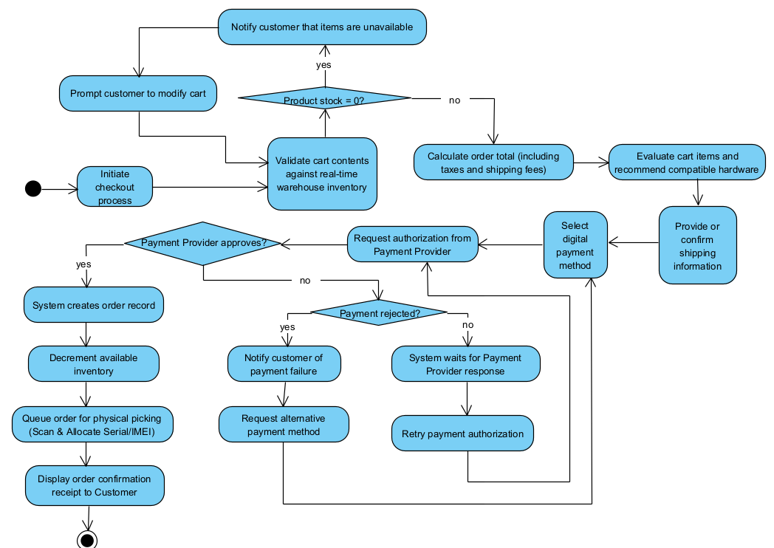
Figure 5. Activity Diagram – UC04 Place Order / Checkout (analysis-level flow).

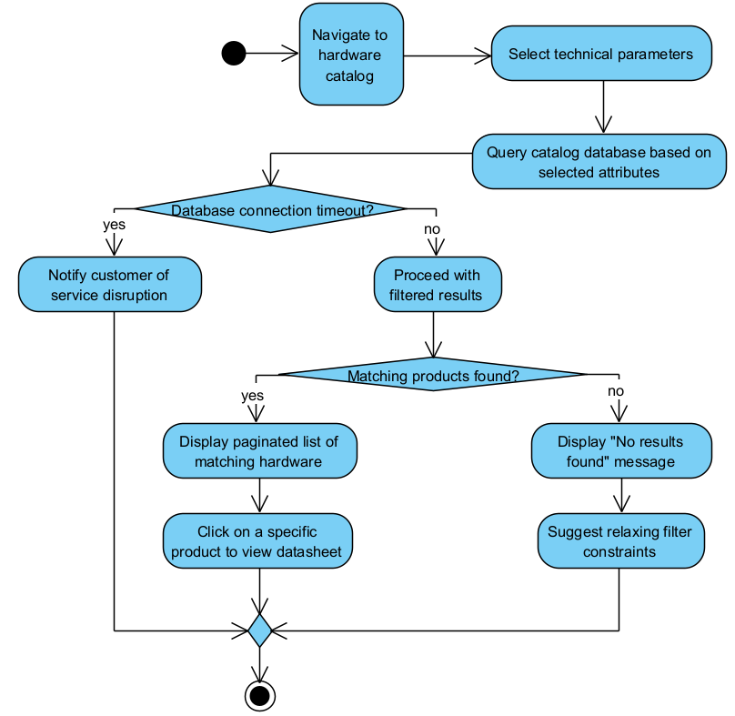
Figure 6. Activity Diagram - UC01 Browse & Filter by Technical Specs.

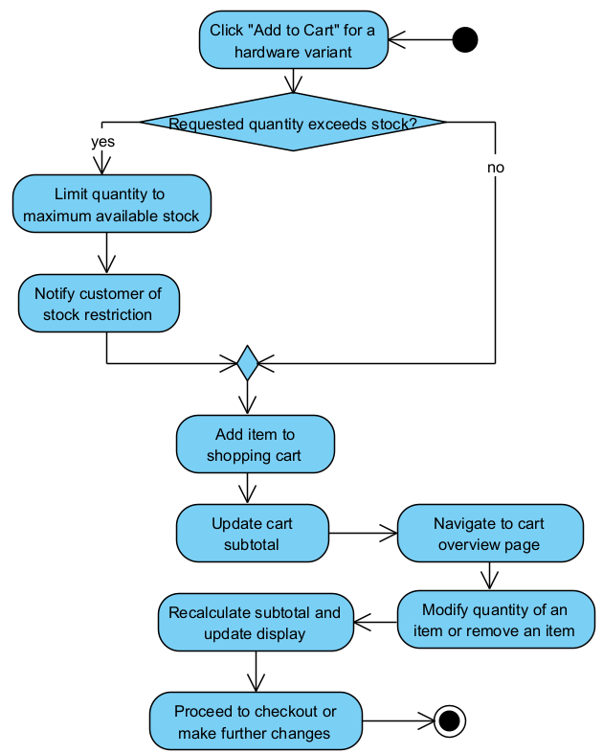
Figure 7. Activity Diagram - UC03 Manage Shopping Cart.

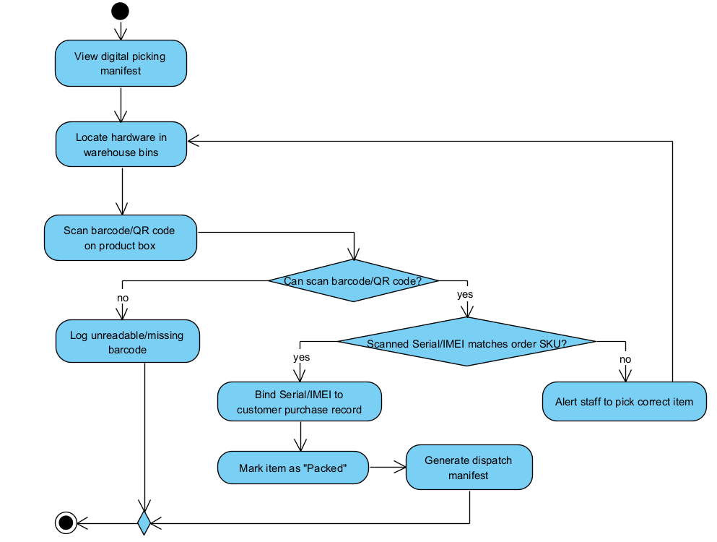
Figure 8. Activity Diagram - UC10 Scan & Allocate Serial/IMEI.

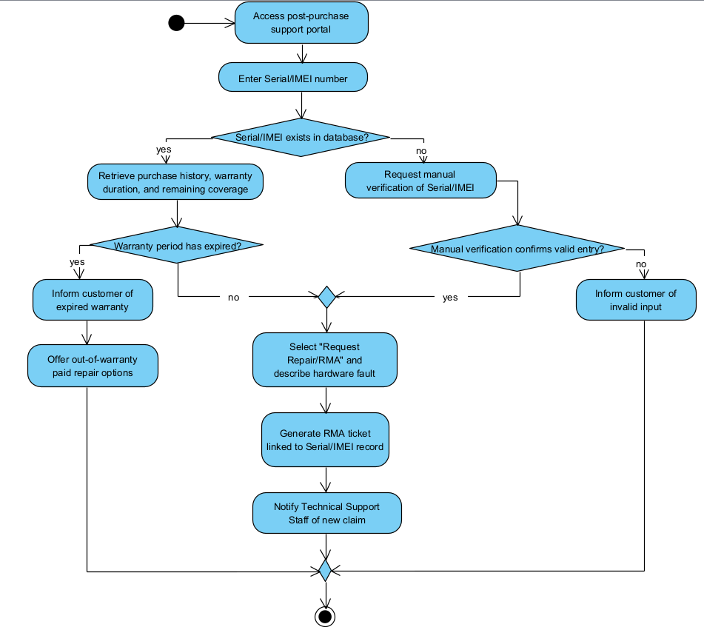
Figure 9. Activity Diagram - UC06 Lookup E-Warranty & Request RMA.

2.6 Requirement Traceability Matrix
Table 7 traces business problems and stakeholder needs to requirements and use cases.
Business Problem | Stakeholder Need | Requirement | Use Case
Inventory Inconsistencies (manual spreadsheet updates) | Warehouse Staff needs exact Serial/IMEI allocation using barcode scanning. | FR13 | UC10 — Scan & Allocate Serial/IMEI
Poor Accessory Matching (high technical return rates) | Customer needs to discover and verify compatible hardware components. | FR03 | UC01 — Browse & Filter by Technical Specs
Poor Accessory Matching (high cart abandonment) | Customer needs real-time suggestions for compatible components during shopping. | FR07 | UC12 — Recommend Compatible Accessories
Fragmented Repair History (no central warranty database) | Technical Support Staff needs instant warranty eligibility validation. | FR21 | UC16 — Process E-Warranty & Repair Log
Delayed Status Lookups (disconnected local files) | Customer needs real-time order and shipment tracking. | FR19 | UC05 — Track Order & Delivery Status
Overselling In-Stock Items (manual configuration verification) | Sales Staff needs instant configuration and stock verification. | FR10 | UC08 — Validate Cart & Inventory
Delayed Business Reports (manual cross-department data) | Store Manager needs real-time sales, revenue, and inventory reports. | FR22 | UC13 — Generate Sales & Inventory Analytics
Slow Financial Reconciliation (disconnected payment systems) | Payment Provider needs secure encrypted payload/token exchange. | FR16 | UC09 — Process Digital Payment
Data Security Risks (fragmented access control) | System Administrator needs secure role-based access and system-health management. | NFR03 | UC14 — Manage User Roles & System Configurations
Inaccurate Stock Dispatch (incorrect variants) | System must enforce absolute data integrity and prevent checkout when stock is unavailable. | NFR11 | UC04 — Place Order / Checkout
Table 7. Requirement Traceability Matrix.
AI traceability: FR03/FR05/NFR01 → UC01 → AIS-S01–AIS-S08; FR06/FR07/NFR02 → UC12 → AIS-R01–AIS-R08.

2.7 Requirement Validation
Table 8 checks representative requirements for clarity and verifiability.
Validation Case | Poor Requirement | Problem | Revised Requirement
Ambiguous performance metric | “The system should load the product catalog fast so customers don’t leave.” | “Fast” is subjective and unverifiable. | NFR01: The system shall return normal product-specification search results within 3 seconds under normal operating conditions.
Vague functional scope | “The system will manage warranties for customers.” | “Manage warranties” does not specify exact behavior, trigger, or output. | FR20: The system shall automatically activate the electronic warranty for recorded Serial/IMEI numbers upon delivery confirmation.
Requirement confused with design/implementation | “Warehouse staff should use a mobile smartphone app to type in the serial numbers for the orders.” | It dictates an implementation choice and reintroduces manual entry error. | FR13: The system shall allow warehouse staff to bind specific unique Serial/IMEI numbers to confirmed orders via barcode/QR scanning.
Table 8. Requirement Validation.
AI services must preserve technical and stock constraints; model failure does not disable core checkout.

PART 3. AI IN E-COMMERCE: INTELLIGENT SEARCH AND RECOMMENDATION
This chapter specifies AI-assisted product search (UC01) and compatible-accessory recommendations (UC12).

3.1 AI Integration Scope and Business Justification
Capability | Customer interaction and business goal | Existing system links
AI Search | Customer expresses a query and/or filters. Improve product discoverability, search success and informed product selection. | Product catalogue, technical specifications and stock visibility; UC01, FR03, FR05, NFR01.
Compatible Recommender | Customer views a product or configures a cart. Surface relevant, technically compatible accessories; improve conversion and AOV while reducing incompatible purchases. | Product and compatibility data, shopping cart, session behaviour and checkout; UC12, FR06, FR07, NFR02.
Table 9. AI Capability Boundaries and Business Objectives.
AI services rank candidates; catalogue, stock, pricing, checkout and warranty rules remain authoritative.
The prototype uses approved pairing records, but manufacturer verification of physical, cable and BIOS constraints remains incomplete.

3.2 AI-Enabled Product Search

3.2.1 Business Problem, Objective and User Scenario
Example queries include “DDR5 motherboard for Intel LGA1700 under my budget” and “compact quiet cooler for this CPU.” The prototype applies explicit filters and uses BGE-M3 for semantic ranking when available, with keyword fallback.
The objective is to improve product discovery and task completion, assessed through retrieval quality and customer interactions.

3.2.2 Search Processing and Information Flow
Search pipeline: query/filters → candidate retrieval → specification and stock checks → ranking → results → permitted event logging.
- Query interpretation: identify product category, relevant concepts, intent and any explicitly stated constraints such as socket type, memory generation, budget or form factor.
- Candidate retrieval: use searchable product names, categories, descriptions and available technical specifications. Source and field completeness vary across the current catalogue.
- Constraint enforcement: apply explicit attribute and demo-stock filters independently of AI scores. Catalogue attributes are not uniformly verified against manufacturer documents.
- Ranking and presentation: order eligible candidates by estimated query relevance, expose key matched specifications, and retain filter controls for the customer.
- Feedback capture: record permitted query, impression, click, filter-change and cart-action events for quality monitoring and later model updates.

3.2.3 Search AI Component Specification
Specification item | Proposed analysis-level requirement
Business problem / objective | Poor interpretation of technical intent; improve relevant product discovery and search success.
AI function | Represent query meaning, retrieve and rank catalogue candidates according to estimated intent relevance. Prototype: BGE-M3 provides semantic ranking when ready; keyword fallback remains available.
Inputs | Query text; selected category/specification filters; current catalogue metadata; optional session context and stock status.
Outputs | Ranked product IDs/SKUs, relevance scores or ranks, applied filters, matched technical attributes, and a no-result state when necessary.
Authoritative data | Product/Technical Catalogue and manufacturer-verified specifications; Inventory Service for availability. Prototype: SQLite holds sourced products and demo stock; specification verification is incomplete.
Interaction | Customer UI ↔ Product/Search API ↔ AI Search Service ↔ catalogue/index; result display uses current product and stock data.
Performance | Comply with NFR01: normal product-specification search results within 3 seconds under normal operating conditions. Prototype status: this latency target has not been demonstrated under representative load.
Update and human role | Refresh searchable representations after catalogue/specification changes; administrators correct inaccurate attributes or aliases.
Risks / controls | Semantic mismatch, stale attributes, incompatible results, missing items and privacy exposure; deterministic filtering, index reconciliation, logging and fallback.
Evaluation | Relevance/Recall@K and NDCG@K on labelled queries; search success, reformulation, latency and conversion-related behaviour. Prototype tests use small/sample datasets and do not establish production search quality.
Table 10. AI Search Component Specification.

3.2.4 Search-Specific Functional Requirements
ID | Requirement and verification intent
AIS-S01 | The system shall accept natural-language product queries together with structured technical filters, and maintain the original query for result traceability.
AIS-S02 | The AI Search Service shall derive a semantic query representation and retrieve candidate products from the current approved catalogue.
AIS-S03 | The system shall exclude candidates that violate mandatory user-specified technical constraints or applicable catalogue validity rules before presenting results.
AIS-S04 | The system shall rank the remaining candidates by predicted relevance and return product identifiers and necessary information for result display.
AIS-S05 | The interface shall show effective filters and relevant technical attributes, and allow customers to revise a query when results do not meet their needs.
AIS-S06 | When AI Search is unavailable, the system shall offer catalogue keyword/specification filtering without silently relaxing hard compatibility constraints.
AIS-S07 | The system shall log permitted search queries, candidate impressions, interactions and outcome signals needed to evaluate search quality.
AIS-S08 | The search index or equivalent representation shall be refreshed or invalidated when product specifications or availability-sensitive information changes.
Table 11. Additional AI Search Functional Requirements.

3.3 Compatible Product Recommendation System

3.3.1 Business Problem, Objective and Trigger
UC12 suggests accessories from product detail or cart context, subject to technical-attribute checks and approved compatibility pairs.
The objective is to increase valid accessory discovery and average order value while reducing incompatible purchases.

3.3.2 Candidate Selection, Scoring and Output
Eligible accessories are ranked by context-dependent relevance, s(u,i,c) = fθ(u,i,c). The top-K list is configurable; prototype scores combine session signals and optional semantic similarity and are not calibrated purchase probabilities.
Only eligible pairs may be recommended. Missing or conflicting compatibility evidence excludes a pair; manufacturer-level verification of all rules remains incomplete.

3.3.3 Recommendation AI Component Specification
Specification item | Proposed analysis-level requirement
Business problem / objective | Difficult accessory selection and incompatible purchases; improve valid cross-selling and customer satisfaction.
AI function | Rank already-eligible accessories by predicted relevance to the customer, primary hardware and shopping context. Prototype: local basket/session signals and optional BGE-M3 scores rank related candidates.
Inputs | Hardware Compatibility Matrix; product/variant specifications; historical co-purchase patterns; permitted clicks/views; current product, cart and optional promotion context. Prototype: part of the basket evidence is sample data; actual catalogue attributes can be incomplete.
Outputs | Top-K compatible accessory IDs, order/rank, relevance scores if used internally, compatibility reason/attributes and fallback status. Prototype: unapproved or UNKNOWN pairs are excluded from top-K; the initial matrix is demo data.
Authoritative data | Product and Compatibility Catalogue plus Inventory; customer interaction or session data is supplemental.
Interaction | Product Detail/Cart/Checkout ↔ Recommendation API ↔ Compatibility filter ↔ AI ranking service; inventory and prices checked by business services.
Performance | Comply with NFR02: online recommendation inference latency not exceeding 200 ms; do not equate this with total webpage response time. Prototype status: the 200 ms target is unverified; total response and model initialization can take longer.
Update and human role | Refresh compatible candidates after catalogue updates; monitor changing interactions; authorized technical staff review incorrect or disputed pairings.
Risks / controls | Cold start, sparse interactions, popularity bias, incompatibility, personal data misuse, stale stock and service outages.
Evaluation | Compatibility violation rate, Recall@K/NDCG@K, coverage, top-K engagement, accessory attach rate, AOV, conversion and return rate.
Table 12. Compatible Recommendation Component Specification.

3.3.4 Recommendation-Specific Functional Requirements
ID | Requirement and verification intent
AIS-R01 | The system shall capture permitted product views, specification searches, cart additions and purchase outcomes required for recommendation evaluation and updates.
AIS-R02 | The system shall generate accessory candidates in relation to the currently viewed primary product or selected cart configuration.
AIS-R03 | The system shall reject candidates that fail verified hardware compatibility rules before they are ranked or shown as compatible. Prototype: known conflicts, unapproved pairs and UNKNOWN pairs are excluded before ranking.
AIS-R04 | The AI Recommendation Service shall rank eligible accessories using available customer/session, product and contextual information and return configurable top-K results.
AIS-R05 | The system shall present recommended items with relevant compatibility information and valid product availability; the customer shall retain full control of cart additions.
AIS-R06 | For a new customer, new product, missing interaction data or service failure, the system shall use category- or popularity-based recommendations only after mandatory compatibility filtering. Prototype: fallback uses only matrix-approved pairs with matching recorded attributes.
AIS-R07 | Authorized Technical Support or Warehouse Staff shall be able to flag, review and correct compatibility pairings through a controlled audit trail.
AIS-R08 | The system shall measure recommendation exposure, clicks, cart additions and purchases without assuming an observed correlation establishes causal business improvement.
Table 13. Additional Compatible Recommendation Functional Requirements.

3.4 Shared Data Requirements and Service Interactions
Data asset | Producer / authority | Search use | Recommendation use
Product catalogue and technical specifications | System Administrator; manufacturers / suppliers | Index fields, interpret constraints, retrieve and rank results. | Identify accessories and describe recommended products.
Hardware Compatibility Matrix | Technical product data under administrator/staff review | Apply explicit hardware constraints to relevant searches. | Hard-filter incompatible candidates before ranking. Prototype: current attributes are compared dynamically; disputed pairs remain subject to review.
Current stock and availability | Inventory Service / Warehouse Staff Prototype: current quantities are demo inventory, not live warehouse counts. | Exclude or label unsellable results per policy. | Validate current recommendation eligibility and display.
Search, click and view interactions | Customer session / event logging | Evaluate search success and adapt relevance. | Provide permitted behavioural and contextual signals.
Cart, purchase and co-purchase records | Cart and Order Services | Measure downstream search outcomes where permitted. | Learn association and relevance; evaluate attach/conversion outcomes.
Context and promotions | Active session and store configuration | Interpret current filters or context where appropriate. | Rank eligible products for the current session.
Table 14. Shared AI Data Catalogue and Provenance.
Catalogue preparation requires deduplication, field completeness, source provenance and update tracking. Unknown mandatory compatibility attributes require exclusion or manual review.
Both AI components serve existing application APIs. Failure of an AI worker must not prevent baseline search, cart or checkout operations.
Customer interaction data require consent, access controls and appropriate retention.

3.5 Non-Functional Requirements and Quality Controls
Table 15 maps AI quality controls to the applicable non-functional requirements.
Quality attribute | AI Search acceptance approach | Recommendation acceptance approach
Latency | Measure end-to-end search result response against NFR01: within 3 seconds under defined normal operating conditions. Prototype: no representative load benchmark has established this target. | Measure AI online inference against NFR02: ≤ 200 ms; also separately monitor full recommendation API time. Prototype: no representative latency benchmark has established this target.
Technical correctness | Validate explicit filter adherence and correct matching of catalogue variants and attributes. | Require zero knowingly incompatible products displayed as compatible in the approved compatibility test suite.
Relevance / ranking | Use labelled-query relevance judgments, Recall@K and NDCG@K; inspect frequent unsuccessful queries. | Use offline top-K ranking quality and compatibility-aware evaluation on appropriately time-ordered historical events.
Availability / resilience | Provide keyword/specification search when semantic service fails; collect timeout and degraded-mode counts. | Provide rule-filtered popular/contextual accessories or omit the recommendation panel if no safe candidate exists.
Explainability / fairness | Show matched product category/specifications, filters and reasons for empty results. | State relevant compatibility facts; review exposure diversity and popularity dominance.
Security / privacy | Authorize event collection and query logging; exclude secrets and avoid unnecessary retention. | Restrict behavioural/profile access, control staff overrides and audit compatibility changes.
Maintainability | Separate catalogue update, retrieval and ranking responsibilities; version data and evaluation sets. | Separate compatibility rules from scoring, monitor model quality, and support safe rollback.
Table 15. AI Non-Functional Verification Criteria.
The 3 s search and 200 ms recommendation targets remain unverified under representative load.

3.6 Failure, Exception, Cold-Start and Human Review
Condition | Required system response | Review / logging
AI Search timeout or model outage | Continue with conventional keyword and structured-specification search; clearly indicate that enhanced ranking is temporarily unavailable. | Log service failure and the fallback path; alert administrator for persistent incidents.
Ambiguous query or no relevant result | Show clarified filters, spelling/category alternatives or a no-results state; never fabricate catalogue products. | Record no-result/reformulation events for relevance review.
Invalid or missing technical specification | Do not assert technical compatibility; show only verified information and direct disputed product data for correction. Prototype: missing mandatory pair attributes prevent compatible suggestions; physical checks remain incomplete. | Administrator or technical specialist validates source data.
Recommendation cold start | Use category or popular items restricted by the verified Compatibility Matrix and current availability. Prototype: fallback excludes UNKNOWN and unapproved pairs. | Log fallback reason; assess coverage for new products/customers.
Recommendation timeout or missing eligible items | Show compatible fallback items if available, otherwise hide/omit suggestions without blocking cart/checkout. Prototype: fallback excludes known conflicts, UNKNOWN and unapproved pairs. | Track fallback frequency and unresolved catalogue coverage.
Human-discovered incorrect pairing | Suspend or correct the pairing, preserve change history and invalidate affected recommendations. | Authorized technical support/warehouse review with administrator audit.
Popularity bias or model drift | Monitor category coverage and business outcomes; schedule controlled review/retraining or rollback. | Manager and system administrator review evaluation and changes.
Table 16. AI Failure and Human-Control Matrix.
Disputed pairings require staff review. Unapproved or conflicting pairs are blocked; incomplete manufacturer evidence remains a limitation.

3.7 Evaluation and Requirements Traceability

3.7.1 Technical and Business Evaluation
Search and recommendation quality are assessed through relevance, compatibility and latency; business indicators include task completion, conversion and returns.
Capability | Technical evidence | Business evidence
AI Search | Query-labelled ranking quality (Recall@K, NDCG@K); hard-filter adherence; empty-result frequency; response-time distribution; fallbacks. Current automated evaluations use samples; they are not representative production evidence. | Search success rate, query reformulation rate, search-to-product-view/cart rate, task completion and downstream conversion.
Compatible Recommender | Top-K relevance (Recall@K, NDCG@K), verified compatibility rate, catalogue coverage, availability, inference latency, cold-start and failure rates. Current checks do not establish a verified-only compatibility rate or real-customer relevance. | Accessory attach rate, recommendation engagement, AOV, conversion, hardware-related returns and customer support burden.
Table 17. Technical and Business Evaluation of AI Services.
Available regression checks are not substitutes for independent relevance or representative load testing.
Table 17A. Small development-set comparison of keyword and BGE-M3 retrieval.
Method | Queries | Recall@3 | NDCG@3 | Median (ms) | p95 (ms)
keyword | 16 | 1.0000 | 1.0000 | 0.301 | 17.906
BGE-M3 | 16 | 1.0000 | 1.0000 | 72.124 | 139.494
Method: 16 manually authored Vietnamese queries, one preselected relevant product per query, against 20 active products in the TechZoneStore synthetic seed catalogue. Both methods use the same eligibility filters and the same labelled target. Recall@3 is the share of targets in the top three; binary NDCG@3 is 1/log2(rank+1) for a target in the top three and zero otherwise, averaged over queries [5]. Only one product was labelled for each query; other potentially relevant products were not exhaustively judged.
Timing is a single warm-document-cache, in-process measurement per query, excluding model startup, HTTP and browser rendering; p95 is the nearest-rank estimate over sixteen samples. The result is a small development check, not an independent or representative benchmark, and must not be used as an NFR latency claim. The query labels, per-query rankings, elapsed times, model revision and reproduction commands are retained under src/test/resources/search-evaluation.tsv and docs/ai-search-evaluation/.

3.7.2 AI Requirements Traceability
Business problem / goal | Baseline requirement and use case | New AI-specific requirement | Primary evidence
Customers cannot find technically relevant items | FR03, FR05, NFR01; UC01 Browse & Filter | AIS-S01–AIS-S05 | Relevance and filter tests, search success and latency.
Unreliable AI-enhanced search during failures | NFR01, NFR10; UC01 | AIS-S06–AIS-S08 | Fallback test, update reconciliation and event audit.
Incompatible accessory purchases and weak cross-selling | FR06, FR07, NFR02; UC12 Recommend Compatible Accessories | AIS-R01–AIS-R05 | Compatibility suite, top-K relevance, AOV and conversion outcomes.
Sparse user history, model failure and incorrect pairing | FR10, FR13; UC12, UC04 / UC10 | AIS-R06–AIS-R08 | Cold-start/failure test, reviewed pairing audit and controlled outcome measurement.
Table 18. AI-Specific Requirements Traceability.

3.8 Validation and Implementation Readiness
The preferred BGE-M3, Whisper Medium, SigLIP 2 Base and Qwen3-4B-Instruct-2507 checkpoints were installed by 11 November 2026. The recorded suite ran BGE-M3, SigLIP 2 and Qwen3; no Whisper Medium speech-inference test was included. These checks do not establish representative model quality, production latency or compatibility coverage. [1–4]

PART 4. SYSTEM DESIGN
This chapter defines the analysis classes (Figure 10), 17-table data model (Figure 11), design classes (Figure 12) and layered architecture (Figure 13).
Core design constraints are stock and compatibility integrity, authorized payment, post-confirmation serial allocation and delivery-based warranty activation.

4.1 Class Diagram in Analysis

4.1.1 Analysis Classes and Responsibilities
Figure 10 shows 19 analysis classes. SearchRequest and RecommendationList are transient concepts; InteractionEvent records permitted activity.
Class group | Principal classes | Analytical role
Customer and cart | Customer; ShoppingCart; CartItem | Customer identity/session and intended variant quantities before checkout.
Products and compatibility | Product; ProductVariant; TechnicalSpec; CompatibilityRule | Product families, sellable SKU variants, manufacturer-backed attributes and approved hardware pairings.
Transaction | SalesOrder; OrderItem; Payment; Shipment | Purchase record, individual order lines, third-party payment authorization and delivery milestones.
Inventory and support | InventoryBalance; InventoryUnit; UnitAllocation; Warranty; RMARequest | Sellable/reserved/allocated quantities, unique Serial/IMEI binding, warranty and repair claims.
AI discovery | SearchRequest; RecommendationList; InteractionEvent | Transient discovery requests/results and permitted persistent user-interaction history.
Table 19. Candidate analysis classes and responsibilities.
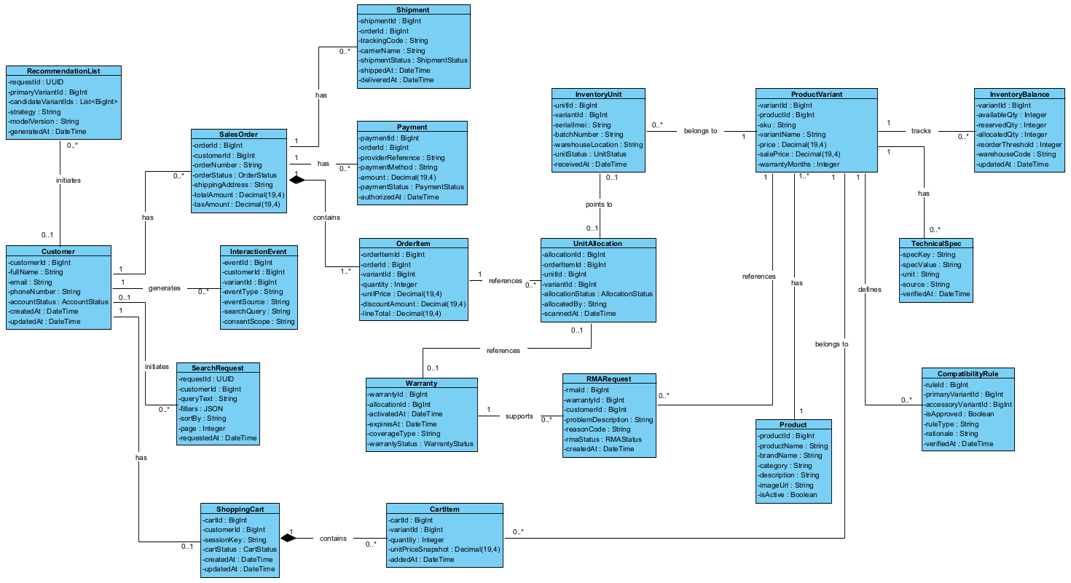
Figure 10. Unified Analysis Class Diagram — Detailed Domain Attributes and Relationships.

4.1.2 Relationships, Multiplicity and Constraints
Figure 10 uses compositions for ShoppingCart–CartItem and SalesOrder–OrderItem. It shows Customer with 0..1 ShoppingCart and 0..* SalesOrders; ProductVariant with multiple InventoryUnits, InventoryBalances and TechnicalSpecs; OrderItem with multiple UnitAllocations; and Warranty with multiple RMARequests. Figure 11 applies additional physical uniqueness constraints.
CompatibilityRule represents approved accessory pairings; interaction concepts support product discovery.

4.2 Data Model and Database Design

4.2.1 Logical-to-Relational Mapping
Figure 11 shows 17 core tables. Table 20A maps their columns to SQLite storage types; physical uniqueness rules supplement the class associations.
Relational area | Tables | Main key relationship
Catalog / compatibility | products, product_variants, compatibility_rules | product_variants.product_id -> products; compatibility_rules.primary_variant_id and accessory_variant_id -> product_variants; technical specifications are stored as JSON text in product_variants.technical_specs per Table 20A.
Cart and checkout | customers, shopping_carts, cart_items, sales_orders, order_items | Customer → cart/order; each item references a variant; an order contains one or more lines.
Stock and traceability | inventory_balances, inventory_units, unit_allocations | One balance per variant; one unit has a unique Serial/IMEI; each allocation references an order item and unique physical unit.
Payment and delivery | payments, shipments | Payment and tracking records reference a sales order; no card credentials are stored.
Warranty and return | warranties, rma_cases | Warranty references a unique assigned unit; RMA references the activated warranty and customer.
AI telemetry | interaction_events, recommendation_impressions | Customer/session and product links support retrieval quality checks, recommender ranking and business evaluation.
Table 20. Relational data groups and foreign-key dependencies.
Relational table | Fields, data types and constraints
customers | customer_id [TEXT] {PK}; email [TEXT] {UQ}; full_name [TEXT]; phone_number [TEXT]; account_status [TEXT]; created_at [TEXT]; updated_at [TEXT]
products | product_id [TEXT] {PK}; product_name [TEXT]; category [TEXT]; brand_name [TEXT]; description [TEXT]; image_url [TEXT]; created_at [TEXT]; is_active [INTEGER]
product_variants | variant_id [TEXT] {PK}; product_id [TEXT] {FK}; sku [TEXT] {UQ}; variant_name [TEXT]; color [TEXT]; capacity [TEXT]; price [INTEGER]; sale_price [INTEGER]; warranty_months [INTEGER]; technical_specs [TEXT]; is_active [INTEGER]; updated_at [TEXT]
compatibility_rules | rule_id [TEXT] {PK}; primary_variant_id [TEXT] {FK}; accessory_variant_id [TEXT] {FK}; is_approved [INTEGER]; rule_type [TEXT]; rationale [TEXT]; verified_by [TEXT]; verified_at [TEXT]
inventory_balances | variant_id [TEXT] {PK/FK}; available_qty [INTEGER]; reserved_qty [INTEGER]; allocated_qty [INTEGER]; reorder_threshold [INTEGER]; warehouse_code [TEXT]; updated_at [TEXT]
inventory_units | unit_id [TEXT] {PK}; variant_id [TEXT] {FK}; serial_imei [TEXT] {UQ}; batch_number [TEXT]; received_at [TEXT]; warehouse_location [TEXT]; unit_status [TEXT]
shopping_carts | cart_id [TEXT] {PK}; customer_id [TEXT] {FK}; session_key [TEXT] {UQ}; cart_status [TEXT]; created_at [TEXT]; updated_at [TEXT]
cart_items | cart_id [TEXT] {PK/FK}; variant_id [TEXT] {PK/FK}; quantity [INTEGER]; unit_price_snapshot [INTEGER]; added_at [TEXT]
sales_orders | order_id [TEXT] {PK}; customer_id [TEXT] {FK}; order_number [TEXT] {UQ}; shipping_address [TEXT]; order_status [TEXT]; total_amount [INTEGER]; currency_code [TEXT]; tax_amount [INTEGER]; shipping_fee [INTEGER]; created_at [TEXT]; idempotency_key [TEXT]{UQ}
order_items | order_item_id [TEXT] {PK}; order_id [TEXT] {FK}; variant_id [TEXT] {FK}; quantity [INTEGER]; unit_price [INTEGER]; discount_amount [INTEGER]; line_total [INTEGER]; reserved_qty [INTEGER]; allocated_qty [INTEGER]; reservation_state [TEXT]; reservation_expires_at [TEXT]
unit_allocations | allocation_id [TEXT] {PK}; order_item_id [TEXT] {FK}; unit_id [TEXT] {FK}; variant_id [TEXT]; allocation_status [TEXT]; allocated_by [TEXT]; scanned_at [TEXT]
payments | payment_id [TEXT] {PK}; order_id [TEXT] {FK}; payment_method [TEXT]; provider_ref [TEXT]; idempotency_key [TEXT]; amount [INTEGER]; currency_code [TEXT]; payment_status [TEXT]; authorized_at [TEXT]; captured_at [TEXT]; updated_at [TEXT]
shipments | shipment_id [TEXT] {PK}; order_id [TEXT] {FK}; tracking_code [TEXT] {UQ}; carrier_name [TEXT]; shipped_at [TEXT]; shipment_status [TEXT]; delivered_at [TEXT]
warranties | warranty_id [TEXT] {PK}; allocation_id [TEXT] {FK}; activated_at [TEXT]; expires_at [TEXT]; coverage_type [TEXT]; warranty_status [TEXT]
rma_cases | rma_id [TEXT] {PK}; warranty_id [TEXT] {FK}; customer_id [TEXT] {FK}; problem_description [TEXT]; reason_code [TEXT]; resolution_notes [TEXT]; closed_at [TEXT]; rma_status [TEXT]; created_at [TEXT]
interaction_events | event_id [TEXT] {PK}; customer_id [TEXT] {FK}; anonymous_session_key [TEXT]; variant_id [TEXT] {FK}; request_id [TEXT]; event_type [TEXT]; event_source [TEXT]; consent_scope [TEXT]; search_query [TEXT]; filters [TEXT]; sort_by [TEXT]; page [INTEGER]; event_context [TEXT]; occurred_at [TEXT]
recommendation_impressions | impression_id [TEXT] {PK}; request_id [TEXT]; customer_id [TEXT] {FK}; primary_variant_id [TEXT] {FK}; accessory_variant_id [TEXT] {FK}; rank_position [INTEGER]; score [REAL]; strategy [TEXT]; model_version [TEXT]; generated_at [TEXT]; shown_at [TEXT]
Table 20A. Figure 11 Column Catalogue with Proposed SQLite Storage Types (17 Tables).
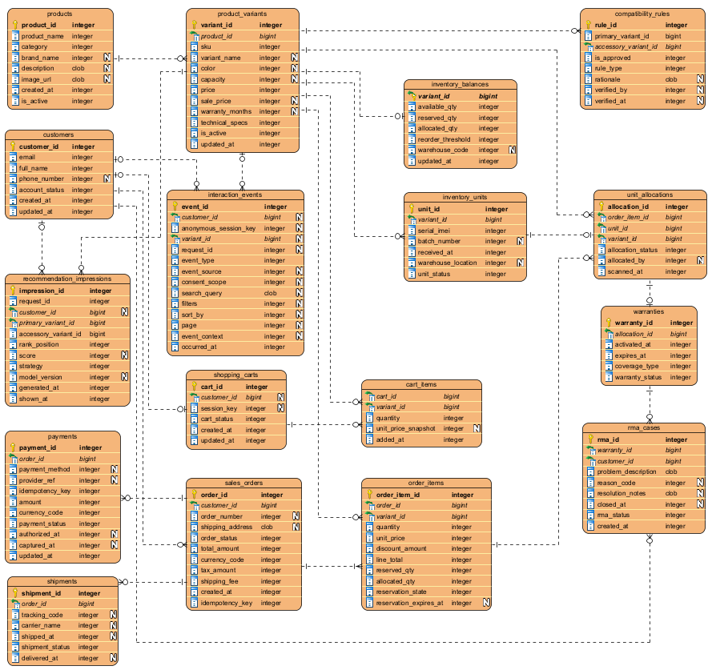
Figure 11. Seventeen-Table Relational ERD — Relationships and Column Names (use Table 20A for physical SQL types).

4.2.2 Data Integrity and Operational Rules
1. Identifier and variant integrity. Unique SKUs and Serial/IMEIs identify variants and physical units. Proposed unique unit_allocations.unit_id and composite foreign keys prevent reused units and variant mismatches; these constraints are not explicit in Figure 11.
2. Ownership and authorization. Foreign keys link payments/shipments to orders and RMA cases to warranties/customers; application authorization must also verify purchase ownership.
3. Reservation. Figure 11 tracks available, reserved and allocated quantities. Atomic updates, nonnegative counters and reserved_qty + allocated_qty <= quantity require transaction-level enforcement.
Inventory transitions. Figure 5 shows the analysis-level post-approval stock update. The design reserves stock atomically before authorization, reconciles UNKNOWN outcomes, and allocates matching Serial/IMEI units only after confirmation without double deduction.
5. Hard compatibility. AI ranking cannot override manufacturer-based attributes or reviewed compatibility_rules.
6. Warranty. Activate once after verified delivery of an allocated unit; RMA requires a valid warranty and customer eligibility. Provider deduplication and authorization are service responsibilities.
7. Privacy. Limit interaction_events to permitted identifiers and apply retention/access rules.

The SQLite excerpts illustrate declarations and stock updates. IDs and JSON values use TEXT; monetary values use INTEGER VND; Boolean flags use INTEGER; scores use REAL.
The following SQLite examples illustrate Table 20A declarations and transactional stock updates. Identifiers use TEXT, monetary values use INTEGER VND, flags use INTEGER 0/1, timestamps and JSON use TEXT, and scores use REAL. The runnable Java prototype now uses the Table 20A names and relational columns for its 17 core tables; it stores technical specifications as JSON TEXT in product_variants.technical_specs. Supporting demo workflows use additional normalized tables, while app_metadata stores revision and active-customer metadata. The former app_state database is read only by a one-time importer that creates a backup and migrates rows into the relational schema. SQLite foreign-key enforcement is enabled per connection. Full authorization, concurrency testing and operational limits require separate validation.

4.2.3.1 Product variant and technical-specification storage
CREATE TABLE product_variants (
variant_id TEXT PRIMARY KEY,
product_id TEXT NOT NULL REFERENCES products(product_id),
sku TEXT NOT NULL UNIQUE,
price INTEGER NOT NULL CHECK (price >= 0),
technical_specs TEXT NOT NULL DEFAULT '{}',
is_active INTEGER NOT NULL DEFAULT 1 CHECK (is_active IN (0, 1)),
updated_at TEXT NOT NULL DEFAULT CURRENT_TIMESTAMP
);
CREATE INDEX idx_variants_product ON product_variants(product_id);
Partial SQLite product_variants example using Figure 11 names and Table 20A types; the runnable prototype stores technical specifications as JSON TEXT in product_variants.technical_specs, not as key-value rows in product_specs.

4.2.3.2 Inventory reservation invariant
CREATE TABLE inventory_balances (
variant_id TEXT PRIMARY KEY REFERENCES product_variants(variant_id),
available_qty INTEGER NOT NULL DEFAULT 0 CHECK (available_qty >= 0),
reserved_qty INTEGER NOT NULL DEFAULT 0 CHECK (reserved_qty >= 0),
allocated_qty INTEGER NOT NULL DEFAULT 0 CHECK (allocated_qty >= 0)
);
-- In a transaction: reserve only if available stock is sufficient.
UPDATE inventory_balances
SET available_qty = available_qty - :quantity,
reserved_qty = reserved_qty + :quantity
WHERE variant_id = :variant_id AND available_qty >= :quantity;
-- Require exactly one affected row; otherwise roll back.
Example nonnegative inventory counters; atomic reservation requires a transaction.
Deployment validation requires database migrations, concurrency tests, provider reconciliation and Serial/IMEI integrity checks.

4.3 Class Diagram in Design

4.3.1 Detailed Attributes and Domain Methods
Figure 12 adds attributes and domain operations to the 19 Analysis classes, covering quantity validation, reservation/allocation, payment status, shipping and warranty/RMA. Application use cases and ports are specified separately in Figure 13 and Table 22.
Classes in Figure 12 | Selected methods visible in Figure 12 | Trace to requirements and storage
Customer; ShoppingCart; CartItem | Customer.updateProfile(), ShoppingCart.addItem()/calculateSubtotal(), CartItem.updateQuantity()/calculateLineTotal() | UC03; customers, shopping_carts, cart_items
Product; ProductVariant; TechnicalSpec; CompatibilityRule | Product.addVariant(), ProductVariant.matchesFilters()/getEffectivePrice(), TechnicalSpec.isVerified(), CompatibilityRule.matchesVariants() | UC01, UC02, UC12; products, product_variants, compatibility_rules
SalesOrder; OrderItem; Payment; Shipment | SalesOrder.confirm()/cancel(), OrderItem.reserveQuantity()/allocateQuantity(), Payment.verifyAuthorization(), Shipment.verifyDelivery() | UC04, UC09, UC17; sales_orders, order_items, payments, shipments
InventoryBalance; InventoryUnit; UnitAllocation | InventoryBalance.reserve()/allocate()/release(), InventoryUnit.verifyVariant(), UnitAllocation.validateAllocation() | UC10–UC11; inventory_balances, inventory_units, unit_allocations
Warranty; RMARequest | Warranty.activateOnDelivery()/isValid(), RMARequest.validateEligibility()/closeClaim() | UC06, UC16; warranties, rma_cases
SearchRequest; RecommendationList; InteractionEvent | SearchRequest.validate()/updateFilters(), RecommendationList.topK(), InteractionEvent.validateConsent() | FR06, UC01, UC12; interaction_events and recommendation_impressions
Table 21. Selected Domain Operations in Figure 12 and Requirements Mapping.

4.3.2 Application Services and Interfaces
SearchUseCase, RecommendUseCase, CheckoutUseCase, AllocateSerialUseCase and WarrantyUseCase coordinate business operations in Figure 13; Table 22 specifies their repository and external-service interfaces.
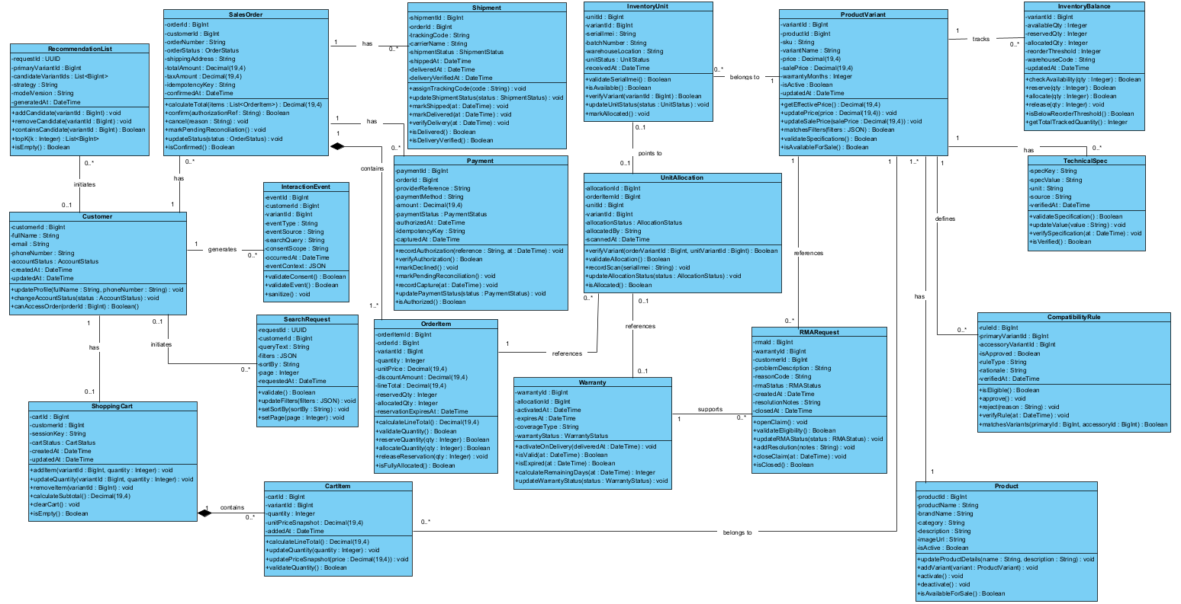
Figure 12. UML Design Class Diagram — Nineteen Domain Classes, Attributes, Operations and Relationships.
Interface (port) | Responsible adapter | Example operation
CatalogPort | Catalogue / technical-spec repository | activeVariants(filters), findVariant(id); hard filters rechecked in use case
InventoryPort | Transactional inventory + Serial/IMEI repository | available(variantId), reserveAtomically(orderId, lines), bindUnit(orderItemId, serial), release(orderId)
CompatibilityPort | Reviewed manufacturer rules / hard policy | eligibleAccessories(primaryId), validatePair(primaryId, accessoryId)
RankingPort | AI scoring + deterministic safe fallback | rank(items, context); never overrides compatibility
PaymentPort | External payment adapter (gateway outside system) | authorize(orderId, amountVnd, key), queryStatus(key); structured AUTHORIZED/DECLINED/UNKNOWN
OrderPort | Order intent and state repository | createPending(cartId, key), confirm(orderId), cancel(orderId), markPendingReview(orderId); cart ownership verified
EventPort | Consent-aware interaction logger | record(event: InteractionEvent)
DeliveryPort | Verified external delivery notification adapter | verifyDelivered(eventId)
WarrantyPort | Warranty repository / one-time activation | activateOnce(allocationId)
Table 22. Interface-based design and replaceable infrastructure adapters.

4.3.3 Relationships and Dependency Direction
Figure 12 preserves the domain associations; Table 22 specifies service and repository interfaces.
Compatibility and stock are checked before confirmation; UC10 allocates unique matching units afterward.

4.3.4 Analysis-to-Design Consistency
Figure 12 extends the analysis classes with operations. Persistent interaction records are stored separately from transient search and recommendation objects.
SQLite types describe storage, whereas UML types express domain concepts; Table 22 defines application port contracts.

4.4 Layered Architecture: Classes and Relationships

4.4.1 Architecture Figure and Layer Responsibilities
Figure 13 separates presentation, application and data responsibilities, with payment and delivery providers outside the system boundary.
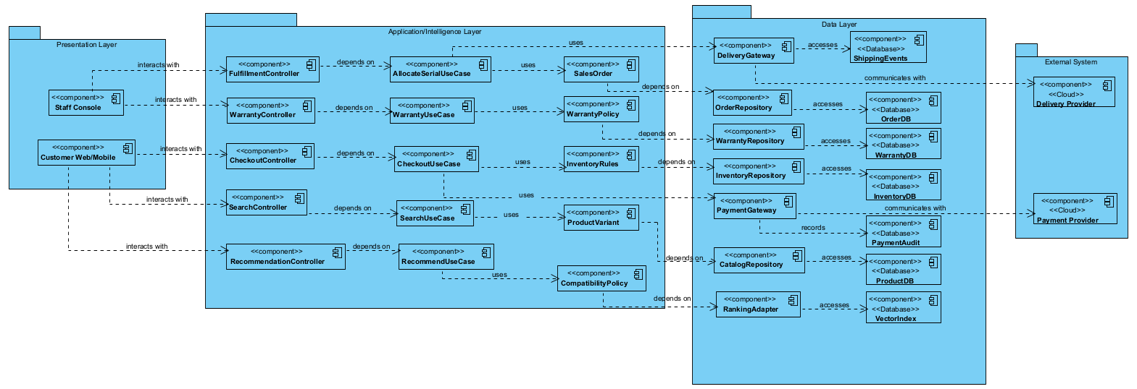
Figure 13. Three-Layer Component Diagram with External Payment and Delivery Providers.
Layer | Classes or components | Responsibility
Presentation Layer | Customer Web/Mobile; Staff Console | Accept user actions and present product, order and staff information.
Application / Intelligence Layer | SearchController/SearchUseCase/ProductVariant; RecommendationController/RecommendUseCase/CompatibilityPolicy; CheckoutController/CheckoutUseCase/InventoryRules; FulfillmentController/AllocateSerialUseCase/SalesOrder; WarrantyController/WarrantyUseCase/WarrantyPolicy | Coordinates the five depicted functional groups; domain rules stay separate from repositories and gateways.
Data Layer + External Systems | Data: CatalogRepository/ProductDB; InventoryRepository/InventoryDB; OrderRepository/OrderDB; WarrantyRepository/WarrantyDB; RankingAdapter/VectorIndex; PaymentGateway/PaymentAudit; DeliveryGateway/ShippingEvents. Outside: Payment Provider, Delivery Provider. | Provides data access, ranking storage and provider adapters. External companies remain outside the internal layers.
Table 23. Layer responsibilities and allocation of design classes.

4.4.2 End-to-End Interaction Scenarios
1. Search (UC01): SearchController → SearchUseCase → ProductVariant uses CatalogRepository/ProductDB; Table 22 specifies filtering and optional ranking contracts.
2. Recommendation (UC12): RecommendationController → RecommendUseCase → CompatibilityPolicy uses RankingAdapter/VectorIndex.
3. Checkout (UC04): CheckoutController → CheckoutUseCase → InventoryRules uses InventoryRepository and PaymentGateway.
4. Fulfillment and warranty (UC10/UC17/FR20): FulfillmentController → AllocateSerialUseCase → SalesOrder and WarrantyController → WarrantyUseCase → WarrantyPolicy use order, delivery and warranty adapters. RMA has no standalone component in Figure 13.

4.4.3 Quality, Security and Deployment Considerations
The design applies RBAC, bounded timeouts, correlation IDs and privacy-aware logging; NFR01 and NFR02 set the response-time targets.
The local prototype uses a Java HTTP backend, a browser interface, SQLite and optional Python AI workers. External payment and delivery are simulated.

4.5 Illustrative Code Mapping from Design

4.5.1 Package and Class Structure
The Java excerpts below illustrate design-to-code correspondence. They were not automatically generated from UML.
4.5.1.1 Illustrative package layout
src/main/java/vn/techzone/
domain/ TechZoneModels.java
application/ SearchUseCase.java, CheckoutWorkflowService.java
application/port/ business interfaces
infrastructure/ adapters and simulated gateways
backend/ CatalogBackend.java, SqliteStore.java
src/main/resources/web/ browser assets
ai/ optional Python workers and GearVN crawler
Domain, application, infrastructure and backend packages correspond to the logical layers.

4.5.2 Domain Entities and Compatibility Rule
4.5.2.1 Domain object and deterministic eligibility
// TechZoneModels.java, ProductVariant (excerpt)
public static final class ProductVariant implements java.io.Serializable {
private static final long serialVersionUID = 1L;
public final String id;
/** Product family ID; legacy snapshots without this field use the variant ID. */
private final String productId;
private final String productName;
// Null in older serialized snapshots; keep separate parent/variant flags after relational reload.
private final Boolean storedProductActive;
private final Boolean storedVariantActive;
private final Boolean originalEffectiveActive;
public final String sku;
public final String name;
public final String category;
public final String brand;
public final String description;
public final String color;

4.5.3 Search and Recommendation Application Services
4.5.3.1 Search and recommender control flow (abbreviated pseudocode)
// CatalogSearchService.java (excerpt)
List<ProductVariant> eligible=catalogue.stream().filter(p->p.active&&available.applyAsInt(p.id)>0)
.filter(p->"Tất cả".equals(fCategory)||p.category.equalsIgnoreCase(fCategory))
.filter(p->!fRequireSocket||p.spec("socket").equalsIgnoreCase(fSocket))
.filter(p->!fRequireMemory||p.spec("memoryType").equalsIgnoreCase(fMemory))
.filter(p->p.matchesFilters(filters)).filter(p->fPrice<=0||p.effectivePrice()<=fPrice).toList();
if(normalized.isBlank())return eligible;
if(embeddingScores!=null&&semanticServiceAvailable)return eligible.stream().filter(p->embeddingScores.getOrDefault(p.id,-1.0)>=0.25)
.sorted(Comparator.comparingDouble((ProductVariant p)->embeddingScores.getOrDefault(p.id,-1.0)).reversed().thenComparing(p->p.id)).toList();
boolean useSemantic=semanticRanking&&semanticServiceAvailable;
Map<String,Double> aiScores=useSemantic&&ranker!=null?ranker.rank(normalized,eligible):Map.of();
return eligible.stream().filter(p->useSemantic?aiScores.getOrDefault(p.id,0.0)>0.025:queryScore(p,normalized)>0)
.sorted(useSemantic?Comparator.comparingDouble((ProductVariant p)->aiScores.getOrDefault(p.id,0.0)).reversed()
Align implementation method names and signatures with the interface contracts in Table 22.

4.5.4 Checkout and Physical Unit Allocation
4.5.4.1 Reservation versus allocation flow (abbreviated pseudocode)
// CheckoutWorkflowService.java, authorization outcome (excerpt)
if (finalVerdict == PaymentVerdict.AUTHORIZED) {
store.completeCheckoutPayment(order);
return store.checkoutResult(order, "Thanh toán được duyệt. Đơn đã xác nhận và chuyển sang danh sách lấy hàng.", true);
}
if (finalVerdict == PaymentVerdict.DECLINED) {
store.rejectCheckoutPayment(order);
return store.checkoutResult(order, "Giao dịch bị từ chối. Đơn chưa xác nhận và phần tồn kho đã được trả lại.", false);
}
store.deferCheckoutPayment(order);
return store.checkoutResult(order, "Cổng thanh toán chưa trả kết quả cuối cùng. Đơn đang chờ đối soát; hệ thống giữ tồn kho và không xác nhận đơn.", false);
}
CheckoutWorkflowService handles approved, declined and unresolved payments. Its 15-minute reconciliation deadline does not automatically release reservations.

4.5.5 HTTP Interfaces and Running the Prototype
Endpoint | Input | Result / linked use case
GET /v1/products | Local HTTP request | Product catalogue
GET /v1/search | Local HTTP request | Text / structured search
POST /v1/search/images | Local HTTP request | Visual search
POST /v1/web/catalog/refresh | Local HTTP request | Crawl and import GearVN catalogue
Table 24. Representative local HTTP interfaces.
4.5.5.1 Development and database generation commands
.\build.bat
.\setup-ai.bat (optional model setup)
.\setup-chat-ai.bat (optional chat model)
.\run.bat
From the project root on Windows, build and run the application with the commands shown above.

4.5.6 Verification, Traceability and Limitations
Scenario | Relevant requirement | Expected result
Search LGA1700 + DDR5 | FR03, NFR01, AIS-S03 | Only product variants meeting both technical filters are returned.
Recommend RAM for LGA1700 DDR5 board | FR07, AIS-R02/AIS-R03 | Approved DDR5 candidates may appear; unapproved DDR4 candidates cannot appear.
Checkout exceeds available stock | FR10, NFR11 | No confirmed order or negative balance.
Reserve, then scan Serial/IMEI | FR13–FR14, NFR12 | Sellable quantity decreases only at reservation; warehouse scanning transfers reserved to allocated and uniquely binds the correct serial.
AI service fails | AIS-S06, AIS-R06 | Safe keyword or approved-compatible fallback remains usable.
Shipment delivered | FR20 / UC17; FR21 / UC06 / UC16 | A verified, deduplicated delivery event activates the allocated unit warranty once. Authorized warranty lookup or RMA may then reference it; unsupported ownership is rejected.
Duplicate payment callback or gateway timeout | FR16–FR17, NFR08 | Proposed integration test: idempotent confirmation, never confirm on unknown status; reserve under bounded reconciliation.
Scan Serial/IMEI for different SKU | FR13–FR14, NFR12 | Proposed service/DB test: reject mismatch atomically; original reservation unchanged.
RMA requested by non-owner | FR21, NFR03 | Proposed authorization test: deny access despite valid foreign keys.
Table 25. Design verification matrix derived from existing requirements.

4.5.7 Design Coverage and Extension Roadmap
Use-case coverage | Present reference evidence | Detailed work still required
UC01–UC02, UC12 | Catalog/technical filters, SearchUseCase, RecommendUseCase and compatibility policy. | Comparison UI, complete semantic search pipeline and offline/online AI evaluation.
UC03–UC04, UC08–UC09 | Cart data, checkout reservation, order/payment ports and sample API. | Promotions/tax/invoicing, persistent transactions, provider callbacks and payment reconciliation.
UC10–UC11 | Inventory units, serial allocation and reservation counters. | Scanner UX, stock alerts, SKU-mismatch integration tests and audit trail.
UC05, UC17–UC18 | Shipment table, delivery adapter boundary and status triggers. | Real delivery-provider integration, supplier procurement/forecast process and retries.
UC06, UC16 | Warranty, RMA relationships and delivery-activation rule. | Authorization checks, claims review, repair-log lifecycle and verified delivery webhook.
UC07, UC13–UC15 | Requirements and actor descriptions remain in Part 2. | Product reviews, managerial analytics, role administration and sales consultation services.
Table 26. Design Coverage and Outstanding Detailed Work.

PART 5. CODING AND PROJECT USER INTERFACES
TechZone is a local web prototype built with Java, SQLite and optional Python AI workers. This chapter maps its implementation and user interface to the design in Part 4.

5.1 Project Structure and Implementation Mapping
Table 27 maps the repository packages to their roles in the layered design.
Table 27. Main project packages and implementation responsibilities.
Source location | Implemented responsibility
src/main/java/vn/techzone/domain | Product variants, customers, carts, orders, payments, shipments, warranties, compatibility rules and value objects.
src/main/java/vn/techzone/application and application/port | Search, recommendation, checkout, serial allocation and warranty use cases; eligibility, ranking and compatibility policies; application ports.
src/main/java/vn/techzone/infrastructure | Adapters for catalogue, ranking, compatibility, inventory, orders, events and warranty; local AI process support and simulated payment/delivery gateways.
src/main/java/vn/techzone/backend | Local HTTP server, web/API endpoints, SQLite persistence, migrations, image processing, semantic-search coordination and advisor orchestration.
src/main/resources/web | HTML, responsive CSS, browser interactions, advisor interface and locally packaged Bootstrap assets.
ai and models | Python workers for semantic ranking, image similarity, speech transcription and chat; model files are downloaded separately by the setup scripts.
The packages separate domain models, use cases, infrastructure adapters and HTTP orchestration. Deployment remains a single local application.

5.2 Key Code Paths

5.2.1 Product search and AI-assisted input
CatalogBackend provides the local product and search endpoints consumed by the browser interface. SearchUseCase carries the explicit category, socket, memory, budget and specification filters through retrieval and ranking. When the semantic-search worker is available, SemanticSearch can use a BGE-M3 multilingual embedding model; a lighter MiniLM model or keyword/specification search provides fallback behavior. This preserves deterministic product restrictions independently of model scores. BGE-M3 source: [1].
The catalogue exposes voice and image entry paths. The speech worker prefers Whisper Medium, then the installed Whisper Small or Tiny fallback, and converts Vietnamese speech into a query passed to the normal search path. The vision worker prefers SigLIP 2 Base, then SigLIP or ResNet-18 when installed, and ranks cached product images by visual embedding similarity. Image similarity is not optical character recognition or proof of a product model or compatibility; the visual embedding cache is versioned by the selected model. Whisper and SigLIP 2 sources: [3, 4].
Code listing 5.1. Product photography and category filters in the catalogue interface (Figure 15).
const quickCategories = categories.map(category => ({
category,
count: products.filter(p => p.category === category).length,
product: products.find(p =>
p.category === category && p.imageAvailable)
})).filter(item => item.product).slice(0, 4);
`${quickCategories.map(item => `
<button data-category="${h(item.category)}">
<img src="${productImageUrl(item.product)}" alt="">
<strong>${h(item.category)}</strong>
</button>
`).join('')}`
Source: src/main/resources/web/app.js. The catalogue selects products that have local images and renders category cards as filter controls; the click handler passes the selected category into search.

5.2.2 Recommendation and chatbot configuration
RecommendUseCase obtains candidates through application ports and applies business eligibility before ranking. RecommendationEligibilityService filters out inactive or unavailable items, products already selected, unapproved pairings and candidates that conflict with the current configuration. RecommendationRankingService then ranks the remaining candidates, applies the output limit and may fall back to popularity-based ordering if the model is unavailable. The fallback changes only the ranking method; it does not remove compatibility or stock restrictions.
The conversational PC advisor uses the catalogue and eligibility checks to assemble candidate configurations. AdvisorService controls product selection; AdvisorChat prefers Qwen3-4B-Instruct-2507 for local natural-language generation and falls back to the installed Qwen2.5-1.5B-Instruct checkpoint. BGE-M3 can support semantic ranking. Product identifiers, prices, availability and compatibility decisions remain controlled by the application and the available catalogue data. The newer model does not itself verify component compatibility or make zero-stock products eligible. Qwen3 source: [2].
AI function | Preferred model / source | Fallback when already installed | Observed status, 11 November 2026
Semantic search and recommendation ranking | BAAI/bge-m3 | MiniLM or keyword search | BGE-M3 ran in semantic search and advisor API regression; small comparison in Table 17A.
Conversational assistant | Qwen/Qwen3-4B-Instruct-2507 | Qwen/Qwen2.5-1.5B-Instruct | Installed Qwen3 4B passed the real chat and advisor API tests in this run.
Speech-to-text | openai/whisper-medium | Whisper Small, then Tiny | Whisper Medium checkpoint installed; no speech-inference test was executed in this suite.
Image search | google/siglip2-base-patch16-224 | SigLIP Base, then ResNet-18 | Installed SigLIP 2 selected by the image-search worker; backend visual-search regression passed.
Model sources: https://huggingface.co/BAAI/bge-m3 ; https://huggingface.co/Qwen/Qwen3-4B-Instruct-2507 ; https://huggingface.co/openai/whisper-medium ; https://huggingface.co/google/siglip2-base-patch16-224. Source files include ai/download_strong_models.py, ai/chat_worker.py, ai/transcribe.py, ai/image_search.py, AdvisorChat and CatalogBackend. On 10 November fallback checks passed while upgraded checkpoints were downloading. On 11 November the completed suite exercised BGE-M3, SigLIP 2 and Qwen3; Whisper Medium inference was not tested. Gemini is not integrated in this prototype.
Code listing 5.2. Hard eligibility gates applied before recommendation ranking.
.filter(candidate -> candidate.active && available.applyAsInt(candidate.id) > 0)
.filter(candidate -> CompatibilityPolicy.needsReviewedRule(primary, candidate))
.filter(candidate -> approvedCompatible.test(primaryId, candidate.id))
Code listing 5.2 shows active and available stock checks followed by reviewed compatibility checks. These hard filters run before scoring and correspond to the related-product interface in Figure 16 and the advisor in Figure 25. They do not establish exhaustive mechanical compatibility when structured evidence is incomplete.
Code listing 5.3. Contextual recommendation ranking with a bounded pretrained score (Figures 16 and 25).
Set<String> scoringContext = Set.copyOf(context);
Map<String, Double> scores = pretrainedScores;
List<ProductVariant> items = eligible.stream().sorted(Comparator
.comparingDouble((ProductVariant p) -> score.applyAsDouble(p, scoringContext)
+ (scores == null ? 0 : Math.max(-1, Math.min(1,
scores.getOrDefault(p.id, 0.0)))))
.reversed().thenComparing(p -> p.id))
.limit(limit).toList();
Source: RecommendationRankingService.java. Ranking runs only on eligible candidates, combines session context with a clipped pretrained score, uses a stable tie-break, limits inference to 90 ms and falls back to popularity ordering when needed.

5.2.3 Checkout, order and after-sales workflows
The implementation refines the high-level UC04 flow in Figure 5. CheckoutUseCase delegates checkout processing to CheckoutWorkflowService via its application port. The workflow validates an idempotency key, the cart, shipping address and promotion; snapshots the line prices; and reserves sellable stock before requesting payment authorization. It distinguishes approval, definitive rejection and unresolved provider outcomes. The pre-authorization reservation and reconciliation controls are not explicitly drawn in the analysis-level activity diagram.
A verified authorization confirms the sales order once and makes it eligible for warehouse picking. A definitive decline rejects the payment and releases reserved stock. An unknown response must retain a nonfinal state for reconciliation rather than being treated as either approved or rejected. Keeping these outcomes separate is necessary to avoid duplicate confirmations and inconsistent stock after a retry.
Code listing 5.4. Checkout snapshots cart lines and stages payment (Figures 17 and 18).
for (CartItem item : items) {
ProductVariant product = store.product(item.variantId);
long unitPrice = item.effectiveSnapshot(product.getEffectivePrice());
store.appendReservedCheckoutLine(order, item, unitPrice, lineDiscount);
}
order.status = OrderStatus.PENDING_PAYMENT;
store.stageCheckoutOrder(order);
PaymentPort.Authorization authorization =
store.authorizePayment(order.id, order.total, key, requestedVerdict);
Source: CheckoutWorkflowService.java. The checkout flow records item price snapshots and reserves quantities before authorization. Figure 17 shows the checkout interface; Figure 18 shows the resulting order-tracking view.
Order state and reservation rules follow the UC04 design. The shown source supports local checkout with simulated payment, not verified live payment integration.
if (finalVerdict == PaymentVerdict.AUTHORIZED) store.completeCheckoutPayment(order);
else if (finalVerdict == PaymentVerdict.DECLINED) store.rejectCheckoutPayment(order);
else store.deferCheckoutPayment(order);

5.2.4 Warehouse dispatch, delivery and warranty
On confirmation, warehouse operations bind a matching Serial/IMEI to an order item. Allocation updates reserved and allocated quantities without deducting available stock twice.
Shipment, warranty and RMA routes are present locally; live carrier callbacks and full warranty integration remain outside the demonstrated scope.

5.3 SQLite Persistence
The local database file is data/techzone.sqlite. SqliteStore persists the core catalogue, inventory, cart, order, payment, shipment, warranty, interaction and recommendation records. The implementation includes products, product_variants, compatibility_rules, inventory_balances, inventory_units, shopping_carts, cart_items, sales_orders, order_items, unit_allocations, payments, shipments, warranties, rma_cases, interaction_events and recommendation_impressions, as well as supporting metadata and operational tables. Product-variant attributes are stored as JSON text in product_variants.technical_specs.
Relational SQLite tables implement the design in Section 4.2. Technical specifications are stored as JSON text; legacy snapshot records are migrated separately.
Code listing 5.6. SQLite product variants and inventory constraints (Figures 15 and 19).
CREATE TABLE product_variants (
variant_id TEXT PRIMARY KEY,
product_id TEXT NOT NULL REFERENCES products(product_id),
sku TEXT NOT NULL UNIQUE,
price INTEGER NOT NULL CHECK(price >= 0),
technical_specs TEXT NOT NULL DEFAULT '{}',
is_active INTEGER NOT NULL CHECK(is_active IN (0, 1))
);
CREATE TABLE inventory_balances (
variant_id TEXT PRIMARY KEY REFERENCES product_variants(variant_id),
available_qty INTEGER NOT NULL CHECK(available_qty >= 0),
reserved_qty INTEGER NOT NULL CHECK(reserved_qty >= 0),
allocated_qty INTEGER NOT NULL CHECK(allocated_qty >= 0)
);
Source: RelationalSchema.java. The schema links each variant to a product and separates available, reserved and allocated stock with nonnegative constraints. Figure 19 presents the corresponding inventory screen.
Unique identifiers, valid variant references and atomic quantity transitions are required; concurrent checkout and allocation still need independent tests.
Figures 14–25 show the interface using demonstration data captured on 4 November 2026. A later GearVN catalogue snapshot is not represented in these screenshots.

5.4 Build and Run
The backend requires JDK 17 or newer. Optional AI functions require Python and corresponding model checkpoints.
Run the build and startup scripts below. AI setup is optional and requires additional model downloads.
.\build.bat
.\setup-ai.bat (install BGE-M3 and the three preferred checkpoints)
.\setup-chat-ai.bat (optional separate Qwen3 download after environment setup)
.\run.bat
The Java build and all stages of test.bat passed locally on 11 November 2026 (exit code 0). Appendix A.1 summarizes the executed tests and remaining verification scope.

5.5 User Interface Screens
Figures 14–25 present customer-facing, warehouse, reporting and AI administration screens of the local web prototype.
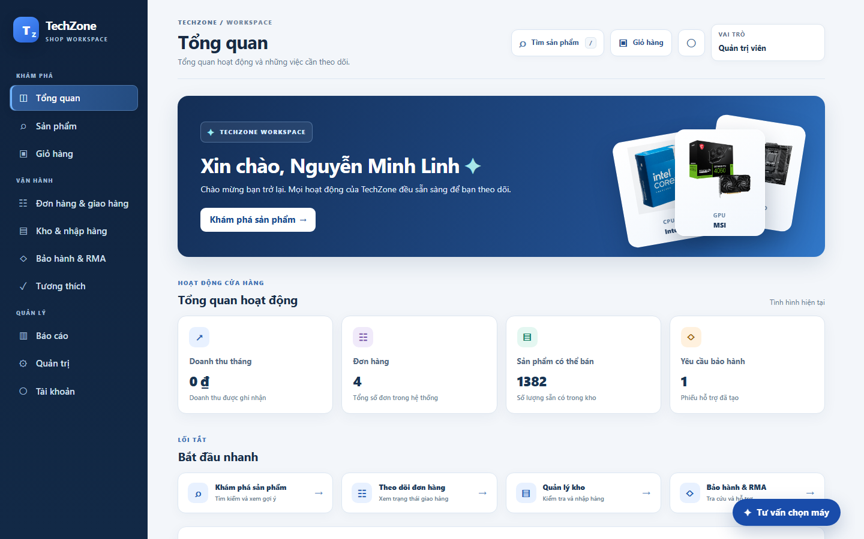
Figure 14. Workspace dashboard with a photographic product showcase, operational summaries and quick links.
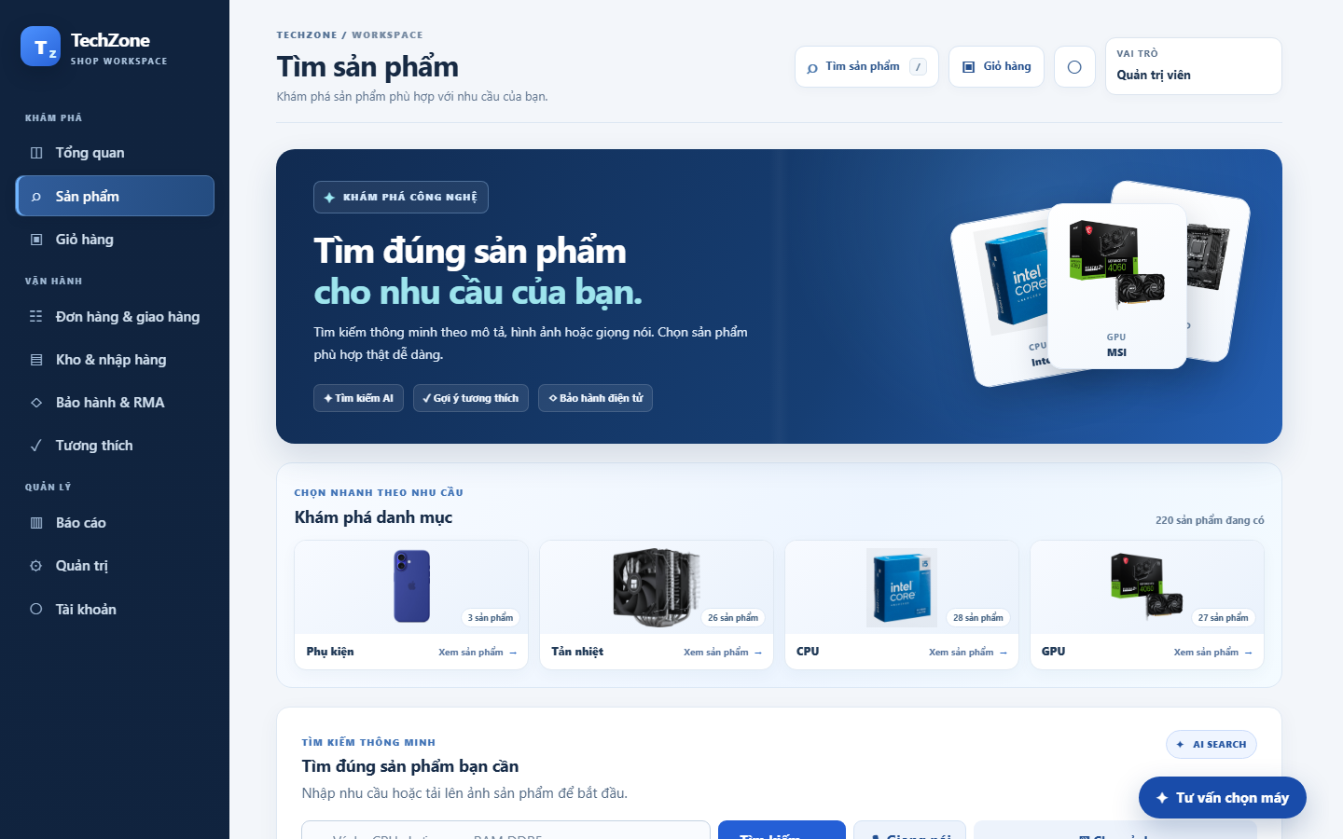
Figure 15. Product catalogue with product photography, image-based category shortcuts, text/voice/image search and specification filters.

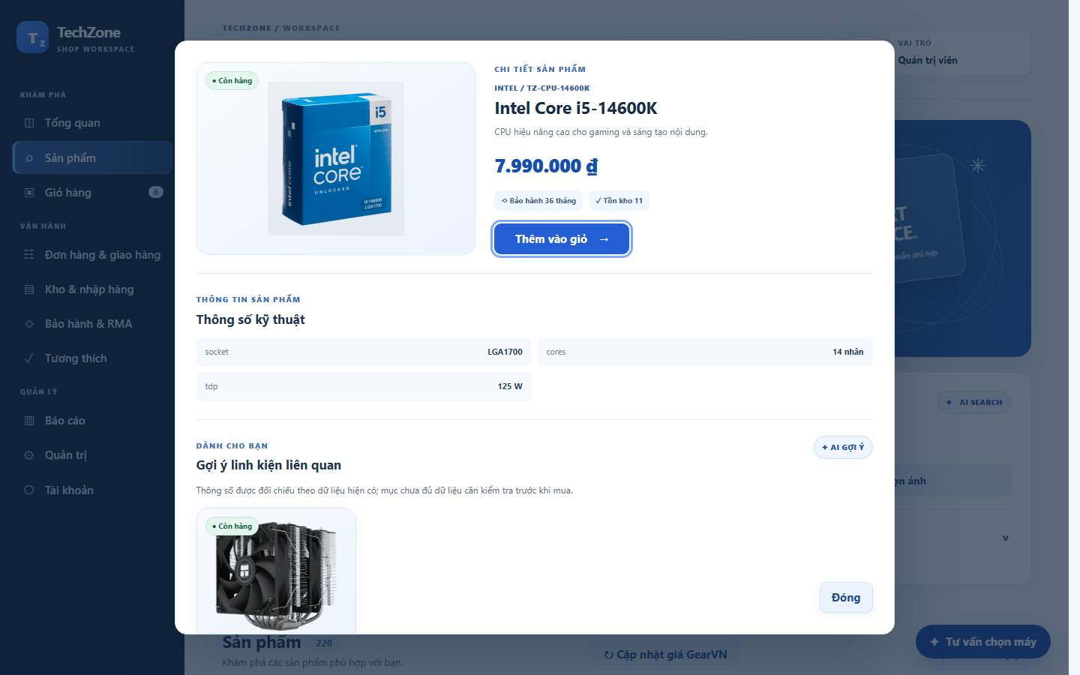
Figure 16. Product detail modal with stock, specifications and eligible related-component recommendations.
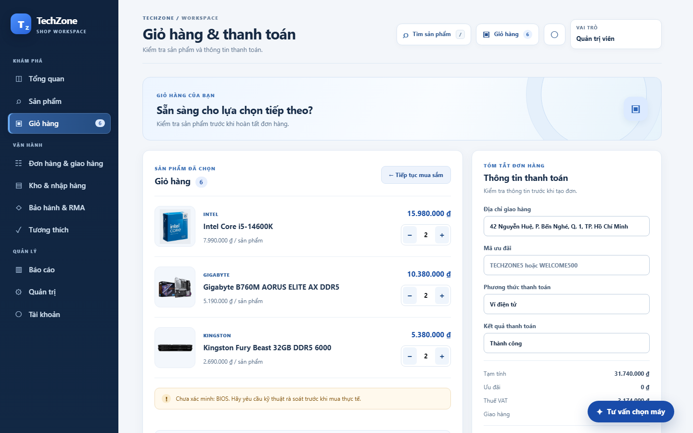
Figure 17. Shopping cart and checkout form with item quantities, price summary and compatibility notice.

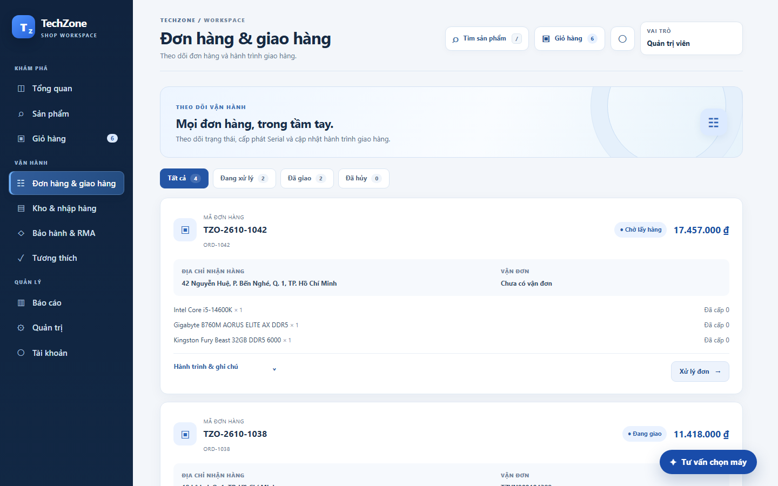
Figure 18. Order list with order status, line items, serial allocation and delivery tracking.
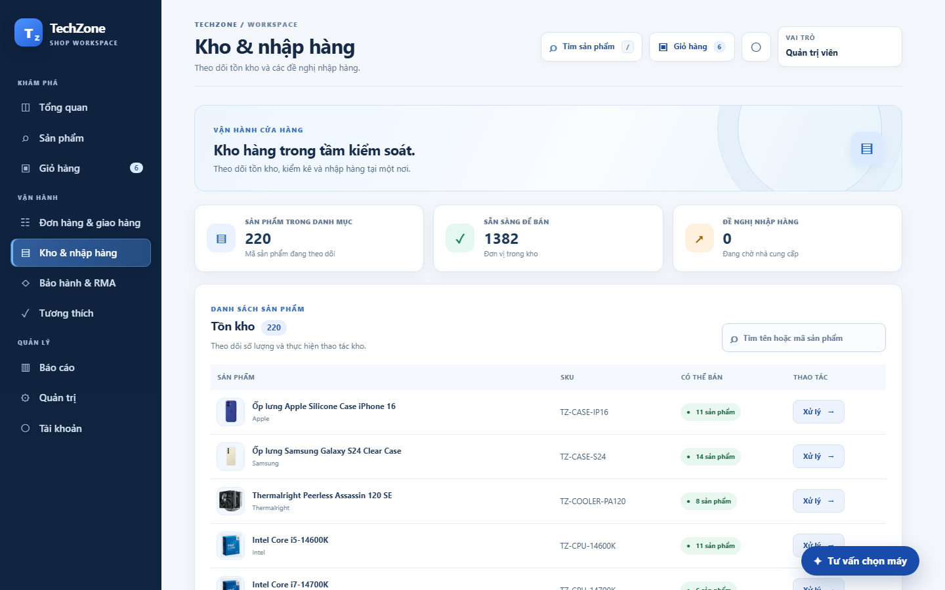
Figure 19. Inventory overview with available quantities, SKU search and warehouse actions.

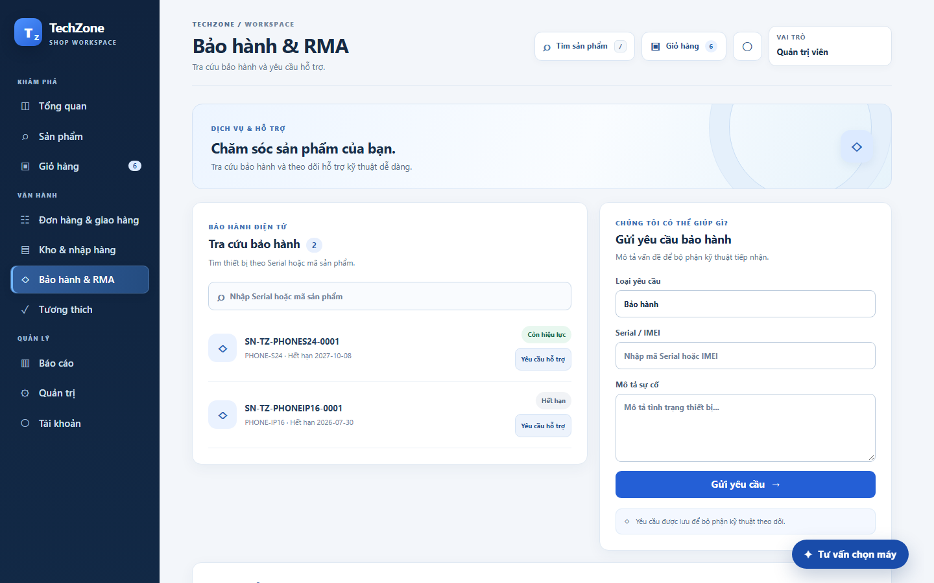
Figure 20. Warranty lookup and customer support request form.
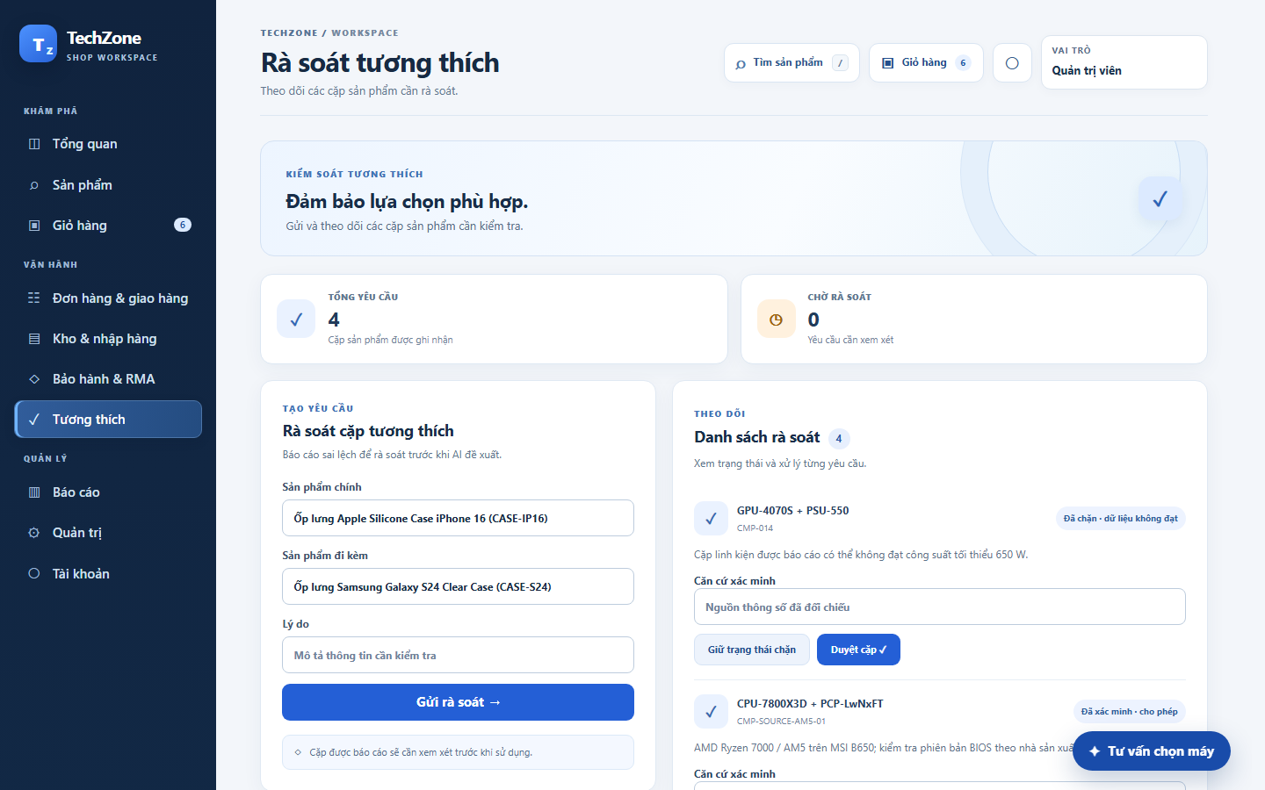
Figure 21. Compatibility review queue with evidence fields and approve/block actions.

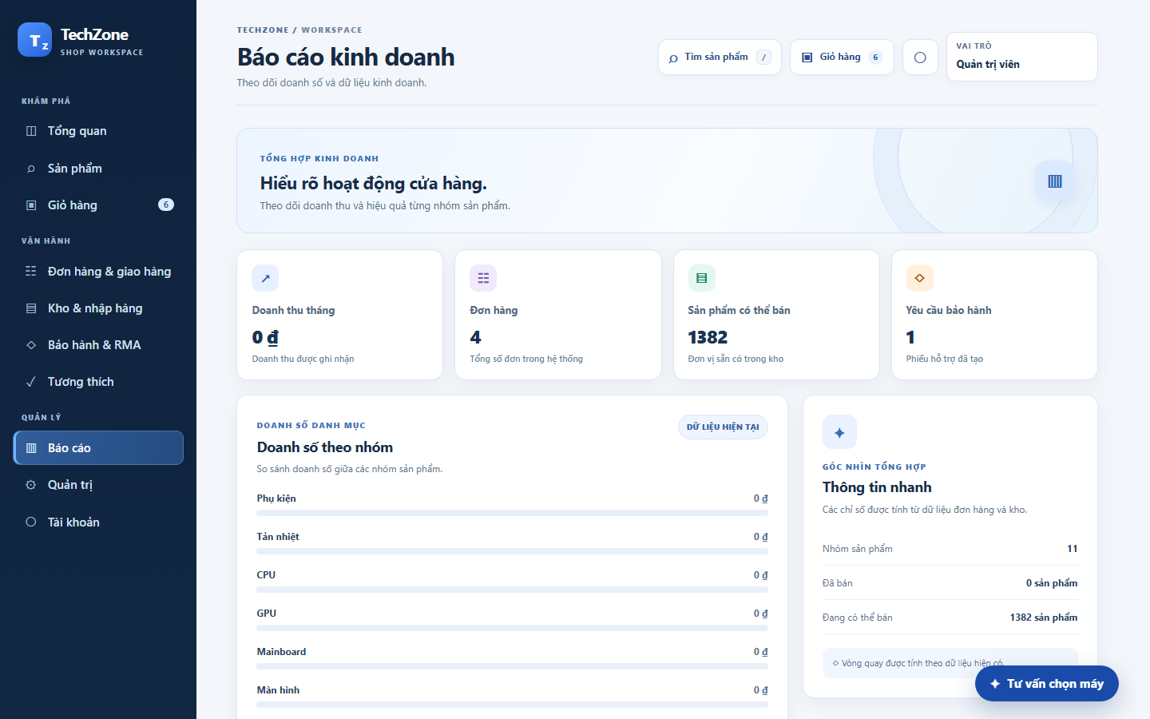
Figure 22. Business report overview with sales and inventory measures by category.
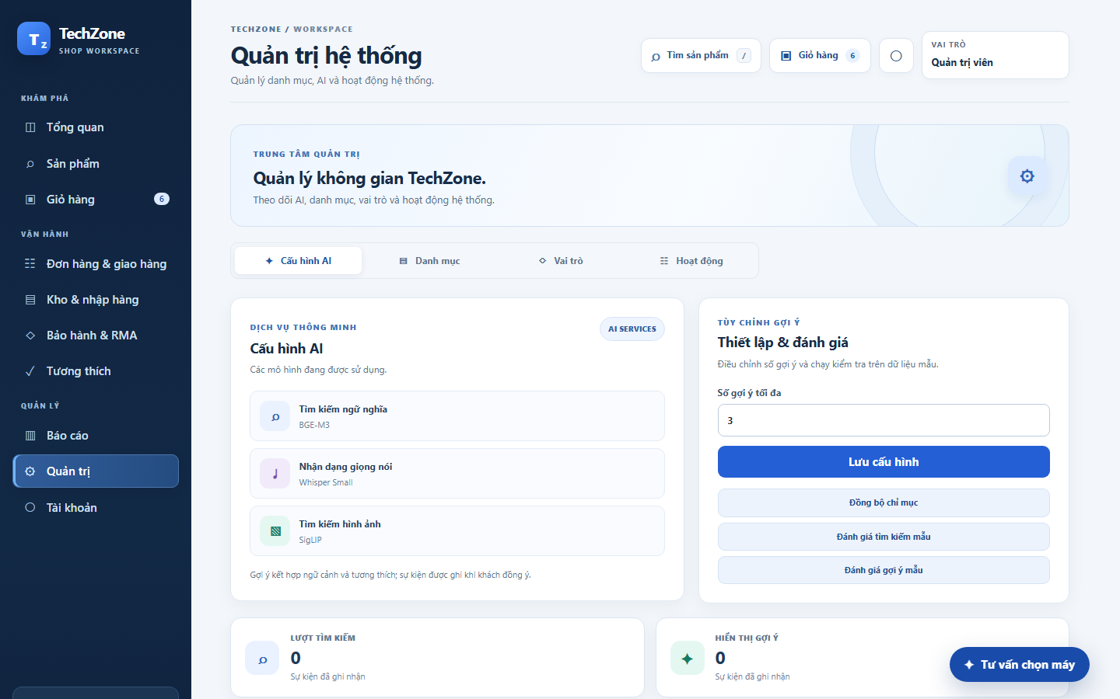
Figure 23. AI administration screen showing search, speech and image model services.

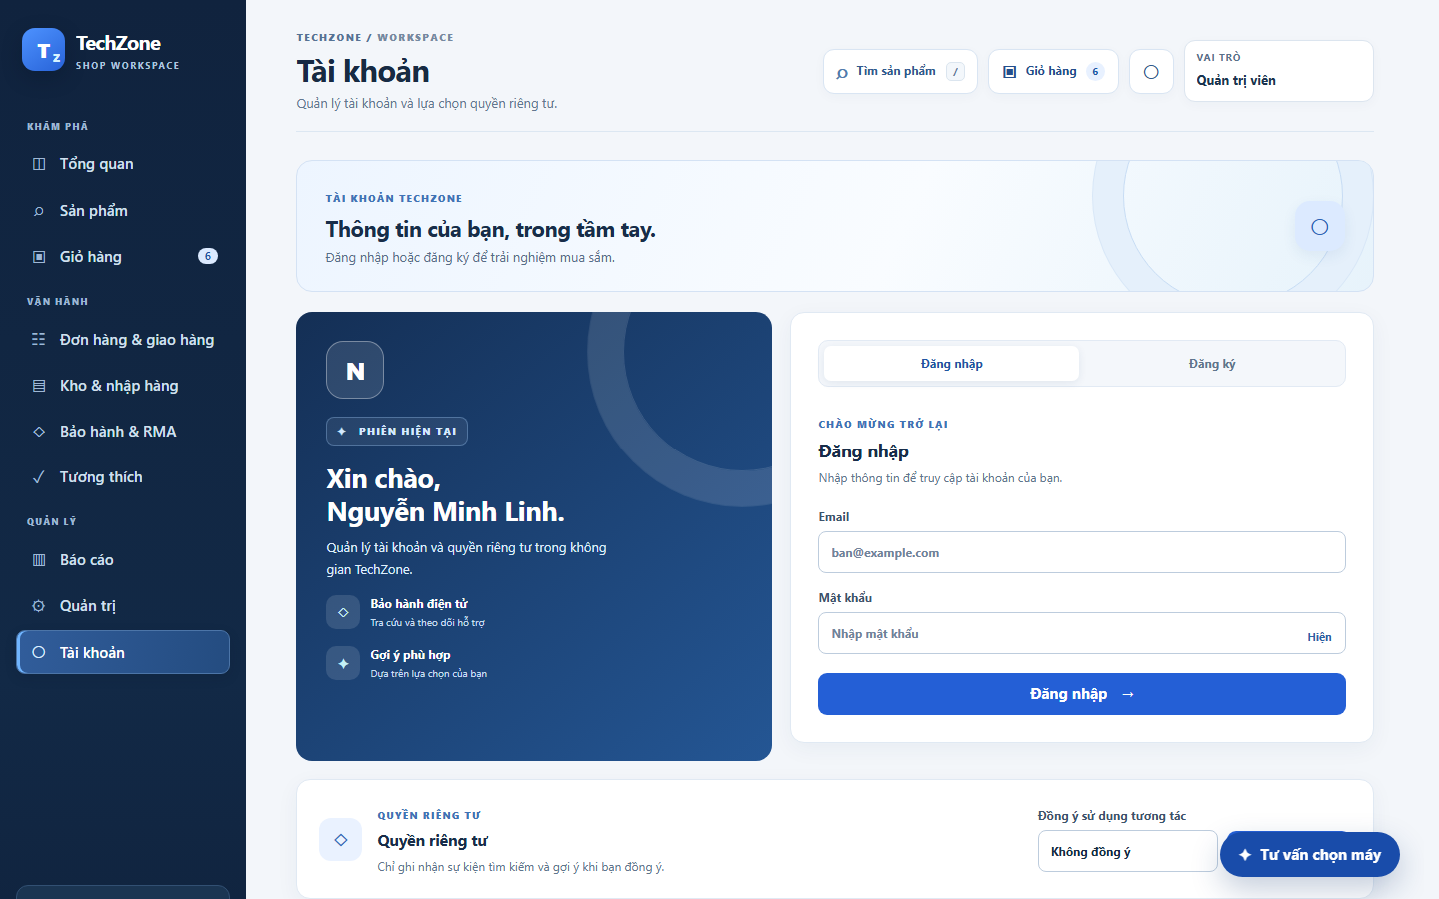
Figure 24. Account sign-in and privacy-consent interface.
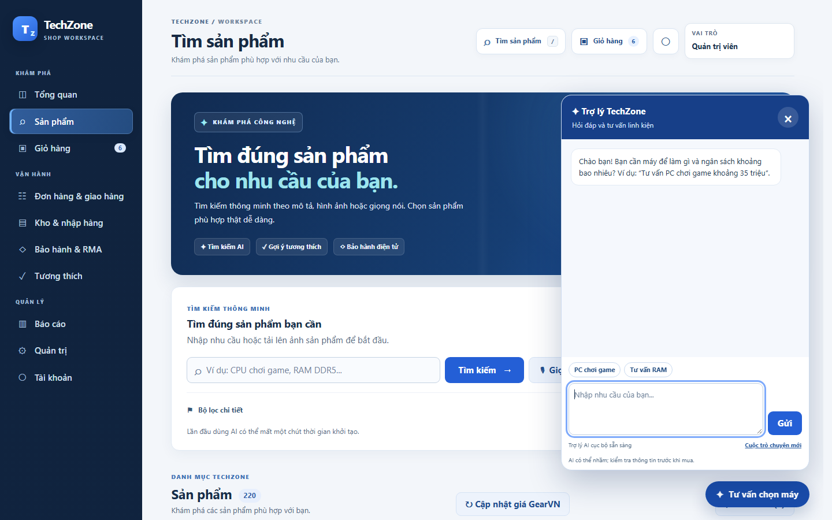
Figure 25. AI advisor panel for conversational PC configuration requests.
Table 28. User Interface Coverage and Requirement Mapping.
Screens | Visible function | Related requirements or use cases
Figures 14, 22 | Workspace overview, sales and stock reporting | UC13; FR22
Figures 15–16 | Catalogue, product specifications, search inputs and related items | UC01, UC02, UC12; FR03–FR07
Figures 17–18 | Cart, checkout, order information and tracking | UC03–UC05; FR08–FR12, FR19
Figure 19 | Inventory and warehouse-facing actions | UC10–UC11; FR13–FR15
Figure 20 | Warranty lookup and service-request entry | UC06, UC16; FR20–FR21
Figures 21, 23 | Compatibility-rule review and AI model administration | FR05; AIS-S/AIS-R controls
Figures 24–25 | Account access, consent and conversational advice | FR01–FR02; UC12; AI data governance

5.6 Implementation Evidence, Limitations and Verification
Table 29. Prototype implementation status and verification limitations.
Area | Evidence recorded in this report | Verification still required
Search / GearVN catalogue | Implemented in local prototype; crawl snapshot present. | Not verified end-to-end after catalogue change: local stock is zero and CatalogSearchService requires positive stock.
Recommendation / chatbot | Eligibility and local model integration implemented; provider and compatibility evidence incomplete. | Not evaluated on an independent labelled dataset; crawled items have no approved pairs or local stock.
Checkout / payment | Workflow and simulated gateway implemented. | 130 broad store checks passed; live payment provider and concurrent production behavior not established.
Inventory / serial allocation | Domain and SQLite constraints implemented. | SQLite regression passed after migration, session, fulfillment and foreign-key fixes; production concurrency and physical dispatch remain to be verified.
Warranty / delivery | Local simulated delivery and warranty paths implemented. | Real provider callback, owner privacy and end-to-end integrations not verified.
Access / reporting | Local role mode and reporting screens implemented. | Role selector is demonstration behavior; production RBAC, SLA and load not verified.
Priority acceptance tests cover catalogue filtering, technical compatibility, checkout outcomes, duplicate Serial/IMEI allocation and delivery-triggered warranty activation. Negative and concurrent-request cases require execution.

5.7 Design-to-Implementation Assessment
The prototype covers the main use cases through local interfaces and adapters, with the remaining design and verification gaps summarized in Table 30.
Table 30. Design-to-Implementation Correspondence.
Design area | Current prototype correspondence | Outstanding work
Product catalogue and AI search | CatalogBackend, SearchUseCase, SemanticSearch; catalogue and filter screens. | Authoritative specification provenance and retrieval evaluation.
Compatibility and recommendation | RecommendationEligibilityService, RecommendationRankingService, AdvisorService; product suggestions. | Verified technical-rule coverage and explanation quality.
Order and payment | CheckoutUseCase, CheckoutWorkflowService; simulated gateway and checkout screen. | Live provider integration, retries, transaction and concurrency tests.
Inventory, delivery and warranty | SQLite units/orders, warehouse and warranty paths, tracking views. | End-to-end barcode scanning, carrier callbacks and warranty reconciliation.
Reporting and administration | Dashboard, reports, rule-review, AI administration and account screens. | Access-control enforcement, auditing and representative workload tests.

Appendix A. Verification Evidence and Limitations
This appendix summarizes local verification completed on 11 November 2026 and the remaining acceptance-testing scope.

A.1 Build and regression evidence
Command / environment | Observed result | Scope and limitation
.\test.bat; Windows; OpenJDK 17.0.10; Python 3.11.9; 11 November 2026 | PASSED (exit code 0). Local regression stages completed, including SQLite, BGE-M3, SigLIP 2, Qwen3 and Chrome smoke tests. | Local and demonstration data with simulated providers; no production load or live-gateway acceptance claim.
Additional acceptance testing | Not yet evaluated. | Independent retrieval relevance, Whisper Medium inference, security, full concurrency, live payment/delivery and service availability require separate verification.

A.2 Proposed measurement and acceptance protocol
Requirement | Proposed workload and measurement | Acceptance target | Observed
NFR01 | Record host CPU/RAM, JVM, catalogue size, query set, concurrency and warm/cold state; measure end-to-end p50/p95, timeout and fallback. | 3 s target under agreed normal workload | Not evaluated
NFR02 | Separate model inference from full API time; record candidate count, model version/readiness, p50/p95 and fallback. | 200 ms inference target | Not evaluated
NFR07 | Monitor availability over a representative agreed period; define uptime, maintenance and incident accounting. | 99.9% target | Not evaluated
NFR09 | Incrementally increase product count and concurrency to 1,000; report throughput, errors, p95 and host capacity. | 1,000 concurrent users target | Not evaluated
Search / recommender | Use a documented, independently labelled query/product set, version and split. Record Recall@K, NDCG@K, candidate coverage, compatibility violations and fallback cases. | Thresholds and sample size require approval | Not evaluated
Proposed acceptance tests cover technical filters, concurrent checkout, duplicate Serial/IMEI scans, payment idempotency and warranty activation. Results must be recorded before claiming compliance.

A.3 Implementation mapping, catalogue provenance and data limits
Search path: app.js -> CatalogBackend -> SearchUseCase / CatalogSearchService -> optional SemanticSearch worker. Technical filters remain mandatory. Search includes active GearVN listings without treating them as local inventory; internal products require positive local stock. Model failure falls back to conventional search. Image search uses indexed local or cached source images.
A GearVN snapshot of 200 product URLs, prices and images was collected on 6 November 2026 and imported into SQLite. External price and availability can change; imported stock defaults to zero and cannot be ordered as TechZone inventory. Customers can open the source listing. Product advice can show external references; when no verified build is available, semantic results are labelled as individual references, not a compatible configuration.
External references are ranked by the semantic model only when it returns scores for the current catalogue. The application does not infer compatibility from similarity. A complete configuration still requires approved compatible pairs and local stock; BIOS, connectors, dimensions and power need verification.
Payment and delivery integrations are simulated, and the displayed roles are not a substitute for production authentication and authorization. The search benchmark uses a small synthetic set and does not establish production quality; speech recognition requires separate recorded-audio testing.
Compatibility reviews block conflicts and unapproved pairs. Manufacturer validation of BIOS, connectors, dimensions and power remains incomplete; the language model does not determine eligibility.
Interaction events include consent scope and pseudonymous session keys. Retention, access and deletion policies require further implementation; transient UML concepts need not map to tables.

A.4 SQLite constraints and proposed versus implemented controls
Area | Code evidence | Status / limit
Schema | RelationalSchema.java: products, product_variants, inventory_balances and other tables | 17 core entities plus supporting tables, including market_offers; diagrams are logical summaries.
Keys and quantities | RelationalSchema.java: foreign keys; CHECK nonnegative stock and prices; UNIQUE inventory_units.serial_imei and unit_allocations.unit_id | DDL present; cross-variant correctness also depends on application validation. Independent transaction/concurrency evidence remains incomplete.
Persistence | SqliteStore.java: foreign_keys=ON; writeRows and writeMarketOffers inside transaction with commit/rollback | SQLite backend and schema regressions passed on 11 November after fixes; SQL examples in Part 4 remain abbreviated.
Checkout | CheckoutWorkflowService.java and TechZoneStore.java: AUTHORIZED / DECLINED / UNKNOWN; reconciliationDueAt is 15 minutes | Simulated provider. Due time triggers follow-up; do not infer automatic cancellation, release or provider polling.
Deployment | BackendMain.java, CatalogBackend.java, SQLite; optional Python workers | Single local prototype; logical components are not independently deployed microservices.

A.5 Requirement Implementation Status
Requirements describe the target capabilities; Table A.3 distinguishes implemented, partial and simulated features.
Must requirement | Use case / design area | Repository evidence | Status
FR01 Account | UC account / customers | CatalogBackend.java; TechZoneStore.java; RelationalSchema.java | Implemented locally; independent acceptance not established
FR02 Account | UC account / customers | CatalogBackend.java; TechZoneStore.java; RelationalSchema.java | Implemented locally; independent acceptance not established
FR03 Product | UC01 / catalogue | CatalogBackend.java; TechZoneStore.java; RelationalSchema.java | Implemented in part; acceptance and current data coverage not verified
FR05 Product | UC01 / catalogue | CatalogBackend.java; TechZoneStore.java; RelationalSchema.java | Implemented in part; acceptance and current data coverage not verified
FR06 AI Services | UC01/UC12 / interaction_events | CatalogBackend.java; TechZoneStore.java; RelationalSchema.java | Implemented in part; acceptance and current data coverage not verified
FR08 Cart | UC03 / cart_items | CatalogBackend.java; TechZoneStore.java; RelationalSchema.java | Implemented locally; independent acceptance not established
FR09 Cart | UC03 / cart_items | CatalogBackend.java; TechZoneStore.java; RelationalSchema.java | Implemented locally; independent acceptance not established
FR10 Order | UC04 / sales_orders | CatalogBackend.java; TechZoneStore.java; RelationalSchema.java | Implemented locally; independent acceptance not established
FR11 Order | UC04 / sales_orders | CatalogBackend.java; TechZoneStore.java; RelationalSchema.java | Implemented locally; independent acceptance not established
FR12 Order | UC04 / sales_orders | CatalogBackend.java; TechZoneStore.java; RelationalSchema.java | Implemented locally; independent acceptance not established
FR13 Inventory | UC10/UC11 / inventory_units | CatalogBackend.java; TechZoneStore.java; RelationalSchema.java | Implemented in part; acceptance and current data coverage not verified
FR14 Inventory | UC10/UC11 / inventory_units | CatalogBackend.java; TechZoneStore.java; RelationalSchema.java | Implemented in part; acceptance and current data coverage not verified
FR16 Payment | UC09 / payments | CatalogBackend.java; TechZoneStore.java; RelationalSchema.java | Simulated provider / local path; real integration not verified
FR17 Payment | UC09 / payments | CatalogBackend.java; TechZoneStore.java; RelationalSchema.java | Simulated provider / local path; real integration not verified
FR18 Shipping | UC17 / shipments | CatalogBackend.java; TechZoneStore.java; RelationalSchema.java | Simulated provider / local path; real integration not verified
FR20 Warranty | UC06/UC16 / warranties | CatalogBackend.java; TechZoneStore.java; RelationalSchema.java | Simulated provider / local path; real integration not verified
FR21 Warranty | UC06/UC16 / warranties | CatalogBackend.java; TechZoneStore.java; RelationalSchema.java | Implemented in part; acceptance and current data coverage not verified
FR22 Reporting | UC13 / reports | CatalogBackend.java; TechZoneStore.java; RelationalSchema.java | Implemented in part; acceptance and current data coverage not verified
Security, availability and load targets remain unverified. SQLite regression coverage includes stale-session conflicts and serial allocation; representative concurrent load still requires separate measurement.

References
[1] J. Chen et al., “M3-Embedding: Multi-Linguality, Multi-Functionality, Multi-Granularity Text Embeddings Through Self-Knowledge Distillation,” arXiv:2402.03216. https://arxiv.org/abs/2402.03216 ; model: https://huggingface.co/BAAI/bge-m3.
[2] Qwen Team, “Qwen3 Technical Report,” arXiv:2505.09388. https://arxiv.org/abs/2505.09388 ; checkpoint: https://huggingface.co/Qwen/Qwen3-4B-Instruct-2507.
[3] A. Radford et al., “Robust Speech Recognition via Large-Scale Weak Supervision,” arXiv:2212.04356. https://arxiv.org/abs/2212.04356 ; checkpoint: https://huggingface.co/openai/whisper-medium.
[4] M. Tschannen et al., “SigLIP 2: Multilingual Vision-Language Encoders with Improved Semantic Understanding, Localization, and Dense Features,” arXiv:2502.14786. https://arxiv.org/abs/2502.14786 ; checkpoint: https://huggingface.co/google/siglip2-base-patch16-224.
[5] K. Järvelin and J. Kekäläinen, “Cumulated Gain-based Evaluation of IR Techniques,” ACM Transactions on Information Systems, 20(4), 422–446, 2002. https://doi.org/10.1145/582415.582418.
[6] SQLite, “SQLite Foreign Key Support.” https://www.sqlite.org/foreignkeys.html (accessed 11 November 2026).

