|  |  |  |
| --- | --- | --- |
| 1. NHOMNGDUNG | | |
| GET | <http://localhost:8080/api/v.1.0/nhomngdung> |  |
| [http://localhost:8080/api/v.1.0/ nhomngdung](http://localhost:8080/api/v.1.0/nguoidung) /{id} |  |
| PUT | [http://localhost:8080/api/v.1.0/ nhomngdung](http://localhost:8080/api/v.1.0/nguoidung) | KQ: |
| POST | [http://localhost:8080/api/v.1.0/ nhomngdung](http://localhost:8080/api/v.1.0/nguoidung) | KQ: |
| DELETE | [http://localhost:8080/api/v.1.0/ nhomngdung](http://localhost:8080/api/v.1.0/nguoidung) /{id} | <http://localhost:8080/api/v.1.0/nhomngdung/5> |

|  |  |  |
| --- | --- | --- |
| 2. NGUOIDUNG | | |
| GET | <http://localhost:8080/api/v.1.0/nguoidung> |  |
| <http://localhost:8080/api/v.1.0/nguoidung>/{id} |  |
| PUT | <http://localhost:8080/api/v.1.0/nguoidung> | KQ:   * Người dùng tồn tại:      * Người dùng **không** tồn tại: |
| POST | <http://localhost:8080/api/v.1.0/nguoidung> | KQ:   * Người dùng tồn tại:      * Người dùng **không** tồn tại: |
| DELETE | <http://localhost:8080/api/v.1.0/nguoidung>/{id} |  |

|  |  |  |
| --- | --- | --- |
| 3. KHOA | | |
| GET | <http://localhost:8080/api/v.1.0/khoa> |  |
| [http://localhost:8080/api/v.1.0/ khoa](http://localhost:8080/api/v.1.0/%20khoa/%7bid%7d%20) /{id} |  |
| PUT | [http://localhost:8080/api/v.1.0/ khoa](http://localhost:8080/api/v.1.0/nguoidung) | KQ: |
| POST | [http://localhost:8080/api/v.1.0/ khoa](http://localhost:8080/api/v.1.0/nguoidung) | KQ: |
| DELETE | [http://localhost:8080/api/v.1.0/ khoa](http://localhost:8080/api/v.1.0/nguoidung) /{id} |  |

|  |  |  |
| --- | --- | --- |
| 4. BACSI | | |
| GET | <http://localhost:8080/api/v.1.0/bacsi> |  |
| <http://localhost:8080/api/v.1.0/bacsi> /{id} |  |
| PUT | <http://localhost:8080/api/v.1.0/bacsi> |  |
| POST | <http://localhost:8080/api/v.1.0/bacsi> |  |
| DELETE | <http://localhost:8080/api/v.1.0/bacsi> /{id} |  |

|  |  |  |
| --- | --- | --- |
| 5. PHONGKHAM | | |
| GET | <http://localhost:8080/api/v.1.0/phongkham> |  |
| [http://localhost:8080/api/v.1.0/phongkham/?mabs={...}&makhoa={...}](http://localhost:8080/api/v.1.0/phongkham/?mabs=%7b...%7d&makhoa=%7b...%7d) | <http://localhost:8080/api/v.1.0/phongkham/?mabs=bs01&makhoa=k01> |
| PUT | <http://localhost:8080/api/v.1.0/phongkham> | * Khong ton tai PhongKham     KQ:     * Ton tai PhongKham     KQ: |
| POST | <http://localhost:8080/api/v.1.0/phongkham> |  |
| DELETE | [http://localhost:8080/api/v.1.0/phongkham/?mabs={...}&makhoa={...}](http://localhost:8080/api/v.1.0/phongkham/?mabs=%7b...%7d&makhoa=%7b...%7d) | <http://localhost:8080/api/v.1.0/phongkham/?mabs=bs01&makhoa=k01>  KQ: |

|  |  |  |
| --- | --- | --- |
| 6. LICHHEN | | |
| GET | <http://localhost:8080/api/v.1.0/lichhen> |  |
| <http://localhost:8080/api/v.1.0/lichhen> /{} |  |
| PUT | <http://localhost:8080/api/v.1.0/lichhen> | * Ton tai: |
| POST | <http://localhost:8080/api/v.1.0/lichhen> | KQ: |
| DELETE | <http://localhost:8080/api/v.1.0/lichhen> | http://localhost:8080/api/v.1.0/lichhen/LH021 |

|  |  |  |
| --- | --- | --- |
| 7. BENHNHAN | | |
| GET | <http://localhost:8080/api/v.1.0/benhnhan> |  |
| <http://localhost:8080/api/v.1.0/benhnhan> /{id} |  |
| GET | <http://localhost:8080/api/v.1.0/benhnhan>/?matk=... |  |
| PUT | <http://localhost:8080/api/v.1.0/benhnhan> |  |
| POST | <http://localhost:8080/api/v.1.0/benhnhan> | KQ: |
| DELETE | <http://localhost:8080/api/v.1.0/benhnhan> |  |

|  |  |  |
| --- | --- | --- |
| 8. NGUOIDATLICH | | |
| GET | <http://localhost:8080/api/v.1.0/nguoidatlich> |  |
| <http://localhost:8080/api/v.1.0/nguoidatlich> /{id} |  |
| PUT | <http://localhost:8080/api/v.1.0/nguoidatlich> | KQ: |
| POST | <http://localhost:8080/api/v.1.0/nguoidatlich> |  |
| DELETE | <http://localhost:8080/api/v.1.0/nguoidatlich> |  |

|  |  |  |
| --- | --- | --- |
| 9. DICHVU | | |
| GET | <http://localhost:8080/api/v.1.0/dichvu> |  |
| <http://localhost:8080/api/v.1.0/dichvu>/{id} |  |
| PUT | <http://localhost:8080/api/v.1.0/dichvu> | KQ: |
| POST | <http://localhost:8080/api/v.1.0/dichvu> | KQ: |
| DELETE | <http://localhost:8080/api/v.1.0/dichvu>/{id} |  |

|  |  |  |
| --- | --- | --- |
| 10. CHITIETDICHVU | | |
| GET | <http://localhost:8080/api/v.1.0/chitietdichvu> |  |
| <http://localhost:8080/api/v.1.0/chitietdichvu> /?madv={...}&malichhen={...} | <http://localhost:8080/api/v.1.0/chitietdichvu/?madv=DV01&malichhen=LH001> |
| PUT | <http://localhost:8080/api/v.1.0/chitietdichvu> | **X** |
| POST | <http://localhost:8080/api/v.1.0/chitietdichvu> | KQ: |
| DELETE | <http://localhost:8080/api/v.1.0/chitietdichvu>  /?madv={...}&malichhen={...} | http://localhost:8080/api/v.1.0/chitietdichvu/?madv=DV01&malichhen=LH001 |

|  |  |  |
| --- | --- | --- |
| 10. Kiểm tra đăng nhập | | |
| GET | **X** | **X** |
| **X** | **X** |
| PUT | **X** | **X** |
| POST | <http://localhost:8080/api/v.1.0/login> | * (tentk, matkhau) sai      * (tentk, matkhau) đúng |
| DELETE | **X** | **X** |

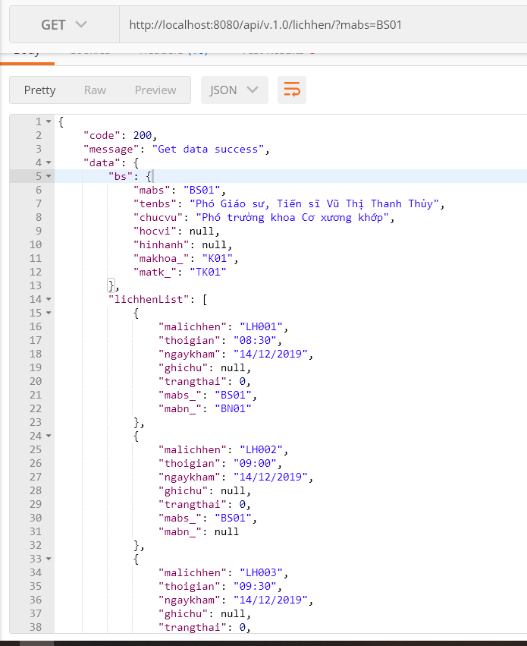

<http://localhost:8080/api/v.1.0/lichhen/?mabs=BS01>

Lichkham cua bac si theo mabs

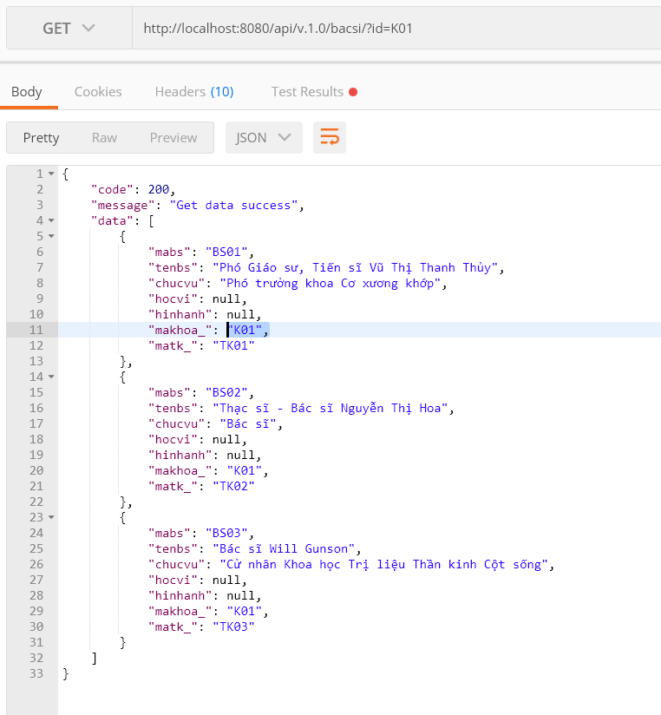

<http://localhost:8080/api/v.1.0/bacsi/?id=K01>

Thong tin cac bac si trong 1 khoa